Latrobe Valley Regional Rehabilitation Strategy
Progress Report 2018 – 2019

Overview
This progress report provides an update on the development of the Latrobe Valley Regional Rehabilitation Strategy (the Strategy) for the 2018/19 financial year. The Strategy is a key element of the Victorian Government’s response to the 2015/16 Hazelwood Mine Fire Inquiry (the Inquiry).

What is the Latrobe Valley Regional Rehabilitation strategy?
On 9 February 2014, embers from a nearby grassfire entered the Hazelwood brown coal mine in the Latrobe Valley in south-east Victoria, sparking a coal fire that would burn for the next 45 days.
The subsequent Hazelwood Mine Fire Inquiry raised several questions regarding the rehabilitation of the Latrobe Valley’s brown coal mines.
The Inquiry concluded that based on the evidence available, filling the mines with water “is currently the most viable rehabilitation option, (however) considerable further investigation is required, as new knowledge could result in an alternative preferred option.”
In response to the Inquiry’s findings, the Victorian Government prepared an Implementation Plan, which includes a commitment to develop a regional rehabilitation strategy to address the knowledge gaps identified by the Inquiry and help guide the planning for future rehabilitation and closure of the Latrobe Valley’s three brown
coal mines.
The preparation of the Latrobe Valley Regional Rehabilitation Strategy (LVRRS) is informed by a four-year program of activities involving technical studies and policy development, delivered in four stages – (I) Project Initiation, (II) Existing Conditions Review, (III) Modelling and Analysis, and (IV) Integration of Findings. Stage III of the work program was concluded during 2018/19 with completion of three technical studies:
- Regional Geotechnical Study
- Regional Water Study
- Regional Land Use Study
These investigations will inform the preparation of the final Strategy as an enabling framework that will guide regional planning for mine rehabilitation, mine closure and post-closure management.
The Strategy is due to be prepared by 30 June 2020

WORK UNDERTAKEN IN 2018/19

REGIONAL GEOTECHNICAL STUDY

Scope of work
This study was undertaken to assess the viability and potential impacts of filling the Latrobe Valley coal mines with water as a rehabilitation option, with a view to understanding how the Strategy should address regional land stability issues.
Existing baseline geotechnical data, regional ground movement history, and predictive methods for assessing potential mine rehabilitation impacts was used to inform the Regional Geotechnical Study.

Summary of findings
Since commencement of coal mining in the Latrobe Valley in the early 1900s, there have been a number of major local failures of the mine walls (batters), several of these have occurred in recent years.
These include the Yallourn Northern Batters failure in 2007, which resulted in the Latrobe River flowing into the Yallourn Mine for a period of six days, and movement in the northern wall of the Hazelwood Mine in 2011, which resulted in cracking in the Princes Freeway and the closure of the freeway to traffic for approximately six months.
There has also been gradual subsidence in land level at a regional scale associated with mining as a consequence of groundwater extraction for mine stability.
Ground movements associated with mine rehabilitation are predicted to be within the range of movements already experienced over the mining history of the region if rehabilitation is well planned.
The extent to which ground subsidence will reverse when the mines are rehabilitated has also been investigated. This rebound effect will require further research and long-term monitoring, with adaptive management measures as necessary.
Control of surface water drainage around the mine voids is a key element to achieving safe and stable rehabilitated mine sites. The geotechnical study highlighted the importance of ongoing management of surface water drainage and adequate buffers around the mines during and after rehabilitation to ensure surrounding assets continue to be protected from ground movement risks.
In evaluating different rehabilitation options, the management of long-term coal fire risk is also of key importance. Coal fire risk is best managed by covering exposed coal with soil or water, and a long-term cover maintenance plan will be required.
Although detailed rehabilitation planning will be completed by each mine operator, the geotechnical study suggests that water, if available in the volumes required for rehabilitation, could be used to effectively manage long-term ground movement and fire risks.
The analysis also suggests that if water is used as the rehabilitation solution, extended fill periods or a lowered final fill level could present additional challenges with respect to the management of stability and fire risks both during the fill period and as part of the final landform design.

How findings will inform the overall LVRRS
These findings will inform the development of an enabling framework for how regional land stability can be managed for mine rehabilitation, including considerations for mine operators’ rehabilitation planning.

REGIONAL WATER STUDY

Scope of work
This study was undertaken to assess the viability and potential impacts and benefits of filling the Latrobe Valley coal mines with water (either partly or fully) as a rehabilitation option, with a view to understanding how the Strategy should address water-related constraints.
This assessment involved technical studies examining projected water availability and the use of regional water resources, possible alternative sources of water, water quality, potential surface water and groundwater impacts including on aquatic ecosystems and other water users, as well as long-term regional groundwater monitoring.

Summary of findings
An integrated study of surface water, groundwater and various options to supply water to the mine voids was conducted to understand how the Latrobe River system could support different rehabilitation options. That study showed that the Latrobe Valley has experienced very dry conditions since 1997 (except between 2010–12) and that under climate change this drying trend could continue into the future.
Under recent and current conditions or a drier future climate, average water availability is less than that needed to supply all consumptive demands and mine rehabilitation while meeting minimum river flow requirements in the Latrobe River system. There could however be wetter periods or seasonal conditions in which all demands could be met and surplus water available.
The Strategy therefore needs to plan for the possibility that dry conditions could continue and worsen rather than improve in the future, while being flexible enough to also utilise water if required during wetter conditions. This means that the allocation and management of water in the Latrobe Valley, particularly for mine rehabilitation, should be adaptive and guided by clear and accountable rules.
The study also found that at present there are no alternative sources of water of suitable quality, volume or price that would be considered feasible to assist in mine rehabilitation compared to existing water sources, although this may change in the future.
A high-level assessment of water quality risks by a panel of experts did not identify any significant water quality risks at any of the mines based on current knowledge, although this will need to be reassessed over the course of the mine rehabilitation planning period by the mine operators.
The relatively minor risks identified are expected to be manageable, and the likelihood of ongoing risks or impacts associated with water within a mine void is considered to be low. It is recognised, however, that filling the mines with water, without connection to the regional surface water system (i.e. without inflow and outflow), would likely result in an unavoidable decline in water quality over the long term due to evaporative concentration of salinity and potentially other accumulated contaminants from the catchment.
The main factor influencing the quality of water in any mine is the chemical composition of the water used to fill the voids. As such, acceptable water quality is considered to be achievable without ongoing water treatment, subject to the intended use of the water, if the water used to fill the mine voids is of a suitable quality. Any releases of water from the mines would be required to meet applicable water quality standards.
Minimum environmental flow recommendations for the Latrobe River and lower estuary and wetlands have been updated as part of the study. These recommendations establish the minimum flows required to maintain river function and achieve sufficiently fresh conditions in the lower reaches of the river to prevent salinisation of the highly valued Ramsar wetlands and other fringing environments of the lower Latrobe River and Lake Wellington. The Strategy needs to ensure that minimum flow requirements are protected, as sustained shortfalls in these minimum flows are likely to result in adverse ecological impacts including continued salinisation of previously freshwater wetlands and ecological areas.
Additional groundwater quality monitoring near the mine pits is expected to only be required if a water quality issue in a mine is identified. No such issues are predicted.
Groundwater level changes can be adequately monitored using the existing private and state-owned monitoring network if maintained and accessible.

How findings will inform overall LVRRS
These findings will inform the development of an enabling framework for how water could be delivered for mine rehabilitation and under what conditions and will form the basis for clear guidance for the mine operators on the constraints on water availability in the Latrobe Valley.

Regional land use study

Scope of work
The Regional Land Use Study consists of a social history study to capture, recognise and celebrate the heritage of the Latrobe Valley, and development of a preliminary vision to start the long-term planning of land-uses and activities in the region in the context of the sequential rehabilitation and closure of the Latrobe Valley’s coal mines.

Summary of findings
Phase one of the Latrobe Valley Social History Study, involving the capture of social history through focus groups and other means, has been completed. Phase two of the study will identify specific opportunities for interpretation and celebration and is due to be completed by the end of 2019.
The Preliminary Land Use Vision Study captures outputs from stakeholder engagement activities to provide a context on land-use planning issues for coal mine land and surrounding areas. The draft Vision report is expected to be released for public exhibition later in 2019.

How findings will inform overall LVRRS
The Social History Study will inform the LVRRS by providing a social history narrative and identifying place-based opportunities that might be reflected in future land use outcomes.
The Preliminary Vision will capture stakeholder feedback on land use planning issues and outline key issues and processes that need to be considered in assessing future land use options.
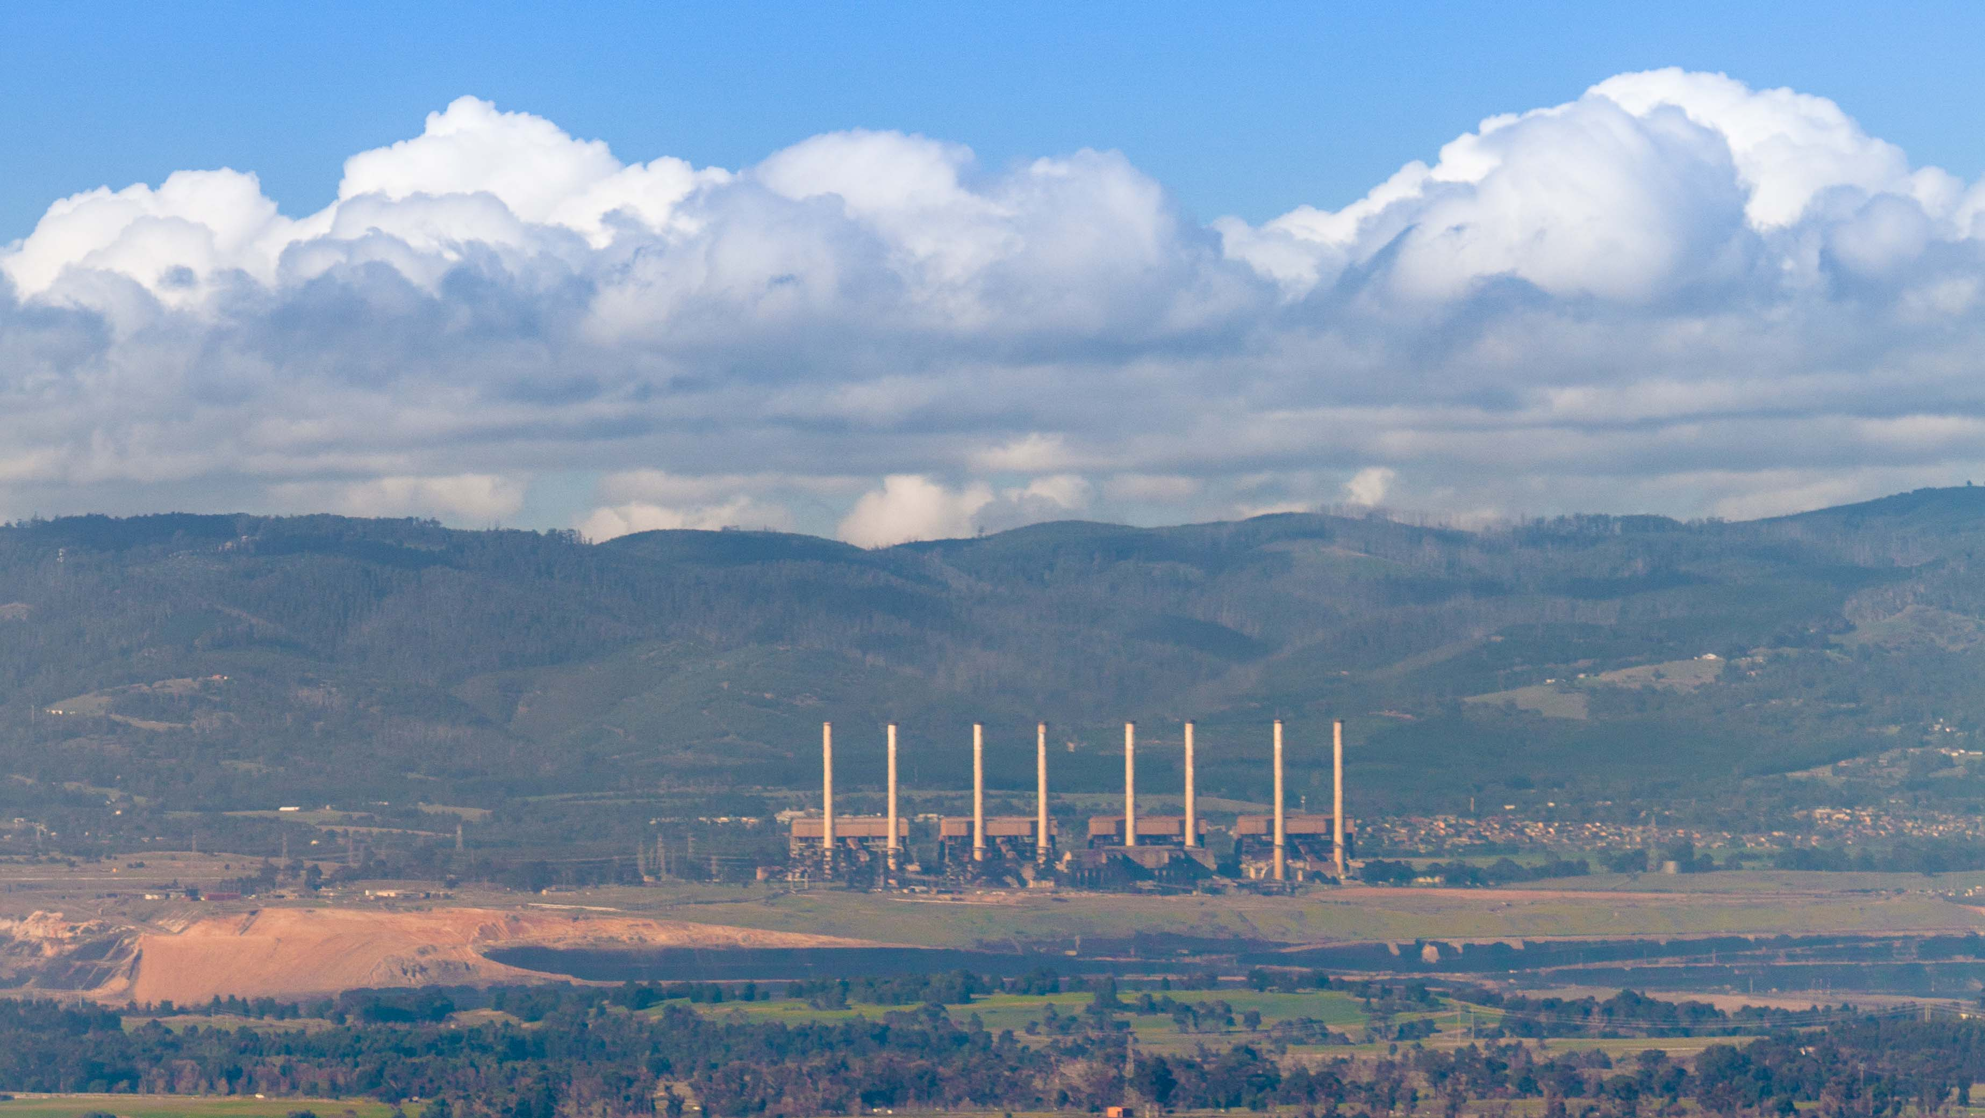

Future activities planned for 2019/20
The primary focus over the coming year will be on integrating the findings of the regional geotechnical, water and land use studies, to develop an enabling framework that will guide rehabilitation planning over the long term. The enabling framework will help guide mine operators and regulators in planning for rehabilitation, without prescribing specific landforms at any mine and recognising the high degree of uncertainty around future climate, community views and economics.
An implementation plan for the Strategy will be developed, assigning responsibility to government agencies and key stakeholders to deliver specific actions to help ensure that rehabilitated mine voids and adjacent land are safe, stable and sustainable.
Ongoing monitoring of the implementation of the Strategy will be needed and will inform future updates to the Strategy, responding to new knowledge and learnings as mine rehabilitation research, planning and works progress.
Stakeholder engagement will continue as the preparation of the Strategy progresses over the course of 2019/20. Government will be seeking opportunities to communicate the findings of the technical studies with key stakeholders, including the local community at appropriate times.
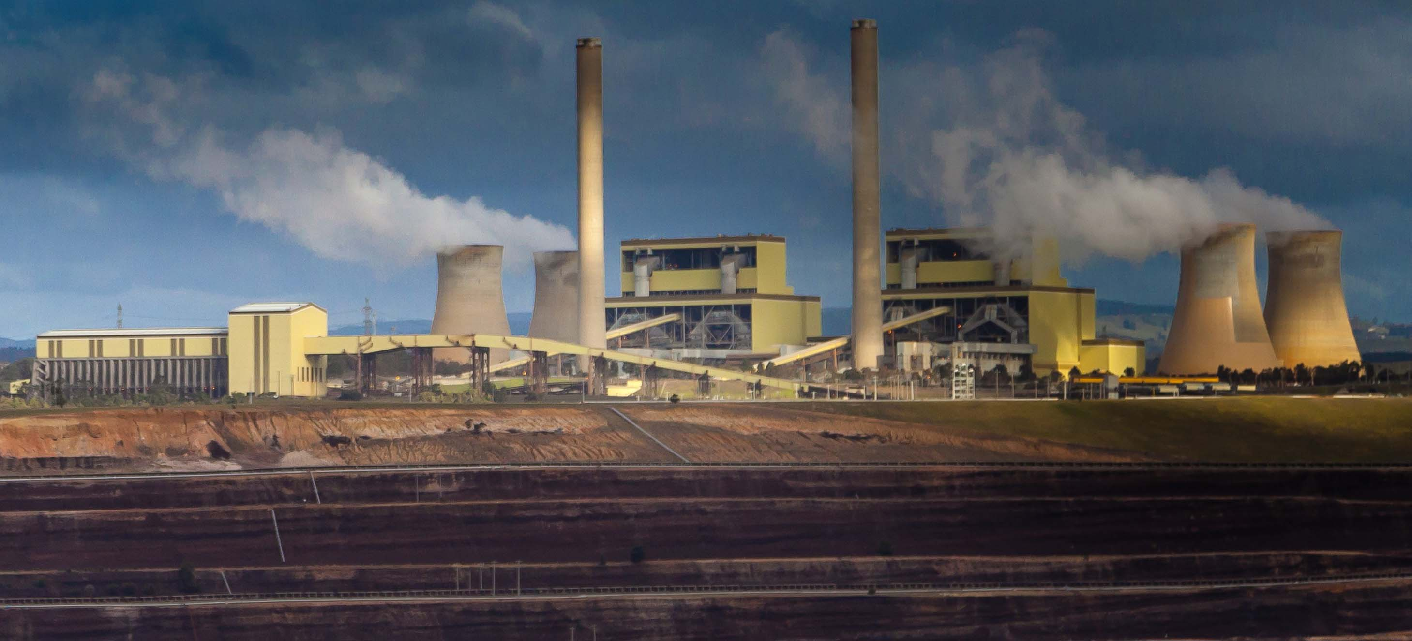

Hazelwood Mine Fire Inquiry Report 2015/16 Volume IV – Mine Rehabilitation, pg. 114.
Hazelwood Mine Fire Inquiry: Victorian Government Implementation Plan June 2016

