Latrobe Valley Regional Rehabilitation Strategy

Preliminary Land Use Vision
The Latrobe Valley’s three brown coal mines – Hazelwood, Yallourn and Loy Yang – have fuelled most of Victoria’s electricity generation since 1924. Hazelwood closed in 2017 and Yallourn and Loy Yang are planned to close by 2032 and 2048 respectively. Each of the Latrobe Valley brown coal mine operators are required to develop a plan to rehabilitate the mine sites in order to achieve a safe, stable and sustainable landscape once mining activity ceases.

Background
A reopened inquiry into a coal fire that burned for 45 days at Hazelwood in 2014 found that using water to create ‘pit lakes’ in the areas where coal has been mined is likely to be the most viable way to achieve safe and stable rehabilitation of the mines. However, the Inquiry recognised that significant knowledge gaps existed in relation to the feasibility of this rehabilitation option, and recommended further investigations be carried out.
These investigations – geotechnical, water and land use planning studies – have been undertaken as part of the Victorian Government’s preparation of the Latrobe Valley Regional Rehabilitation Strategy (LVRRS).
The studies, which were carried out by technical specialists from 2017 to 2019, considered the regional benefits and risks associated with stabilising the mine pits (or voids) by creating full or partial pit lakes.
The Strategy will provide information on the:
- regional risks that need to be considered and addressed in rehabilitation plans;
- feasibility of using water if required for safe, stable and sustainable rehabilitation; and
- possible future land uses for the rehabilitated sites in a regional context.
The final Strategy will be prepared by 30 June 2020.

A vision of the Latrobe Valley’s future
How will land use and the landscape change, especially around the Latrobe Valley’s three brown coal mine sites, as mining activity at each mine ceases in the years to come?
The Victorian Government, Latrobe Valley community, mine operators and other stakeholders are working together to develop a multi-generational land use vision for the Latrobe Valley. The Vision will help inform the development of the LVRRS.
The Vision considers land use and associated economic and social opportunities that could be created over time as the mines close and are rehabilitated.
For example, opportunities may also emerge for renewable energy and new agriculture activities. If filling the mine voids with water was determined to be essential to achieve a safe, stable and sustainable landform for rehabilitation, then water-based uses and activities might be possible.
The draft Latrobe Valley Preliminary Land Use Vision has been developed based on key land use themes. These themes include tourism, energy, and service industries and were highlighted in conversations and workshops in 2018 and 2019 with local community members and other stakeholders, including the Latrobe Valley mine operators and government agencies.
A social history study, which captures and celebrates the Latrobe Valley’s heritage, provides additional context for the Vision.
The draft Preliminary Land Use Vision is informing and assisting the development of the Latrobe Valley Regional Rehabilitation Strategy.

Map of the Latrobe Valley
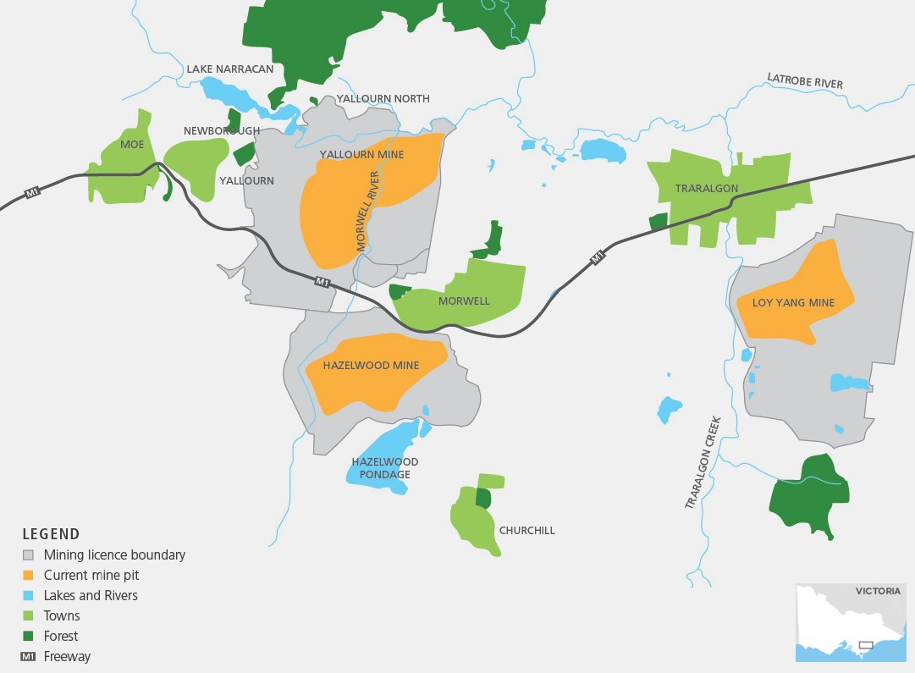

Developing new opportunities
There is a strong legacy of industry in the Latrobe Valley and this has occurred at a large scale across the landscape. The scale of the mine sites, power stations and associated land holdings offer a range of opportunities which could generate jobs, tourism, innovative agriculture and major events.
The draft Preliminary Land Use Vision recognises and builds upon these features within the Latrobe Valley as a key part of Victoria’s future food economy; a sustainable, low carbon service hub; a great place to live, work and visit; and an education and business centre with strong connections to Melbourne and Gippsland.
Key considerations in developing the Preliminary Land Use Vision have been the following policies and plans:
- The Gippsland Regional Growth Plan (2014), which provides the land use framework plan for the region, including the Latrobe Valley
- Latrobe City Council’s Live Work Latrobe, a planning initiative that seeks to make the most of built and natural assets to create jobs, ensure housing meets community needs and enable new investment opportunities.

Next steps
A draft Preliminary Land Use Vision has been prepared. It identifies beneficial land use and development opportunities that may arise from the closure and rehabilitation of the Latrobe Valley’s brown coal mines.
Community feedback on the draft Preliminary Land Use Vision will be integrated into the final Latrobe Valley Regional Rehabilitation Strategy due in June 2020. Elements of the land use vision may require changes to state and local planning policy in the future.
The draft Preliminary Land Use Vision can be viewed at engage.vic.gov.au
Submissions can be made:
- online at engage.vic.gov.au
- via email to planning.implementation@delwp.vic.gov.au
- By post to Planning Implementation PO Box 500, Melbourne VIC 8002

