Earth Resources Regulation

Annual Statistical Report
FY 2021–22
Acknowledgement of Traditional Owners
The Victorian Government proudly acknowledges Traditional Owners as Victoria’s first peoples and pays its respects to their Elders past and present.
We recognise the intrinsic connection of the first peoples to their Country for countless generations and their inherent obligation to maintain and strengthen their distinct cultural rights and responsibilities to care for their Country.
We value Traditional Owners’ role in the management of land, water and biodiversity and acknowledge the ongoing contribution this makes to our earth resources.
We have distinct legislative obligations to Traditional Owner groups that are paramount in our responsibilities in managing Victoria’s resources.
We support the need for genuine and lasting partnerships with Aboriginal people and communities to understand culture and connections to Country in the way we plan for and regulate our earth resources.
Published by
Department of Jobs, Precincts and Regions
1 Spring Street Melbourne, Victoria 3000
Telephone +61 (03) 9651 9999
December 2022
© Copyright State of Victoria, Department of Jobs, Precincts and Regions
Except for any logos, emblems, trademarks, artwork and photography this document is made available under the terms of the Creative Commons Attribution 3.0 Australia licence.
Authorised by the Victorian Government, Melbourne.
Designed by DJPR Design Studio
Disclaimer
The information contained in this report is provided for general guidance and assistance only and is not intended as advice. You should make your own enquiries as to the appropriateness and suitability of the information provided. While every effort has been made to ensure the currency, accuracy or completeness of the content, we endeavour to keep the content relevant and up to date and reserve the right to make changes as required. The Victorian Government, authors and presenters do not accept any liability to any person for the information (or the use of the information) which is provided or referred to in the report.
For more information, see the Earth Resources Regulation website www.earthresources.vic.gov.au/earth-resources-regulation
Accessibility
This document is also available in PDF and accessible Word format at http://earthresources.vic.gov.au/earth-resources-regulation/about-us/regulator-and-industry-reporting/earth-resources-regulation-annual-statistical-report/
Table of Contents
1 Introduction 2
1.1 Key observations and statistics 3
2 Extractive industries 4
2.1 Extractive industries production 4
2.2 Extractive industries work authorities 10
2.3 Extractive work plans and administrative updates by notification 10
3 Minerals 12
3.1 Mineral exploration and mining expenditure 12
3.2 Mineral production 16
3.3 Mineral tenements 17
3.4 Mineral work plans, codes of practice and administrative updates by notification 21
4 Petroleum, geothermal, offshore pipelines and greenhouse gas 22
4.1 Gas production and storage 23
4.2 Drilling 24
4.3 Petroleum, offshore pipelines, geothermal and greenhouse gas licences 24
5 Revenue 27
5.1 Royalties payable 27
5.2 Regulatory fees 27
6 Rehabilitation bonds 28
6.1 Bonds held 28
6.2 Bond reviews 30
7 Compliance 30
7.1 Compliance activities 30
7.2 Industry annual returns submission rate 31

Introduction
Earth Resources Regulation, within the Department of Jobs, Precincts and Regions (DJPR), is responsible for the regulation of minerals, extractive industries (quarries), petroleum, geothermal and carbon storage activities in Victoria and offshore Victorian waters, and for offshore pipelines in Victorian waters. We are committed to being an effective regulator.
Earth Resources Regulation’s role includes:
- granting rights to access resources
- assessing works and setting controls for the extraction of resources
- assessing site rehabilitation liabilities and setting bonds
- overseeing site rehabilitation activities
- conducting compliance operations to ensure that authority holders fulfil their regulatory obligations
- engaging with communities and stakeholders
collecting regulatory fees and royalties
Earth Resources Regulation administers the following Acts:
- Mineral Resources (Sustainable Development) Act 1990 (MRSDA) (mineral exploration mining and quarrying)
- Petroleum Act 1998 (petroleum exploration and development onshore)
- Offshore Petroleum and Greenhouse Gas Storage Act 2010 (OPGGSA) (petroleum exploration and development, greenhouse gas storage and pipelines in Victorian offshore waters)
- Geothermal Energy Resources Act 2005 (geothermal energy exploration and development)
- Greenhouse Gas Geological Sequestration Act 2008 (greenhouse gas storage onshore)
- Extractive Industries (Lysterfield) Act 1986
- Nuclear Activities (Prohibitions) Act 1983
- Underseas Mineral Resources Act 1963
Mines (Aluminium Agreement) Act 1961

Key observations and statistics
The Earth Resources Regulation 2021-22 Statistical Report presents a compilation of data as reported by tenement holders to Earth Resources Regulation. All production and expenditure figures are certified by tenement holders. The industry data in the report is derived from about 96.5 per cent of mineral industry and 79.3 per cent of extractive industries annual returns. Detailed breakdowns of annual returns submission rates are shown in Table 7.2.1.
Extractive industries operations
- Stone production increased 4.7 per cent from 66.78 million tonnes to 69.91 million tonnes (Table 2.1.1)
- Value of sales increased 4.0 per cent from $1,112.39 million to $1,156.90 million (Table 2.1.1)
New extractive industries work authorities granted increased from 3 to 15 (Table 2.2.1)
Minerals exploration and mining operations
- Mineral exploration expenditure increased 12.1 per cent from $198.3 million to $222.2 million (Table 3.1.1)
- Mineral sand exploration expenditure increased 110.4 per cent from $16.4 million to $34.5 million (Table 3.1.2)
- Mining expenditure decreased 3.5 per cent from $831.7 million to $802.4 million (Table 3.1.1)
- Gold mining expenditure increased 6.6 per cent from $401.2 million to $427.5 million (Table 3.1.4)
- Gold production decreased 13.2 per cent from 722,239 ounces to 627,011 ounces (Table 3.2.1)
Licence applications submitted increased by 9.4 per cent from 127 to 139 (Table 3.3.2)
Petroleum
Gas production increased 16.3 per cent from 8.17 petajoules to 9.50 petajoules of energy (Table 4.1.1)
Royalties and regulatory fees
- Royalties payable decreased 3.2 per cent from $147.0 million to $142.3 million (Table 5.1.1)
- Gold royalties accounted for 30.1 per cent of total royalties payable ($42.8 million out of $142.3 million) (Table 5.1.1)
Revenue from regulatory fees was $6.7 million (Table 5.2.1)
Rehabilitation bonds
Total value of rehabilitation bonds held under the MRSDA was approximately $824.5 million (Table 6.1.1)

Extractive industries
Quarries predominantly produce hard rock, clay, sand and gravel, which are mostly used for constructing houses, public infrastructure and private sector developments.

Extractive industries production
As at 30 June 2022, there were 847 quarries holding current extractive industries work authorities under the MRSDA. As at 11 Dec 2022, a total of 439 quarries reported production in FY2021-22. The production volume increased from 66.78 million tonnes to 69.91 million tonnes and the value of sales increased from $1,112.39 million to $1,156.90 million.
Table 2.1.1 Production and value of sales by financial year
 | 2015-16 | 2016-17 | 2017-18 | 2018-19 | 2019-20 | 2020-21 | 2021-22
Current quarries at EOFY | 888 | 888 | 881 | 873 | 860 | 848 | 847
Quarries recorded production | 543 | 548 | 554 | 546 | 527 | 489 | 439
Production (million tonnes) | 54.10 | 58.10 | 61.20 | 62.92 | 64.65 | 66.78 | 69.91
Value of sales ($million) | $801.04 | $854.82 | $989.30 | $1,021.49 | $1,075.90 | $1,112.39 | $1,156.90
Note: Some historical data has been adjusted to accommodate amendments to annual returns by tenement holders and annual returns received after the publication of the previous year’s report.
Figure 2.1.1 Production and value of sales by financial year
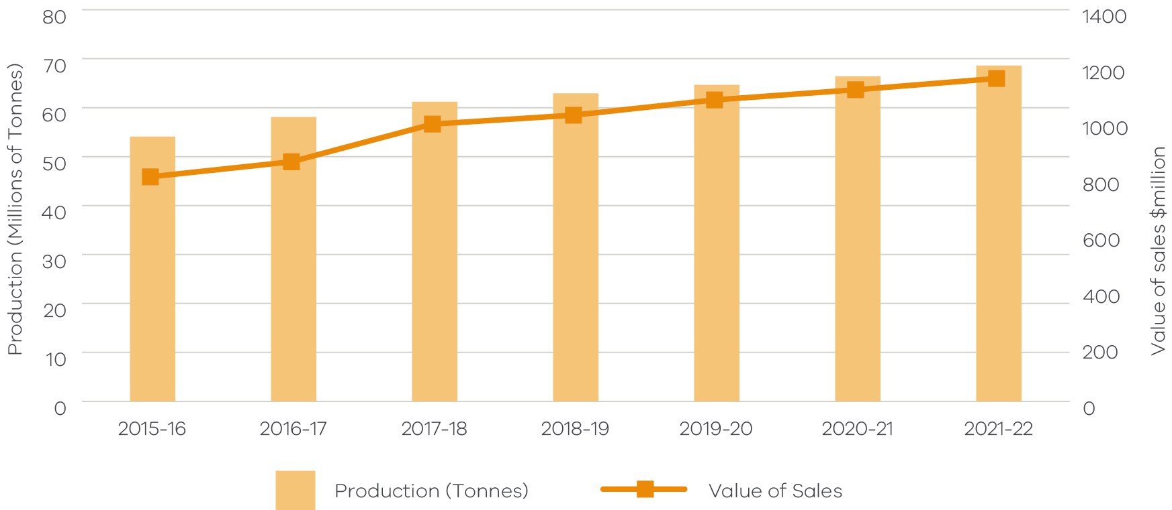

Table 2.1.2 Extractive industries production and value of sales by product type over five financial years
Product group | Product type groups | 2017-18  Production  (million tonnes) | 2017-18  Value of sales  ($ million) | 2018-19  Production  (million tonnes) | 2018-19  Value of sales  ($ million) | 2019-20  Production  (million tonnes) | 2019-20  Value of sales  ($ million) | 2020-21  Production  (million tonnes) | 2020-21  Value of sales  ($ million) | 2021-22  Production  (million tonnes) | 2021-22  Value of sales  ($ million)
Clay products | Brick | 0.99 | $3.02 | 0.94 | $2.71 | 0.93 | $2.59 | 0.91 | $2.54 | 1.08 | $2.18
Clay products | Stoneware Pottery | 0.001 | $0.04 | 0.004 | $0.05 | 0.001 | $0.02 | 0.001 | $0.01 | 0.001 | $0.02
Clay products | Tile/Pipe | 0.02 | $0.08 | 0.00 | $0.00 | 0.00 | $0.00 | 0.00 | $0.00 | 0.00 | $0.00
Total clay products |  | 1.01 | $3.14 | 0.94 | $2.75 | 0.93 | $2.60 | 0.91 | $2.55 | 1.08 | $2.20
Limestone products | Agriculture | 0.65 | $17.46 | 0.62 | $16.25 | 0.63 | $17.49 | 0.85 | $24.26 | 0.77 | $21.36
Limestone products | Cement | 0.08 | $1.70 | 0.04 | $0.89 | 0.06 | $1.03 | 0.07 | $1.25 | 0.03 | $0.81
Limestone products | Lime | 0.08 | $1.57 | 0.07 | $1.28 | 0.09 | $1.63 | 0.20 | $3.30 | 0.37 | $5.82
Total limestone products |  | 0.80 | $20.73 | 0.73 | $18.42 | 0.78 | $20.15 | 1.13 | $28.81 | 1.17 | $27.99
Miscellaneous | Dimension Stone | 0.01 | $0.25 | 0.0005 | $0.12 | 0.01 | $0.29 | 0.24 | $1.11 | 0.08 | $1.38
Miscellaneous | Soil | 0.05 | $0.60 | 0.05 | $0.59 | 0.03 | $0.11 | 0.15 | $1.06 | 0.18 | $1.13
Miscellaneous | Unspecified | 5.31 | $61.58 | 2.88 | $31.56 | 4.66 | $70.96 | 6.49 | $104.41 | 0.22 | $4.01
Total miscellaneous |  | 5.36 | $62.43 | 2.92 | $32.27 | 4.70 | $71.36 | 6.87 | $106.58 | 0.48 | $6.52
Multi-size products | Fill | 3.92 | $38.97 | 3.79 | $37.95 | 4.85 | $46.42 | 4.18 | $43.65 | 6.91 | $62.39
Multi-size products | Road Base | 6.09 | $104.25 | 7.62 | $122.04 | 5.49 | $91.16 | 4.36 | $79.30 | 7.15 | $139.36
Multi-size products | Road Sub-Base | 11.97 | $144.31 | 12.91 | $159.15 | 13.17 | $177.11 | 12.15 | $165.42 | 17.52 | $242.10
Total multi size products |  | 21.98 | $287.53 | 24.31 | $319.14 | 23.51 | $314.68 | 20.69 | $288.37 | 31.58 | $443.85
Sand products | Concrete Sand | 7.20 | $132.49 | 9.25 | $151.73 | 8.76 | $153.84 | 9.65 | $151.62 | 11.76 | $173.51
Sand products | Fine Sand | 2.50 | $39.67 | 1.61 | $19.33 | 3.01 | $43.49 | 2.32 | $35.12 | 1.77 | $28.37
Sand products | Foundry Sand | 0.003 | $0.04 | 0.86 | $19.11 | 0.002 | $0.10 | 0.57 | $13.35 | 0.08 | $7.25
Sand products | Industrial Filters | 0.02 | $0.12 | 0.02 | $0.20 | 0.00 | $0.00 | 0.05 | $0.82 | 0.05 | $3.18
Total sand products |  | 9.72 | $172.33 | 11.74 | $190.37 | 11.77 | $197.42 | 12.59 | $200.92 | 13.66 | $212.31
Single-size products | Aggregate | 22.27 | $441.86 | 21.36 | $427.62 | 22.90 | $467.94 | 24.48 | $483.63 | 21.76 | $461.85
Single-size products | Armour | 0.07 | $1.30 | 0.92 | $30.90 | 0.06 | $1.76 | 0.11 | $1.53 | 0.18 | $2.18
Total single size products |  | 22.33 | $443.15 | 22.28 | $458.53 | 22.97 | $469.69 | 24.59 | $485.16 | 21.94 | $464.03
Financial Year Total |  | 61.20 | $989.30 | 62.92 | $1,021.49 | 64.65 | $1,075.90 | 66.78 | $1,112.39 | 69.91 | $1,156.90
Note: Some historical data has been adjusted to accommodate amendments to annual returns by tenement holders and annual returns received after the publication of the previous year’s report.

Table 2.1.3 Extractive industries production and value of sales by rock type over five financial years
Rock type | Rock type groups | 2017-18  Production  (million tonnes) | 2017-18  Value of sales  ($ million) | 2018-19  Production  (million tonnes) | 2018-19  Value of sales  ($ million) | 2019-20  Production  (million tonnes) | 2019-20  Value of sales  ($ million) | 2020-21  Production  (million tonnes) | 2020-21  Value of sales  ($ million) | 2021-22  Production  (million tonnes) | 2021-22  Value of sales  ($ million)
Hard rock | Basalt new | 20.21 | $318.29 | 21.61 | $351.07 | 21.53 | $364.34 | 22.68 | $384.29 | 23.87 | $391.61
Hard rock | Basalt old | 3.12 | $63.72 | 3.85 | $82.08 | 4.38 | $80.31 | 2.86 | $60.22 | 4.00 | $83.01
Hard rock | Dolerite | 0.02 | $0.23 | 0.001 | $0.01 | 0.00 | $0.00 | 0.35 | $6.68 | 0.00 | $0.00
Hard rock | Gneiss | 0.01 | $0.01 | 0.01 | $0.00 | 0.08 | $1.92 | 0.004 | $0.00 | 0.001 | $0.00
Hard rock | Granite | 5.37 | $123.00 | 5.35 | $117.65 | 7.06 | $138.83 | 7.38 | $138.80 | 6.65 | $133.97
Hard rock | Hornfels | 5.23 | $85.85 | 5.22 | $86.87 | 5.27 | $89.60 | 5.58 | $111.36 | 7.26 | $141.05
Hard rock | Quartzite | 0.03 | $0.64 | 0.03 | $0.75 | 0.01 | $0.60 | 0.04 | $1.06 | 0.08 | $1.51
Hard rock | Rhyodacite | 1.79 | $43.64 | 1.52 | $33.52 | 1.54 | $35.53 | 1.73 | $39.99 | 2.16 | $51.31
Hard rock | Schist | 0.27 | $5.86 | 0.48 | $9.31 | 0.43 | $8.32 | 0.19 | $4.54 | 0.43 | $9.71
Hard rock | Slate | 0.04 | $1.25 | 0.04 | $1.17 | 0.04 | $1.36 | 0.23 | $1.46 | 0.06 | $0.95
Hard rock | Trachyte | 0.04 | $0.80 | 0.03 | $0.70 | 0.03 | $0.51 | 0.02 | $0.54 | 0.03 | $0.64
Total hard rock |  | 36.14 | $643.28 | 38.14 | $683.14 | 40.38 | $721.32 | 41.08 | $748.93 | 44.55 | $813.76
Soft rock | Clay and clay shale | 1.48 | $3.90 | 1.20 | $3.49 | 1.47 | $5.33 | 1.30 | $3.28 | 2.74 | $4.35
Soft rock | Limestone | 1.80 | $28.62 | 1.99 | $29.08 | 1.98 | $31.35 | 2.27 | $38.48 | 2.02 | $35.86
Soft rock | Sand and gravel | 16.92 | $253.93 | 16.70 | $248.96 | 15.75 | $257.70 | 17.11 | $262.13 | 16.48 | $247.36
Soft rock | Scoria | 1.15 | $18.07 | 0.76 | $12.97 | 0.94 | $15.39 | 1.12 | $18.78 | 0.95 | $18.38
Soft rock | Sedimentary* | 3.09 | $36.13 | 3.76 | $39.75 | 3.51 | $39.28 | 3.57 | $37.45 | 2.75 | $33.76
Soft rock | Soil | 0.05 | $0.60 | 0.05 | $0.62 | 0.06 | $0.11 | 0.15 | $1.08 | 0.18 | $1.13
Soft rock | Tuff | 0.58 | $4.79 | 0.32 | $3.48 | 0.56 | $5.41 | 0.20 | $2.26 | 0.24 | $2.31
Total soft rock |  | 25.07 | $346.02 | 24.77 | $338.35 | 24.27 | $354.58 | 25.71 | $363.46 | 25.36 | $343.14
Financial year total |  | 61.20 | $989.30 | 62.92 | $1,021.49 | 64.65 | $1,075.90 | 66.78 | $1,112.39 | 69.91 | $1,156.90
Note: Some historical data has been adjusted to accommodate amendments to annual returns by tenement holders and annual returns received after the publication of the previous year’s report.
*Sedimentary (usually rippable rocks, including sandstone, shale, siltstone, chert, mudstone, claystone).

Extractive industries work authorities
Table 2.2.1 Extractive industries work authorities granted by financial year
 | 2015-16 | 2016-17 | 2017-18 | 2018-19 | 2019-20 | 2020-21 | 2021-22
Work authorities granted | 15 | 10 | 13 | 11 | 4 | 3 | 15
Resource estimate* (tonnes) | - | - | - | - | - | - | 56.1M
*Resource estimate: The total estimated resource available for extraction from the granted work authorities. The data was provided by the tenement holder. Resource estimate data is not available prior to FY2021-22.
Table 2.2.2 Extractive industries work authority variations by financial year
 | 2015-16 | 2016-17 | 2017-18 | 2018-19 | 2019-20 | 2020-21 | 2021-22
WA variations submitted | 60 | 50 | 51 | 62 | 52 | 66 | 47
WA variations completed | 45 | 37 | 59 | 52 | 55 | 24 | 41

Figure 2.2.2 Extractive industries work authority variations by financial year
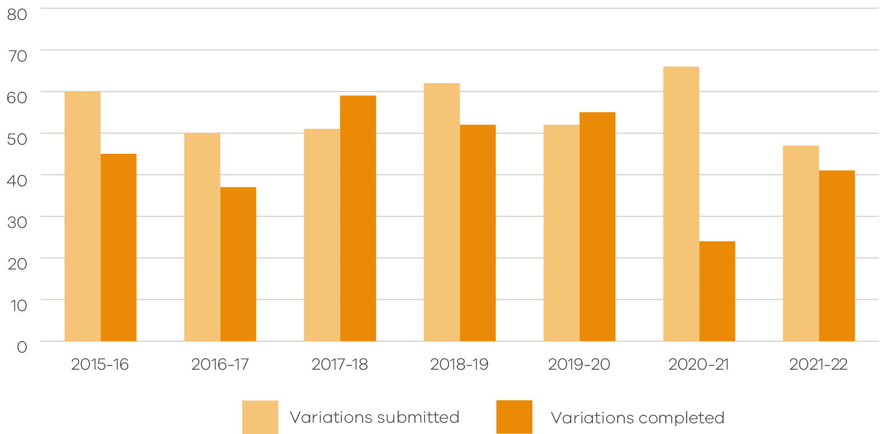

Extractive work plans and administrative updates by notification
Work plans and codes of practices submitted and approved by financial year:
- An initial work plan (WP) is the primary document describing the permitted activities to be undertaken on a work authority.
- A work plan variation (WPV) is submitted by a licence holder when they want to change the scope of work in an existing work plan.
Code of practice (eligible to operate under the Code of Practice for Small Quarries).
Table 2.3.1 Extractive industries work plans, work plan variations and codes of practice applications submitted
 | 2015-16 | 2016-17 | 2017-18 | 2018-19 | 2019-20 | 2020-21 | 2021-22
Initial work plan | 19 | 15 | 6 | 10 | 7 | 6 | 8
Work plan variation | 11 | 22 | 10 | 11 | 21 | 12 | 13
Code of practice | 1 | 2 | 8 | 7 | 5 | 5 | 3
Total submitted | 31 | 39 | 24 | 28 | 33 | 23 | 24

Table 2.3.2 Extractive industries work plans, work plan variations and codes of practice applications approved
 | 2015-16 | 2016-17 | 2017-18 | 2018-19 | 2019-20 | 2020-21 | 2021-22
Initial work plan | 17 | 4 | 11 | 9 | 6 | 5 | 5
Work plan variation | 2 | 12 | 9 | 6 | 14 | 14 | 5
Code of practice | 1 | 0 | 8 | 3 | 3 | 1 | 3
Total approved | 20 | 16 | 28 | 18 | 23 | 20 | 13

Table 2.3.3 Extractive industries work plans, work plan variations and codes of practice applications withdrawn/refused
 | 2015-16 | 2016-17 | 2017-18 | 2018-19 | 2019-20 | 2020-21 | 2021-22
Initial work plan | 1 | 3 | 4 | 7 | 4 | 2 | 7
Work plan variation | 0 | 0 | 2 | 2 | 4 | 4 | 6
Code of practice | 0 | 2 | 1 | 1 | 0 | 0 | 5
Total WITHDRAWN/ REFUSED | 1 | 5 | 7 | 10 | 8 | 6 | 18

Statutory endorsement indicates that Earth Resources Regulation has assessed and endorsed the work plan or work plan variation as having met the requirements under the MRSDA.
Table 2.3.4 Extractive industries work plans and work plan variations statutory endorsements
 | 2015-16 | 2016-17 | 2017-18 | 2018-19 | 2019-20 | 2020-21 | 2021-22
Initial work plan | 9 | 5 | 7 | 4 | 9 | 6 | 4
Work plan variation | 3 | 1 | 2 | 8 | 12 | 7 | 6
Total endorsed | 23 | 14 | 12 | 12 | 21 | 13 | 10

Administrative updates by notification are minor changes to the existing work plan with no significant increase in risk arising from the new or changing work. Administrative updates do not require statutory endorsement (no further planning permission required). The administrative updates by notification process was introduced at the end of FY2017-18.
Table 2.3.5 Extractive industries administrative updates by notifications received and acknowledged
 | 2015-16 | 2016-17 | 2017-18 | 2018-19 | 2019-20 | 2020-21 | 2021-22
Received | - | - | 3 | 14 | 30 | 12 | 26
Acknowledged | - | - | 2 | 14 | 17 | 10 | 12

Minerals

Mineral exploration and mining expenditure
Table 3.1.1 Expenditure on mineral exploration and mining development ($ million)
 | 2015-16 | 2016-17 | 2017-18 | 2018-19 | 2019-20 | 2020-21 | 2021-22
Mineral exploration (ABS seasonally adjusted data) | $28.9 | $40.5 | $73.3 | $102.2 | $135.7 | $183.7 | $222.2
MRSDA exploration | $38.5 | $44.2 | $69.0 | $107.3 | $132.2 | $198.3 | $222.2
MRSDA mining | $685.8 | $749.1 | $654.6 | $734.5 | $837.1 | $831.7 | $802.4
Source: Figures collated from annual activity reports required under the MRSDA and ABS
(https://www.abs.gov.au/statistics/industry/mining/mineral-and-petroleum-exploration-australia/latest-release#data-download).

Figure 3.1.1 Expenditure on mineral exploration and mining
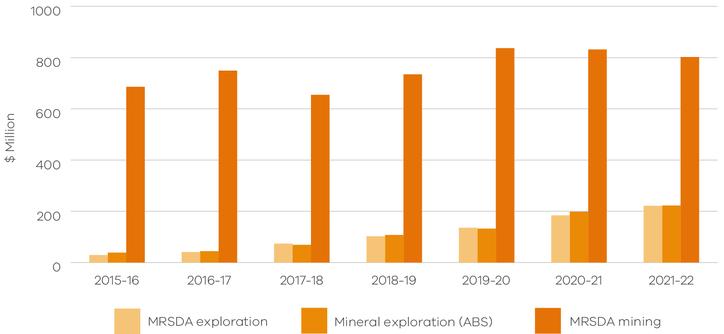
Table 3.1.2 Mineral exploration expenditure by commodity and financial year ($ million)
Exploration expenditure is allocated to the primary nominated mineral commodity on the licence in accordance with the MRSDA.
Year | Gold | Mineral sands | Coal | Other* | Total
2015-16 | $16.9 | $6.6 | $0.4 | $14.6 | $38.5
2016-17 | $26.1 | $5.2 | $0.5 | $12.5 | $44.2
2017-18 | $44.3 | $8.2 | $0.5 | $16.1 | $69.0
2018-19 | $57.3 | $24.2 | $7.1 | $18.8 | $107.3
2019-20 | $81.8 | $23.7 | $6.0 | $20.7 | $132.2
2020-21 | $149.3 | $16.4 | $6.9 | $25.7 | $198.3
2021-22 | $141.7 | $34.5 | $7.2 | $38.8 | $222.2
*Other includes cases where there is more than one primary mineral.
Figure 3.1.2 Mineral exploration expenditure by commodity and financial year ($ million)
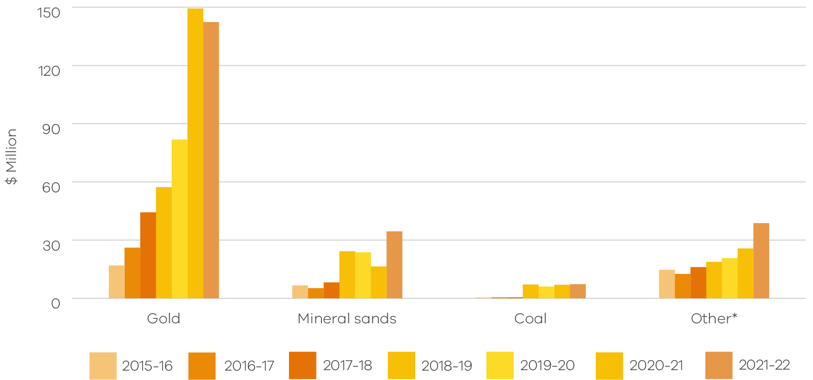
Table 3.1.3 Mineral exploration expenditure by licence type and financial year ($ million)
Year | Exploration licence | Mining licence | Prospecting licence | Retention licence | Total
2015-16 | $15.4 | $19.8 | $0.1 | $3.3 | $38.5
2016-17 | $17.0 | $24.5 | $0.1 | $2.7 | $44.2
2017-18 | $21.8 | $42.4 | $0.1 | $4.7 | $69.0
2018-19 | $43.1 | $41.4 | $0.1 | $22.7 | $107.3
2019-20 | $46.2 | $56.2 | $0.1 | $29.6 | $132.2
2020-21 | $45.7 | $97.2 | $0.1 | $55.3 | $198.3
2021-22 | $62.3 | $97.5 | $0.2 | $62.1 | $222.2

Figure 3.1.3 Mineral exploration expenditure by licence type financial year ($ million)
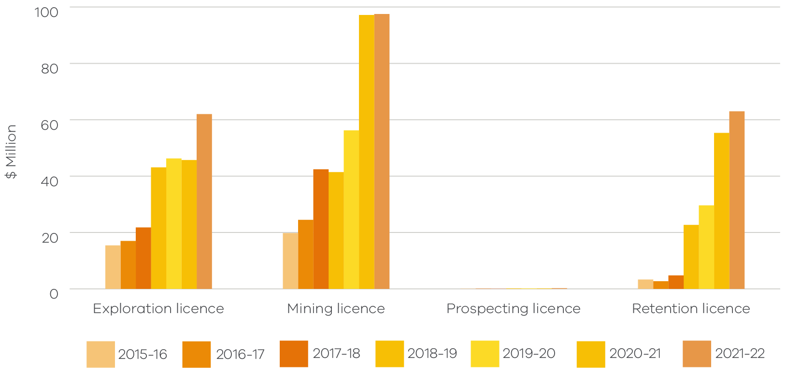

Table 3.1.4 Mining expenditure by commodity and financial year ($ million)
Mining expenditure is allocated to the primary nominated mineral commodity on the licence in accordance with the MRSDA.
Year | Gold | Mineral sands | Coal | Other* | Total
2015-16 | $280.2 | $21.8 | $339.4 | $44.4 | $685.8
2016-17 | $260.0 | $15.2 | $431.2 | $42.7 | $749.1
2017-18 | $238.2 | $12.6 | $359.1 | $44.8 | $654.6
2018-19 | $316.4 | $14.6 | $329.3 | $74.2 | $734.5
2019-20 | $422.5 | $12.4 | $362.2 | $40.0 | $837.1
2020-21 | $401.2 | $13.2 | $361.9 | $55.3 | $831.7
2021-22 | $427.5 | $15.6 | $303.7 | $55.7 | $802.4
*Other includes cases where there is more than one primary mineral.
Figure 3.1.4 Mining expenditure by commodity and financial year ($ million)
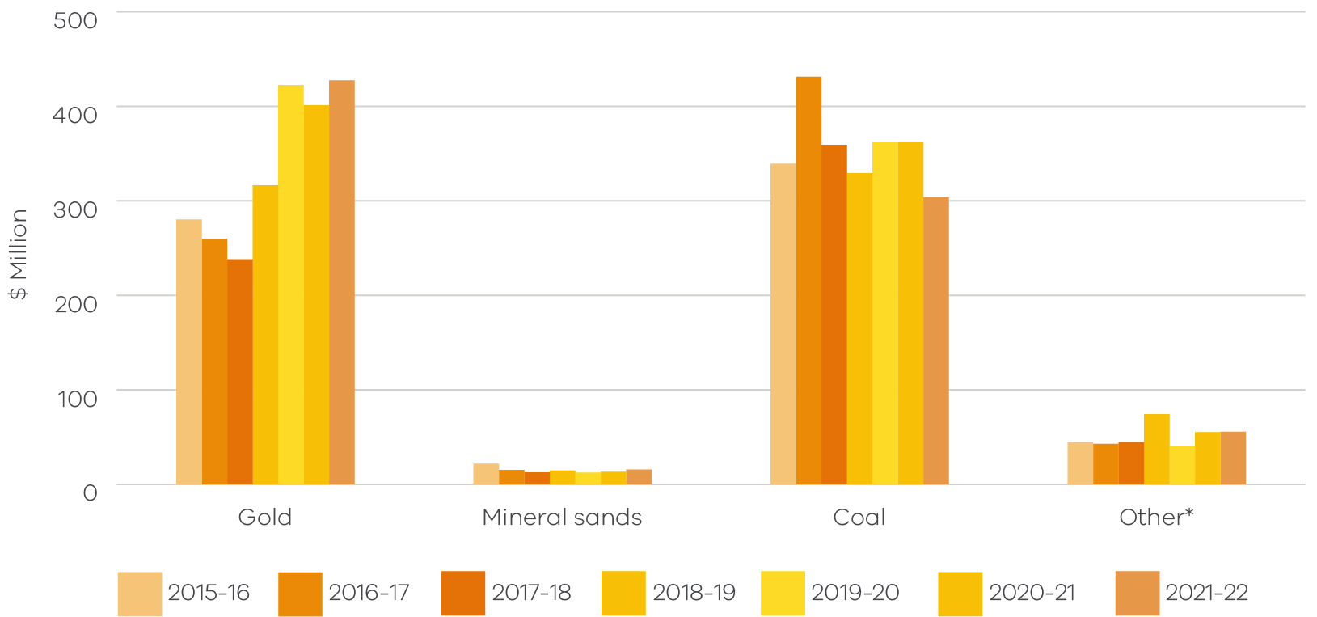
Table 3.1.5 Mining expenditure by licence types and financial year ($ million)
Year | Mining licence | Prospecting licence | Total
2015-16 | $685.1 | $0.7 | $685.8
2016-17 | $748.4 | $0.6 | $749.1
2017-18 | $653.9 | $0.7 | $654.6
2018-19 | $733.7 | $0.8 | $734.5
2019-20 | $836.4 | $0.8 | $837.1
2020-21 | $830.3 | $1.4 | $831.7
2021-22 | $800.6 | $1.9 | $802.4

Figure 3.1.5 Mining expenditure for mining licences by financial year ($ million)
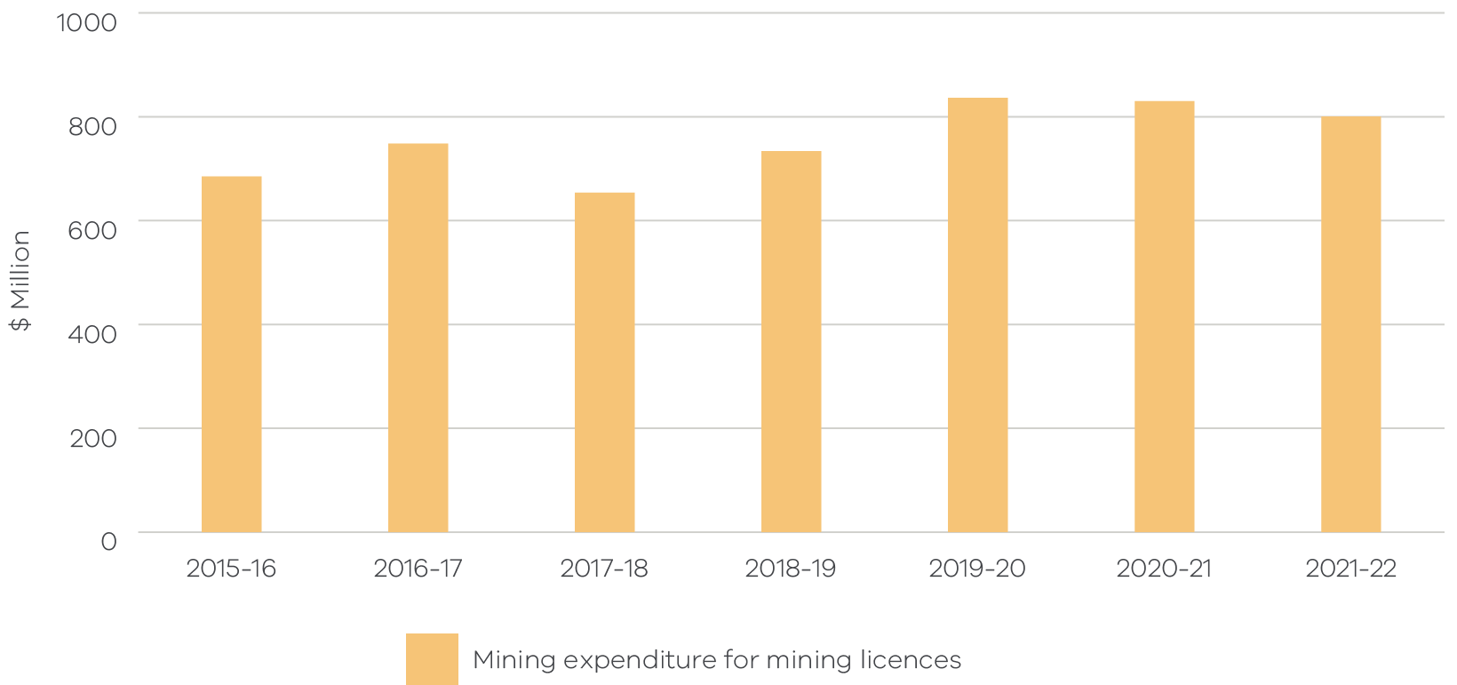
Figure 3.1.6 Mining expenditure for prospecting licences by financial year ($ million)
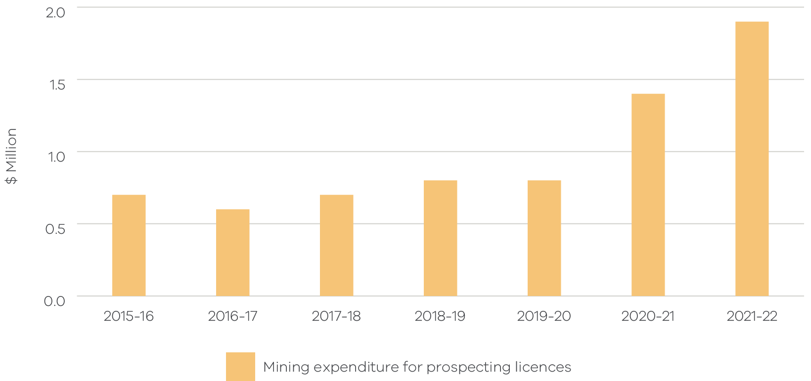

Mineral production
Table 3.2.1 Mineral production by financial year
FY | Gold* (ounce) | Silver* (ounce) | Antimony (tonne) | Zircon (tonne) | Rutile (tonne) | Ilmenite (tonne) | Coal (tonnes) | Gypsum (tonne) | Kaolin and clay (tonne) | Peat (tonne) | Quartz (tonne)
2015-16 | 256,697 | 6,899 | 3,769 | 52,026 | 90,318 | 57,763 | 59,740,649 | 504,244 | 202,229 | 3,025 | 18,200
2016-17 | 312,835 | 4,116 | 17,975 | 45,597 | 73,812 | 44,944 | 56,095,491 | 453,067 | 192,150 | 3,207 | 1
2017-18 | 364,294 | 0 | 2,570 | 27,515 | 48,381 | 24,390 | 45,061,567 | 637,018 | 171,932 | 4,840 | 8
2018-19 | 567,501 | 1,931 | 2,016 | 0 | 0 | 0 | 42,255,570 | 474,084 | 114,050 | 6,050 | 0
2019-20 | 790,054 | 7,481 | 3,141 | 0 | 0 | 0 | 40,372,215 | 533,066 | 154,812 | 3,146 | 3,495
2020-21 | 722,239 | 7,689 | 3,551 | 0 | 0 | 0 | 42,263,209 | 679,741 | 172,983 | 3,993 | 9,829
2021-22 | 627,011 | 41,445 | 2,896 | 0 | 0 | 0 | 39,126,368 | 836,249 | 167,133 | 5,275 | 9,894
*Gold and silver reported in troy ounces.
Note: Some historical data has been adjusted to accommodate amendments to annual returns by tenement holders and annual returns received after the publication of the previous year’s report.
Table 3.2.2 Mineral production value by financial year ($ million)
Year | Gold | Silver | Antimony | Mineral sands¹ | Industrial minerals² | Coal³ | Others* | Total
2015-16 | $412.5 | $0.1 | $30.1 | $176.0 | $10.0 | N/A | $0.4 | $629.6
2016-17 | $519.8 | $0.1 | $33.6 | $188.5 | $8.0 | N/A | $0.1 | $750.2
2017-18 | $613.5 | $0.0 | $28.2 | $172.6 | $11.7 | N/A | $0.2 | $827.0
2018-19 | $1,015.5 | $0.04 | $21.2 | $0.0 | $10.3 | N/A | $0.0 | $1,093.7
2019-20 | $1,843.0 | $0.2 | $24.8 | $0.0 | $10.3 | N/A | $0.2 | $1,924.5
2020-21 | $1,781.5 | $0.3 | $36.7 | $0.0 | $13.6 | N/A | $0.3 | $1,878.2
2021-22 | $1,592.5 | $1.3 | $58.2 | $0.0 | $15.5 | N/A | $0.8 | $1,669.5
1. Mineral sands (zircon, rutile, ilmenite).
2. Industrial minerals (feldspar, gypsum, kaolin and fine clay).
3. Unit value is assigned to coal for the purposes of determining its production value. Coal is almost entirely used for electricity production and is largely an internal transfer within mining/generation entities. As such, there is no available market price for coal.
* Others (includes peat, quartz and tailings,).
Note: Some historical data has been adjusted to accommodate amendments to annual returns by tenement holders and annual returns received since last publication of this report.
Figure 3.2.1 Gold production (ounces) by financial year
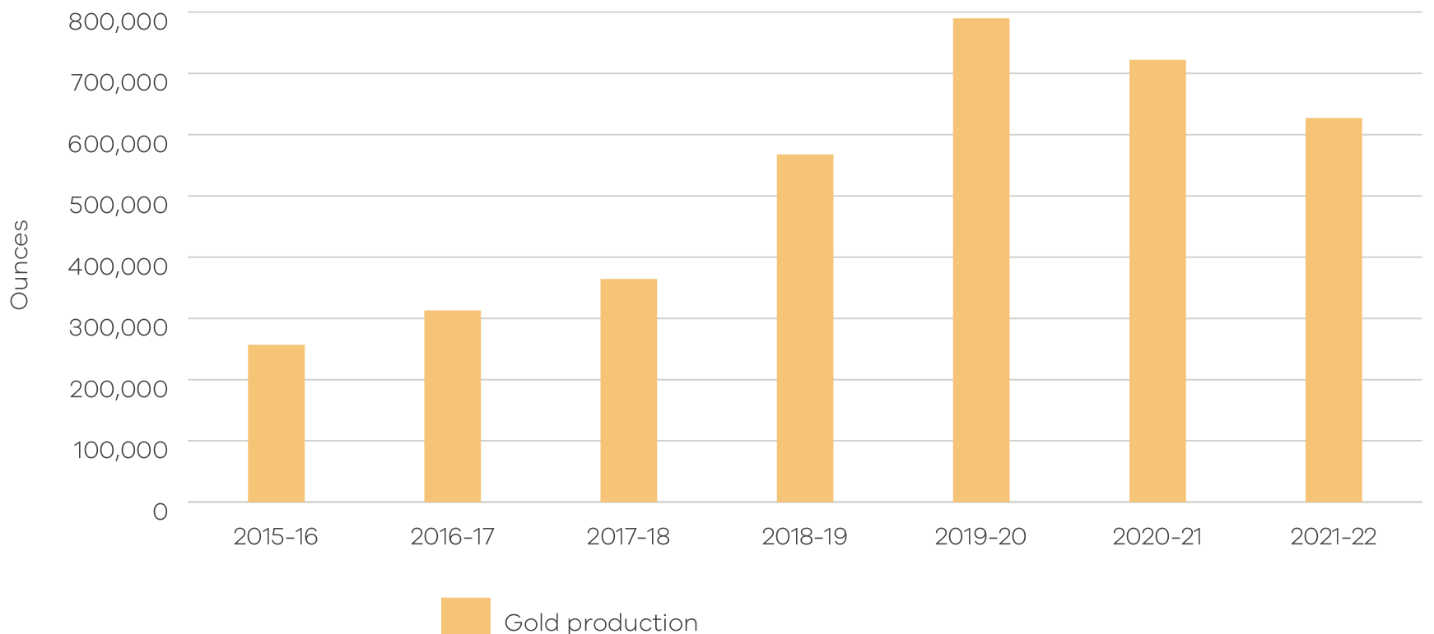

Mineral tenements
Table 3.3.1 Number of current licences at the end of each financial year
Licence type | 2015-16 | 2016-17 | 2017-18 | 2018-19 | 2019-20 | 2020-21 | 2021-22
Exploration licence | 211 | 180 | 200 | 212 | 217 | 291 | 357
Mining licence | 170 | 162 | 156 | 145 | 141 | 139 | 131
Prospecting licence | 51 | 54 | 59 | 55 | 60 | 66 | 57
Retention licence | 11 | 15 | 20 | 21 | 27 | 30 | 32
Total | 443 | 411 | 435 | 433 | 445 | 526 | 577

Figure 3.3.1 Number of current licences at the end of each financial year
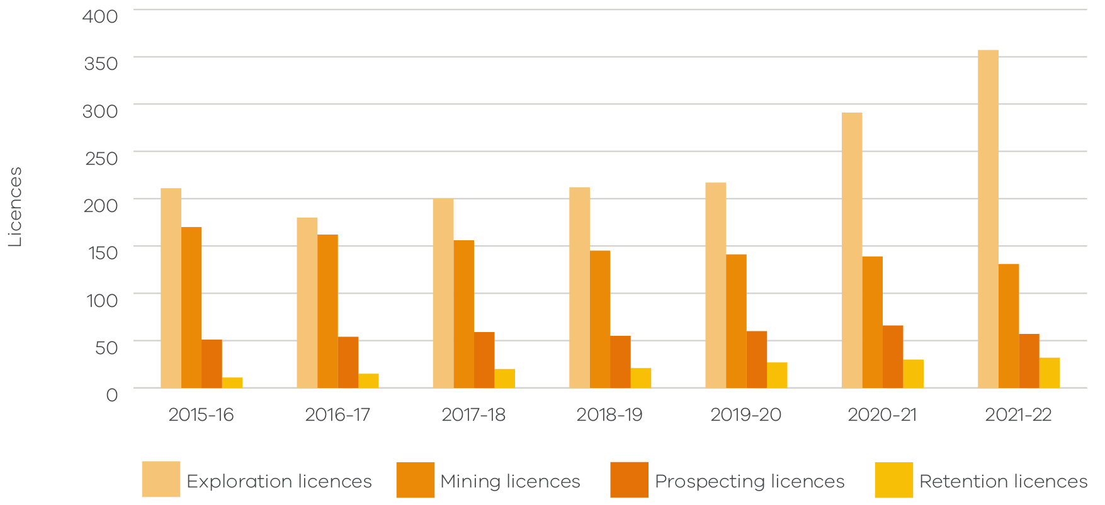
Table 3.3.2 Number of licence applications submitted by financial year
Licence type | 2015-16 | 2016-17 | 2017-18 | 2018-19 | 2019-20 | 2020-21 | 2021-22
Exploration licence | 32 | 38 | 72 | 67 | 138 | 111 | 126
Mining licence | 3 | 1 | 2 | 1 | 1 | 1 | 3
Prospecting licence | 14 | 18 | 17 | 14 | 7 | 10 | 8
Retention licence | 7 | 3 | 7 | 6 | 14 | 5 | 2
Total | 56 | 60 | 98 | 88 | 160 | 127 | 139

Figure 3.3.2 Number of licence applications submitted by financial year
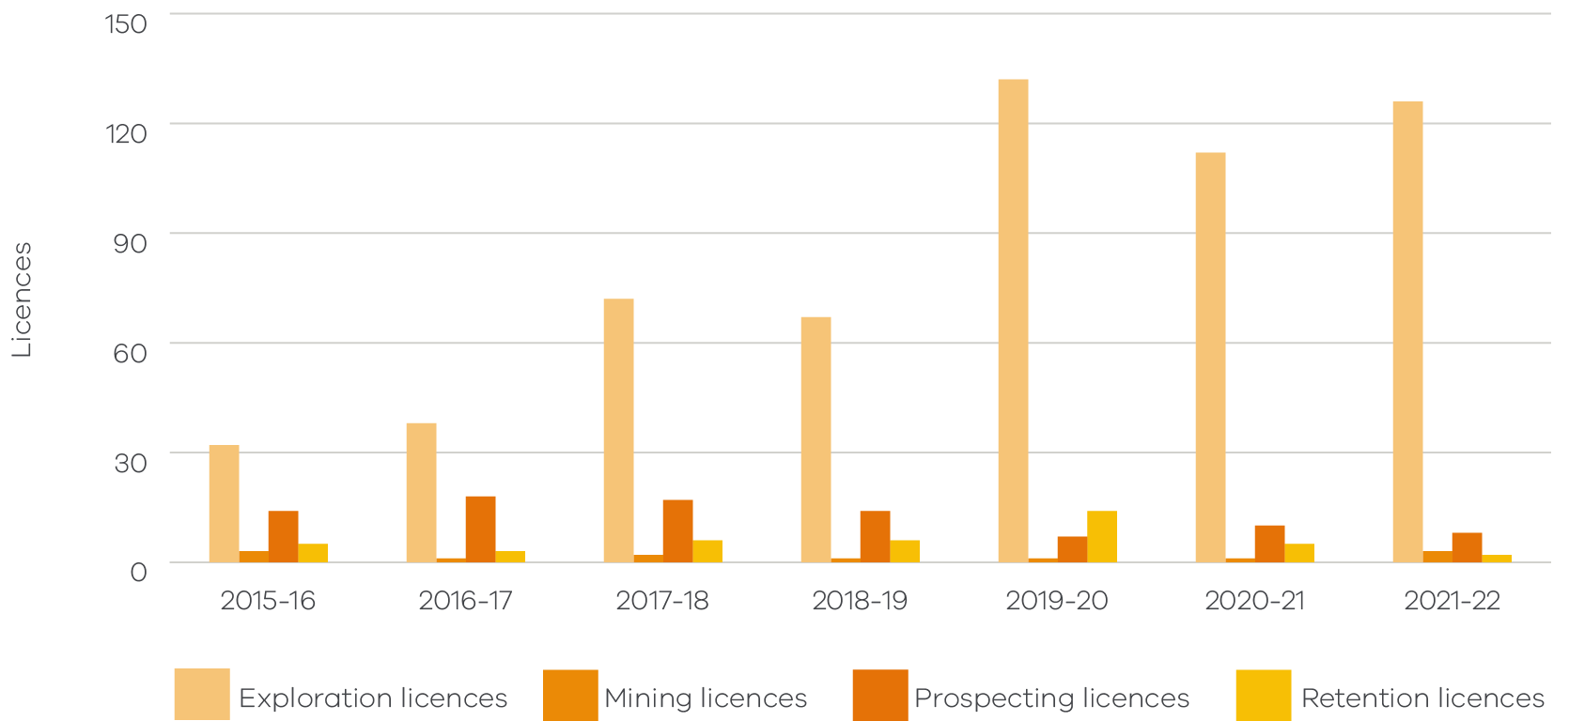
Table 3.3.3 Licence applications granted by financial year
Licence type | 2015-16 | 2016-17 | 2017-18 | 2018-19 | 2019-20 | 2020-21 | 2021-22
Exploration licence | 17 | 21 | 63 | 36 | 25 | 89 | 77
Mining licence | 2 | 0 | 3 | 1 | 2 | 0 | 0
Prospecting licence | 12 | 11 | 12 | 14 | 14 | 9 | 4
Retention licence | 3 | 4 | 7 | 1 | 6 | 3 | 2
Total | 34 | 36 | 85 | 52 | 47 | 101 | 83

Figure 3.3.3 Number of licence applications granted by financial year
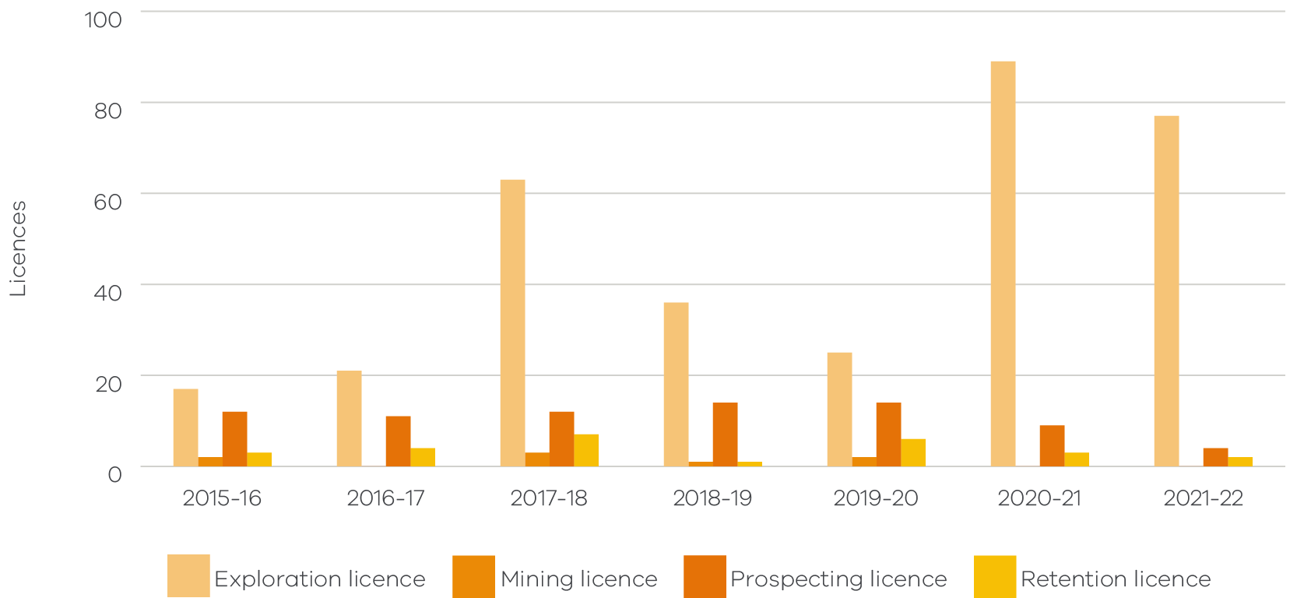
Table 3.3.4 Licences renewed by financial year
Licence Type | 2015-16 | 2016-17 | 2017-18 | 2018-19 | 2019-20 | 2020-21 | 2021-22
Exploration licence | 13 | 17 | 29 | 19 | 11 | 15 | 6
Mining licence | 10 | 15 | 26 | 22 | 9 | 4 | 5
Retention licence | - | - | - | - | 1 | 2 | 1
Total | 23 | 32 | 55 | 41 | 21 | 21 | 12

Figure 3.3.4 Number of licence applications renewed by financial year
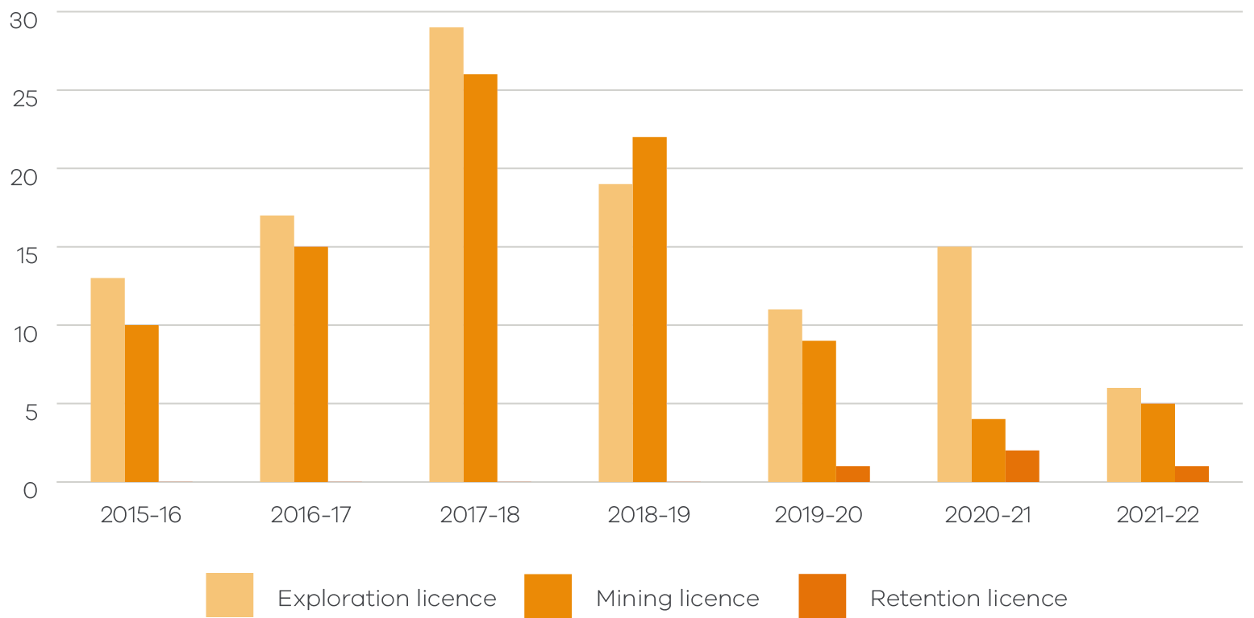
Table 3.3.5 Licence variations submitted by financial year
Licence type | 2015-16 | 2016-17 | 2017-18 | 2018-19 | 2019-20 | 2020-21 | 2021-22
Exploration licence | 205 | 173 | 124 | 191 | 211 | 187 | 171
Mining licence | 49 | 44 | 48 | 63 | 28 | 17 | 22
Prospecting licence | 2 | 13 | 3 | 14 | 8 | 5 | 9
Retention licence | 3 | 2 | 5 | 7 | 9 | 4 | 6
Total | 259 | 232 | 180 | 275 | 256 | 213 | 208

Figure 3.3.5 Number of licence variations submitted by financial year
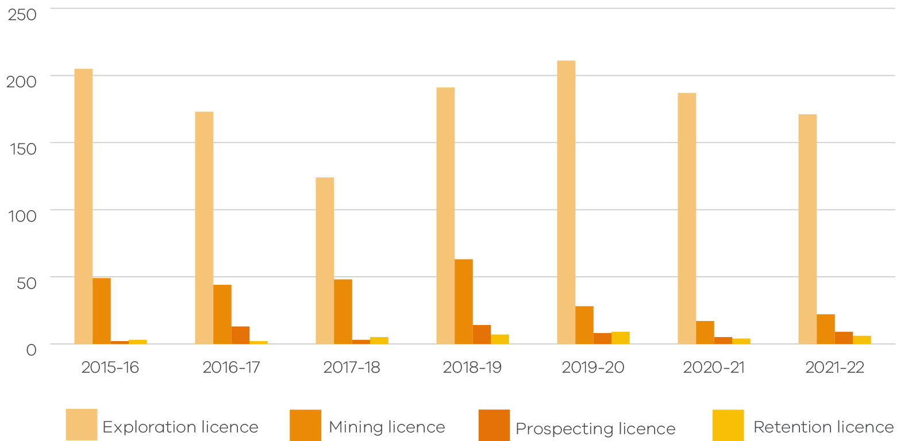
Table 3.3.6 Licence variations completed by financial year
Licence type | 2015-16 | 2016-17 | 2017-18 | 2018-19 | 2019-20 | 2020-21 | 2021-22
Exploration licence | 168 | 167 | 147 | 185 | 145 | 152 | 121
Mining licence | 30 | 40 | 55 | 56 | 15 | 13 | 20
Prospecting licence | 2 | 8 | 4 | 13 | 7 | 3 | 7
Retention licence | 3 | 0 | 5 | 7 | 4 | 4 | 4
Total | 203 | 215 | 211 | 261 | 171 | 172 | 152

Figure 3.3.6 Number of licence variations completed by financial year
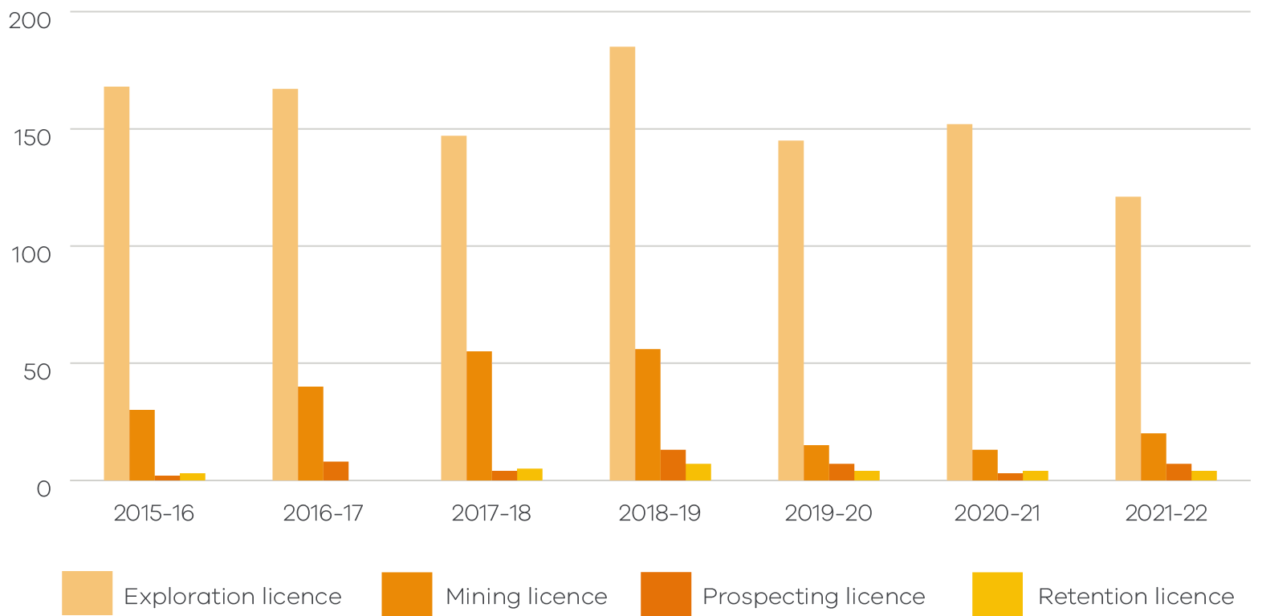

Mineral work plans, codes of practice and administrative updates by notification
Work plans and codes of practices submitted and approved by financial year:
- An initial work plan (WP) is the primary document describing the permitted activities to be undertaken on a licence.
- A work plan variation (WPV) is submitted by a licence holder when they want to change the scope of work in an existing work plan.
Code of practice (eligible to operate under the Code of Practice for low impact exploration or low risk mines).
Table 3.4.1 Mineral work plans, work plan variations and codes of practice applications submitted
 | 2015-16 | 2016-17 | 2017-18 | 2018-19 | 2019-20 | 2020-21 | 2021-22
Initial work plan | 13 | 7 | 14 | 11 | 8 | 9 | 13
Work plan variation | 7 | 13 | 16 | 11 | 14 | 3 | 4
Code of practice | 6 | 7 | 4 | 10 | 3 | 4 | 6
Total submitted | 26 | 27 | 34 | 32 | 25 | 16 | 23

Table 3.4.2 Mineral work plans, work plan variations and codes of practice applications approved
 | 2015-16 | 2016-17 | 2017-18 | 2018-19 | 2019-20 | 2020-21 | 2021-22
Initial work plan | 9 | 3 | 4 | 6 | 7 | 3 | 10
Work plan variation | 3 | 1 | 11 | 14 | 7 | 4 | 2
Code of practice | 5 | 5 | 3 | 2 | 5 | 4 | 5
Total approved | 17 | 9 | 18 | 22 | 19 | 11 | 17

Table 3.4.3 Mineral work plans, work plan variations and codes of practice applications withdrawn/refused
 | 2015-16 | 2016-17 | 2017-18 | 2018-19 | 2019-20 | 2020-21 | 2021-22
Initial work plan | 1 | 4 | 2 | 1 | 2 | 2 | 12
Work plan variation | 0 | 1 | 7 | 2 | 4 | 1 | 0
Code of practice | 0 | 0 | 0 | 0 | 0 | 0 | 1
Total withdrawn/ refused | 1 | 5 | 9 | 3 | 6 | 3 | 13

Statutory endorsement indicates that Earth Resources Regulation has assessed and endorsed the work plan or work plan variation as having met the requirements under the MRSDA.
Table 3.4.4 Mineral work plans and work plan variations statutory endorsements
 | 2015-16 | 2016-17 | 2017-18 | 2018-19 | 2019-20 | 2020-21 | 2021-22
Initial work plan | 4 | 1 | 0 | 1 | 1 | 2 | 0
Work plan variation | 4 | 0 | 1 | 4 | 3 | 1 | 0
Total endorsed | 8 | 1 | 1 | 5 | 4 | 3 | 0

Administrative updates by notification are minor changes to the existing work plan with no significant increase in risk arising from the new or changing work. Administrative updates do not require statutory endorsement (no further planning permission required). The administrative updates by notification process was introduced at the end of FY2017-18.
Table 3.4.5 Mineral administrative updates by notifications received and acknowledged
 | 2015-16 | 2016-17 | 2017-18 | 2018-19 | 2019-20 | 2020-21 | 2021-22
Received | - | - | 2 | 11 | 10 | 7 | 12
Acknowledged | - | - | 2 | 8 | 9 | 7 | 7

Petroleum, geothermal, offshore pipelines and greenhouse gas
Exploration, within Victoria’s jurisdiction, for petroleum occurred in the offshore parts of the Otway and Gippsland geological basins. Production activity occurred in the Otway Basin.
Offshore activities occur within three nautical miles of the coast, according to Victorian legislation. Waters further than three nautical miles are covered by Commonwealth legislation and reported separately by Commonwealth Government agencies.
Hydraulic fracturing is banned under Victorian legislation.

Gas production and storage
Gas production located offshore within Victoria’s three nautical mile zone.
Table 4.1.1 Gas production by financial years
Year | Condensate (barrels) | Gas production (MMscf*) | Gas production (petajoules^) | CO2 production. (tonnes) | Comments
2015-16 | 3.7 | 0 | 0 | 32,991 | Ex-wellhead figures
2016-17 | 201,972 | 19,598 | 21.26 | 34,937 | Ex-wellhead figures
2017-18 | 134,178 | 13,118 | 13.91 | 33,643 | Ex-wellhead figures
2018-19 | 146,186 | 14,523 | 15.40 | 32,293 | Ex-wellhead figures
2019-20 | 99,094 | 9,069 | 9.83 | 31,029 | Ex-wellhead figures
2020-21 | 122,569 | 7,534 | 8.17 | 27,149 | Ex-wellhead figures
2021-22 | 167,353 | 8,759 | 9.50 | 27,003 | Ex-wellhead figures
* MMscf = million standard cubic feet.
^ Convert Gas MMscf to petajoules using online sales gas converter: https://www.convert-me.com/en/convert/energy/mscfgas.html.
Table 4.1.2 Underground gas storage by financial years
Year | Condensate (barrels) | Gas storage (MMscf**) | Gas storage (petajoules^) | Gas injection (MMscf) | Comments
2015-16 | 1,967 | 16,881 | 18.31 | 9,970 | Storage
2016-17 | 587 | 9,668 | 10.49 | 13,952 | Storage
2017-18 | 465 | 11,670 | 12.38 | 13,745 | Storage
2018-19 | 1,220 | 13,100 | 13.89 | 12,514 | Storage
2019-20 | 944 | 15,959 | 17.31 | 12,231 | Storage
2020-21 | 283 | 16,144 | 17.51 | 10,201 | Storage
2021-22 | 311 | 12,470 | 13.52 | 16,216 | Storage
**MMscf = million standard cubic feet.
^ Convert Gas MMscf to petajoules using online sales gas converter: https://www.convert-me.com/en/convert/energy/mscfgas.html.

Drilling
Exploration, appraisal and production wells
Table 4.2.1 Number of wells drilled in Victoria by financial year
Year | Offshore (Vic) Gippsland | Offshore (Vic) Otway | Onshore Gippsland | Onshore Otway | Total wells
2015-16 | 0 | 1 | 0 | 0 | 1
2016-17 | 0 | 0 | 0 | 0 | 0
2017-18 | 0 | 0 | 0 | 0 | 0
2018-19 | 0 | 0 | 0 | 1 | 1
2019-20 | 0 | 1 | 0 | 0 | 1
2020-21 | 0 | 1 | 0 | 0 | 1
2021-22 | 0 | 0 | 0 | 1 | 1

Figure 4.2.1 Number of wells drilled by financial year
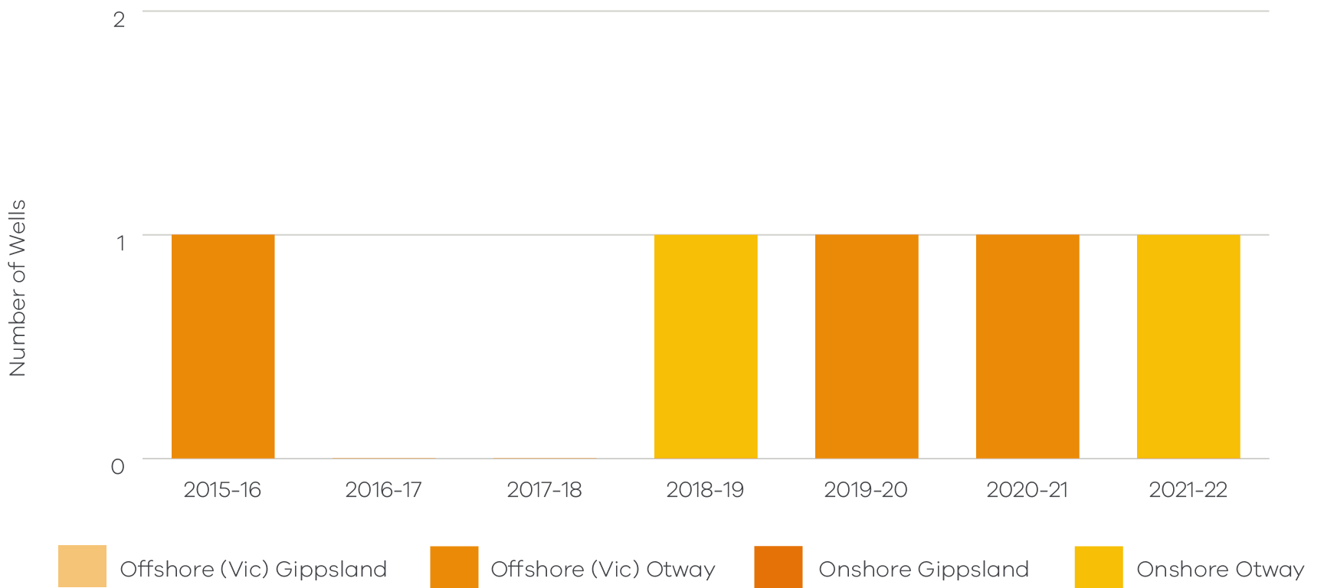

Petroleum, offshore pipelines, geothermal and greenhouse gas licences
Table 4.3.1 Overview of onshore petroleum tenements as at 30 June 2022
Onshore petroleum licences and permits | No. of licences and permits
Onshore petroleum production licence | 11
Onshore petroleum exploration permit | 10
Onshore petroleum special drilling authorisation | 2
Onshore petroleum retention lease | 1
Total | 24
Table 4.3.2 Overview of offshore (Victorian waters) petroleum tenements as at 30 June 2022
Offshore petroleum licences and permits | No. of licences and permits
Offshore petroleum exploration permit | 5
Offshore petroleum production licence | 2
Offshore petroleum retention lease | 1
Offshore petroleum access authority | 1
Total | 9

Table 4.3.3 Offshore pipeline licences as at 30 June 2022
Offshore pipeline licences | No. of licences
Offshore pipeline licence | 14

Table 4.3.4 Geothermal exploration permits as at 30 June 2022
Geothermal energy permits | No. of permits
Geothermal exploration permit | 1

Table 4.3.5 Offshore greenhouse gas assessment permits as at 30 June 2022
Greenhouse gas storage permits | No. of permits
Offshore greenhouse gas assessment permit | 1

Table 4.3.6 Non-MRSDA licence variations submitted by financial year
Licence type | 2015-16 | 2016-17 | 2017-18 | 2018-19 | 2019-20 | 2020-21 | 2021-22
Geothermal exploration permit | 2 | 1 | 2 | 0 | 0 | 0 | 0
Offshore greenhouse gas assessment permit | 0 | 0 | 0 | 1 | 1 | 0 | 0
Offshore petroleum access authority | 0 | 0 | 0 | 2 | 2 | 0 | 0
Offshore petroleum exploration permit | 3 | 0 | 2 | 6 | 2 | 10 | 1
Offshore petroleum production licence | 0 | 0 | 0 | 2 | 2 | 0 | 0
Offshore petroleum retention lease | 0 | 1 | 1 | 1 | 0 | 0 | 0
Offshore pipeline licence | 0 | 9 | 16 | 5 | 3 | 1 | 3
Onshore petroleum exploration permit | 23 | 5 | 30 | 9 | 5 | 4 | 19
Onshore petroleum production licence | 3 | 0 | 16 | 17 | 9 | 0 | 0
Onshore petroleum retention lease | 0 | 0 | 4 | 0 | 1 | 0 | 2
Onshore petroleum special drilling authorisation | 0 | 0 | 0 | 1 | 2 | 2 | 0
Total | 31 | 16 | 71 | 44 | 27 | 17 | 25

Table 4.3.7 Non-MRSDA licence variations completed by financial year
Licence type | 2015-16 | 2016-17 | 2017-18 | 2018-19 | 2019-20 | 2020-21 | 2021-22
Geothermal exploration permit | 0 | 0 | 2 | 1 | 0 | 0 | 0
Offshore greenhouse gas assessment permit | 0 | 0 | 0 | 0 | 1 | 1 | 0
Offshore petroleum access authority | 0 | 0 | 0 | 1 | 3 | 0 | 0
Offshore petroleum exploration permit | 0 | 2 | 1 | 2 | 3 | 12 | 0
Offshore petroleum production licence | 0 | 0 | 0 | 1 | 3 | 0 | 0
Offshore petroleum retention lease | 0 | 0 | 2 | 0 | 2 | 0 | 0
Offshore pipeline licence | 0 | 3 | 22 | 3 | 6 | 2 | 0
Onshore petroleum exploration permit | 17 | 7 | 15 | 17 | 10 | 2 | 21
Onshore petroleum production licence | 2 | 0 | 9 | 7 | 18 | 8 | 1
Onshore petroleum retention lease | 0 | 1 | 4 | 0 | 1 | 0 | 2
Onshore petroleum special drilling authorisation | 0 | 0 | 0 | 1 | 2 | 2 | 0
Total | 19 | 13 | 55 | 33 | 49 | 27 | 24

Revenue

Royalties payable
Table 5.1.1 Royalties payable by financial year ($ million)
Year | Extractive industries  ($ million) | Gold*  ($ million) | Other minerals ($ million) | Petroleum  ($ million) | Coal  ($ million) | Total  ($ million)
2015-16 | $6.2 | N/A | $5.7 | $0.1 | $36.6 | 47.7
2016-17 | $5.9 | N/A | $6.1 | $4.2 | $66.9 | $83.1
2017-18 | $6.2 | N/A | $5.6 | $3.2 | $84.0 | $99.1
2018-19 | $6.2 | N/A | $1.9 | $7.9 | $80.4 | $96.1
2019-20 | $5.9 | $25.4 | $1.7 | $4.1 | $78.7 | $115.8
2020-21 | $6.9 | $48.2 | $1.8 | $5.3 | $82.8 | $145.0
2021-22 | $7.8 | $42.8 | $3.2 | $9.2 | $79.2 | $142.3
*From 1 January 2020, gold produced under a mining licence in Victoria is subject to a royalty. The royalty only applies to gold produced in a financial year in excess of 2,500 ounces.
Figure 5.1.1 Royalties payable by financial year ($ million)
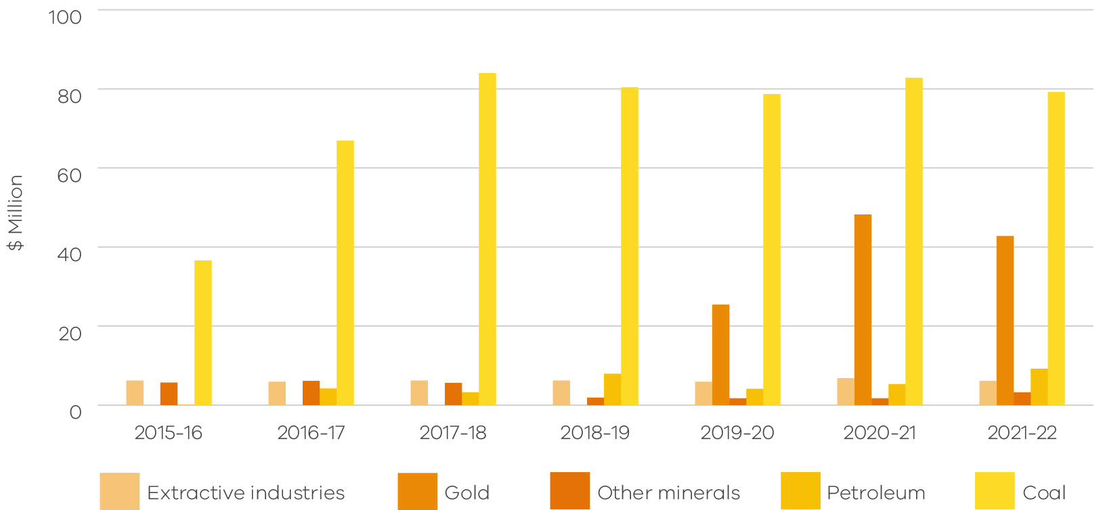

Regulatory fees
Table 5.2.1 Regulatory fees by financial year ($ million)
Year | Regulatory charges  ($ million) | Rent  ($ million) | Mine Stability Levy  ($ million) | Total  ($ million)
2015-16 | $0.7 | $2.0 | $1.4 | $4.1
2016-17 | $0.7 | $1.4 | $1.4 | $3.5
2017-18 | $0.8 | $2.8 | $1.5 | $5.1
2018-19 | $0.9 | $3.5 | $1.5 | $5.9
2019-20 | $1.1 | $3.6 | $1.5 | $6.2
2020-21 | $1.2 | $3.8 | $1.5 | $6.5
2021-22 | $1.2 | $4.0 | $1.5 | $6.7

Figure 5.2.1 Regulatory fees by financial year ($ million)
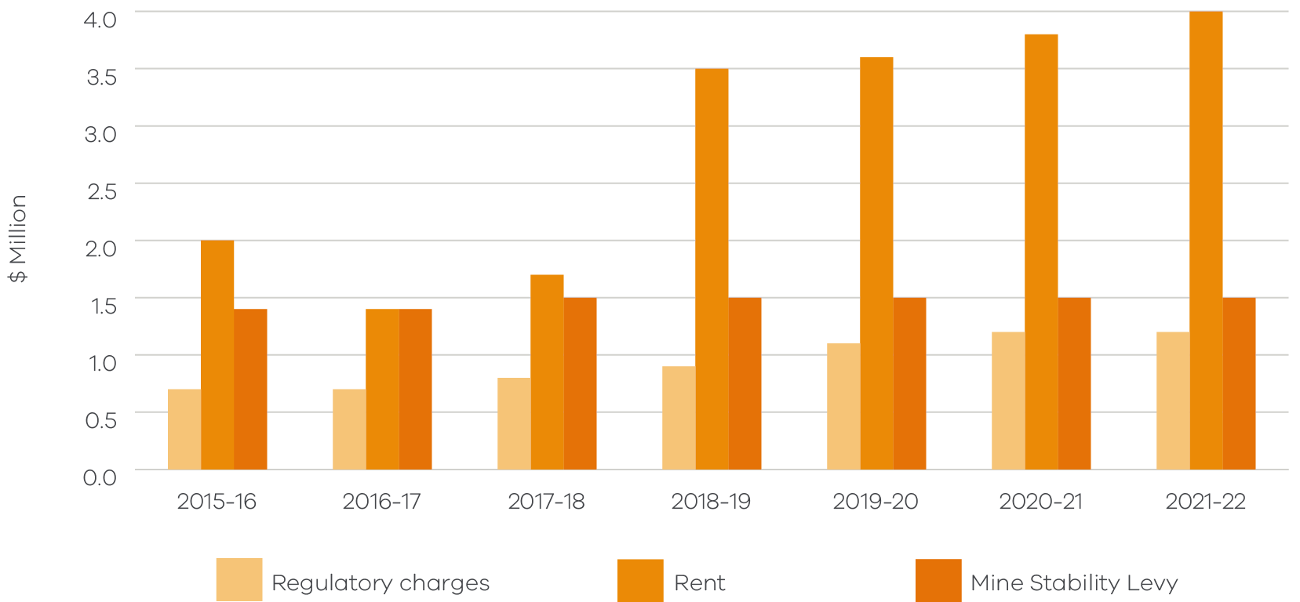

Rehabilitation bonds

Bonds held
The total monetary value of the rehabilitation bonds held by the State under the MRSDA in 2021-22 was $824.5 million as at 30 June 2022. Up to date bonds held by the State can be found on the Earth Resources Regulation website: https://earthresources.vic.gov.au/community-and-land-use/rehabilitation.
Table 6.1.1 Value of rehabilitation bonds by tenement type and by financial year ($ million)
Year | Extractive industries ($ million) | Mining licences ($ million) | Exploration licences ($ million) | Prospecting licences ($ million) | Retention licences ($ million) | Total ($ million)
2015-16 | $88.6 | $239.6 | $2.0 | $0.2 | $0.1 | $330.5
2016-17 | $91.7 | $380.5 | $2.0 | $0.2 | $0.1 | $474.5
2017-18 | $92.2 | $717.7 | $2.0 | $0.2 | $0.1 | $812.2
2018-19 | $91.9 | $717.7 | $2.6 | $0.2 | $0.4 | $812.7
2019-20 | $93.0 | $717.9 | $2.7 | $0.2 | $0.4 | $814.1
2020-21 | $92.9 | $717.8 | $3.0 | $0.4 | $0.4 | $814.4
2021-22 | $100.8 | $719.7 | $3.1 | $0.5 | $0.5 | $824.5

Figure 6.1.1 Extractive industries and mining rehabilitation bonds held at the end of financial year ($ million)
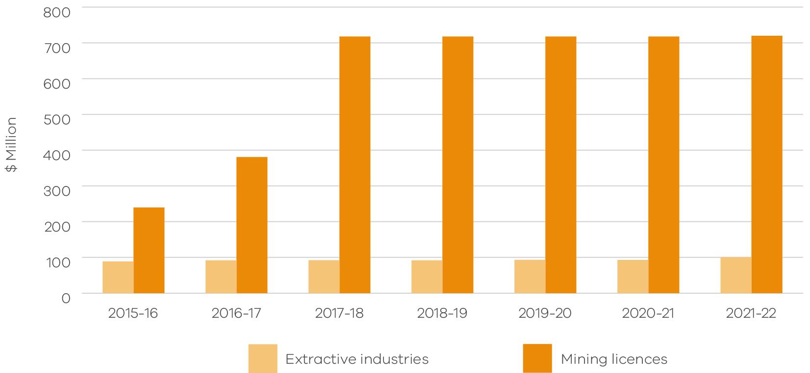
Figure 6.1.2 Exploration, prospecting and retention licence rehabilitation bonds held at the end of financial year ($ million)
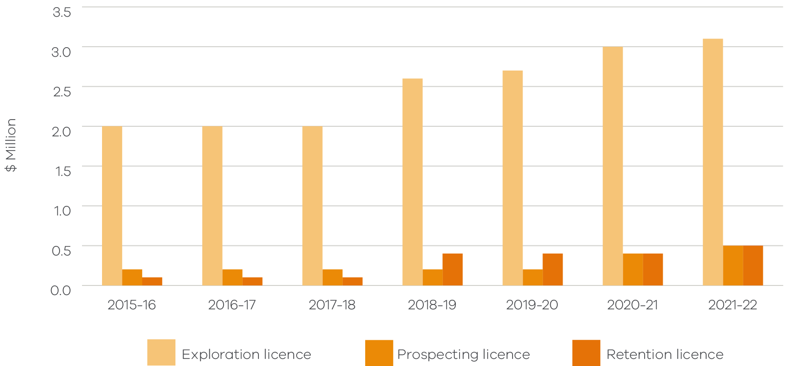

Bond reviews
Table 6.2.1 Rehabilitation bond reviews by financial year
Year | Result of review – increase of initial bond | Result of review –no change | Result of review – partial or full release | Number of bonds reviewed
2015-16 | 53 | 0 | 50 | 102
2016-17 | 54 | 8 | 37 | 99
2017-18 | 53 | 7 | 55 | 115
2018-19 | 49 | 2 | 38 | 89
2019-20 | 46 | 1 | 30 | 77
2020-21 | 91 | 1 | 26 | 118
2021-22 | 85 | 2 | 34 | 121

The bond review numbers differ slightly from previous reports due to the undertaking of a data cleansing and re-alignment exercise for historical bond review records.
Figure 6.2.1 Outcome of bond reviews by financial year
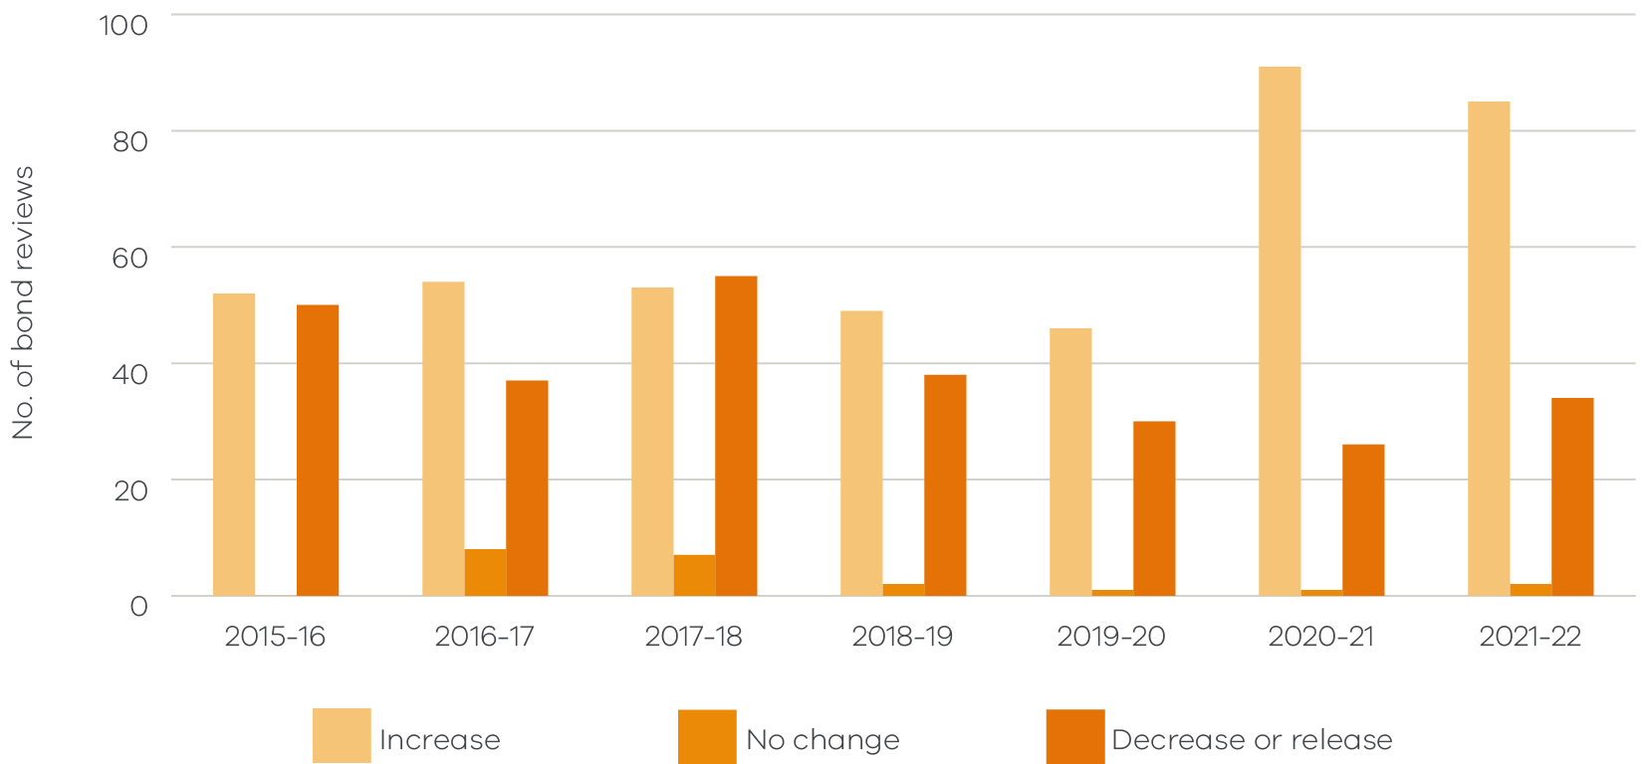

Compliance

Compliance activities
Earth Resources Regulation undertakes a compliance program to ensure that tenement holders comply with their obligations. Monitoring, compliance and enforcement activities under the MRSDA are summarised in the table below. Inspector field activities were limited to responding to critical incidents and key preventative measures during the period of COVID-19 restrictions.
Table 7.1.1 Compliance activities by financial year
Activities | Audits | Inspections^ | Meetings | Enforcement notices* | Total
2015-16 | 186 | 478 | 199 | 59 | 922
2016-17 | 170 | 468 | 106 | 61 | 805
2017-18 | 160 | 533 | 91 | 8 | 792
2018-19 | 164 | 460 | 58 | 27 | 709
2019-20 | 108 | 515 | 69 | 62 | 754
2020-21 | 75 | 378 | 77 | 61 | 591
2021-22 | 55 | 295 | 55 | 49 | 454
^Inspections include site closures and site visits.
*MRSDA s110 and s110a Notices issued.
Figure 7.1.1 Compliance activities by financial year
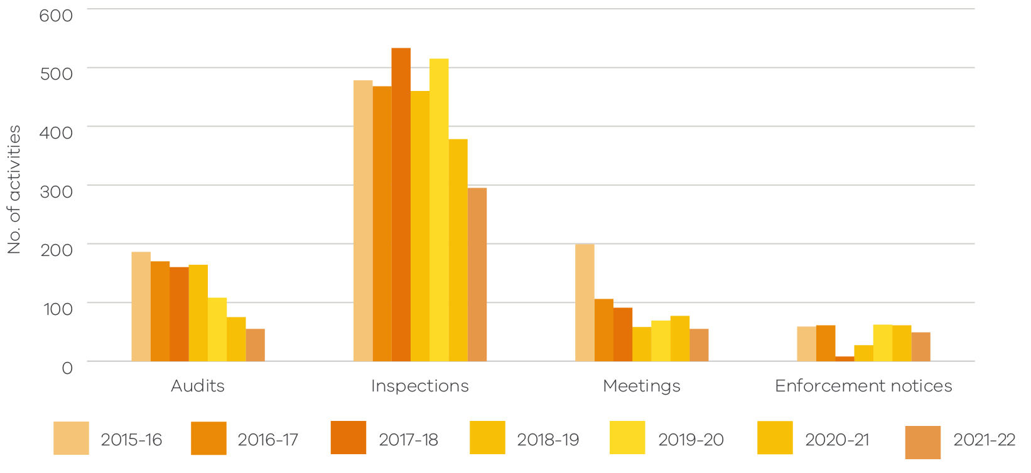

Industry annual returns submission rate
Tenement holders are obliged to submit an annual report on their activities by the due date even if no work has been undertaken in the financial year. The information submitted is used to monitor industry activities, specify regulatory fees and royalties, and inform management of Victoria’s earth resources sector by understanding the state of the industry and aiding further investment and jobs.
Table 7.2.1 MRSDA tenements FY2021-22 annual report submission rate as at 11 December 2022
Tenement type | % annual returns received by due date or with extensions* | % annual returns received late | % total annual returns received | % annual returns outstanding
Extractive industries | 56.8% | 22.5% | 79.3% | 20.7%
Mining licences | 82.3% | 12.3% | 94.6% | 5.4%
Prospecting licences | 85.6% | 6.8% | 92.4% | 7.6%
Exploration licences | 93.4% | 5.7% | 99.1% | 0.9%
Retention licences | 93.3% | 6.7% | 100.0% | 0.0%
*Due dates: extractive industries 31 July 2022; mining and prospecting 28 July 2022; exploration and retention dates varied during the year. (Note: annual returns submitted includes regulator approved extensions.)
Annual returns submitted by tenement type:
Tenement type | Annual returns
Extractive industries | - Annual return extractive industries
Extractive industries | - Royalty return
Mining licences | - Expenditure and activity
Mining licences | - Production and royalty
Prospecting licences | - Expenditure and activity
Prospecting licences | - Production and royalty
Exploration licences | - Expenditure and activity
Retention licences | - Expenditure and activity

earthresources.vic.gov.au

Victorian waters are within three nautical miles of the coastline.
The ABS reports quarterly on private mineral exploration expenditure for all Australian states and the Northern Territory. Victorian mineral exploration and mining expenditure is also reported in accordance with the requirements of the MRSDA. The ABS exploration expenditure statistics can vary significantly from expenditure reported under the MRSDA. The difference between these two exploration expenditure data sets is mainly due to the difference in methodologies for data collection and the inclusion of the exploration expenditure on mining licences in the MRSDA figure. The ABS statistics are a valid basis for comparison of Victorian expenditure with other states and territories. However, the MRSDA figures provide greater detail.
The mineral exploration expenditure figures covers exploration and retention licences with expenditure reporting period that ends within the financial year any specified exploration expenditure on mining and prospecting licences.
The mineral mining expenditure figure covers all expenditure on mining and prospecting licences (including capital and operating expenses), less any specified exploration expenditure on mining and prospecting licences.

