WHAT DOES MINERALS EXPLORATION INVOLVE?

Snapshot: some key facts
- Victoria is endowed with minerals which occur naturally in the earth’s crust. Minerals found in Victoria include gold, molybdenum, antimony, as well as copper and other base metals.
- Victoria has a long history of minerals exploration and mining, dating back to the 1850s gold rush.
- The Victorian Government is committed to creating greater prosperity and a better quality of life for regional communities.
- Encouraging exploration for minerals in suitable areas can boost economic activity in small towns and regional communities.
- Local businesses can beneﬁt directly from increased spending on local services and products such as accommodation, food, fuel, and equipment, with ﬂow on beneﬁts throughout regional communities.
- A minerals exploration licence provides the licensee rights to explore in a speciﬁed area and is valid for up to ﬁve years.
- Licensed minerals explorers have a duty to consult with landholders and local communities.

Early stage exploration
Once an explorer has a minerals exploration licence, ﬁeld exploration usually starts with broader scale low impact activities such as aerial surveying, ground mapping, rock sampling, water, and soil testing.
- Explorers take measurements through surveying, sometimes using magnetic or electrical instruments.
- Advanced technologies via aerial surveys can mean explorers do not need to access private property at all.

Later stage exploration – targeted
As the explorer learns more about the geology, the exploration program progressively focuses on much smaller areas, or targets, within the minerals licence boundary.
- Explorers may adopt more speciﬁc directed exploration techniques, such as drilling to sample rock at different depths below the surface.
- Drilling is expensive and is used selectively.
- Initial drilling involves taking samples through a small hole – usually less than 100 mm in diameter – through soil and loose rock. This tells the geologist what types of rock exist under the surface and if minerals are present.
- If minerals are identiﬁed, explorers may drill deeper holes, often using diamond drills to cut through hard rock.
- Through this process the geologist can determine how much mineral is present and give an indication of whether minerals may occur in economic quantities. At this stage, bulk samples may also be taken.

Did you know?
Nature is helping explorers detect mineralisation.
- Traces of gold in ant and termite mounds
- Samples of eucalyptus plants show traces of metals have been drawn up through their roots
- Small balls of iron oxide trap metals and are used in exploration – these are also found on Mars.
Source: CSIRO

Does exploration lead to mineral development?
The likelihood of exploration activity leading to a mine is very low. Apart from the size and quality of the mineral deposit identiﬁed through exploration, a range of other factors will determine the commercial viability of a project, such as establishment and production costs, commodity prices, transport costs, international supply competition and demand, as well as exchange rates. Mines are subject to planning approval and strong regulatory controls.
Applications for mining activities involves detailed, stringent planning approvals and regulatory controls.
Studies are undertaken to assess potential environmental, social and economic impacts, how these will be managed, and extensive consultation with communities. This process is expensive and can take between 10 and 20 years from the commencement of exploration to approving a commercially viable minerals development project.

Did you know?
Currently around 30 per cent of Victoria is under a minerals exploration licence.
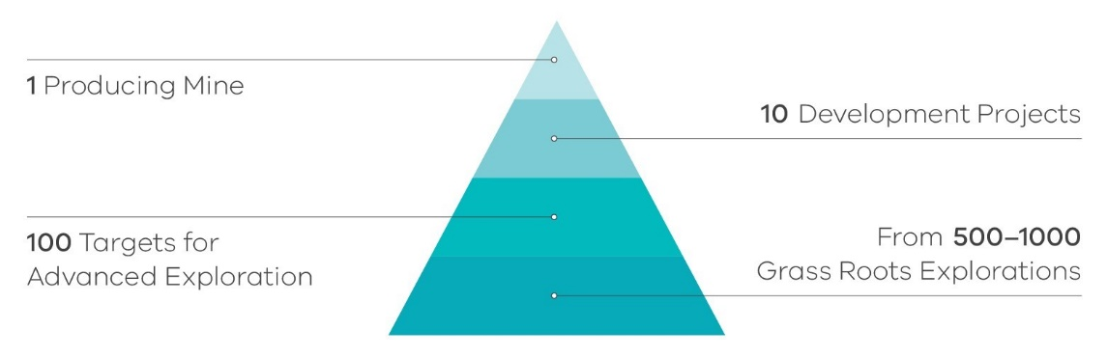
Less than one per cent of minerals exploration projects progress to the minerals development stage.
Source: Fraser Institute

Changes in technology or markets lead to new phases of exploration and resource evaluation
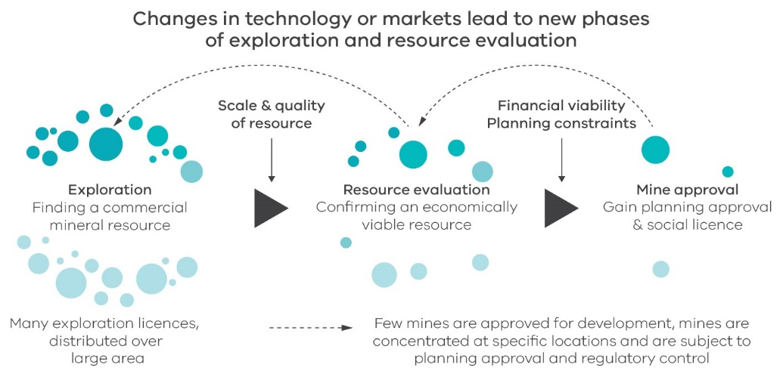

Further information
Learn more about how exploration is regulated at: www.earthresources.vic.gov.au/legislation-and-regulations

Authorised by the State Government of Victoria, Melbourne.
© Copyright State Government of Victoria 2020
This publication is copyright. No part may be reproduced by any process except in accordance with provisions of the Copyright Act 1968.

