Benambra Tailings Storage Facility (TSF) Surface Water Sampling Results

Map of sampling area
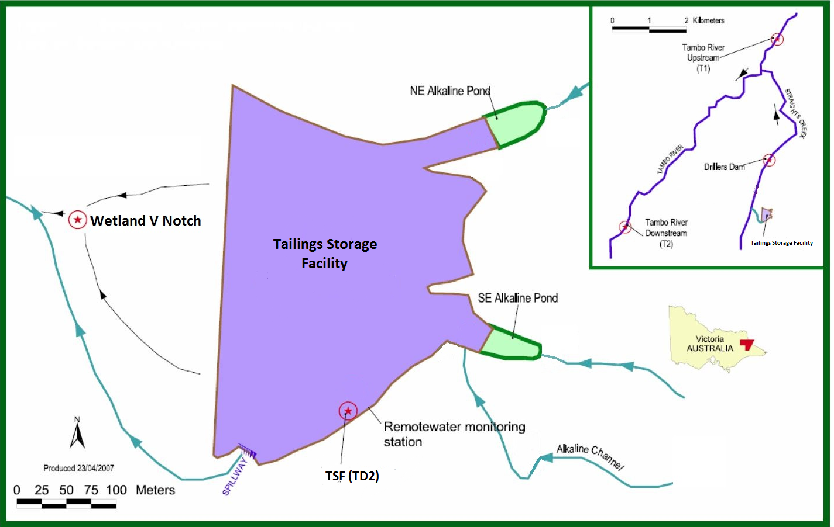

Benambra Tailings Storage Facility (TSF) Surface Water

Sampling Results - pH

The below image is indicative of sampling locations. Not to scale.
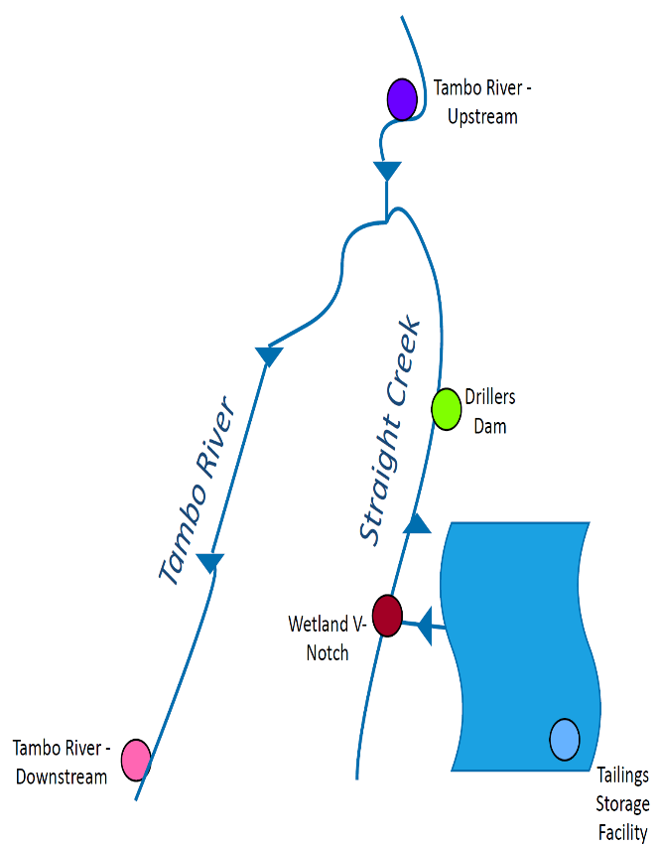

The data plotted in the above graph can vary with rainfall and water levels. The TSF sampling is taken from the dam. There is no regular discharge to the creek, except in flood conditions. Environmental Quality Objectives (i.e. levels acceptable for this receiving environment) have not yet been developed.

Benambra Tailings Storage Facility (TSF) Surface Water Sampling Results - Copper

The below image is indicative of sampling locations. Not to scale.

The data plotted in the above graph can vary with rainfall and water levels. The TSF sampling is taken from the dam. There is no regular discharge to the creek, except in flood conditions. Environmental Quality Objectives (i.e. levels acceptable for this receiving environment) have not yet been developed. Copper values <0.001mg/L are shown as 0.001mg/L to display the overall trend.

Benambra Tailings Storage Facility (TSF) Surface Water

Sampling Results - Zinc

The below image is indicative of sampling locations. Not to Scale.

The data plotted in the above graph can vary with rainfall and water levels. The TSF sampling is taken from the dam. There is no regular discharge to the creek, except in flood conditions. Environmental Quality Objectives (i.e. levels acceptable for this receiving environment) have not yet been developed. Zinc values <0.005mg/L are shown as 0.005mg/L to display the overall trend.

