Contents
1. OVERVIEW 4
2. Our engagement principles 5
Principle 1: Engagement is transparent and accountable 5
Principle 2: Engagement is considered and genuine 5
Principle 3: Engagement is fit for purpose 5
Principle 4: Engagement is clear, accessible and simple to understand 5
Principle 5: Engagement is used to listen, learn and improve 5
3. Stakeholder enagement framework 6
4. Our Engagement guidelines 6
5. Complaint procedures 7
6. Authorisation 7
7. Records Management 7

Stakeholder Engagement Charter
Department of Jobs, Precincts and Regions - Earth Resources Regulation
Enquiries ERRFeedback@ecodev.vic.gov.au
 Contact 1800 366 356

OVERVIEW
Earth Resources Regulation performs a range of regulatory functions for the use of earth resources, including:
- Authorising access to Crown-owned mineral, petroleum, geothermal and extractive resources.
- Assessing applications for work plans for exploration, mines, quarries and petroleum operations, including rehabilitation and community engagement, in line with recognised standards to protect public safety, land, infrastructure and the environment.
- Assessing site rehabilitation liabilities and setting rehabilitation bonds.
- Conducting education, monitoring and enforcement to ensure operator’s compliance with public safety, environmental, ground stability and site rehabilitation standards.
- Collecting fees and royalties.
We frequently engage with authority holders and site operators, land holders and local communities, and other government agencies. Engagement plays an important role in what we do.
We recognise that public confidence in the mining, quarrying, recreational prospecting, petroleum and other resource sectors and our role as a regulator depends on good engagement practices.
It helps build respectful and productive relationships, allows us to identify emerging issues and trends affecting the sectors we work within and is important to inform our compliance and decision-making processes.
We take our duty to inform, consult and respond seriously.
We aim to build trust and confidence in Earth Resources Regulation as a regulator through engagement.
Our engagement is conducted in line with our responsibilities under the following legislation:
- Mineral Resources (Sustainable Development) Act 1990
- Petroleum Act (1998)
- Offshore Petroleum and Greenhouse Gas Storage Act (2010)
- Geothermal Energy Resource Act (2005)
- Greenhouse Gas Geological Sequestration Act (2008)
This charter describes our approach to engagement with the industries we regulate and the communities that have an interest in these operations. It outlines our approach to ensure we:
- drive better outcomes through improved working relations; and
- encourage feedback to inform improvements and better ways of working.
Elements of this charter are based on Earth Resource Regulation Engagement Guidelines, and Regulatory Practice, Essential Services Commission’s 2018 Stakeholder Engagement Framework: Charter of Consultation, and the International Association for Public Participation’s (IAP2) Public Participation Spectrum.

Our engagement principles
Our engagement principles outline how stakeholder engagement is conducted within the boundaries of our roles and responsibilities as a regulator.

Principle 1: Engagement is transparent and accountable
We are honest in our interactions and work to keep stakeholders informed about our operations and the decisions we make. We explain key issues to assist stakeholder understanding and seek and consider stakeholder input to improve our ways of working. We publish information about the outcomes of our work and undertake regular reviews.

Principle 2: Engagement is considered and genuine
We seek to facilitate meaningful engagement with the organisations and people affected by or interested in our work and ask that they are genuine and honest in their participation. We recognise the different interests of authority holders, landowners, agencies and community members. We are clear about the purpose of our engagement and aim to respond to stakeholder and community enquiries in a timely and considered manner.

Principle 3: Engagement is fit for purpose
Our engagement activities are tailored to the complexity and potential impact of activities taking place and the opportunity for stakeholder and community input. We use a variety of engagement methods to enable a diverse array of stakeholders to have input.

Principle 4: Engagement is clear, accessible and simple to understand
We aim to present information simply and outline what we are doing and how interested stakeholders can get involved. We are working to improve accessibility and understanding of our documents by ensuring new and updated information is in plain English and conforms to the Web Content Accessibility Guidelines.

Principle 5: Engagement is used to listen, learn and improve
We evaluate and monitor our activities, against best regulatory practice. We collect feedback from stakeholders and look for ways to address issues that are raised, and to improve our process of engagement.
In addition: Earth Resources Regulation works with our co-regulators to ensure that operators comply to all relevant legislation; that their licence and work plan submissions contain appropriate information; and that their operational environments remain compliant.

We adhere to requirements of the Code of Conduct for Public Sector Employees, the Public Administration Act 2004 and various other Acts including the Privacy Act 1988, Commercial in Confidence provisions, Part 12 of Petroleum Act 1998 and Secrecy provisions s119 of Mineral Resources (Sustainable Development) Act 1990.

Stakeholder enagement framework
Earth Resources Regulation uses IAP2’s Public Participation Spectrum as the framework for our stakeholder and community engagement practice.
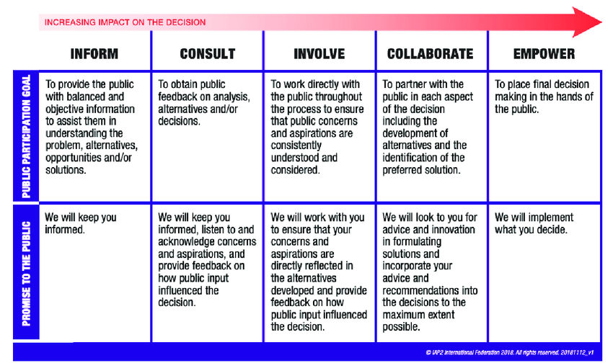
Figure 1. Public Participation Spectrum courtesy of International Association for Public Participation
The Framework guides Earth Resources Regulation to plan the most appropriate method of engagement within the boundaries of our roles and responsibilities as a regulator.
We select a mix of engagement methodologies, from inform through to empower (refer Figure 1), to develop an engagement program that reflects the complexity and potential impact of activities taking place and opportunity for stakeholder and community input.

Our Engagement guidelines
All forms of engagement between Earth Resources Regulation and industry participants, landowners, community members and agencies should be courteous and professional.
Earth Resources Regulation staff will:
- listen;
- treat all people with courtesy and respect;
- respond to queries in a timely manner and provide updates; and
- seek to resolve issues fairly, efficiently and effectively.
We expect industry participants and community members to:
- treat Earth Resources Regulation personnel with courtesy and respect, focusing on the issue, not the person
- communicate any issues or grievances with honesty and clarity
- cooperate with Earth Resources Regulation in the resolution of issues, understanding that complex issues may take some time to resolve; and
- understand that new information may be required for a decision or an outcome to be changed.
Earth Resources Regulation will cease engagement with anyone who does not uphold the above guidelines, including:
- ending a telephone conversation or closing a meeting;
- modifying, curtailing or declining a service; and
- undertaking an investigation for serious matters.
Under no circumstances is aggressive, abusive, demeaning or discriminatory behaviour acceptable.

Complaint procedures
We are committed to having an effective complaints management system that meets the needs, expectations and rights of our stakeholders. If you consider that engagement with Earth Resources Regulation is not in accordance with this charter, you may:
- contact a Director or the Executive Director of Earth Resources Regulation;
- contact DJPR complaints;
- use our online form;
- email us at ERRFeedback@ecodev.vic.gov.au; and
- contact the Victorian Ombudsman
  - Better-practice-guide-to-complaint-handling
For complaints relating to an authorised officer refer to the Department of Jobs, Precincts and Region’s authorised officer complaints management policy

Authorisation
Title Stakeholder Engagement Charter
Issuing Division/ Branch Earth Resources Regulations
Date Effective 26 May 2020
Enquiries ERRFeedback@ecodev.vic.gov.au
 Contact 1800 366 356
Approved by Anthony Hurst, Executive Director, Earth Resources Regulation

Records Management
Last Updated October 2022
Version No. 1.0.1
Reference DOC/22/82814

