`
2018 Victorian Offshore
Petroleum Acreage Release
Otway Basin

2018 Victorian Offshore
Petroleum Acreage Release
Otway Basin

May 2018

Department of Economic Development, Jobs, Transport and Resources

Department of Economic Development, Jobs, Transport and Resources
1 Spring Street Melbourne Victoria 3000
Telephone (03) 9651 9999
© Copyright State of Victoria,
Department of Economic Development, Jobs, Transport and Resources 2018
Except for any logos, emblems, trademarks, artwork and photography this document is made available under the terms of the Creative Commons Attribution 3.0 Australia license.
If you would like to receive this publication in an accessible format, such as large print or audio, telephone email vgp@ecodev.vic.gov.au

Bibliographic reference:
ISBN 978-1-925734-11-9 (pdf/online/MS word)
Geological Survey of Victoria, 2018. 2018 Victorian Offshore Petroleum Acreage Release: Otway Basin. Department of Economic Development, Jobs, Transport and Resources.
Acknowledgements:
This report was compiled by Louise Goldie Divko, David Whittam, Caroline Kettle, Luong Tran, Sean Howman and Suzanne Haydon.
Copies of this report may be obtained from:
http://earthresources.vic.gov.au/home/2018-acreage-release
Cover photo
The Gables, Otway region, south west Victoria.
For information and queries about applications for release areas:
vgp@ecodev.vic.gov.au
Disclaimer:
This publication may be of assistance to you but the State of Victoria and its employees do not guarantee that the publication is without flaw of any kind or is wholly appropriate for your particular purposes and therefore disclaims all liability for any error, loss or other consequence which may arise from you relying on any information in this publication. The Victorian Government, authors and presenters do not accept any liability to any person for the information (or the use of the information) which is provided or referred to in the report.

Table of contents
1 Victorian offshore petroleum acreage release 2018 2
1.1 Summary information 2
1.2 Victorian Gas Program 3
2 Regional Geology 4
2.1 Tectonic setting 4
2.2 Stratigraphy 4
2.3 Petroleum systems 11
3 Exploration and production history 13
4 Acreage release areas 15
4.1 18-1(v) 15
4.2 18-2(v) 16
4.3 18-3(v) 16
4.4 18-4(v) 18
4.5 18-5(v) 19
5 Data and information 20
5.1 Data coverage and access 20
5.2 Further information 21
6 Special notes 22
6.1 Legislation 22
6.2 Environmental and coastal land considerations 22
6.3 Fisheries 23
6.4 Historic sites 23
6.5 Native Title and Aboriginal Heritage 24
6.6 Marine safety 25
7 References 26
Appendix 1 Graticular block listing 31
Appendix 2 Wells and boreholes near 18-1(v) to 18-5(v) 32
Appendix 3 Seismic coverage 34
Appendix 4 Marine and Terrestrial Parks and Reserves 35
Appendix 5 Historic sites - protected shipwrecks 36

Victorian offshore petroleum acreage release 2018

Summary information
The Victorian Government is inviting applications for five petroleum acreage release areas 18-1(v), 18-2(v), 18-3(v), 18-4(v) and 18-5(v), within State Coastal Waters in the Otway Basin (Figure 1). These five offshore acreage release areas cover 1318 km² and are located between Port Campbell and the South Australian border.
The five petroleum release areas are all underexplored with limited seismic acquisition and no previous exploration drilling. 18-4(v) and 18-5(v) are adjacent to existing producing gas fields in the Shipwreck Trough. This acreage is within the proven Austral 2 petroleum system and could provide exploration opportunities similar to the Halladale and Speculant gas fields, brought into production in 2016.
Drilling from onshore to access offshore fields is permissible, subject to regulatory approvals.
Applications for the five blocks are via work program bidding, with the release closing at 6pm on 15 February 2019.
Details regarding applications are included in the 2018 Offshore Acreage Release – Application form, released with this report and available at http://earthresources.vic.gov.au/home/2018-acreage-release.
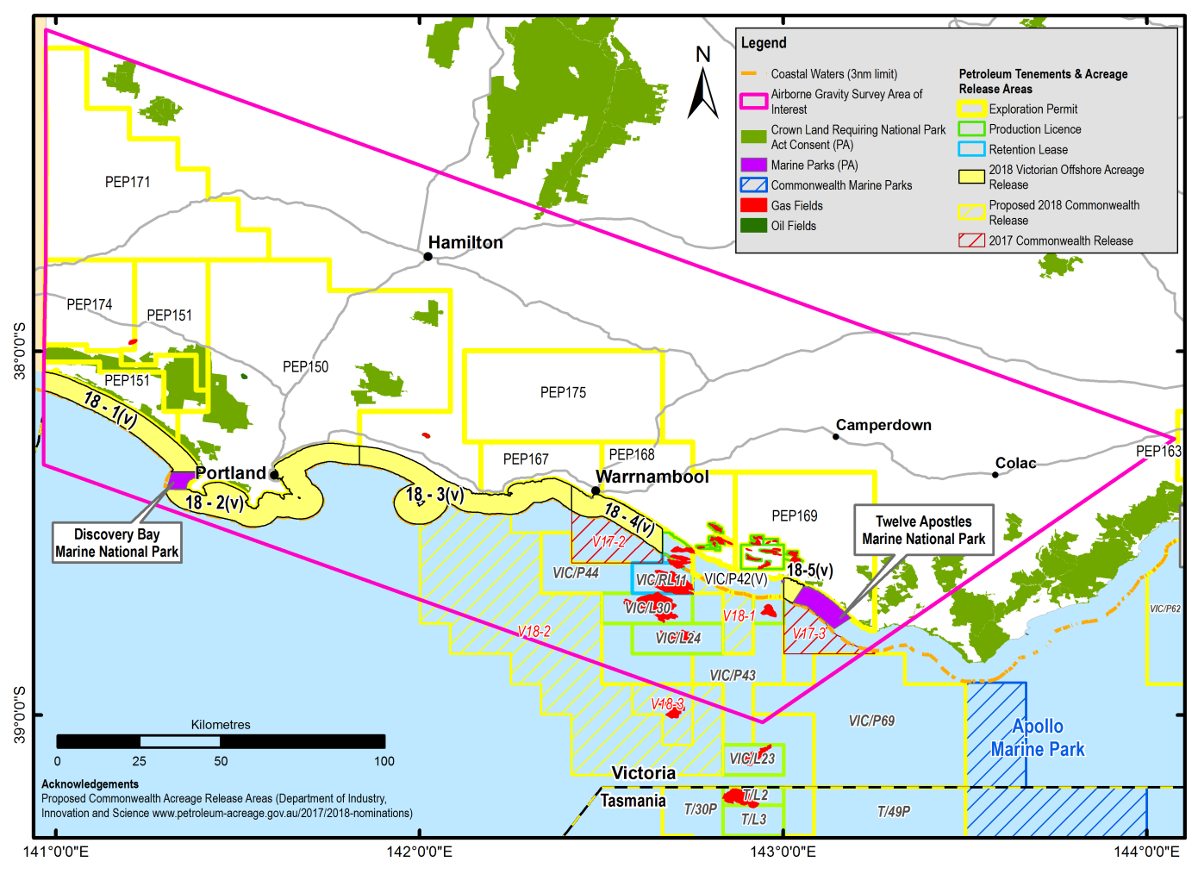
Figure 1 Location of the 2018 offshore petroleum acreage release in the Otway Basin

Victorian Gas Program
The Victorian State Government has allocated $42.5 million to the Geological Survey of Victoria (GSV) to deliver the Victorian Gas Program, which includes actions to support commercial exploration for further discoveries of gas off Victoria’s coast.
The Victorian Gas Program (VGP), which is currently underway until 2020, will deliver a comprehensive program of geoscience and environmental research and related activities, including community engagement, resource planning and regulatory improvements for onshore conventional gas, offshore gas and underground gas storage. It will assess Victoria’s gas prospectivity and issues associated with gas exploration and development to inform future decisions made by the Victorian Government.
The objectives of the VGP are:
Delivering extensive scientific, technical and environmental studies on the risks, benefits and impacts of onshore conventional gas while the moratorium is in place until 30 June 2020. As there are no proved and probable onshore gas reserves in Victoria, the geoscience investigations into onshore conventional gas are designed to provide an evidence-based resource estimate.
Supporting commercial exploration for further discoveries of gas off Victoria’s coast to help increase gas supply. This work will acquire new geoscientific information to identify prospective areas in the offshore part of the Otway Basin.
Investigating the opportunities for further underground gas storage in the onshore Otway Basin to boost the security of gas supplies and to mitigate short-term price peaks, particularly during any interruptions in the gas supply system.
Supporting the work programs for onshore conventional gas and offshore gas, including resource planning, regulatory improvements and a comprehensive engagement program for farmers, industry, local government and regional communities.
The studies will be undertaken by scientists and other professionals from GSV and will focus on the Otway Basin in south west Victoria and the Gippsland Basin in south east Victoria. All study results will be made publicly available.

Offshore gas geoscience program
The 2018 acreage release is part of the offshore gas geoscience program within the VGP.
The offshore gas geoscience program will support the commercial exploration for further gas discoveries off the Victorian coast. This work will acquire new geoscientific information to identify areas off the Victorian coast, specifically in the Otway Basin, that are likely to be prospective for offshore gas.
The offshore gas geoscience program will improve the understanding of gas prospectivity through the acquisition of a new airborne gravity survey (Figure1 – pink polygon). The survey area of interest covers 30,000 square km of the Otway geological basin, including State onshore and offshore areas and Commonwealth waters. The airborne gravity survey aims to provide new data to better understand basin architecture, particularly in the three nautical mile zone where seismic data is limited.

Regional Geology

Tectonic setting
The Otway Basin is a northwest-southeast trending basin that extends for 500 km along the onshore and offshore parts of south-eastern Australia (Figure 2). It is a passive margin, rift basin (Brown et al., 2003) that formed during the break-up of southern and eastern Gondwana.
Rifting in the Late Jurassic-Early Cretaceous resulted in the development of grabens and half grabens of limited lateral extent (Krassay et al., 2004) and varying orientations (NW-SE in the onshore Otway Basin, E-W in the western and central Otway Basin, SW-NE in the eastern Otway Basin and Torquay Sub-basin, and N-S in the Shipwreck Trough) (Stacey et al., 2013). Up to 8 km of Otway Group continental and fluvio-lacustrine sediments were deposited in the Early Cretaceous depocentres.
Compressional inversion and uplift in the early Late Cretaceous separated the Torquay Sub-basin from the eastern Otway Basin and shifted the locus of extension offshore (Krassay et al., 2004). A thick sequence of Sherbrook Group fluvial, deltaic and shallow marine sediments was deposited in the Late Cretaceous depocentres, including the Shipwreck Trough.
Rifting in the Otway Basin “culminated at the end of the Cretaceous and is marked by a regional intra-Maastrichtian unconformity” (Holford et al, 2014). Krassay et al (2004) have interpreted this to represent the time when the continental plates of Australia and Antarctica separated, although the first evidence of oceanic crust in the Otway Basin does not appear until the middle Eocene (Norvick & Smith, 2001).
The intra-Maastrichtian unconformity was followed by basin margin subsidence and the deposition of the transgressive siliciclastic Wangerrip Group, which reaches a maximum thickness of more than 1200 m in the Portland Trough (Holdgate & Gallagher, 2003). Local inversion in the middle Eocene resulted in the intra-Lutetian unconformity, which separates the Wangerrip Group from the overlying prograding marine clastics and carbonates of the Nirranda Group (Holdgate & Gallagher, 2003; Krassay et al., 2004). The Nirranda Group has a maximum thickness of about 200 m in the Portland Trough and the Port Campbell Embayment (Holdgate & Gallagher, 2003). The marine marls and limestones of the Heytesbury Group are separated by two regional unconformities from the underlying Nirranda Group and the overlying thin Pliocene to Pleistocene shallow marine sediments and basalts of the Bridgewater Bay Group.

Stratigraphy
The mostly sedimentary rock units found both at the surface and in the subsurface across the Otway region have been described to various extents. Based on lithological variations in the Otway Basin, six main sequences are described: the Otway Group, Sherbrook Group, Wangerrip Group, Nirranda Group, Heytesbury Group and Bridgewater Bay Group (Figure 3).

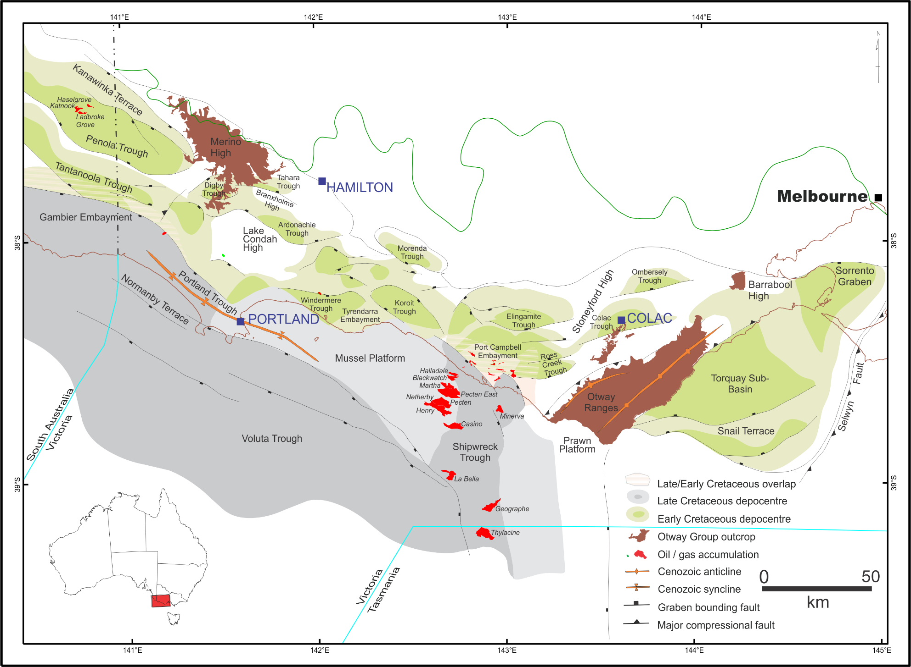
Figure 2 Depocentres of the Otway Basin showing the distribution of gas fields

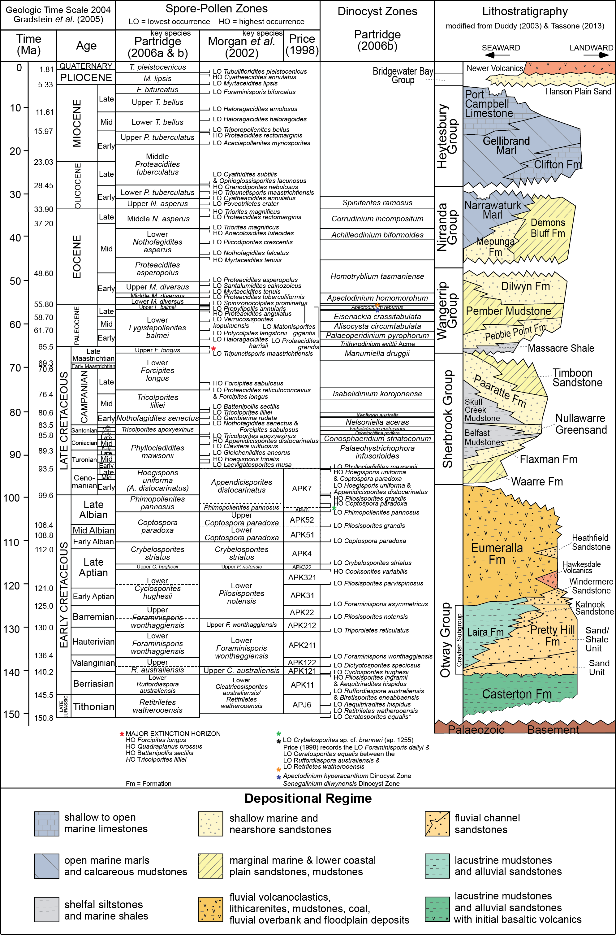
Figure 3 Stratigraphy of the Victorian Otway Basin

Casterton Formation
The Casterton Formation was deposited during the latest Jurassic to Early Cretaceous in half-grabens related to rifting between Australia and Antarctica (Mitchell et al., 1997). The Casterton Formation type section is found between 2220 mKB and 2450 mKB in Casterton-1 (Morton et al., 1994). It “consists of interbedded carbonaceous shale, with minor feldspathic sandstone and siltstone and basaltic volcanics” (Morton et al., 1994).

Otway Group
There are some notable discrepancies between the accepted stratigraphic nomenclature for the Otway Group as adopted for the South Australian portion of Otway Basin versus that for Victoria. For instance, the status of the Group is raised to Supergroup in South Australia. Units such as the Katnook Sandstone and the Laira Formation are identified within the Crayfish Group in South Australia, whereas these have not been identified in Victoria (Parker, 1995).

Pretty Hill Formation
The Pretty Hill Formation is the only lithostratigraphic unit from the Crayfish Subgroup that is identified in Victoria. The Pretty Hill Formation consists of sandstone, with varying proportions of interbedded siltstone, claystone and shale, which were deposited in fluvio-lacustrine and alluvial environments, although at the top of Moyne Falls-1 rare saline algae indicate brackish conditions (Morgan, 1997).
In the Penola Trough, the Pretty Hill Formation is subdivided into four informal members: the Pretty Hill sandstone, Sawpit sandstone, Sawpit shale and McEachern sandstone (Lovibond et al., 1995) but the application of this division is questioned (Guzel, 2015).

Laira Formation
The Laira Formation consists of light grey to green siltstone and claystone interbedded with fine grained sandstone deposited in fluvial floodplain to shallow lacustrine environments (Boult et al, 2002) and was first defined by Morton (1990) from the type section encountered in Katnook-2 in South Australia. It is most well developed in the Penola Trough and gives way to the Pretty Hill Formation in the eastern part of the basin. Parker (1995) identified the Laira Formation from several wells in the Victorian section of the Penola Trough, but pointed out that the stratigraphic units described in Early Cretaceous half grabens are often restricted to these depocentres.

Eumeralla Formation
The Eumeralla Formation is composed of medium to coarse grained fluvial channel sandstones interbedded with mudstone, fine sandstone and shale, including palaeosoils and coal seams that were deposited in levees and floodplains (Duddy, 2003). The sandstones and mudstones are quartz-poor, volcanogenic sediments derived largely from the products of contemporaneous explosive dacitic volcanism (Duddy, 2003).
Outcrops of the Eumeralla Formation occur in the Otway Ranges, Barrabool High and Merino High. In the Victorian Otway Basin, the Windermere and Heathfield sandstones and the Killara Coal Measures are recognised as distinct units within the Eumeralla Formation.

Windermere Sandstone
The Windermere Sandstone is composed of interbedded sandstones and shales and is 105 m thick at its type section in Windermere-2. The Windermere Sandstone is considered to occur at the base of the Eumeralla Formation and was deposited in the base of troughs; usually upon an unconformable base, due to a “significant change in depositional and structural style” (Morton et al., 1994).
The gas discovered in Katnook-1 in South Australia was reservoired in the Windermere Sandstone, although the reservoir was reported to be of poor quality (Kopsen & Scholefield, 1990). In Victoria, oil in the Windermere Sandstone is considered to be sourced from a coaly lithology in the Crayfish Subgroup – an Austral-1 source (Boreham et al., 2004).

Heathfield Sandstone
The Heathfield Sandstone is a distinct quartzose sandstone and is recognised in a number of wells in the Penola Trough (Duddy, 2003). It is represented by poorly consolidated quartz sand between 1254.3 and 1263.1 m in the well Heathfield-1 (Brown, 1965). Whilst the Heathfield Sandstone probably reflects limited accumulations derived from local basement sources its widespread distribution in the Albian suggests a common origin, perhaps related to a period of uplift and erosion of the northern margin to the Penola Trough that rejuvenated the supply of quartzose detritus and possibly during “a lull in local contemporaneous volcanism” (Duddy, 2003).
Distinct sandstones of the same age have also been identified on the Merino High, on the central northern margin of the Otway Basin, in the Ross Creek Trough, in the Windermere Trough, and in Fergusons Hill-1, between the Ross Creek Trough and the Otway Ranges, and in North Eumeralla-1, Eumeralla-1 and Killara-1, north of the Windermere Trough (Guzel, 2015).

Killara Coal Measures
The black coals of the Early Cretaceous Eumeralla Formation have been intersected by petroleum exploration companies for many decades. Following the drilling of Killara-1, Buckingham (1992) first applied the informal name - the ‘Killara Coals’ to describe the coal seams found at the base of the Eumeralla Formation. The Killara Coal Measures are therefore not a formal lithostratigraphic unit and, whilst coal beds may occur in the “Basal Eumeralla Formation”, they also occur elsewhere in the Eumeralla Formation (Guzel, 2015). Coals of the same age (as found in Killara-1) from the base of the Eumeralla Formation are found in Lindon-1 on the Lake Condah High, Stoneyford-1 on the Stoneyford High, and possibly in Hawkesdale-1 on the central northern margin of the Otway Basin (Wakelin-King & Menpes, 2007). The coals of the Eumeralla Formation are not laterally extensive and as a consequence, are difficult to correlate.

Sherbrook Group
The siliciclastic Sherbrook Group was derived largely from eroded Palaeozoic basement and the Eumeralla Formation (Duddy, 2003). The nature of the contact between the Sherbrook and Otway groups is variable – from conformable or mildly disconformable in the Late Cretaceous depocentres to massively unconformable where the Sherbrook Group wedges out onto the mid-Cretaceous inversion structures (Duddy, 2003). As a consequence, the Sherbrook Group is absent from the northern margin of the Otway Basin, except in Heathfield-1 in the Penola Trough, where it is only 140.6 m thick (Guzel, 2015).

Waarre Formation
The Waarre Formation (previously the Waarre Sandstone of Bock & Glenie, 1965) is the basal unit of the Sherbrook Group. The unit is characterised by clean quartzose sandstones, conglomerates and minor siltstones and shales of non-marine origin. The type section is identified in the petroleum well Port Campbell-2 (Morton et al., 1994). Commonly in the Port Campbell Embayment wells, the Waarre Formation is divided into units A, B and C on the basis of lithological variations (Buffin, 1989).

Flaxman Formation
The Flaxman Formation is typically an interbedded sand/shale unit. It is composed of dark grey silty mudstone and fine grained grey brown sandstones, with distinctive ‘floating quartz’ from coarse sand to pebbles, common microplankton, and irregular glauconite, which becomes more common along with rare arenaceous and calcareous foraminifera towards the top (Duddy, 2003). It is considered that the Flaxman Formation was deposited in a lower delta plain environment (Boyd & Gallagher, 2001).

Belfast Mudstone
The Belfast Mudstone, in the middle of the Sherbrook Group, is a “remarkably uniform pyritic marine shale” (Duddy, 2003). In Victoria, the Belfast Mudstone represents a middle to outer shelf, open marine prodelta environment (Boyd & Gallagher, 2001) and forms a major regional seal for prospective hydrocarbon accumulations in sandstone reservoirs in the Waarre and Flaxman Formations (Duddy, 2003). It is conformable with, and partly a facies variant of, the underlying Flaxman Formation and the overlying Paaratte Formation, and includes a “significant contribution of detritus from reworking of the volcanogenic sediments of the Eumeralla Formation” (Duddy, 2003).

Nullawarre Greensand
The Nullawarre Greensand, also originally described as part of the Paaratte Formation, is a distinctive green, glauconitic, fine to coarse grained sandstone. It has been intersected in wells and bores in and around the Port Campbell Embayment, Tyrendarra Embayment and Mussel Platform (Woollands & Wong, 2001).

Skull Creek Mudstone
The Skull Creek Mudstone exists in the onshore and nearshore areas of the Port Campbell Embayment as a thin unit, thickening substantially in the offshore towards the outer shelf. Initially described as a member of the Paaratte Formation, it was proposed as a formation by Partridge (2001) who assigned it to Early Campanian zones in the onshore, ranging to Late Campanian offshore.

Paaratte Formation
The Paaratte Formation consists of quartzose, fine to coarse grained, laminated, sometimes bioturbated, cross-bedded, greenish sandstones interbedded with mudstone and occasional coals (Duddy, 2003) that were mainly deposited in a marine lower-upper deltaic environment (Boyd & Gallagher, 2001).

Timboon Sandstone
The Timboon Sandstone, at the top of the Sherbrook Group, is characterised by fine to very coarse sandstones with siltstone/mudstone interbeds with occasional leaf fossils and represents the onset of fluvial terrestrial interdistributary deposition in the Otway Basin (Boyd & Gallagher, 2001). The culmination of rifting in the Otway Basin is marked by a regional intra-Maastrichtian unconformity (Holford et al., 2014) at the top of the Sherbrook Group.

Wangerrip Group
The transgressive siliciclastic Wangerrip Group consists of the Cretaceous/Tertiary Boundary Shale (the Massacre Shale), the Pebble Point Formation, Pember Mudstone and the Dilwyn Formation. Local inversion in the middle Eocene resulted in an intra-Lutetian unconformity that separates the Wangerrip Group from the overlying Nirranda Group (Holdgate & Gallagher, 2003; Krassay et al., 2004); whilst an intra-Maastrichtian unconformity, associated with the culmination of rifting in the Otway Basin (Holford et al., 2014), separates it from the underlying Sherbrook Group.

Massacre Shale
The Massacre Shale occurs as a thin shale unit straddling the Cretaceous-Tertiary boundary and was deposited in a widespread transgressive event. The formation has a distinctive log signature and pinches out in the offshore section of the basin (Partridge, 2001).

Pebble Point Formation
The Pebble Point Formation consists of ferruginous (mainly quartz) sandstone, grit and conglomerate with less common fossiliferous beds (Holdgate & Gallagher, 2003). In the Gambier Embayment oolitic and pelletal sandstone and claystones display a complex mineralogy ranging from chlorite to glauconite with secondary replacement by siderite and phosphate (Holdgate & Gallagher, 2003). Macro and microfossil content indicate a dominantly transgressive shallow marine environment and an early to middle Paleocene age (Holdgate & Gallagher, 2003).

Pember Mudstone
The Pember Mudstone consists of tan to grey siltstones, mudstones and shales, usually pyritic, carbonaceous and micaceous, and locally glauconitic. Carbonate-cemented sandstones are more common in the upper part of the formation, as are rare arenaceous foraminifera (Holdgate & Gallagher, 2003). The Pember Mudstone represents a delta-front and prodelta environment. Although it usually conformably overlies the Pebble Point Formation (Holdgate & Gallagher, 2003), in places there is evidence of a disconformable relationship (Tabassi & Davey, 1986; Keating, 1993) and in Greenslopes-1, north of the Windermere Trough, it is absent.

Dilwyn Formation
The Dilwyn Formation is transitional with the underlying Pember Mudstone and is characterised by sandstones predominating over shales and by transgressive-regressive repetitions of sandstone-siltstone claystone (Holdgate & Gallagher, 2003). The sandstones were deposited as distributary channels, and barriers and offshore bars associated with a delta-front environment, whilst the shales may include marine arenaceous and calcareous foraminifera (Holdgate & Gallagher, 2003). Brown coals are found in the Dilwyn Formation; such as those at Benwerrin that are considered Palaeocene in age (Gloe & Holdgate, 1991).

Nirranda Group
The marine Nirranda Group consists of the carbonate dominated Narrawaturk Marl, the mixed carbonate and clastic Mepunga Formation (Holdgate & Gallagher, 2003) and, northeast of the Port Campbell Embayment, the clastic Demons Bluff Formation (Tickell et al., 1992). An intra-Lutetian unconformity, due to local inversion in the middle Eocene, separates the Nirranda Group from the underlying Wangerrip Group (Holdgate & Gallagher, 2003; Krassay et al., 2004), and an early-late Oligocene regional unconformity occurs between the Nirranda Group and the overlying Heytesbury Group.

Mepunga Formation
The Mepunga Formation consists of coarse often pebbly, ferruginous, occasionally glauconitic sandstones, with sandstones and sandy limestones that are often dolomitic, glauconitic and ferruginous offshore and in the Portland Trough (Holdgate & Gallagher, 2003). The foraminiferal faunas indicate deposition in paralic high-energy shoreline environments in the north, to outer shelf marine environments in the south; whilst the preservation of restricted calcareous faunas and miliolinids indicates inner to mid-shelf marine environments in the eastern part of the basin (Holdgate & Gallagher, 2003).

Narrawaturk Marl
The Narrawaturk Marl consists of marly, sandy, ferruginous, glauconitic, occasionally dolomitic mudstone, occasionally cherty and dolomitic marl; some coarse ferruginous sandstone; sandy limestone and sandy marl; and, in the west, a dolomitic marly limestone (Holdgate & Gallagher, 2003). Based on planktonic foraminifera most of the Narrawaturk Marl is early Oligocene in age (Holdgate & Gallagher, 2003).

Clifton Formation
The Clifton Formation consists of sandy limestone, which may be dolomitic or contain thin horizons of phosphate and limonite nodules, limestone and, northeast of the Port Campbell Embayment, ferruginous sandy marl (Holdgate & Gallagher, 2003). The clastics in the sandy facies, deposited around the margin of the basin, were supplied by rivers to the north and east. The depositional environment transitions from paralic coastal environments in the north and east, to high-energy outer shelf environments, where clastic poor limestones are deposited, in the south and west (Holdgate & Gallagher, 2003).

Heytesbury Group
The marine Heytesbury Group consists of the carbonate-dominated Port Campbell Limestone and Gellibrand Marl, and the basal part-clastic, part-carbonate Clifton Formation (Holdgate & Gallagher, 2003). The base of the Heytesbury Group is marked by a disconformity (Holdgate & Gallagher, 2003), whilst at the top is an unconformity, which formed due to tectonic uplift and regression at the end of the Miocene (Holdgate & Gallagher, 2003).

Gellibrand Marl
The Gellibrand Marl has abundant planktonic foraminifera that indicate a middle Miocene to late Oligocene age (Holdgate & Gallagher, 2003). The marl was deposited in a low-energy inner shelf environment north of Port Campbell where there was clastic input; whilst an outer shelf environment was predominant around the Portland area (Holdgate & Gallagher, 2003). In the Gambier Embayment, more limestone-rich facies were deposited in shallower seas.

Port Campbell Limestone
The Port Campbell Limestone was deposited in outer shelf water depths during peak transgressions and at mid to inner shelf depths during regressions. The upper part of the Port Campbell Limestone records continuous sea level fall towards the end of the Miocene. Based on planktonic foraminifera it is late to early middle Miocene in age (Holdgate & Gallagher, 2003).

Bridgewater Bay Group
Following widespread tectonic uplift in the Pliocene (e.g. Dickinson et al., 2001), a sequence of relatively thin localised units was deposited during the Pliocene to Pleistocene. Some discrepancies exist in the nomenclature but named units include: the Whalers Bluff Formation, Werrikoo Limestone, Nelson Bay Formation, Dorodong Sands, Grange Burn Formation, Hanson Plain Sand, Moorabool Viaduct Formation and the Newer Volcanics (Holdgate & Gallagher, 2003; Cupper et al., 2003).

Petroleum systems
The hydrocarbons of the Otway Basin belong to the Austral petroleum supersystem. The Austral petroleum supersystem, as defined by Bradshaw (1993) and Summons et al. (1998), on the basis of the age of the source rocks and their common tectonic history, includes all southern Australian sedimentary basins. As such, the hydrocarbons of the Otway Basin are assigned to the Austral supersystem.
The Austral petroleum supersystem is further divided into three sub-systems (Edwards et al., 1999); Austral-1, -2 and -3. The three-fold subdivision recognizes the difference in geochemical characteristics of liquid hydrocarbons encountered in petroleum exploration wells. The main difference between the liquid hydrocarbons is related to the different stratigraphic age and depositional environment of the source rocks that form part of each subsystem.
Most Otway Basin hydrocarbon discoveries belong to the Austral-1 and Austral-2 petroleum systems (Edwards et al., 1999). The Waarre Formation reservoirs, together with the source rocks of the Eumeralla Formation, and overlying Belfast Mudstone seal units comprise the key elements of the Austral-2 petroleum system.

Exploration and production history
Exploration for oil began prior to 1900 in the South Australian portion of the onshore Otway Basin but it was not until the 1920s that wells were sunk for that purpose in Victoria. Some of those initial wells were drilled around Torquay and Anglesea with no success. A small number of companies searched again a decade later around areas such as Geelong. Little exploration had occurred until gas was discovered in 1959 in the Waarre Formation in the Port Campbell-1 well near the Port Campbell township (Woollands & Wong, 2001).
With more holes drilled and subsequent resolution of the deeper geology, further drilling in the 1960s targeted the Waarre reservoir sands in seismically defined structures, and tested the underlying Otway Group (e.g. Bain, 1961). Wells were drilled from one end of the basin to the other – from Casterton-1 in the Penola Trough to Hindhaugh Creek-1 on the Bellarine Peninsula. In the late 1960s, the first wells were drilled offshore by Esso and Shell – including Nautilus, Nerita, Mussel, Pecten and Voluta. Hoping to find an analogue for the Gippsland Basin, their efforts were largely unrewarded with only minor gas shows in Pecten-1.
After a period of limited drilling and seismic acquisition, Beach Petroleum discovered gas in North Paaratte-1 in 1980, only 3 km NE of Port Campbell -1 which had been drilled 20 years before. Encouraged by the gas find, onshore permits were taken out offshore by Esso, Phillips and Ultramar. More small onshore gas discoveries were later made by Beach Petroleum in 1981 at Grumby-1 and Wallaby Creek-1.
In 1986, gas fields in the Port Campbell area went into production, supplying the regional centres of Portland and Warrnambool with gas. For 20 years between 1986 and 2006, two facilities, North Paaratte and Heytesbury, processed gas from the onshore fields, until the fields were largely depleted and production ceased.
BHPP took out three permits in the offshore area and drilled two discovery wells, Minerva-1 in 1993 and La Bella-1 in 1994, as well as two dry wells. After drilling an additional three wells, which recorded a few gas shows, BHPP relinquished the permits in 1997-98, retaining only the Minerva and La Bella fields.
In 1999, a gas pipeline was completed between the Port Campbell onshore fields and Lara to link to the Victorian pipeline network. The construction of this pipeline (and the deregulation and privatisation of the Victorian gas industry) provided for the development of Australia's first commercial underground gas storage facility at Iona, near Port Campbell. Completion of the pipeline also facilitated the development of the Minerva gas field with first gas in January 2005 and other smaller fields connected over time. It also encouraged further exploration and development with Woodside Petroleum discovering the Thylacine/Geographe offshore gas fields in 1999/2000 and producing first gas in September 2007. Gas was processed through the Woodside operated Otway Gas Plant. The same plant still services those fields today but is owned by Beach Energy.
In 2005, Halladale-1 was the first well to be drilled in Victorian State Waters in the Otway Basin. Halladale-1 was a vertical well with three side tracks, designed to test two structures mapped from the Antares 3D seismic. The Halladale gas field, discovered by Origin Energy, lies about five km offshore.
Between September 2014 and June 2015, Origin Energy undertook a three-well drilling campaign from an onshore well pad located on the coast near Peterborough. Extended-reach wells were drilled to evaluate the Speculant and Halladale prospects located offshore in Victorian State Waters.
The Halladale and Speculant gas fields were brought into production in August 2016, boosting production at the Otway Gas Plant by 80 TJ/d. Origin Energy’s June 2017 reserves report showed that the project had 2P gas reserves of 37 PJ. Contingent (2C) gas resources in the project area were estimated to be 29 PJ. (Origin Energy, 2017).
Onshore, in the Port Campbell Embayment, gas remains in place in the Grumby and Langley fields due to the high CO2 content – 53% and 66% respectively (Woollands & Wong, 2001); whilst methane remains in place in the Lavers Field. Current onshore activities comprise gas storage at the Iona Gas Plant and minor CO2 production at Boggy Creek.
In addition, O’Brien & Thomas (2007) estimated that the Victorian Otway Basin could contain between 1.8 and 3.6 trillion cubic feet of undiscovered conventional gas, although this calculation included both onshore and offshore areas in State and Commonwealth waters.

Acreage release areas

18-1(v)
Block 18-1(v) contains parts of 12 graticular blocks and covers an area of 258 km² (Figure 4). The acreage release area lies approximately 350 km WSW of Melbourne and the port city of Portland is located 20 km to the east.
Block 18-1(v) is located to the south of the Mussel-Tartwaup Fault zone over the early Tertiary depocentre of the Portland Trough and underlying Late Cretaceous Voluta Trough. Although no wells have been drilled in 18-1(v), nearby petroleum exploration wells include Fermat-1, Normamby-1 and Discovery Bay-1 in offshore Commonwealth Waters. Onshore, geological control is provided by wells such as Glenelg-1 (aka Nelson Bore) and deep groundwater bores including Kentbruck-3, Mouzie-1 and Warrain-7. Although none of the onshore wells in the area adjacent to 18-1(v) penetrate the base of the Sherbrook Group/top of the Otway Group. Glenelg-1, drilled onshore close to the South Australian border was a dry hole but only reached the Paaratte Formation, with a total well depth of 2226 m.
The two wells that are located closest to 18-1(v) offshore, Normanby-1 (1986) and Fermat-1 (2009), both reached and tested the Waarre Formation at total depths of 3308 and 3586 m and reported a weak gas show and oil/gas shows respectively. Fermat-1 tested a stratigraphic trap on the Normanby High (Beach Petroleum, 2009), whilst Normanby-1 tested a regional NW-SE trending closure. The Waarre Formation had good to moderate porosity in both wells (i.e. 11-19%), with 224 m of the formation intersected in Normanby-1. Fermat-1 MDT samples recovered water with minor associated gas. Subsequent geochemical analysis suggests that the fluorescence was from in situ generation at relatively low levels of thermal maturity (equivalent Ro of 0.64%). Minor gas shows and a small amount of gas from an RFT at 3178 m were recorded from Normanby-1 (Templeton & Peattie, 1986).
Post well analysis for Fermat-1 concluded that a targeted AVO anomaly was a false positive for the presence of gas, whereas failure in Normanby-1 was attributed to the absence of charge or possible cross-fault leaking at the crest of the structure.
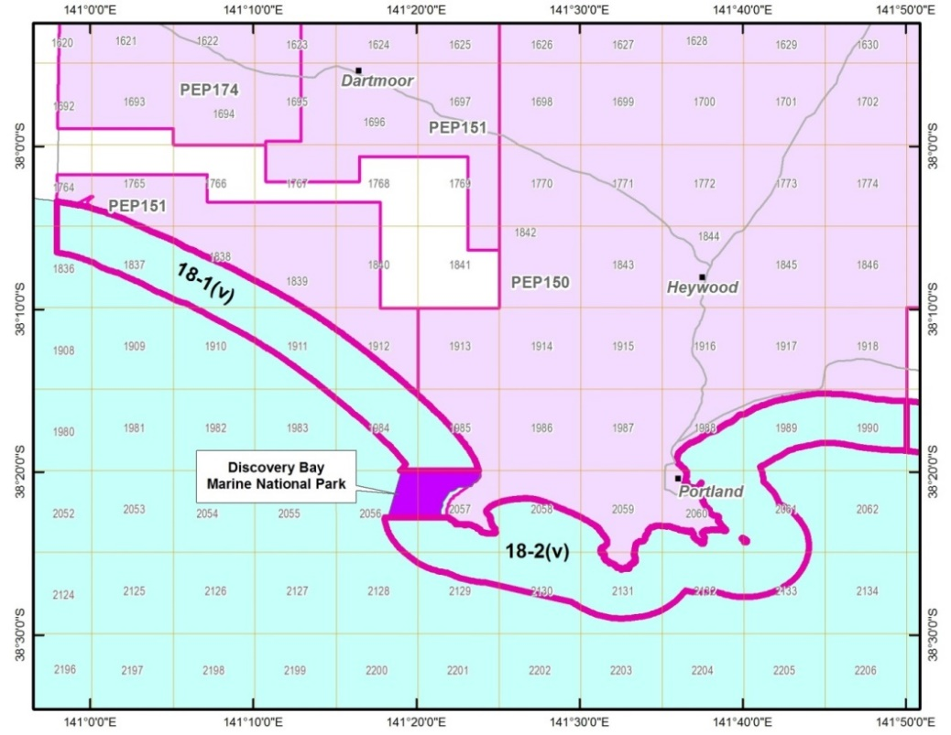
Figure 4 Location of areas 18-1(v) and 18-2(v) and graticular blocks

18-2(v)
Block 18-2(v) contains parts of 15 graticular blocks and covers an area of 439 km² (Figure 5). The town of Portland is located in the centre of the release area on the coast. 18-2(v) is also situated over the Portland and Voluta troughs.
Onshore, two petroleum wells drilled adjacent to the coast near Portland are of limited value. Mirams-1 and Portland North-1 were drilled in the early 1940s, reaching down no further than the Nirranda Group at 382 and 864 m respectively. Nearby groundwater bores Narrawong-13 and -15, reach the Pember Mudstone and the Paaratte Formation at 1713 and 1905 m. As is the case near 18-1(v), there are no intersections of the base of the Sherbrook Group or top of the Otway Group from onshore drilling.
Offshore, Voluta-1 and Callister-1 both recorded shows in the lower Sherbrook Group. Voluta-1, drilled by Shell in 1967, was the first offshore well drilled in the western Otway Basin, testing an anticlinal closure (the Bridgewater Bay High) with the Waarre Formation being the primary reservoir objective (Shell, 1968). The Belfast Mudstone proved to be substantially thicker than expected, resulting in the deepening of the well by some 1100 m to reach the Waarre Formation. Minor gas shows were recorded in the Belfast Formation which did not warrant further evaluation and the well was abandoned at 3974 m.
Located approximately 18 km to the southeast of Voluta-1, the Callister-1 well was drilled by Santos in 2004 reaching TD at 3914 m in the Waarre A (Subramanian, 2005). The well tested the culmination of a northwest to southeast oriented horst block at the south-eastern end of the Bridgewater Bay High. Callister-1 was designed to test the unproven Austral 3 Belfast-Paaratte gas play with the Austral 2 Waarre play forming a secondary objective. Geochemical analysis of samples from the Belfast Mudstone in Voluta-1 demonstrated the presence of mature gas-prone source rock within the section. Although the intra-Paaratte Formation and Nullawarre Greensand were intersected, neither unit had hydrocarbon shows. The Waarre C was intersected with minor moderately bright fluorescence seen at the top of the formation with 1.5 m of net pay (Φ; 11.8%) in the Waarre C and 3.5 m net pay (Φ: 11%) in the Waarre A. The well was plugged and abandoned.

18-3(v)
Block 18-3(v) contains parts of 15 graticular blocks and covers an area of 443 km² (Figure 5). The township of Port Fairy is adjacent to block 18-3(v) on the coast and is approximately 248 km from Melbourne.
Although no wells have been drilled in block 18(-3(v), a number of petroleum wells have tested plays in the Windermere and Koroit troughs and the Tyrendarra Embayment onshore near the coast. Toward the eastern margin of 18-3(v), Port Fairy-1 (2002) and Killarney EPRL-1 (2004), both drilled by Essential Petroleum, targeted the Waarre Formation. Port Fairy-1 was drilled to test the target formation in a faulted anticlinal closure in the hanging-wall of the WNW-ESE trending Tyrendarra Fault. Killarney EPRL-1, was drilled 4 km to the east of Port Fairy-1 in a combined structural and stratigraphic trap. The structural trap was a three-way closure against an en-echelon NW-SE trending fault in the hanging-wall of the Tyrendarra Fault.
In both wells the Waarre Formation was absent. However, in Port Fairy-1, good gas shows were observed in poor quality fine grained glauconitic sandstones in the Flaxman Formation and in the underlying uppermost Eumeralla Formation. The well was cased and tested the Flaxman Formation to recover gas to surface. Swabbing produced samples of 52°API oil and a static pressure survey indicated a 15-metre oil column in the production tubing. The Paaratte and Eumeralla formations were also tested with the former producing fresh water at a stabilised rate of 240 bpd (Essential Petroleum, 2003). The well was subsequently plugged below the Belfast Mudstone and converted into a water well (Essential Petroleum, 2006).
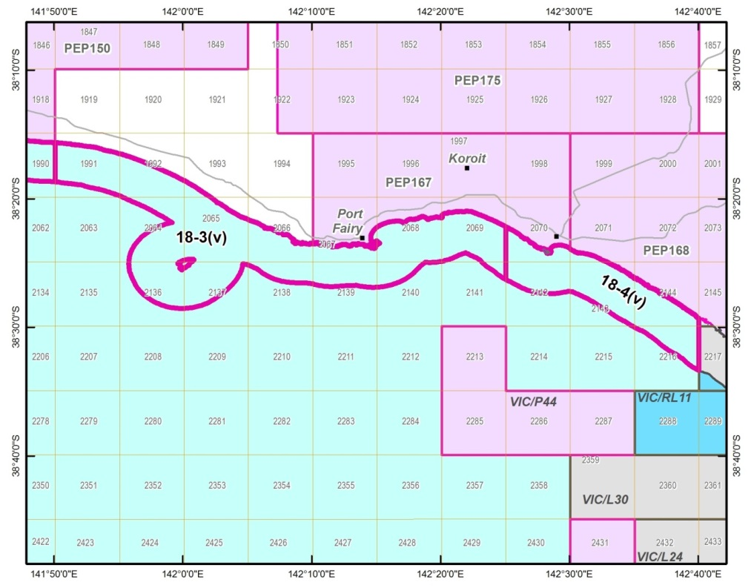
Figure 5 Location of areas 18-3(v) and 18-4(v) and graticular blocks
Killarney EPRL-1 intersected good quality reservoir sandstones in the Paaratte and Dilwyn formations and the Nullawarre Greensand, however the Flaxman and Waarre formations had generally poor to moderate porosity. Minor gas shows were recorded in the Belfast Mudstone and deeper units, however log analysis and pressure data confirmed all reservoirs were water-bearing. No oil shows were observed and the well was plugged and abandoned.
Windermere wells -1, -2 and -3, were drilled to test the Windermere prospect initially recognised on 2D seismic data acquired in 1985, and located toward the northwest of 18-3(v). The structure is a broad anticline in the hanging-wall of a major east-west trending fault, downthrown to the south. Strike-slip movement along this fault during the Late Tertiary resulted in minor inversion of the younger stratigraphy.
Windermere-1 was drilled by Minora Resources in 1987 with the primary objective of evaluating the Pebble Point Formation. Secondary reservoir objectives were identified in the Eumeralla Formation and, more speculatively, an equivalent of the Waarre Formation. Although the Heathfield Member within the Eumeralla Formation was recognised as a possible objective, due to poor reservoir characteristics in nearby wells, the original drilling program terminated the well above this unit. During drilling of the Tertiary section, background gas was very low but the increasing strength and richness of the gas shows below the top of the Belfast Mudstone resulted in a decision to deepen the well to evaluate the Heathfield Member. Dull yellow fluorescence with poor crush cut was observed at the top of a tuffaceous sand unit at the base of the Heathfield Member (1805 - 1810m). Subsequent open-hole drill stem tests of this interval recovered 40.9° API waxy oil, however cased-hole testing only recovered formation water with traces of oil. Whilst it is possible that the well depleted during the test, post-drill mapping suggested that the well was in a transition zone close to an oil-water contact (Minora Resources, 1988).
Windermere-2 (1989) was drilled at a location 1 km southeast of the first well to further evaluate the Heathfield Member. Secondary objectives were the deeper sandstones at the base of the Eumeralla Formation and unspecified Crayfish Group reservoirs (equivalents of the Pretty Hill Formation). Placement of the well benefitted from additional 2D seismic acquired in 1988, which allowed more detailed mapping of the faults in the Lower Cretaceous section. The Heathfield Member was devoid of hydrocarbon shows, however there were minor gas shows in deeper sands in the Eumeralla Formation (subsequently named the Windermere Member) were sufficient encouragement to run an open-hole drill stem test, which recovered traces of oil and gas-cut water. The Windermere Member was 300m low to prognosis as the mapped seismic reflection was found to be the top of the overlying Eumeralla coals (Killara Coals equivalent). Analysis of the oils recovered from the two wells show that they are both derived from terrestrial plant matter but have different thermal maturity. Detailed biomarker geochemistry suggests two different sources within the Lower Cretaceous and it is possible that these are coals at different stratigraphic levels within the Eumeralla Formation (Minora Resources, 1989).
Windermere-3, located 114 m north of Windermere-1, was drilled in 2011 with a primary objective of evaluating the Heathfield Member in a small up-thrown fault compartment. No significant shows were encountered during drilling other than indications of residual hydrocarbons in the Heathfield Member. The absence of hydrocarbons was attributed to very low permeability, preventing lateral migration into the Heathfield Member reservoir. An integrated review of the results from the three Windermere wells suggested that the oil seen in Windermere-1 was related to migration within the fault at the top of the unit in that well (Bass Strait Oil, 2012).

18-4(v)
Block 18-4(v) contains parts of 7 graticular blocks and covers an area of 153 km² (Figure 6).
Although no petroleum wells have been drilled in 18-4(v) or in the adjacent onshore area, several deep groundwater bores were drilled in the 1960s; some near Warrnambool (Wangoom-2 and -6) and Mepunga-9 and -10 at the eastern margin of the block. All of these boreholes intersect the Eumeralla Formation, with the Waarre Formation absent.
The eastern extremity of block 18-4(v) is adjacent to the Halladale and Speculant gas fields in VIC/P42(v) at the margin of the Shipwreck Trough/Port Campbell Embayment/Tyrendarra Embayment.
Halladale-1 (2005) was the first well to be drilled in Victorian State Waters in the Otway Basin. The well was designed to test two separate Waarre Formation Unit C structures with anomalous AVO mapped on the Antares 3D seismic survey. Halladale-1 comprises a vertical well drilled to 833m with three sidetracks.
Halladale-1 DW1 evaluated an E-W trending fault-dependant closure with termed ‘Black Watch’ and was directionally drilled towards the SSW. Good gas shows were recorded in two separate sandstone units within the Nullawarre Greensand. After dropping back to background levels in the Belfast Mudstone, gas readings began to gradually increase in the Flaxman Formation before sharply increasing on penetrating the Waarre C. Interpretation of the wireline logs indicated 18.4m of net pay in the Waarre Formation Unit C with a further 1.3 m of net pay at the top of the Waarre Formation Unit A (thicknesses are not corrected to true vertical). Wireline pressure data indicated a common gas gradient in the two Waarre Formation sand units, with a gas-water contact at 1770mss in the Waarre Formation Unit A. A gas-water contact was not seen in the Waarre Formation Unit C, however aquifer pressures obtained from Halladale-1 DW3 sidetrack suggest that the gas-water contact in this unit is at 1776mss. Gas samples from the Waarre Formation Unit C were predominantly methane (87.8%) with a condensate-gas ratio of 12.6 bbls/MMscf. Pressure data also confirmed the presence of gas in the Nullawarre Greensand, which was not in pressure communication with the deeper Waarre Formation accumulation.
On completion of logging, the well was plugged-back and Halladale-1 DW2 kicked-off in a NNW direction to evaluate the Halladale structure, a WNW-ESE trending fault-dependant closure bounded to the SSW by a normal fault with down-throw to the south. No gas shows were encountered in the Nullawarre Greensand, however strong gas shows were again seen on entering the Waarre Formation Unit C. Hydrocarbons were not seen in Unit A. Log analysis identified 18.6 m of net pay in Unit C, which was confirmed with wireline pressure data but a gas-water contact could not be established. Gas samples recovered from the Waarre Formation Unit C were compositionally slightly drier than the Halladale-1 DW1 gas and a pressure difference of 10 psi indicates that the two accumulations are not in communication.
Halladale-1 DW3 was drilled as an appraisal well to determine the gas-water contact in the Waarre Formation Unit C by obtaining pressure data in the water leg. As expected, there were no significant gas shows in the well apart from a small kick at the top of Unit C.
Between September 2014 and June 2015, Origin Energy undertook a three-well drilling campaign from an onshore well pad located on the coast near Peterborough. These extended-reach wells were drilled to evaluate the Speculant and Halladale prospects located offshore in Victorian State Waters. The details of these wells are currently confidential, however the announcement of the Speculant-1 discovery noted that the well had tested a tilted fault block immediately north of the Halladale structure and encountered a gross gas column of approximately 145 m in the Waarre Formation Unit C. An appraisal well, Speculant-2, was drilled in 2015 and was also side-tracked (Speculant-2 ST1). The program also included an extended-reach appraisal/development well, Halladale-2.

18-5(v)
Block 18-5(v) contains parts of 2 graticular blocks and covers an area of 24 km² (Figure 6). The township of Port Campbell is located at the northwest corner of 18-5(v) and is approximately 193 km from Melbourne.
Block 18-5(v) is located between VIC/P42(v) to the west and the Twelve Apostles Marine National Park to the east-southeast. 18-5(v) is at the eastern margin of the Shipwreck Trough.
From the mid-point of 18-5(v), the Iona gas field is located 7 km to the north, and to the south, the Minerva gas field. Iona had an initial recoverable reserve of 19 BCF and the Minerva field, 558 In-place BCF (Mehin & Kamel, 2002). The depleted Iona field is now used for gas storage, whilst production from Minerva continues.
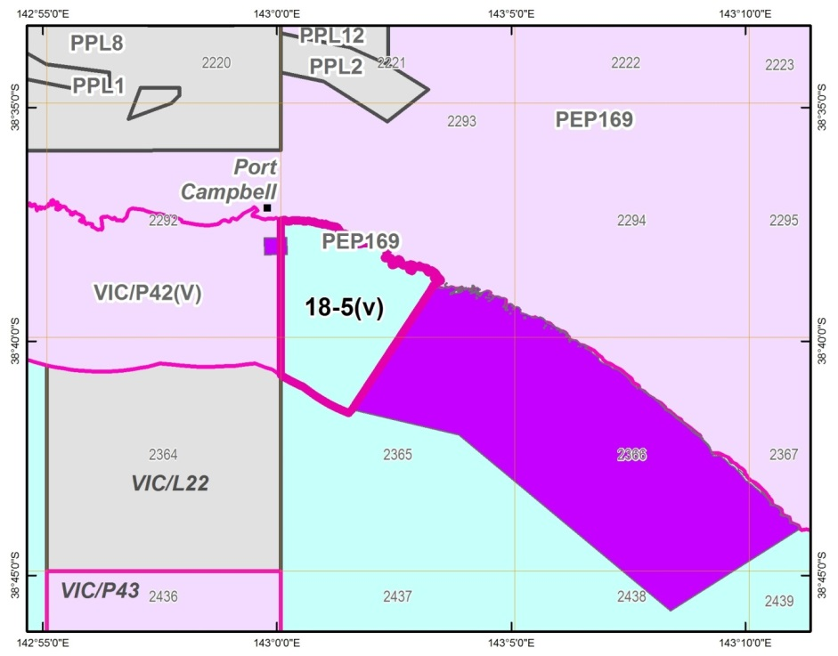
Figure 6 Location of area 18-5(v) and graticular blocks

Data and information
Access to online resources, direct client contact with geoscience information officers and physical resources such as the Werribee core library are available via GSV. Although some data and information for offshore Commonwealth Waters can be accessed via Victoria’s Earth Resources online portals as summarised below, most offshore resources are available via Geoscience Australia’s (GA’s National Offshore Petroleum Information Management System (NOPIMS) at http://www.ga.gov.au/nopims.

Data coverage and access
No wells have been drilled within the boundaries of areas 18-1(v) to 18-5(v). Limited seismic data has been acquired, with the majority of lines crossing into Victorian State coastal waters from offshore surveys in Commonwealth waters.
Well and borehole details from areas adjacent to the 2018 acreage release blocks are listed in Appendix 1 and details of the seismic surveys in Appendix 2.

Well data
Two online resources are available for well data access: GeoVic, GSV’s interactive mapping tool and external web links.
Through GeoVic http://earthresources.vic.gov.au/earth-resources/maps-reports-and-data/geovic, borehole or well names can be entered via the search function to display their location on the map of Victoria. Selecting the well/bore and using the information tool will provide access to data, such as lithology descriptions, stratigraphic information, and core/cuttings availability.
An external web link to Otway Basin petroleum wells, provides users with access to original files submitted to the Victorian Government by exploration companies. For each petroleum well listed on this page, summary well data including depths and formation tops and further links to original company submitted documents and data may be viewed/accessed via http://geology.data.vic.gov.au/energy/index.html.

Seismic surveys
The external web link http://geology.data.vic.gov.au/energy/index.html provides access to seismic surveys acquired in the Otway Basin. Some seismic survey reports and data can be downloaded directly from this site. For onshore data, explorers can contact GSV’s Petroleum Geoscience Information officers: terry.smith@ecodev.vic.gov.au and kusum.gunatillake@ecodev.vic.gov.au. For offshore, explorers are directed to access the NOPIMS site.

Geophysical surveys
Otway Basin acreage release areas are covered by high quality airborne magnetic data and very limited marine gravity data.
The airborne magnetic data was acquired in 1994 at 500 m line spacing for AGSO/GSV/SADME as the Offshore Otway Basin Survey. The location and extent of the survey is shown in GSV’s Digital Airborne Geophysical Survey Index, found as a layer in GeoVic. The index also contains brief survey metadata. The survey data and grids are available from GA’s Geophysical Archive Data Delivery System www.geoscience.gov.au/gadds.
Gravity data across the acreage release areas is almost non-existent. A few ship tracks pass through the areas and data was acquired by ships entering and leaving the Port of Portland. In deeper water, gravity data has been acquired along irregular, widely-spaced ship tracks and in association with 3D seismic surveys. Onshore, GSV and GA acquired ground gravity data along roads as part of a program to achieve semi-regional (1.5 km nominal station spacing) gravity coverage across Victoria. Detailed ground gravity data has been acquired along lines and grids by companies at station spacings ranging from 100 to 800 m. The onshore gravity survey data and grids are available from GA’s Geophysical Archive Data Delivery System www.geoscience.gov.au/gadds.
A gravity grid published in 2009 that combines offshore Free air gravity derived from satellite altimetry and onshore Bouguer gravity from onshore observations is available from GA at https://data.gov.au/dataset/gravity-anomaly-grid-of-the-australian-region-2009/resource/29994acd-8e66-4be0-aff9-6b53e478c428.
FitzGerald et al (2009) produced grids of levelled marine and ground gravity data as part of a project to calculate isostatic and decompensative corrections for Victoria and surrounds. The report and data package is available from GSV’s online store at http://earthresources.vic.gov.au/earth-resources/maps-reports-and-data. A gravity grid published in 2009 that combines offshore Freeair gravity derived from satellite altimetry and onshore Bouguer gravity from onshore observations is available from GA at https://data.gov.au/dataset/gravity-anomaly-grid-of-the-australian-region-2009/resource/29994acd-8e66-4be0-aff9-6b53e478c428.

Further information
A range of pre-competitive geoscience data is available from GSV. Reports and datasets are available for download from the Earth Resources online store http://earthresources.efirst.com.au/.
During the 1990s and into the 2000s, GSV undertook regional geoscience programs and acquired new data as part of the Victorian Initiative for Petroleum and Minerals (VIMP). As part of VIMP, petroleum exploration initiatives involved detailed studies of the regional geology of the Gippsland and Otway basins to assess the remaining hydrocarbon potential of these provinces. Numerous detailed technical studies were completed, covering the onshore and offshore Otway Basin. These reports can be accessed via the online store>Reports>Victorian Initiative for Minerals and Petroleum Reports.
As part of VIMP, the Petroleum Atlas of Victoria (Woollands & Wong, 2001) was compiled. The atlas contains a compilation of regional maps and images that summarise the geological and geophysical framework of the hydrocarbon occurrences, and provide an overview of oil and gas exploration in the State. The atlas was designed as an introductory guide to new explorers and a reference book for those with previous experience in these basins, as well as general interest in the petroleum geology of the State. This report is also available through the online store>Special Publications.
Report compilations including Otway Basin Published Papers (2001) and Victorian Petroleum Publications are also available (online store>Reports>Report compilations), along with various data compilations (online store>Digital Data>Petroleum Data Packages).

Special notes

Legislation
If a petroleum exploration permit is granted, applicants should be aware that before conducting any exploration activities they must be familiar with (and refer to) the following legislation:
Aboriginal Heritage Act 2006 (Vic)
Conservation, Forests and Lands Act 1987 (Vic)
Catchment and Land Protection Act 1994 (Vic)
Coastal Management Act 1995 (Vic)
Country Fire Authority Act 1958 (Vic)
Crown Land (Reserves) Act 1978 (Vic)
Dangerous Goods Act 1985 (Vic)
Environment Effects Act 1978 (Vic)
Environment Protection Act 1970 (Vic)
Environment Protection and Biodiversity Conservation Act 1999 (Cmlth)
Flora and Fauna Guarantee Act 1988 (Vic)
Heritage Act 2017 (Vic)
Heritage Rivers Act 1992 (Vic)
Historic Shipwrecks Act 1976 (Cmlth)
Marine Safety Act 2010 (Vic)
National Parks Act 1975 (Vic)
Native Title Act 1993 (Cmlth)
Occupational Health and Safety Act 2004 (Vic)
Offshore Petroleum and Greenhouse Gas Storage Act 2010 (Vic)
Petroleum Act 1998 (Vic)
Planning and Environment Act 1987 (Vic)
Pollution of Waters by Oil and Noxious Substances Act 1986 (Vic)
Traditional Owner Settlement Act 2010 (Vic)
Water Act 1989 (Vic)
Wildlife Act 1975 (Vic)

Environmental and coastal land considerations
The acreage release areas abut a number of marine and terrestrial parks and reserves, listed in Appendix 4.
The Department of Environment, Land, Water and Planning and Parks Victoria advise that any petroleum operations in areas managed under the National Parks Act 1975, such as Marine National Parks and Marine Sanctuaries, will need to conform to section 40 of that Act. Any directional drilling from onshore under a national park requires consent under that Act.
Land that is a coastal reserve is restricted Crown land under the Petroleum Act 1998, which requires consent for access.
Flora and fauna are protected under a range of legislation, including the Flora and Fauna Guarantee Act 1988 and the Wildlife Act 1975.
Cetaceans overwinter in water within the release areas. There are seal colonies at Cape Bridgewater and Lady Julia Percy Island, a gannet rookery on the tip of Point Danger and penguin colonies on Lady Julia Percy Island and Middle Island.
Any works will need to take into consideration the Victorian Coastal Strategy 2014 - the Victorian government’s policy commitment for coastal, estuarine and marine environments in Victoria.
Specific exploration activity, such as seismic surveying and drilling, require an acceptable environment management plan that may be reviewed by Environment Protection Authority Victoria, whose jurisdiction extends to State waters.
Any petroleum operation should be undertaken in such a way as to minimise deleterious environmental and social impacts. The Department of Environment, Land, Water and Planning and Parks Victoria request adequate and timely consultation to enable comprehensive consideration of any proposal.

Fisheries
The coastal waters are subject to active fishing activity including abalone and rock lobster. Finfish, wrasse, octopus, shark, pipi and scallop fisheries also occur in this area.
While Commonwealth licensed fisheries generally do not operate in Victorian waters, there are still Commonwealth fishers that may be indirectly impacted by exploration activities.
Fisheries are particularly concerned about the impacts of seismic, drilling muds and cuttings disposal, the cumulative impact of development in the region and the impact of infrastructure such as pipelines. In addition, there is a high chance that potential exploration may impact on nursery areas for school and gummy shark in coastal waters.
The Victorian Fisheries Authority’s policy Undertaking seismic surveys in Victorian Managed Waters provides information on their role assisting Victorian fishers and companies wishing to explore in Victorian waters.
Permit holders will be required to demonstrate effective consultation with fishers about the potential impacts of a proposed operation on fish stocks and fishing operations. Seafood Industry Victoria represents commercial fishing licence holders and the body representing Victorian recreational fishers is VRFish.
The South East Trawl Fishing Industry Association, the Southern Shark Industry Alliance and the Sustainable Shark Fishing Association should also be consulted.
It would also be desirable for permit holders to consult with relevant scientists to identify potential overlap and impacts on shark nursery areas.

Historic sites
Protected shipwrecks within the release areas are listed in Appendix 5 Historic sites.
A permit from Heritage Victoria is required to disturb or interfere with a protected shipwreck.
Any work that involves disturbance of the sea bed in the release areas would need to be surveyed for shipwreck remains prior to work commencing, so shipwrecks whose locations are not currently known can be protected.

Native Title and Aboriginal Heritage
Applicants should consider the consequences that the Native Title Act 1993 (NTA) and the Traditional Owner Settlement Act 2010 (Settlement Act) may have on their exploration rights and any future production rights.
Information on Native Title can be found at http://earthresources.vic.gov.au/earth-resources-regulation/licensing-and-approvals/minerals/get-a-licence/native-title-act.
Details about the native title determinations are available at the National Native Title Tribunal web site. Details about agreements recognising certain Traditional Owner rights under the Settlement Act are available at the Department of Justice.
The offshore release areas 18-1(v) and 18-2(v) contain areas for which native title has been determined for the Gunditjmara peoples. The relevant area is a corridor 100 m seaward of the mean low water mark.
The western portion of offshore release area 18-3(v) contains areas for which native title has been determined to be jointly held by the Gunditjmara and Eastern Maar peoples. The relevant area is a corridor 100 m seaward of the mean low water mark, including along the coast line of the Lady Julia Percy Island.
The eastern portion of offshore release area 18-3(v) and offshore release areas 18-4(v) and 18-5(v) contain areas over which the Eastern Maar have a registered native title claim, and are also subject to negotiations with the State of Victoria under the Settlement Act. The relevant area is a corridor 100 m seaward of the mean low water mark.
Native title processes apply to operations in the above areas. The Native Title Services Body representing the Gunditjmara and Eastern Maar Peoples is First Nations Legal and Research.
Before an exploration permit is granted, a ‘future act assessment’ will be undertaken in accordance with the NTA. This will determine what native title requirements need to be addressed prior to the grant of the permit.
Victoria’s Aboriginal cultural heritage is protected under the Aboriginal Heritage Act 2006. Information about the operation of the Act can be found at Aboriginal Victoria.
The release areas may contain regions of Cultural Heritage Sensitivity. The location of these regions are shown on Aboriginal Victoria’s online mapping tool called GeoVic available on the web site (https://applications.vic.gov.au/apps/achris/public/public-registry/home).
When planning exploration work, including any onshore activities on the coastline adjacent to the offshore release areas, it is recommended that a cultural heritage advisor is engaged to prepare a desktop study of known Aboriginal cultural heritage and areas likely to contain Aboriginal cultural heritage. A Cultural Heritage Management Plan may be required prior to requesting consent to commence an exploration work plan.
The Gunditj Mirring Traditional Owners Aboriginal Corporation RNTBC is the Registered Aboriginal Party (RAP) under the Aboriginal Heritage Act 2006 with respect to offshore release areas 18-1(v) and 18-2(v).
The Gunditj Mirring Traditional Owners Aboriginal Corporation RNTBC and the Eastern Maar Aboriginal Corporation RNTBC are jointly the RAP for the western portion of offshore release area 18-3(v).
Aboriginal Victoria is responsible for cultural heritage management in the eastern portion of offshore release area 18-3(v) and offshore release areas 18-4(v) and 18-5(v).

Marine safety
Maritime Safety Victoria regulates vessel operations within State waters. If a vessel’s operations are out of the ordinary and may pose a risk to mariners (as well as organisations who are undertaking activities and works such as drilling, surveys and diving operations), Maritime Safety Victoria will issue a Notices to Mariners, which provides advice on general navigation and safety issues.
Maritime Safety Victoria may also issue a Notice to prohibit the navigation and other movement of vessels in the vicinity where works are being carried out or regulate the position and the manner in which any vessel may anchor, or be secured, in the vicinity where works are being carried out.

References
BAIN, J. S., 1961. Well completion report Flaxmans No.1 Southwest Victoria. Frome-Broken Hill Company Pty Ltd. Report No. 7200-G-85. Unpublished Report. 86p.
BASS STRAIT OIL COMPANY LTD., 2012. Windermere-3 Well completion report. Bass Strait Oil Company Ltd. Unpublished Report. 201p.
BEACH PETROLEUM LTD., 2009. Fermat-1 Well completion report, Interpretive data. Beach Petroleum Ltd. Unpublished Report. 152p.
BOCK, P. E. & GLENIE, R. C., 1965. Late Cretaceous and Tertiary depositional cycles in southwestern Victoria. Proceedings of the Royal Society of Victoria, 79, pp. 153-163.
BOREHAM, C. J., HOPE, J. M., JACKSON, P., DAVENPORT, R., EARL, K. L., EDWARDS, D. S., LOGAN, G. A. & KRASSAY, A. A., 2004. Gas–oil–source correlations in the Otway Basin, southern Australia In P. J. Boult, D. R. Johns & S. C. Lang (eds) Eastern Australasian Basins Symposium II: Petroleum Exploration Society of Australia Special Publication, pp. 603–627.
BOYD, G.A. & GALLAGHER, S.J., 2001. The sedimentology and palaeoenvironments of the Late Cretaceous Sherbrook Group in the Otway Basin. In K.C. Hill & T. Bernecker (eds) Eastern Australasian Basins Symposium – A Refocussed Energy Perspective for the Future, Petroleum Exploration Society of Australia, Special Publication, pp. 475-483.
BRADSHAW, M.T., 1993, Australian Petroleum Systems. Petroleum Exploration Society of Australia Journal, 21, pp. 43-53.
BROWN, G.A., 1965. New Geological Concepts in the Casterton Area, Otway Basin, Victoria. APEA Journal 5, pp. 27-35.
BROWN, B.J., MÜLLER, R.D., GAINA, C., STRUCKMEYER, H.I.M., STAGG, H.M.J. & SYMONDS, P.A., 2003. Formation and evolution of Australian passive margins: implications for locating the boundary between continental and oceanic crust. Geological Society of Australia Special Publication 22 and Geological Society of America Special Paper 372, pp. 223‐243.
BUCKINGHAM, I. D., 1992. Well Completion Report Killara-1 PEP 101 Otway Basin Victoria, Volume 1: text. Anglo Australian Oil Company N.L.. Unpublished Report, 62p.
BUFFIN, A., J. 1989. Waarre Sandstone Development within the Port Campbell Embayment. The APEA Journal, pp. 299-311.
CUPPER, M. L., WHITE, S. & NEILSON, J. L., 2003. Quaternary: ice ages – environments of change. In W.D. Birch (ed) Geology of Victoria, Geological Society of Australia, Special Publication 23, pp. 337-359.
DICKINSON, J.A., WALLACE, M.W., HOLDGATE, G.R., DANIELS, J., GALLAGHER, S.J. & THOMAS, L., 2001. Neogene tectonics in SE Australia: implications for petroleum systems, The APEA Journal, 41, pp. 37-52.
DUDDY, I.R., 2003. Mesozoic, a time of change in tectonic regime. In W.D. Birch (ed) Geology of Victoria, Geological Society of Australia, Special Publication 23, pp. 239‐286.
EDWARDS, D.S., STRUCKMEYER, H.I.M., BRADSHAW, M.T. & SKINNER, J.E., 1999. Geochemical Characteristics of Australia’s Southern Margin Petroleum Systems. Australian Petroleum Production and Exploration Association Journal, 39(1), pp. 297-321.
ESSENTIAL PETROLEUM RESOURCES LTD., 2003. Well completion report Port Fairy1. Essential Petroleum Resources Ltd. Unpublished Report. 236p.
ESSENTIAL PETROLEUM RESOURCES LTD., 2006. PEP 152 Port Fairy1 Abandonment Report. Essential Petroleum Resources Ltd. Unpublished Report. 6p.
ESSENTIAL PETROLEUM RESOURCES LTD., 2004. Well completion report Kilarney EPRL-1. Essential Petroleum Resources Ltd. Unpublished Report. 116p.
FITZGERALD, D., PATERSON, R. & SKLADZIEN, P.B., 2009. Isostatic and decompensative corrections for Victorian gravity data. GeoScience Victoria 3D Victoria Report 3. Department of Primary Industries.
GLOE & HOLDGATE, G., 1991. Chapter 1 - Geology and Resources. In R.A. Durie (ed.) The Science of Victorian Brown Coal: Structure, Properties and Consequences for Utilisation, Butterworth-Heinemann, Oxford, UK.
GRADSTEIN, F. M., OGG, J. G. & SMITH, A. G., 2005. A Geologic Time Scale 2004. University Press, Cambridge.
GUZEL, M., 2015. Review of Formation Tops of the onshore Otway Basin, Victoria, Australia. Unpublished report.
HOLFORD, S. P., TUITT, A. K., HILLIS, R. R., GREEN, P. F., STOKER, M. S., DUDDY, I. R., SANDIFORD, M. & TASSONE, D.R., 2014. Cenozoic deformation in the Otway Basin, southern Australian margin: implications for the origin and nature of post‐breakup compression at rifted margins. Basin Research 26, pp. 10‐37.
HOLDGATE, G. R. & GALLAGHER, S. J., 2003. Tertiary, a period of transition to marine basin environments. In W.D. Birch (ed.) Geology of Victoria, Geological Society of Australia, Special Publication 23, pp. 289‐335.
KEATING, K., 1993. The lithostratigraphy, palynology and sequence stratigraphy of the Pebble Point Formation. Unpublished BSc (Hons) thesis. La Trobe University, Bundoora, Victoria.
KOPSEN, E. & SCHOLEFIELD, T., 1990. Prospectivity of the Otway Supergroup in the central and western Otway Basin. The APEA Journal, 30, pp. 263-278.
KRASSAY, A.A., CATHRO, D.L. & RYAN, D.J., 2004. A regional tectonostratigraphic framework for the Otway Basin. In P.J. Boult, D.R. Johns & S.C. Lang (eds) Eastern Australasian Basins Symposium II, Petroleum Exploration Society of Australia, Special Publication, pp. 97‐116.
LOVIBOND, R., SUTTILL, R.J., SKINNER, J.E. & ABURAS, A.N., 1995. The Hydrocarbon Potential of the Penola Trough, Otway Basin. APEA Journal 35, pp. 358-371.
MEHIN, K. & KAMEL, M., 2002 Gas resources of the Otway Basin in Victoria. Department of Natural Resources and the Environment. 54p.
MINORA RESOURCES NL., 1988. Windermere-1 Well completion report. Minora Resources NL. Unpublished Report. 200p.
MINORA RESOURCES NL., 1989. Windermere-2 Well completion report. Minora Resources NL. Unpublished Report. 43p.
MITCHELL, M.M., DUDDY, I.R. & O’SULLIVAN, P.B., 1997. Reappraisal of the age and origin of the Casterton Formation, western Otway Basin, Victoria. Australian Journal of Earth Sciences 44, pp. 819-830.
MORGAN, R., 1997. Early Cretaceous/Latest Jurassic palynology review of the Victorian Otway Basin. Morgan Palaeo Associates Report 1997/14.
MORTON, J.G.G., 1990. Revisions to stratigraphic nomenclature of the Otway Basin, South Australia. Quarterly Notes of the Geological Survey of South Australia 116(19).
MORTON, J.G.G., HILL, A.J., PARKER, G. & TABASSI, A. 1994. Towards a unified stratigraphy of the Otway Basin. In: National Geoscience Mapping Accord Symposium April 1994, Melbourne, Australian Geological Survey Organisation Record 1994/14, pp. 7-12.
NORVICK, M.S. & SMITH, M.A., 2001. Mapping the plate tectonic reconstruction of southern and southeastern Australia and implications for petroleum systems. The APPEA Journal 41, pp. 15‐35.
O’BRIEN, G.W. & THOMAS, J.H. (2007). A technical assessment of the yet-to-find hydrocarbon resource inventory, offshore and onshore Otway Basin, Victoria, Australia. Victorian Initiative for Minerals and Petroleum Report 90, Department of Primary Industries.
PARKER, G. J., 1995. Early Cretaceous stratigraphy along the northern margin of the Otway Basin, Victoria. Victorian Initiative for Minerals and Petroleum Report 23. Department of Agriculture, Energy and Minerals.
PARTRIDGE, A. D., 2001. Revised Stratigraphy for the Sherbrook Group. In K.C. Hill & T. Bernecker (eds) Eastern Australasian Basins Symposium – A Refocussed Energy Perspective for the Future, Petroleum Exploration Society of Australia, Special Publication, pp. 455-464.
PARTRIDGE, A.D., 2006a. Jurassic – Early Cretaceous spore‐pollen and dinocyst zonations for Australia. In: E. Monteil (coord) Australian Mesozoic and Cenozoic Palynology Zonations – updated to the 2004 Geologic Time Scale, Geoscience Australia Record 2006/23.
PARTRIDGE, A.D., 2006b. Late Cretaceous ‐ Cenozoic palynology zonations Gippsland Basin. In: E. Monteil (coord) Australian Mesozoic and Cenozoic Palynology Zonations – updated to the 2004 Geologic Time Scale, Geoscience Australia Record 2006/23.
PRICE, P.L., 1998. Palynostratigraphic Review of PEP 119, Otway Basin, Victoria for SANTOS Ltd. APG Consultants Report 640/06, SANTOS File 1997/46.
SHELL DEVELOPMENT (AUSTRALIA) PTY. LTD., 1968. Voluta-1, Offshore Victoria, Well completion report. Shell Development (Australia) Pty. Ltd. Unpublished Report. 89p.
STACEY, A., MITCHELL, C., STRUCKMEYER, H. & TOTTERDELL, J., 2013. Geology and hydrocarbon prospectivity of the deepwater Otway and Sorell basins, offshore southeastern Australia. Geoscience Australia Record 2013/02, 55 p.
SUBRAMANIAN, R., 2005. Callister-1 Interpreted Data Report. Santos Ltd. Unpublished Report. 43p.
SUMMONS, R. E., BRADSHAW, M., CROWLEY, J., EDWARDS, D. E., GEORGE, S. C. & ZUMBERGE, J. E., 1998. Vagrant oils: geochemical signposts to unrecognised petroleum systems. In P. G. Purcell & R. R. Purcell (eds) The Sedimentary Basins of Western Australia 2, Petroleum Exploration Society of Australia Symposium, Perth, pp. 447-472.
TEMPLETON, G. & PEATTIE, D.K., 1986. Geological and engineering completion report, BP well Normanby-1. BP Petroleum Development. Unpublished Report. 70p.
WAKELIN‐KING, G. & MENPES, S., 2007. Appendix 2. Summary of Coal Data from Petroleum Wells. In T.J. Evans, B.W. Cuffley & R. Blake. Exploration Licences EL 4604, EL 4952, Coal Seam Gas Project, onshore Otway Basin, south west Victoria, Final Annual Technical and Relinquishment Report. Purus Energy Ltd. Unpublished report.
WOOLLANDS, M. A. & WONG, D., 2001. Petroleum Atlas of Victoria, Australia. Department of Natural Resources and Environment. 208p.

List of other reports relevant to the acreage release
18-1(v)
BERNECKER, T., DRISCOLL, J., POWELL, A. and THOMAS, J.H., 2004. Hydrocarbon prospectivity of the 2004 Acreage Release Areas, Victoria, Australia. Victorian Initiative for Minerals and Petroleum Report 83. Department of Primary Industries.
LAVIN, C.J. 1998. Geology and prospectivity of the western Victorian Voluta Trough—Otway Basin for the 1998 Acreage Release. Victorian Initiative for Minerals and Petroleum Report 57. Department of Natural Resources and Environment.
18-2(v)
CONSTANTINE, A.E., GEARY, G.C. & REID, I.S.A, 2001. Hydrocarbon prospectivity of areas V01-1, V01-2 and V01-3, offshore Otway Basin, Victoria, Australia: 2001 Acreage Release. Victorian Initiative for Minerals and Petroleum Report 68. Department of Natural Resources and Environment.
GEARY, G.C. & REID, I.S.A., 1998. Hydrocarbon prospectivity of the offshore eastern Otway Basin, Victoria, for the 1998 Acreage Release. Victorian Initiative for Minerals and Petroleum Report 55. Department of Natural Resources and Environment.
LAVIN, C.J. 1998. Geology and prospectivity of the western Victorian Voluta Trough—Otway Basin for the 1998 Acreage Release. Victorian Initiative for Minerals and Petroleum Report 57. Department of Natural Resources and Environment.
18-3(v)
GEARY, G.C. & REID, I.S.A., 1998. Hydrocarbon prospectivity of the offshore eastern Otway Basin, Victoria, for the 1998 Acreage Release. Victorian Initiative for Minerals and Petroleum Report 55. Department of Natural Resources and Environment.
O'BRIEN, G. W., BERNECKER, T., THOMAS, J. H., DRISCOLL, J.P, & RIKUS, L., 2006. An Assessment of the Hydrocarbon Prospectivity of Areas VIC/O-06(1), VIC/O-06(2), VIC/O-06(3) and V06-1, Eastern Onshore and Offshore Otway Basin, Victoria, Australia. Victorian Initiative for Minerals and Petroleum Report 87, Department of Primary Industries.
18-4(v)
GEARY, G.C. & REID, I.S.A., 1998. Hydrocarbon prospectivity of the offshore eastern Otway Basin, Victoria, for the 1998 Acreage Release. Victorian Initiative for Minerals and Petroleum Report 55. Department of Natural Resources and Environment.
Geoscience Australia, 2017. Otway Basin – Offshore Petroleum Exploration Acreage Release: Australia 2017. Petroleum-acreage.gov.au . Geoscience Australia. http://www.petroleum-acreage.gov.au/2017/geology/otway-basin/inner-otway-basin Access Date: 08-May-2018
O'BRIEN, G. W., BERNECKER, T., THOMAS, J. H., DRISCOLL, J.P, & RIKUS, L., 2006. An Assessment of the Hydrocarbon Prospectivity of Areas VIC/O-06(1), VIC/O-06(2), VIC/O-06(3) and V06-1, Eastern Onshore and Offshore Otway Basin, Victoria, Australia. Victorian Initiative for Minerals and Petroleum Report 87, Department of Primary Industries.
18-5(v)
CAMPI, M.J. & O'BRIEN, G.W., 2010. 2010 Petroleum Acreage Release: Otway Basin. Department of Primary Industries.
GEARY, G.C. & REID, I.S.A., 1998. Hydrocarbon prospectivity of the offshore eastern Otway Basin, Victoria, for the 1998 Acreage Release. Victorian Initiative for Minerals and Petroleum Report 55. Department of Natural Resources and Environment.
Geoscience Australia, 2017. Otway Basin – Offshore Petroleum Exploration Acreage Release: Australia 2017. Petroleum-acreage.gov.au . Geoscience Australia. http://www.petroleum-acreage.gov.au/2017/geology/otway-basin/inner-otway-basin Access Date: 08-May-2018
O'BRIEN, G. W., BERNECKER, T., THOMAS, J. H., DRISCOLL, J.P, & RIKUS, L., 2006. An Assessment of the Hydrocarbon Prospectivity of Areas VIC/O-06(1), VIC/O-06(2), VIC/O-06(3) and V06-1, Eastern Onshore and Offshore Otway Basin, Victoria, Australia. Victorian Initiative for Minerals and Petroleum Report 87, Department of Primary Industries.

Appendix 1 Graticular block listing
Release Area 18-1(v)
12 part blocks approximately 259 km²
Map sheet SJ54 (Hamilton)
1764 Part | 1765 Part | 1836 Part | 1837 Part | 1838 Part | 1839 Part | 1910 Part | 1911 Part
1912 Part | 1983 Part | 1984 Part | 1985 Part
Release Area 18-2(v)
15 part blocks approximately 439 km²
Map sheet SJ54 (Hamilton)
1988 Part | 1989 Part | 1990 Part | 2056 Part | 2057 Part | 2058 Part | 2059 Part | 2060 Part
2061 Part | 2128 Part | 2129 Part | 2130 Part | 2131 Part | 2132 Part | 2133 Part
Release Area 18-3(v)
15 part blocks approximately 443 km²
Map sheet SJ54 (Hamilton)
1991 Part | 1992 Part | 1993 Part | 2064 Part | 2065 Part | 2066 Part | 2067 Part | 2068 Part
2069 Part | 2136 Part | 2137 Part | 2138 Part | 2139 Part | 2140 Part | 2141 Part
Release Area 18-4(v)
7 part blocks approximately 153 km²
Map sheet SJ54 (Hamilton)
2070 Part | 2071 Part | 2142 Part | 2143 Part | 2144 Part | 2215 Part | 2216 Part
Release Area 18-5(v)
2 part blocks approximately 24 km²
Map sheet SJ54 (Hamilton)
2293 Part | 2365 Part

Appendix 2 Wells and boreholes near 18-1(v) to 18-5(v)
Release Area 18-1(v)
Well/Borehole name | Year | Purpose | Total Depth (m) | Formation at TD | Company | Show observed
Glenelg-1 | 1945 | Petroleum | 2226 | Paaratte Formation | Commonwealth Government | Dry hole
Warrain-7 | 1975 | Groundwater | 1787 | Paaratte Formation | Department of Manufacturing and Industry Development | NA
Kentbruck-3 | 1977 | Groundwater | 1733 | Pember Mudstone | Department of Manufacturing and Industry Development | NA
Mouzie-1 | 1979 | Groundwater | 1948 | Pember Mudstone | Department of Manufacturing and Industry Development | NA
Discovery Bay-1 | 1982 | Petroleum | 2776 | Paaratte Formation | Phillips Australia Oil Company | Dry hole
Normanby-1 | 1986 | Petroleum | 3308 | Waarre Formation | BP Petroleum Development Ltd | Weak gas show
Fermat-1 | 2009 | Petroleum | 3586 | Waarre Formation | Beach Petroleum Limited | Oil/Gas Shows
Release Area 18-2(v)
Well/Borehole name | Year | Purpose | Total Depth (m) | Formation at TD | Company | Shows observed
Mirams-1 | 1942 | Petroleum | 383 | Marl and limestone | H.N.H.Mirams | Weak Gas Show
Portland North-1 | 1942 | Petroleum | 864 | Narrawaturk Marl | Producing Oilfields Ltd. | Dry Hole
Voluta-1 | 1967 | Petroleum | 3974 | Waarre Formation | Shell Development (Australia) Proprietary Limited | Strong Gas Show
Narrawong-13 | 1968 | Groundwater | 1713 | Pember Mudstone | Department of Manufacturing and Industry Development | NA
Narrawong-15 | 1972 | Groundwater | 1905 | Paaratte Formation | Department of Manufacturing and Industry Development | NA
Tarragal-3 | 1975 | Groundwater | 1729 | Pember Mudstone | Department of Manufacturing and Industry Development | NA
Bridgewater Bay-1 | 1983 | Petroleum | 4200 | Waarre Formation | Phillips Australia Oil Company | Dry Hole
Callister-1 | 2004 | Petroleum | 3915 | Eumeralla Formation | Santos Ltd | Weak Gas Show

Release Area 18-3(v)
Well/Borehole name | Year | Purpose | Total Depth (m) | Formation at TD | Company | Shows observed
Eumeralla-1 | 1963 | Petroleum | 3139 | Eumeralla Formation | Frome-Broken Hill Company Proprietary Limited | Strong Gas Show
Nth Eumeralla-1 | 1974 | Petroleum | 2961 | Basement | Shell Development (Australia) Proprietary Limited | Oil & Gas Show
Windermere-1 | 1987 | Petroleum | 1852 | Eumeralla Formation | Minora Resources N.L. | Strong Oil Show
Windermere-2 | 1989 | Petroleum | 3595 | Pretty Hill Formation (equivalent) | Minora Resources N.L. | Dry Hole
Port Fairy-1 | 2002 | Petroleum | 1550 | Eumeralla Formation | Essential Petroleum Resources Ltd | Oil & Gas Well
Killarney EPRL-1 | 2004 | Petroleum | 1640 | Eumeralla Formation | Essential Petroleum Resources Ltd | Strong Gas Show
Windermere-3 | 2011 | Petroleum | 1840 | Eumeralla Formation | Bass Strait Oil Co Ltd | Dry Hole
Release Area 18-4(v)
Well/Borehole Name | Year | Purpose | Total Depth (m) | Formation at TD | Company | Status
Wangoom-2 | 1960 | Groundwater | 1288 | Eumeralla Formation | Department of Manufacturing and Industry Development | NA
Mepunga-10 | 1964 | Groundwater | 1829 | Eumeralla Formation | Department of Manufacturing and Industry Development | NA
Howmains-1 | 1994 | Petroleum | 2150 | Eumeralla Formation | GFE Resources Limited | Strong Gas Show
Halladale-1 DW1 | 2005 | Petroleum | 1918 | Eumeralla Formation | Origin Energy Resources Limited | Gas well/ discovery
Halladale-1 DW2 | 2005 | Petroleum | 1941 | Eumeralla Formation | Origin Energy Resources Limited | Gas well/ discovery
Halladale-1 DW3 | 2005 | Petroleum | 1969 | Waarre Formation | Origin Energy Resources Limited | Dry hole
Halladale-2 | 2015 | Petroleum | 6015 | Not available | Origin Energy Resources Limited | Gas well/ discovery
Release Area 18-5(v)
Well/Borehole Name | Year | Purpose | Total Depth (m) | Formation at TD | Company | Status
Port Campbell-2 | 1960 | Petroleum | 2696 | Eumeralla Formation | Frome-Broken Hill Company Proprietary Limited | Strong Gas Show
Minerva-1 | 1993 | Petroleum | 2425 | Eumeralla Formation | BHP Petroleum Pty Ltd | Gas well/ discovery
Minerva-2A | 1993 | Petroleum | 2170 | Waarre Formation | BHP Petroleum Pty Ltd | Gas well/ discovery
Minerva-3 | 2002 | Petroleum | 1760 | Waarre Formation equivalent | BHP Petroleum Pty Ltd | Gas well/ discovery
Minerva-4 | 2003 | Petroleum | 1857 | Waarre Formation equivalent | BHP Petroleum Pty Ltd | Gas well/ discovery

Appendix 3 Seismic coverage
Note that many of the following surveys provide minimal coverage of the acreage release blocks.
Release Area 18-1(v)
Survey Name | Survey Number | Survey Type | Year | Availability of SEGY | Operator
Offshore Otway | OS66A | 2D | 1966 |  | Shell Development (Australia) Pty Ltd
OP80 | OP80 | 2D | 1981 | Y | Phillips Australia Oil Company
OEP02A | OEP02A | 2D | 2002 | Y | Essential Petroleum Resources Ltd
Release Area 18-2(v)
Survey Name | Survey Number | Survey Type | Year | Availability of SEGY | Operator
Offshore Otway | OS66A | 2D | 1966 |  | Shell Development (Australia) Pty Ltd
PEP22/D | OS66C | 2D | 1966 |  | Shell Development (Australia) Pty Ltd
Portland Experimental | OS70A | 2D | 1970 |  | Shell Development (Australia) Pty Ltd
OP80 | OP80 | 2D | 1981 | Y | Phillips Australia Oil Company
Howick | OC96D | 2D | 1996 | Y | Cultus Timor Sea Ltd
OEP02A | OEP02A | 2D | 2002 | Y | Essential Petroleum Resources Ltd
Southern Margin | OS03 | 2D | 2003 | Y | SANTOS Limited ACN007550923
Release Area 18-3(v)
Survey Name | Survey Number | Survey Type | Year | Availability of SEGY | Operator
Offshore Otway | OS66A | 2D | 1966 |  | Shell Development (Australia) Pty Ltd
PEP22/D | OS66C | 2D | 1966 |  | Shell Development (Australia) Pty Ltd
OP80 | OP80 | 2D | 1981 | Y | Phillips Australian Oil Company
Howick | OC96D | 2D | 1996 | Y | Cultus Timor Sea Ltd
Southern Margin | OS03 | 2D | 2003 | Y | SANTOS Limited ACN007550923
Release Area 18-4(v)
Survey Name | Survey Number | Survey Type | Year | Availability of SEGY | Operator
Offshore Otway | OS66A | 2D | 1966 |  | Shell Development (Australia) Pty Ltd
PEP22/D | OS66C | 2D | 1966 |  | Shell Development (Australia) Pty Ltd
Minerva | OH94 | 2D | 1994 | Y | BHP Petroleum Pty Ltd
Antares | OWS03 | 3D | 2003 | Y | Woodside Energy Ltd
Release Area 18-5(v)
Survey Name | Survey Number | Survey Type | Year | Availability of SEGY | Operator
Offshore Otway | OS66A | 2D | 1966 | Y | Shell Development (Australia) Pty Ltd
Princetown | OI75 | 2D | 1975 | Y | Interstate Oil Limited
OE81A | OE81A | 2D | 1981 | Y | Esso Australia Ltd
Minerva | OH94 | 3D | 1994 | Y | BHP Petroleum Pty Ltd

Appendix 4 Marine and Terrestrial Parks and Reserves
Release area | Adjacent Parks/Reserves
 | Marine | Terrestrial
18-1(v) | Discovery Bay Marine National Park | Discovery Bay Coastal Park
18-2(v) | Discovery Bay Marine National Park  Lawrence Rocks Wildlife Reserve | Cape Nelson State Park  Foreshore reserves, including Nelson Bay, Narrawong, Point Danger, Portland  Narrawong Coastal Reserve
18-3(v) | Lady Julia Percy Island Wildlife Reserve | Narrawong Coastal Reserve  Yambuk Coastal Reserve  Eumerella (Yambuk) Coastal Reserve  Yambuk Flora and Fauna Reserve  Port Fairy Coastal Reserve  Belfast Coastal Reserve
18-4(v) | Merri Marine Sanctuary | Belfast Coastal Reserve  Mepunga Coastal Reserve  Bay of Islands Coastal Park
18-5(v) | The Arches Marine Sanctuary  Twelve Apostles Marine National Park | Port Campbell National Park

Appendix 5 Historic sites - protected shipwrecks
Release Area | VHR | Shipwreck | Latitude | Longitude | Datum
18-2(v) | S234 | Emily S | -38.4050 | 141.66667 | WGS 84
 | S342 | Isabella | -38.4262 | 141.558 | GDA 94
 | S429 | Lifeboat: Narrawong Beach | -38.2677 | 141.6822035 | WGS 84
 | S489 | New Zealander | -38.3385 | 141.6104833 | WGS 84
 | S567 | Regia | -38.3452 | 141.6076667 | WGS 84
 | S69 | SS Barwon | -38.3917 | 141.4083333 | WGS 84
 | S760 | Unidentified: Tyrendarra. | -38.2667 | 141.805 | WGS 84
18-3(v) | S67 | Balmoral | -38.3749 | 142.248 | WGS 84
 | S172 | Diana | -38.3646 | 142.2636 | WGS 84
 | S240 | Essington | -38.3854 | 142.2449167 | WGS 84
 | S405 | Lady Mary Pelham | -38.3821 | 142.2499753 | WGS 84
 | S422 | Lydia | -38.3822 | 142.2447222 | WGS 84
 | S882 | Port Fairy Unid Site B | -38.3825 | 142.2433333 | WGS 84
 | S883 | Port Fairy Unid Site C | -38.3731 | 142.2508333 | WGS 84
 | S884 | Port Fairy Unid Site D | -38.3767 | 142.2469444 | WGS 84
 | S621 | Sir John Byng | -38.3741 | 142.251084 | WGS 84
 | S623 | Socrates | -38.3805 | 142.24455 | WGS 84
 | S609 | Thistle | -38.3842 | 142.243623 | WGS 84
 | S764 | Unidentified: Killarney Beach. | -38.3589 | 142.3 | WGS 84
18-4(v) | S34 | Antares | -38.5569 | 142.7638855 | WGS 84
 | S208 | Edinburgh Castle | -38.4025 | 142.4930 | WGS 84
 | S267 | Free Trader | -38.3936 | 142.484184 | WGS 84
 | S401 | La Bella | -38.4043 | 142.48135 | WGS 84
 | S416 | Lillias | -38.4027 | 142.508 | WGS 84

