Helping Victoria Grow

Extractive Resources Strategy

Department of Economic Development, Jobs, Transport and Resources

# Ministerial Foreword



Victoria is growing fast.

More people also want to live in Victoria. Our population grew by 2.3 per cent last financial year – making Victoria the fastest growing state in the nation.

With this growth comes demand for services and pressure on our infrastructure. That’s why we’re building the projects both big and small that our state needs – and using local workers and products as we build.

A key ingredient for all this new infrastructure currently lies beneath our ground. We must act now to secure our extractive resources: the sand, rock, gravel and clay that will be used to make the bricks, concrete, buildings and roads of tomorrow. Otherwise, we risk building over these crucial resources and they will become inaccessible.

That’s why we have developed Victoria’s first Extractive Resources Strategy. This new strategic approach will be key to helping Victoria grow.

Tim Pallas MP

Minister for Resources

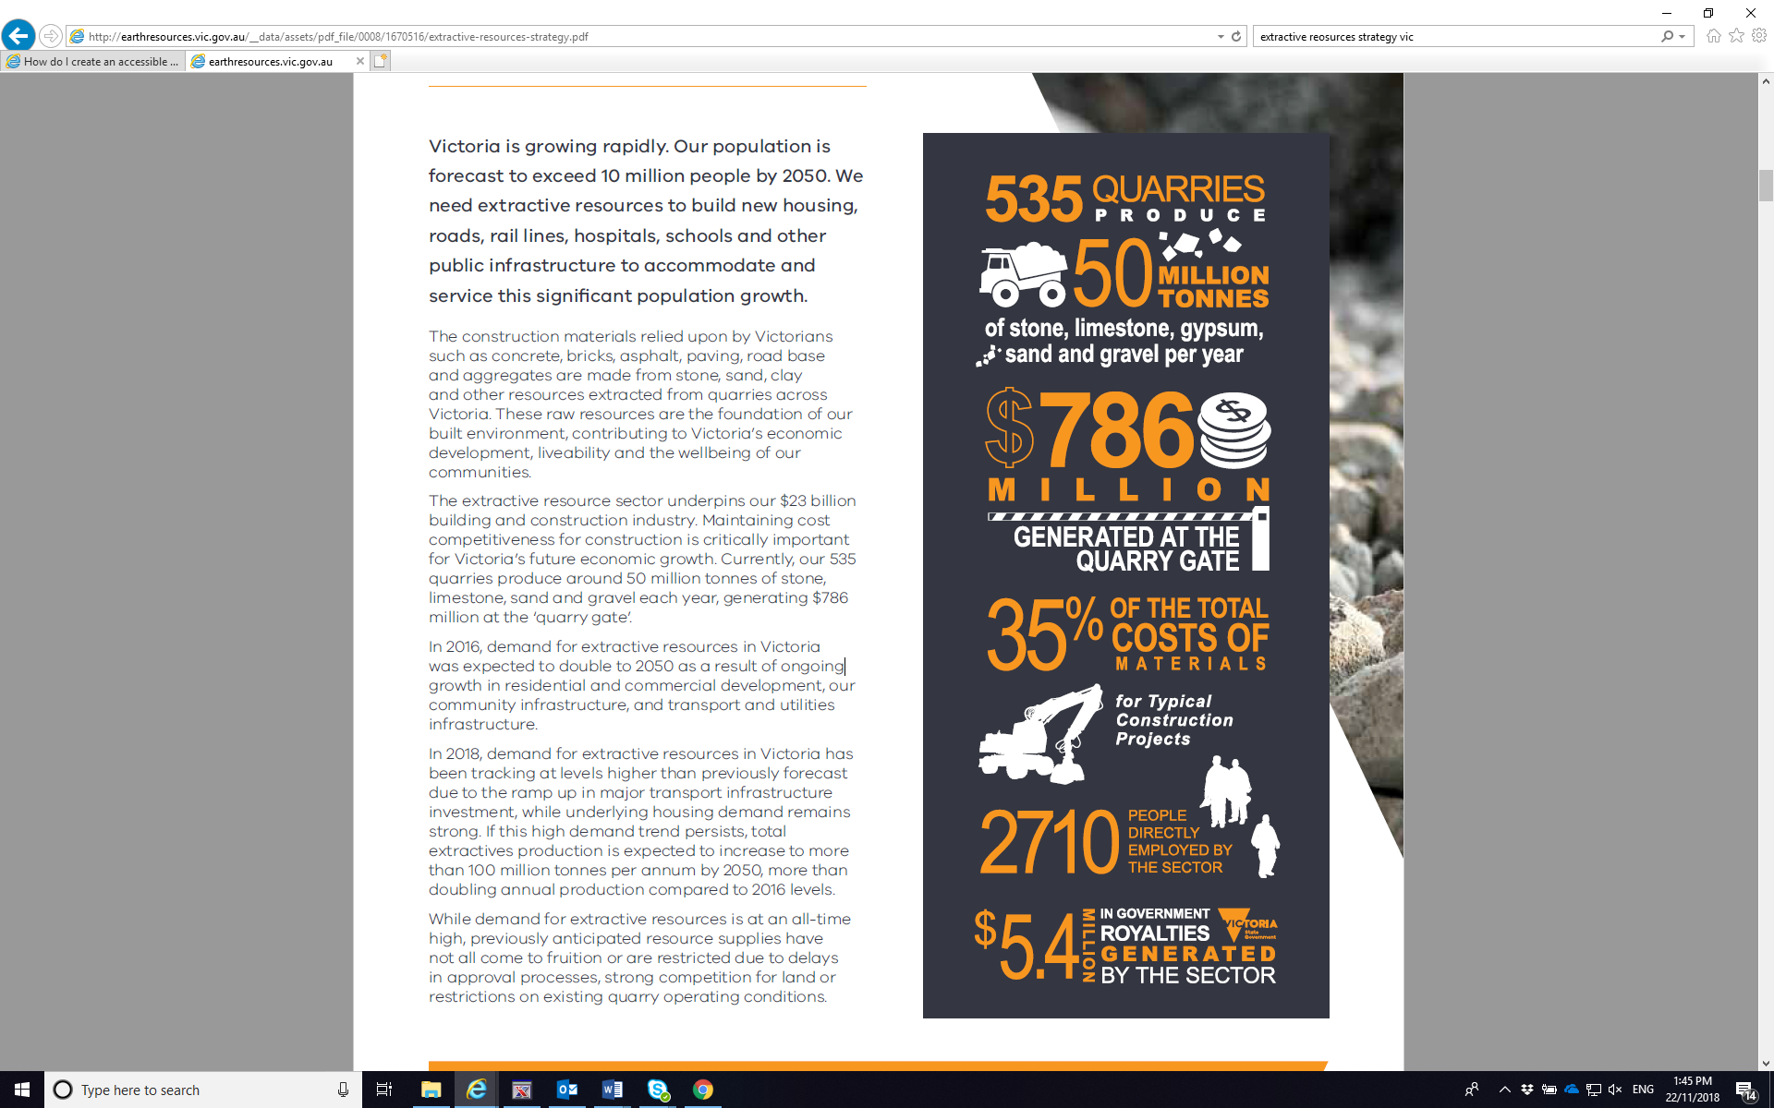

The Government will invest $15.7 million over 2 years to address Victoria’s growing extractive resources

needs and to support the Government’s record $45 billion infrastructure investment.

Demand for extractive resources is at an all-time high due to high population growth and the ramp up in major infrastructure projects.

Emerging shortfalls in the supply of extractive resources is creating an urgent need for the Government to take immediate action to secure high quality resources that are needed to meet Victoria’s current and future infrastructure and affordable housing requirements.

# Demand is Increasing

Extractive resources are high volume, heavy, low value materials that are ideally extracted close to where they are needed in order to minimise transport costs as well as social and environmental impacts. Failure to ensure that a sufficient supply of extractive resources is available within close proximity to our growth areas and infrastructure projects will likely increase the cost of constructing houses and infrastructure. This will mean more expensive and potentially fewer infrastructure projects for Victorians. Impacts on transport infrastructure, greenhouse gas emissions and other environmental impacts will also increase.

We have the opportunity to proactively plan for the development of extractive resource projects to meet the future housing and essential infrastructure needs of all Victorians.

In 2018, demand for extractive resources has been tracking above the previous high demand forecast. At this rate, demand would increase to over 100 million tonnes per year by 2050, more than doubling 2015 annual production.

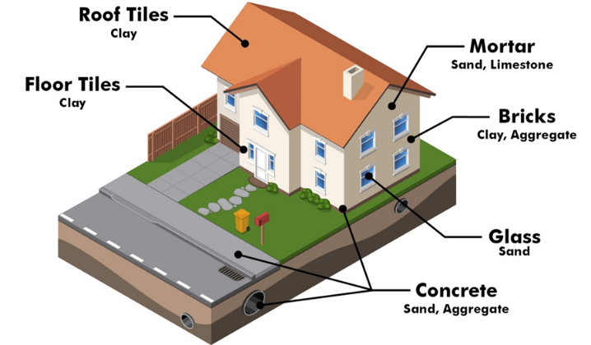

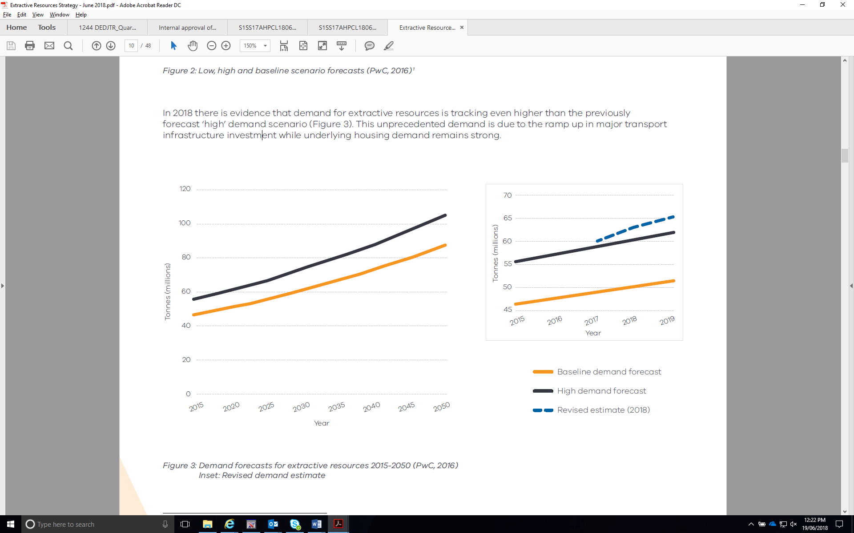Photograph of construction of a rail overpass in Mernda.

# Secure Strategic Resources

## The Extractive Resources Strategy sets a framework for securing cost-effective extractive resources for the benefit of all Victorians

The priority areas for action under the Extractive Resources Strategy are:

* Implementing the recommendations of the Commissioner for Better Regulation’s report, Getting the Groundwork Right: Better regulation of mines and quarries;
* Resource, land use and transport planning initiatives to secure strategic extractive resources close to where they are needed;
* Other initiatives to build community awareness and acceptance in the extractives sector, promote sustainability and environmental stewardship in the sector and promote innovation – including innovative end land use for quarries post-closure.

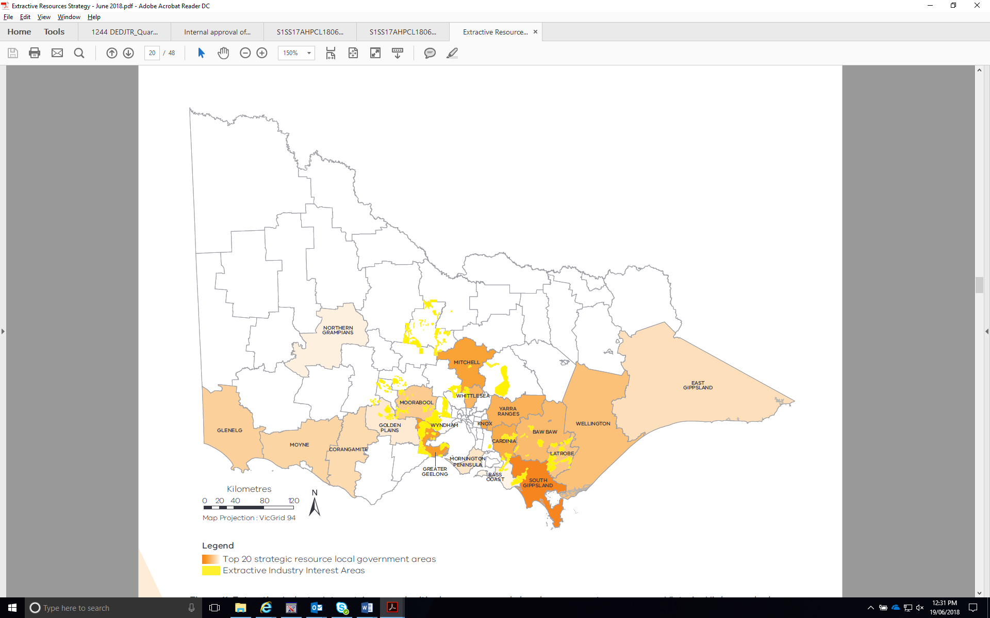

To help meet Victoria’s future needs, we will consult with local government, industry and the community to establish Strategic Extractive Resource Areas and review existing Extractive Industry Interest Areas.

# Priority Actions

## Resource and Land Use Planning

* Conduct a pilot Strategic Extractive Resource Area project in partnership with local government
* Revise short term supply and demand forecasts
* Refresh the Extractive Industry Interest Areas
* Engage early and often with stakeholders on key strategic planning initiatives
* Build a better understanding of the economic case for securing strategic extractive resources.

## Transport and Local Infrastructure Planning

* Inform the development of transport strategies and plans to recognise critical transport networks for transporting extractive resources
* Encourage development of dedicated quarries close to new major regional infrastructure projects.

## Efficient Regulation

* Implement the recommendations set out in the Commissioner for Better Regulation’s Report Getting the Groundwork Right: Better regulation of mines and quarries, including:
* Simplifying the assessment processes for proposed quarries
* Improving coordination across the regulatory system
* Ensuring laws and regulations governing the earth resources sector are fit for purpose, based on modern technologies and best practice regulatory frameworks.

## Confident Communities

* Engage with communities to raise awareness of the importance of quarries
* Better enable community participation in decision-making about quarries.

## Environmental Sustainability

* Work with the extractives industry to reduce net greenhouse gas emissions
* Improve the management of waste across the industry
* Develop a strategic approach to securing biodiversity offsets.

## Innovative Sector

* Investigate the feasibility of short-life quarries
* Investigate the feasibility of different innovative end-land use opportunities for quarries
* Develop and deliver an innovative post-quarrying land use flagship project.

Acknowledgements

The Department acknowledges the contributions to the development of this Strategy made by the Extractive Industries Taskforce, local and state government agencies and community interest groups.

For more information: The full strategy, Helping Victoria Grow, Extractive Resources Strategy June 2018, can be downloaded at energyandresources.vic.gov.au/earth-resources

For further information about the Department’s extractives work program, please contact Minerals Development Victoria mdv@ecodev.vic.gov.au

Published by Department of Economic Development, Jobs, Transport and Resources 1 Spring Street Melbourne, Victoria 3000

Telephone (03) 9651 9999

June 2018

© Copyright State Government of Victoria 2018 This publication is copyright. No part may be reproduced by any process except in accordance with provisions of the Copyright Act 1968.

Authorised by the Victorian Government, Melbourne.

Printed by Impact Digital – Brunswick.

Designed by Jacobs.

Disclaimer:

The information contained in this brochure is provided for general guidance and assistance only and is not intended as advice. You should make your own inquiries as to the appropriateness and suitability of the information provided. While every effort has been made to ensure the currency, accuracy and completeness of the content, we endeavour to keep the content relevant and up to date and reserve the right to make changes as required. The Victorian Government, authors and presenters do not accept any liability to any person for the information (or the use of the information) which is provided or referred to in the brochure.

Except for any logos, emblems, trademarks, artwork and photography this, document is made available under the terms of the Creative Commons Attribution 3.0 Australia licence.

Accessibility:

This document is also available in PDF and accessible Word format at energyandresources.vic.gov.au/earth-resources