delwp.vic.gov.au

|  |
| --- |
| **Innovative Quarry End Land Use Grant Project**  Grant Guidelines  Title  Subtitle |

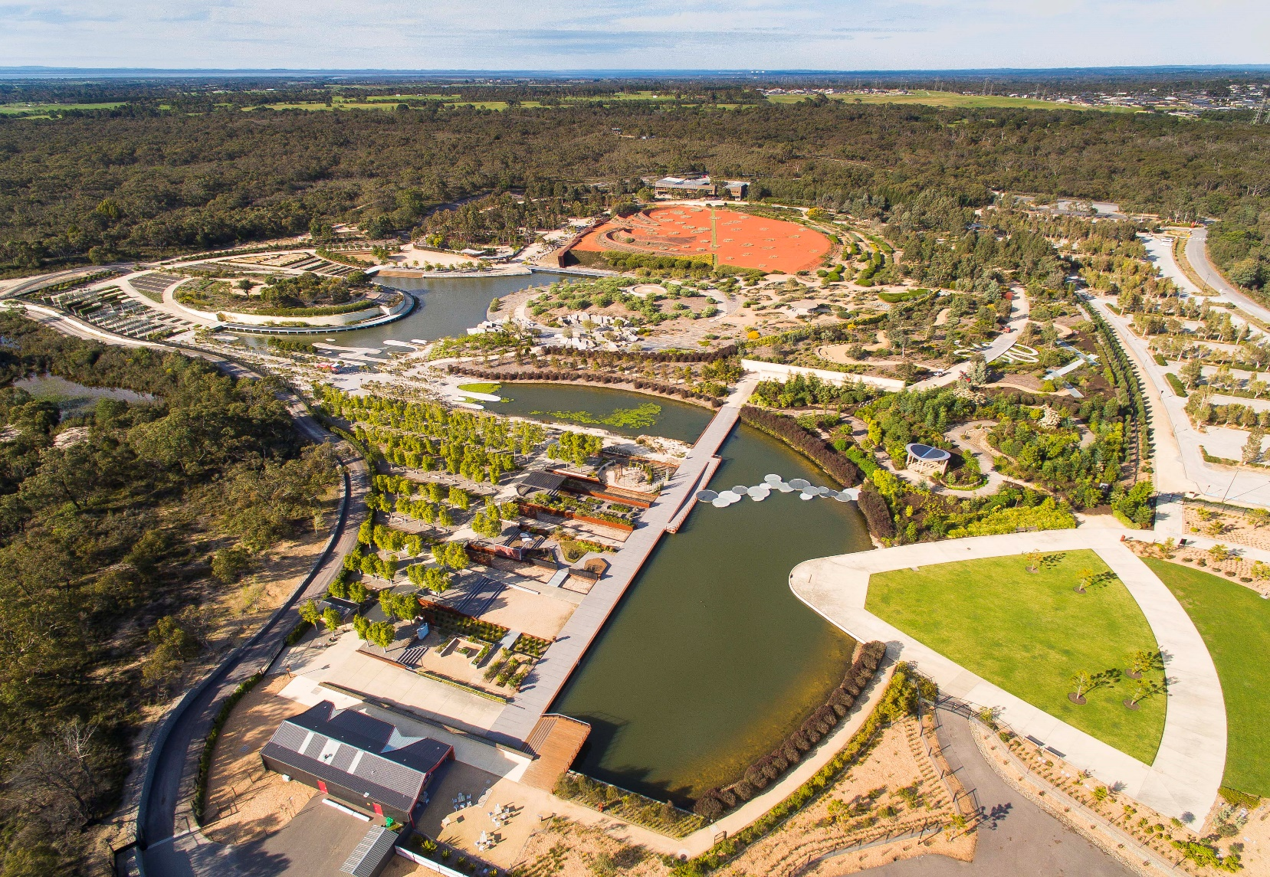

|  |  |
| --- | --- |
|  |  |

**Photo credit**

Cover photo: Royal Botanic Gardens Cranbourne, supplied by Department of Jobs, Precincts and Regions.

|  |
| --- |
| © The State of Victoria Department of Environment, Land, Water and Planning 2022  LogoThis work is licensed under a Creative Commons Attribution 4.0 International licence. You are free to re-use the work under that licence, on the condition that you credit the State of Victoria as author. The licence does not apply to any images, photographs or branding, including the Victorian Coat of Arms, the Victorian Government logo and the Department of Environment, Land, Water and Planning (DELWP) logo. To view a copy of this licence, visit <http://creativecommons.org/licenses/by/4.0/>  Disclaimer  This publication may be of assistance to you but the State of Victoria and its employees do not guarantee that the publication is without flaw of any kind or is wholly appropriate for your particular purposes and therefore disclaims all liability for any error, loss or other consequence which may arise from you relying on any information in this publication.  Accessibility  If you would like to receive this publication in an alternative format, please telephone the DELWP Customer Service Centre on 136186, email [customer.service@delwp.vic.gov.au](mailto:customer.service@delwp.vic.gov.au), or via the National Relay Service on 133 677 [www.relayservice.com.au](http://www.relayservice.com.au). This document is also available on the internet at [www.delwp.vic.gov.au](http://www.delwp.vic.gov.au). |

Contents

1. Supporting positive end land uses for quarries 2

2. What is the Innovative Quarry End Land Use Project? 2

3. Who can apply? 2

4. Who cannot apply? 2

5. How much finding is available? 2

6. What might be funded? 2

7. What sorts of projects and initiatives are ineligible for funding? 2

8. How will applications for funding be assessed? 3

9. What are the funding conditions? 3

10. When are applications due? 4

11. How do I submit my application? 4

12. How and when will the successful applicants be notified? 4

13. Tax implications 4

14. Payments 4

15. Monitoring 4

16. Privacy 4

17. Checklist 5

## Supporting positive end land uses for quarries

The Victorian Government recognises the role that planning and investing in innovative end uses for quarries can play in improving social, environmental, and economic outcomes for communities and the extractives sector.

One of the key themes of *Helping Victoria Grow: Extractives Resources Strategy* (Strategy, 2018) is to promote innovation within the extractives sector, particularly in relation to the end uses for quarries. The Victorian Government is committed to supporting industry in planning for and implementing innovative end land uses that benefit local community.

The Strategy commits to:

1. investigating the feasibility of different end land use opportunities for quarries, and
2. developing and delivering innovative post‑quarrying end land use opportunities.

## What is the Innovative Quarry End Land Use Project?

The Innovative Quarry End Land Use Grant Project (also known as the Quarry Transformation Grants) provides grants to promote innovation in land uses for quarries as they reach the end of their operational life.

These grants will assist quarry operators by providing opportunities to develop and test ideas and options for repurposing land after quarrying stops.

Through these grants, the Victorian Government is assisting the extractives sector to identify new opportunities, build on emerging capabilities and adopt new technologies to ensure it continues to grow and prosper into the future.

## Who can apply?

Any extractive industry Work Authority (WA) holder under the *Mineral Resources (Sustainable Development) Act 1990* is eligible to apply for funding under the Innovative Quarry End Land Use Project.

## Who cannot apply?

Organisations and individuals who cannot apply for funding under this grant program include:

* Government agencies
* Educational institutions
* Local government authorities, and
* Not for profit organisations.

## How much finding is available?

The total grant amount available under this project is $550,000.

Allocation of funding will be available in two streams. A stream for small/medium quarries and another for large quarries—those that produced more than 0.5 million tonnes in the 2021 financial year. Funding will vary depending on the quality of the applications that meet the assessment criteria.

## What might be funded?

This project offers grants to quarry operators to advance innovative ideas for quarry site rehabilitation that go beyond the safe and stable and sustainable minimum requirements under the *Mineral Resources (Sustainable Development) Act 1990.*

Innovative ideas for quarry end land use may include projects and initiatives that:

* provide ongoing local community access and critical local services, e.g., power generation, water management
* generate employment opportunities,   
  e.g., residential construction
* have a direct and tangible positive impact on surrounding land and property values, and/or
* improve the overall liveability of an area, e.g., open space/recreation.

## What sorts of projects and initiatives are ineligible for funding?

The Innovative Quarry End Land Use Grant project will not fund the following activities:

* the purchase of land
* routine or ongoing maintenance activities
* activities that have already started
* where duplicate services are in operation or planned for in a targeted community
* recurrent operating costs, for example rent and utility costs, and/or
* activities establishing expectations of ongoing funding.

## How will applications for funding be assessed?

Applications will first be checked for completeness and eligibility to make sure that the applicant and the proposed activity are eligible for funding.

Assuming the application is complete and the activities eligible, applications will then be assessed using the criteria listed below.

Each criterion is given a percentage weighting to indicate its relative importance in the assessment process.

Applications should address all relevant criteria.

**Design proposal**

Provide a proposal for an end land use for a quarry site that clearly demonstrates a problem that could be solved by an innovative solution.

(Include findings from research/ case study reviews of other completed projects).

Criteria weighting: **10 per cent**

**Design innovation**

Demonstrate how the proposal meets the definition of ‘innovative end land use for quarries’.

(Include examples/details of how new systems, materials, processes and/or technologies may be utilised in a unique and imaginative way).

Criteria weighting: **45 per cent**

**Design Impact**

Provide details of what inspired the proposal, including any visual, contextual, and cultural perspectives considered relevant to the location or community around the quarry.

(Include e.g., inspiration for design elements, shapes, structures, use of local endemic vegetation etc).

Criteria weighting: **10 per cent**

**Net Benefit**

Outline how the proposal would result in a net benefit. Benefit may be to community, sustainability, and/or commercial benefit.

(Include details of any community consultation undertaken, proposed use of recycled materials and/or processes that demonstrate sustainability, and/or demonstrate the potential for a significant financial return on investment).

Criteria weighting: **35 per cent**

## What are the funding conditions?

### Funding agreements

Successful applicants must enter into a funding agreement with DELWP. The Victorian Common Standing Agreement can be used for funding agreements with businesses. It is recommended that applicants review the Standard Form Terms and Conditions before applying.

Information about the Victorian Common Standing Agreement is available on <https://www.vic.gov.au/victorian-common-funding-agreement-templates#vcfa-standard-form-and-standard-form-clause-bank>.

The activity does not include using the funding for political campaigning or advocacy.

### Legislative and regulatory requirements

In delivering the activity grant recipients are required to comply with all relevant Commonwealth and state/territory legislations and regulations, including but not limited to:

* *The Privacy Act 1988 (Commonwealth)*
* *The Freedom of Information Act 1982 (Vic)*
* *Occupational Health and Safety Act 2004*

### Acknowledging the Victorian Government’s support

Successful applicants are expected to acknowledge the Victorian Government’s support and promotional guidelines (<https://www2.delwp.vic.gov.au/grants>) will form part of the funding agreement. Successful applicants must liaise with the departmental program area to coordinate any public events or announcements related to the project.

## When are applications due?

Applications must be submitted by **5pm AEST 14 April 2022.**

No hard copy, late or and/or incomplete application will be considered.

## How do I submit my application?

Applications are submitted online using the Grants Online portal.

To apply, go to the grant program web page. To start a new application clink on the link (<https://delwp1.force.com/publicform?id=a0i8u0000000TVY>. To return to a saved draft application, click on the link ([https://delwp1.force.com/](https://urldefense.com/v3/__https:/delwp1.force.com/__;!!C5rN6bSF!QlHMBBpOrQUpGAvFdsvPVuPZ-r3gj-QPNetxitw7kyJn1pqk_-x9WdnQh8N1xtC8CZOz-cTCXmg-$)).

### Attaching required documents:

Supporting documents must be in an acceptable file type, such as Word, Excel, PDF, or JPEG. The maximum file size for each file is 10MB.

You will receive an application number when you submit an application online. Please quote this number in all communications with the department relating to your application.

If you have an attachment that exceeds the maximum size of 10MB, they must be emailed AFTER you have submitted the application to [grantsinfo@delwp.vic.gov.au](mailto:grantsinfo@delwp.vic.gov.au) quoting your application number. Attach all documents to one email, zipping the files if required.

## How and when will the successful applicants be notified?

Successful and unsuccessful applicants will be notified in writing after the assessment process is completed. All decisions are final and are not subject to further review.

Unsuccessful applicants can ask for feedback on their application.

|  |  |
| --- | --- |
| **Key dates** |  |
| Applications open | 7 March 2022 |
| Applications close | 14 April 2022 |
| Applicants notified | 16 May 2022 |
| Agreement executed | 27 May 2022 |
| Activities commence | 30 May 2022 |
| Activities completed and acquittal reports submitted by | 7 March 2023 |

## Tax implications

Applicants should consult the Australian Taxation Office or seek professional advice on any taxation implications that may arise from this grant funding.

Successful applicants without an ABN will need to provide a completed Australian Taxation Office form ‘Statement by a Supplier” so that no withholding tax is required from the grant payment.

## Payments

Payments will be made as long as:

* the funding agreement has been signed by both parties
* grant recipients provide reports as required, or otherwise demonstrate that the activity is progressing as expected
* other terms and conditions of funding continue to be met.

## Monitoring

Grant recipients are required to comply with project monitoring and reporting requirements as outlined in the funding agreement. This may include progress reports, site inspections, completion reports and acquittal documentation.

## Privacy

Any personal information about you or a third party in your application will be collected by the department for the purposes of administering your grant application and informing Members of Parliament of successful applications. Personal information may also be disclosed to external experts, such as members of assessment panels, or other government departments for assessment, reporting, advice, comment or for discussions regarding alternative or collaborative grant funding opportunities. If you intend to include personal information about third parties in your application, please ensure that they are aware of the contents of this privacy statement.

Any personal information about you or a third party in your correspondence will be collected, held, managed, used, disclosed or transferred in accordance with the provisions of the *Privacy and Data Protection Act 2014* and other applicable laws.

DELWP is committed to protecting the privacy of personal information. You can find the DELWP Privacy Policy online at www.delwp.vic.gov.au/privacy.

Requests for access to information about you held by DELWP should be sent to the Manager Privacy, P.O. Box 500 East Melbourne 8002 or contact by phone on 9637 8697.

## Checklist

Read these guidelines and the information about this grant program at <https://earthresources.vic.gov.au/projects/quarry-transformation-grants> before applying and complete the following checklist.

Have you:

 read these guidelines carefully?

 checked if you are, or your organisation is, eligible for this grant funding?

 checked if your activity is eligible for this grant funding?

 prepared the appropriate supporting documents?

|  |
| --- |
| If you require assistance submitting your application online, email grantsinfo@delwp.vic.gov.au. |
| If you require further information about the Quarry Transformation Grants, email [Belinda.lucas@ecodev.vic.gov.au](mailto:Belinda.lucas@ecodev.vic.gov.au) |