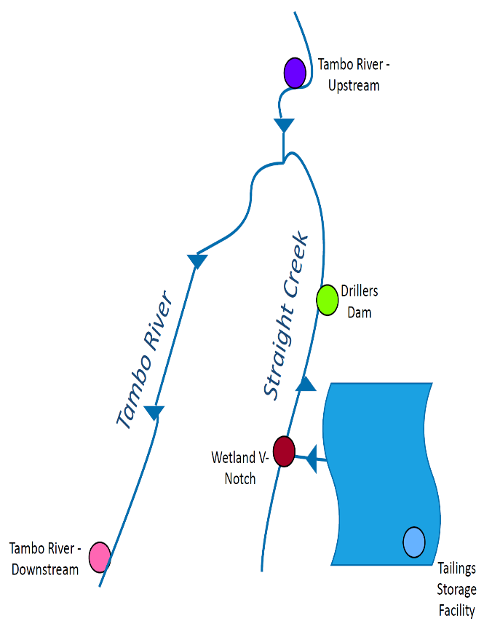

0.97mg/L

## Not to scale

## Please note that the data plotted in the above graph needs to be interpreted taking into account other contributing factors, such as weather conditions (e.g. rainfall events). Environmental Quality Objectives (i.e. levels acceptable for the receiving environment) are currently being developed and this baseline data should be interpreted with reference to these objectives.

Zinc values <0.005mg/L are shown as 0.005mg/L to display the overall trend.

## Benambra Surface Water

## Sampling Results - Zinc

## The below image is indicative of sampling locations.