March 2015

DESKTOP REVIEW

Antimony in the Costerfield Area

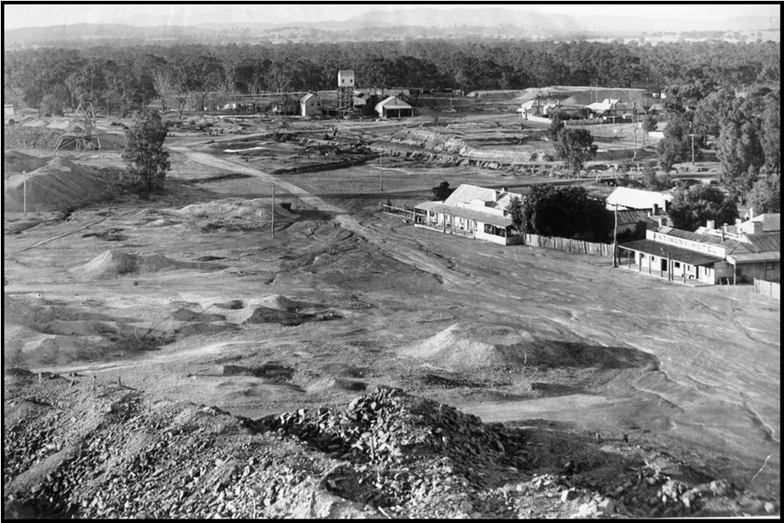

Submitted to:
Victorian Government Reference Group
c/o Department of Economic Development, Jobs, Transport and Resources
Level 9, 121 Exhibition Street,
REPORT
Melbourne, 3000

Report Number. 1413212-002-R-Rev0

Background

Golder Associates Pty Ltd (Golder) was commissioned by the Government of Victoria Reference Group (GVRG), chaired by the Department of Economic Development, Jobs, Transport and Resources (DEDJTR), to prepare this desktop review of the nature, transport and distribution of antimony in the environment, for the Costerfield area. This desktop review has been prepared following the completion of a series of environmental assessments in the Costerfield area, which were commissioned in response to concerns raised by the Costerfield community in early 2014 about exposure to antimony related to the local mining operations.
This desktop review has been undertaken to support the development of a comprehensive health risk assessment for antimony and related chemicals of interest in the Costerfield area. Although focused on antimony, the scope of this desktop review considers other potential chemicals of interest that may be present with antimony in the Costerfield area, either due to geological, mining and/or other development activities.
This review was undertaken to answer the following questions:

- What are the sources of antimony in the Costerfield area?

- What is the distribution of antimony and related chemicals within the Costerfield
area?

- How do antimony and related chemicals of interest behave in the environment?

- What further assessment or information is required to assess risks to human
health, associated with exposure to antimony and related chemicals?
In order to address these questions, Golder reviewed information provided by Mandalay Resources and publically available data, maps and literature. The review considered:

- The environmental setting (including the geology and hydrogeology of Costerfield).

- Historical activities and associated potential sources of antimony and related chemicals.

- Potential pathways for movement of antimony and related chemicals.

- Identification of potential receiving environments.

Environmental Setting

The Costerfield area lies within a distinct geological unit, referred to as the Costerfield Dome (see Figure i), which contains zones of mineral enrichment (enriched with metals including gold, antimony and arsenic).

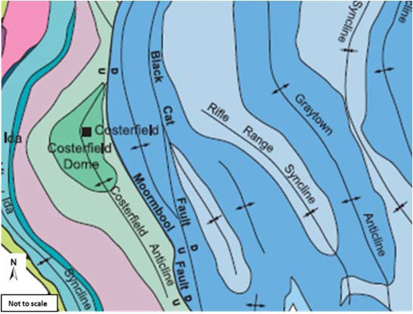

Figure i: Regional Geology, showing the Costerfield Dome
Mining activities have occurred extensively within the Costerfield area, predominantly along the Costerfield Anticline shown in Figure i).
Halos of metal enrichment have been reported within rock immediately surrounding mineral ore deposits (Arne, 2009a). Metal enrichment halos typically extend up to 50 metres from the ore deposit, characterised by antimony concentrations up to 50 mg/kg. Other elements (gold, molybdenum,

copper, manganese, and bismuth) are also reported to be naturally enriched within close proximity (typically within 10 metres) of ore deposits (Arne, 2008). However enrichment of these metals is less consistent than that of antimony.
Surface water features within the area include Tin Pot Gully and Wappentake Creek. The catchment area around Costerfield typical flows south, into Wappentake Creek which feeds into the Goulburn River.
Perched groundwater is present within near surface alluvial material, typically less than 4 metres below ground level and is likely connected to localised surface water features. Many manmade surface water features are present within the Costerfield area including evaporation ponds, water diversion channels and tailing dams.
The deeper groundwater aquifer in the Costerfield area is expected to be at approximately 20 metres below ground level, and flows in a northerly direction towards the Murray Darling Basin.
Groundwater flow direction is in a northerly direction, therefore it is expected that groundwater below operating mines (Cuffley Lode and Augusta Mine) is likely to flow towards the Costerfield Township.
Historical Activities in Costerfield

The rural town of Costerfield was developed during the gold rush, due to the presence of antimony and gold. The area around the town has been extensively mined since the 1860’s. A timeline of historical activities in Costerfield is summarised in Figure ii).

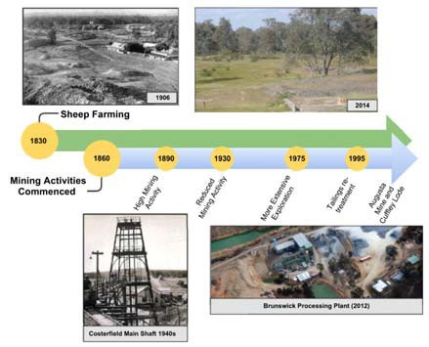

Figure ii: Timeline of historical activities in Costerfield

Current mining activities are present south of the township, at Augusta Mine and the Cuffley Lode. Current and former mining activities are presented in Figure iii.

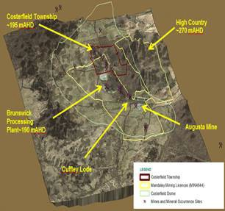
Figure iii: Historical and current mine locations within the Costerfield Dome

The natural soil profile within Costerfield has been disturbed by extensive mining activities and land clearing. These activities are likely to have resulted in:

- Addition of mine wastes to the soil surface.
- Excavation and re-distribution of surface soils and overburden.

- Increased weathering due to land clearing and changes in surface water movement.

- Physical and chemical changes to soil and rock properties during mine processes
(including crushing).

Mine processing activities including crushing, milling, roasting, cyaniding and smelting have occurred at many of the historical mine sites within the Costerfield area, as presented in Figure iii.
Mine waste materials including tailings are distributed within the town and have been exposed to weathering over the past 150 years, as presented in Figure iv. Mine wastes vary in metal content and particle size (from waste rock/slum to fine grained tailings and particulates emitted from roasting of material). Weathering and dust generation is likely to be significantly greater from fine grained mine wastes (such as tailings) compared to coarse mine waste rocks.

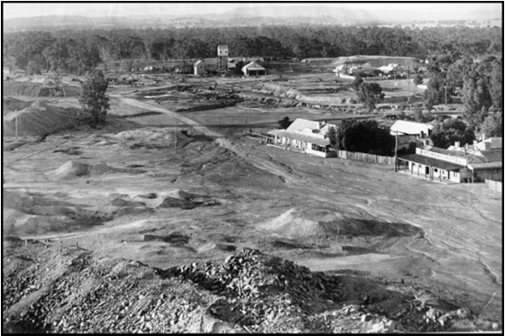
Figure iv: Historical mine tailings within the Costerfield township

Concentrations of antimony in the surface soils of the Costerfield area are greater than those within the underlying alluvial soils and are greater than those expected concentrations within mineral halos (as defined within Arne and House, 2009a). This data suggests that antimony concentrations at the soil surface may be associated with redistribution of mine wastes including waste rock and tailings, sourced from the Costerfield).
Other chemicals of interest include manganese, copper, gold, bismuth, lead, mercury, zinc,
cyanide that may be present within mine wastes due to mineral ore extraction processes. Of these potential chemicals of interest, antimony and to a lesser extent arsenic are considered the priority chemicals of interest in relation to human health risk assessment (due to their likely widespread distribution and reported concentrations within the Costerfield soils).
Antimony Sources, Pathways and Receiving Environments
A review of distribution of antimony within the Costerfield environment suggests that mine wastes (rather than weathering of insitu minerals) are the key source of added antimony to surface soils in the Costerfield Area.
Insitu minerals (i.e. unmined stibnite and arsenopyrite) may also be a source of antimony to the environment, particularly to surface and groundwater.
Pathways for movement of antimony in the environment include direct movement via, trucking and hauling of ore and mine waste, and indirect secondary movement, via dust, run off, or infiltration into surface water or groundwater.

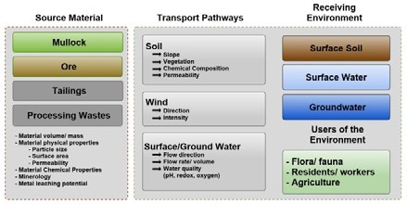
Figure v: Summary of antimony sources, pathways and receiving environments

Activities or processes which may increase the distribution of antimony include:

- Generation of dust (such as vehicles on unpaved roads, use of dirt bikes on tailing
piles, crushing of mined material).

- Erosion of stockpiled materials (i.e. surface water run off).

- Surface water and groundwater extraction/relocation.

chlorine, floatation agents, acids, alkalis and

Areas and environmental features which may experience added antimony concentrations due to migration of metals from mine wastes and/or undisturbed mineralised materials include surrounding surface soils, surface water features and groundwater as well as users of the environment.
- What are the sources of antimony in the Costerfield area?

The main source of antimony in the Costerfield area is mineralised zones of sulphide minerals such as stibnite and adjacent altered host rocks of the Costerfield Formation. Mining activities have resulted in the relocation (and in some cases) concentration of antimony in the Costerfield environment.

What is the distribution of antimony and related chemicals within the Costerfield area?

During historic mining activities, mine wastes have been distributed widely within the township and across the landscape. There may also be some local point sources of chemicals in the Costerfield environment primarily related with processing and/or extraction of antimony and gold. Early processing occurred around waterways leading to direct discharges without containment. Potential mining related chemicals include manganese, copper, gold, bismuth, lead, mercury, zinc, chlorine, floatation agents, acids, alkalis and cyanide.

How do antimony and related chemicals of interest behave in the environment?

The concentration and mobility of antimony and related chemicals within mine wastes can be influenced by mine processing, the particle sizes within the wastes, and the prevailing environmental conditions. The weathering of antimony containing minerals commonly results in the formation of metal oxides which have limited mobility within the environment except under highly oxidised conditions (oxygen rich). Therefore the physical size of antimony containing particles and land disturbance practices have a significant influence on its
redistribution in the environment following the initial relocation of mine waste to the land surface.
Golder has not undertaken chemical assessment of groundwater or surface water
within the Costerfield area, however, oxidation of mineralised rock, during dewatering activities, could potentially result in mobilisation of antimony into the environment.

4. What further assessment or information is required to assess risks to human health, associated with exposure to antimony and related chemicals?

Further soil assessment should be considered to understand the distribution of antimony and related chemicals within the Costerfield area, specifically where mine wastes are present at the surface. Golder is currently undertaking soil assessment at selected residential properties and road reserves.
To assist in understanding the potential risk of antimony and related chemicals to human health and the environment, the following further information is considered important:

- Arsenic and antimony leachability within different mine wastes (particularly tailings
and dewatered mineralised zones).

- Arsenic and antimony impacts to groundwater and surface water. The EPA
has been commissioned to review the water (surface and groundwater) management issues. The EPA findings will also inform the HRA.

- Arsenic and antimony bioaccessability and bioavailability (for humans, flora and fauna).
The bioaccessibility and bioavailability of antimony and related chemicals are typically limited in the environmental media. Investigations will inform the HRA.

Table of Contents
1.0 INTRODUCTION 1
  - Background 1
  - Objectives 1
  - Scope of Desktop Review 2
  - Information Sources 2
2.0 ENVIRONMENTAL SETTING 2
  - Location and General Description. 2
  - Geological Setting 4
    - Geology and Antimony Mineralisation 5
    - The Ore 7
    - Mineral Enrichment Halos 8
  - Soil 10
    - Soil Profile 10
    - Metal Enrichment Patterns in Soil 12
  - Hydrogeological Setting 12
    - General 12
    - Dewatering 14
  - Surface Water 15
3.0 HISTORY OF THE COSTERFIELD AREA 15
  - Settlement of Costerfield 16
  - Regional Mining Activities 18
    - Mining in Costerfield. 19
    - Mining Processes 21
  - Distribution of Mine Wastes 23
  - Current Mining Activities 26
  - Water Management 27
4.0 WALKOVER OF THE COSTERFIELD AREA 28
5.0 POTENTIAL SOURCES OF ANTIMONY AND RELATED CHEMICALS IN THE ENVIRONMENT 30
  - Identification of Potential Chemicals of Interest 30
  - Identification of Sources of Antimony and Related Chemicals 30

6.0 ANTIMONY BEHAVIOUR IN THE ENVIRONMENT 31
7.0 REVIEW OF SOURCE-PATHWAY-RECEIVING ENVIRONMENT 33
  - Source Materials 33
  - Transport Pathways 34
  - Receiving Environment 34
  - Source, Pathway and Receiving Environment Linkages 35
8.0 CONCLUSIONS AND RECOMMENDATIONS 36
9.0 LIMITATIONS 37

10.0 REFERENCES 34

TABLES
Table 1: Metal concentrations within Costerfield Ore, Enrichment Halos and Background in mg/kg 9
Table 2: Summary of DEPI soil and Bedrock data within the Costerfield Dome 11
Table 3: Summary of Historic Mining Processes within Costerfield 23

FIGURES
Figure 1: Costerfield Location Plan 3
Figure 2: Topographical plan showing the Costerfield Township, current active mine sites and the extent of
Mandalay Resources mining licence 4
Figure 3: Regional Geology, showing Costerfield Dome 5
Figure 4: Five primary zones of mineralisation, as indicated by the presence of historic mines 7
Figure 5: Examples of mineral deposits in the Costerfield area 8
Figure 6: Examples of Surface soils in the Costerfield area 10
Figure 7: Groundwater Bores within the Costerfield area 14
Figure 8: Conceptual groundwater flow, showing influence of dewatering at Augusta Mine 15
Figure 9: Timeline of historical activities in Costerfield 16
Figure 10: Costerfield Township, 1906 17
Figure 11: (a) Men creating hay bales in Costerfield, 1930; (b) Residential development within the Costerfield
Township (photo likely taken between 1900s and 1940s) 18
Figure 12: Example of miners sluicing for Gold at Tarnagulla, Central Victoria, 1880 19
Figure 13: Remnants of historical mine infrastructure 20
Figure 14: Typical Mine Processes and wastes generated 21
Figure 15: Costerfield township and mine tailings 24
Figure 16: Location of Mine waste, including tailings, within the township of Costerfield during 1926 25
Figure 17 (a) Augusta Underground Mine (b) The Augusta Mine Site groundwater evaporation ponds shown in top
of photo 26

Figure 18: The Brunswick Processing Plant (Mandalay Resources, 2012) 27
Figure 19: Site observations during walkover of the Costerfield area 29
Figure 20: Source of potential contamination and associated chemicals of interest 31
Figure 21: Simplified schematic of antimony behaviour within the environment 32
Figure 22: Schematic of linkages between sources and the receiving environment 35

APPENDICES APPENDIX A
Limitations
APPENDIX B
Soil and Ore data
APPENDIX C
Summary of Mine Processes
APPENDIX D
Photographs from Costerfield Walkover
APPENDIX E
Selection of Chemicals of Interest
APPENDIX F
Antimony in the Environment

  - INTRODUCTION
Golder Associates Pty Ltd (Golder) was commissioned by the Government of Victoria Reference Group (GVRG), chaired by the Department of Economic Development, Jobs, Transport and Resources (DEDJTR), to prepare this desktop review of the nature, transport and distribution of antimony in the environment, for the Costerfield area, Victoria.
This desktop review has been undertaken as part of a series of staged environmental assessment works to support the development of a comprehensive human health risk assessment for antimony and related chemicals of interest in the Costerfield area. Although focussed on antimony, the scope of this desktop review considers other potential chemicals of interest that may also be present in the Costerfield area, either due to geological conditions, mining and/or other development activities.
This scope of work was prepared in consultation with Department of Health and Human Services, Environment Protection Authority (EPA) and DEDJTR. The scope of this desktop review evolved based on the evaluation of findings from a rapid environmental assessment, undertaken during June 2014, (Golder, 2014) and feedback from community consultations held since the delivery of the rapid assessment report, as discussed below.

Background
The rural town of Costerfield was developed during the gold rush, due to the presence of ore containing antimony and gold. The local area has been extensively mined since the 1860’s. Current mining activities in the Costerfield area comprise underground ore extraction at Augusta Mine and Cuffley Lode, and ore processing at the Brunswick processing plant, south of the township. These mining activities are operated by Mandalay Resources Corporation (Mandalay Resources).
During early 2014 the Costerfield community raised concerns of exposure to antimony related to the local mining operations. In response to the concerns of the Costerfield community, Golder was engaged as an independent expert by a Reference Group of State Government Agencies to conduct an environmental monitoring program and a human health risk assessment.
In addition to the above works, and recognising the need to address immediate health concerns, a rapid assessment was conducted. The rapid assessment focussed on important sources for human exposure, including drinking water obtained from tanks, surface soils and ambient air particulates. Within a two week period from 2 June 2014 to 13 June 2014, sampling was undertaken at properties within 3 kilometres of the Brunswick Processing Plant and at one residential property at Heathcote (approximately 8 kilometres away).
The rapid assessment, titled “Rapid Health Assessment and Preliminary Report on Monitoring Program Based Information and Data Available to 15 June 2014” (Golder, 2014) concluded that, based on the limited sample results, immediate adverse health effects are not expected from exposure to antimony in the Costerfield area. However, further investigation is required to assess the significance and extent of antimony and related chemical levels in the Costerfield area.
In order to further assess risk to human health, a range of additional investigations are continuing. These investigations include monthly tank water sampling, stock sampling, air monitoring and this desktop review.

Objectives
The objective of this desktop review is to provide information to support the understanding of the nature, transport and distribution of antimony and related chemicals in the environment, in the Costerfield area.
This objective will be met by answering the following questions:

- What are the sources of antimony in the Costerfield area?

- What is the distribution of antimony and related chemicals within the Costerfield area?

- How do antimony and related chemicals behave in the environment?

- What further assessment or information is required to assess risks to human health, associated with exposure to antimony and related chemicals?

Scope of Desktop Review
In order to address these questions, Golder reviewed information provided by Mandalay Resources and publically available data, maps and literature. The scope of this review considered:

- The environmental setting (including the geology and hydrogeology of Costerfield).
- Historical activities and associated potential sources of antimony and related chemicals.
- Potential pathways for movement of antimony and related chemicals.
- Identification of potential receiving environments.

Information Sources
The following information sources have been reviewed:

- Publically available Mandalay Resource reports and economic assessment reports.
- Maps and soil data produced by the former Department of Primary Industries.
- Historical Victoria Geological Survey reports, books and maps.
- Publically available hydrogeological information.
- Historical newspaper articles, aerial photographs and photo records.
Reviewed documents used within this report are listed within Section 10.0 of this report.

ENVIRONMENTAL SETTING
  - Location and General Description
Costerfield is located in rural Victoria, approximately 100 km north-west of Melbourne and 50 km south- east of Bendigo (Figure 1). The largest township within close proximity of Costerfield is Heathcote. The population of the Heathcote District (including the Costerfield area), during 2011, was less than 4000 residents.
Land uses within the township of Costerfield comprise mining, agriculture, low density residential development, and limited commercial and recreational activities. Land south of the Costerfield Township (south of Cochranes Road) is currently part of the Puckapunyal Military Area.

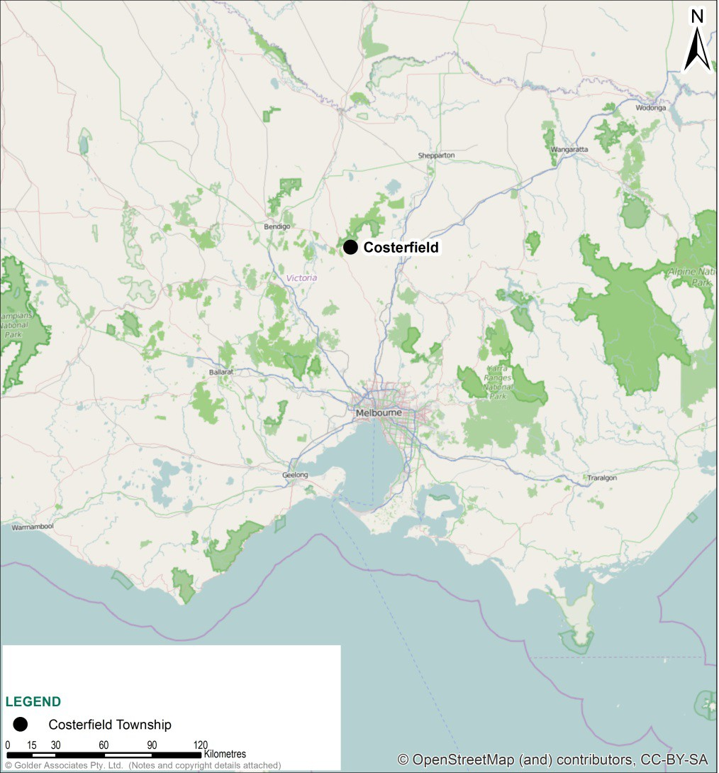
Figure 1: Costerfield Location Plan

For the purposes of this desktop review, the study area includes the broader Costerfield area with particular focus on geological conditions and related mining activities. The Costerfield Township and the extent of the current mining licence (owned by Mandalay Resources) are presented in Figure 2.

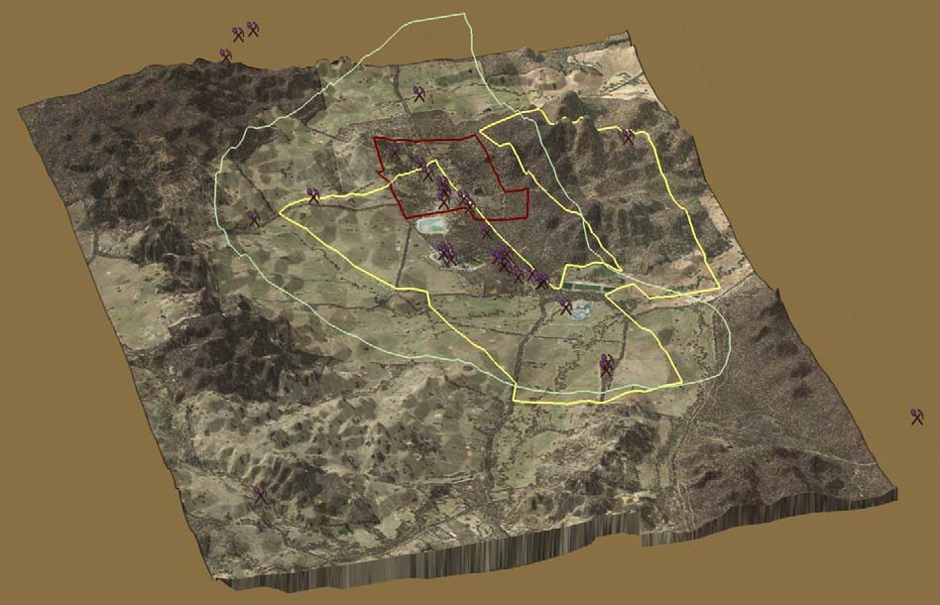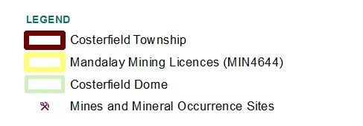
Costerfield Township
~195 mAHD
High Country
~270 mAHD
Brunswick
Processing Plant~190 mAHD
Augusta Mine
Cuffley Lode

Figure 2: Topographical plan showing the Costerfield Township, current active mine sites and the extent of Mandalay Resources mining licence

The Costerfield Township is located within relatively flat to undulating terrain at an approximate elevation of 200-300 metres above sea level (Federation University, 2014). The township is bound by rugged hill country, undulating rises, gentle slopes and drainage depressions (Mandalay Resources, 2012). The low lying areas of Costerfield (north and east) act as a floodplain during periods of high rainfall (SRK Consulting, 2013). Open forest is present within the valleys and shrubby box gum is scattered across the stony gravelly hills (Mandalay Resources, 2012). Most of the undulating to flat areas of the region has been cleared for farming purposes (Mandalay Resources, 2012).
The Costerfield area has a Mediterranean climate with temperatures ranging from -2oC in winter to +40oC in summer (SRK Consulting, 2013). The area is typically dry with annual pan evaporation of 1300 mm to 14000 mm, exceeding the average annual rainfall of 500 mm (SRK Consulting, 2013). Prevailing winds within the Costerfield area are generally from the south-south east direction, except in winter when they are more from the north east direction.

Geological Setting
Metals such as antimony are naturally present within the environment. The concentration of metals naturally present in the environment is highly variable and is influenced by many factors including the underlying geology from which the soil has formed and the extent of weathering.
Human activities, including industrialisation, mining, agricultural and domestic activities has resulted in the re-distribution of metals within the environment.

The following sections describe the geology and soil condition of the Costerfield area, including how and where antimony is naturally enriched (i.e. present at a higher concentration than average) in the Costerfield environment and a summary of the expected concentration of antimony and related chemicals within different geological materials.

Geology and Antimony Mineralisation
Costerfield is located within the western portion of the ‘Melbourne Structural Zone’ (SRK Consulting, 2013). The Melbourne Structural Zone encompasses a large portion of central and eastern Victoria and consists of a thick sequence of marine sedimentary rocks.
The Melbourne Zone has been deformed into a series of folds, including the Mount Ida Syncline; the Costerfield Dome/anticline; the Black Cat and the Graytown anticlines; and the Rifle Range Syncline. The folds have been deformed and truncated by movement along faults.
The Costerfield Township is located within the Costerfield Dome anticline, which is truncated in the east by the Moormbool Fault, resulting in an asymmetric dome like structure (Figure 3). The eroded peak of the Costerfield Dome (comprising Costerfield Siltstone) is exposed approximately 1 km west of the Costerfield Township.

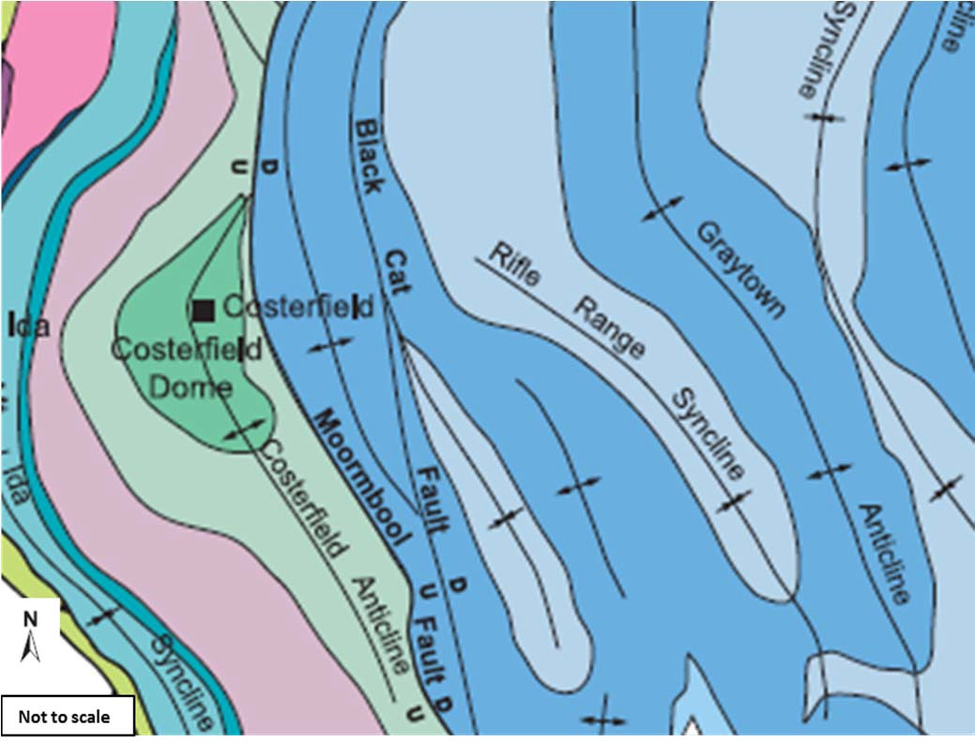
Figure 3: Regional Geology, showing Costerfield Dome
(extracted from SRK Consulting 2013 and created by Vandenberg et. al 2000)

The Costerfield Dome is part of a broad gold-antimony province. Mineralisation in the area is thought to have occurred approximately 380 to 370 million years ago, during subduction of a region of crust (referred to as the ‘Selwyn Block’) under the mafic volcanic region of the Bendigo Zone. During the subduction

event deposits rich in stibnite, and gold, were intruded along steeply dipping cracks east of the crest of the Costerfield Dome.
Five zones of significant mineralisation have been identified within the Costerfield area comprising the following:

- The Costerfield Zone, located within close proximity to the axial region of the Costerfield Dome including the Costerfield Township and dome peak. This zone hosts the major ore deposits.

- The Western Zone, about 1.5 km west of Costerfield, on the western boundary of the Costerfield Zone.

- The Antimony Creek Zone, located approximately 6.5 km south-west of Costerfield, on the outer west boundary of the Costerfield Dome.

- The Robinsons-Browns Zone, 2 km east of Costerfield.
- The North Western Zone, approximately 2- 3 km, north-west of the Costerfield Main mine, comprising Damper mine and Shellback Gully.

These zones of mineralisation have been mined for ore containing gold and antimony. The historic mines located within each of the five identified areas of mineralisation are presented in Figure 4.

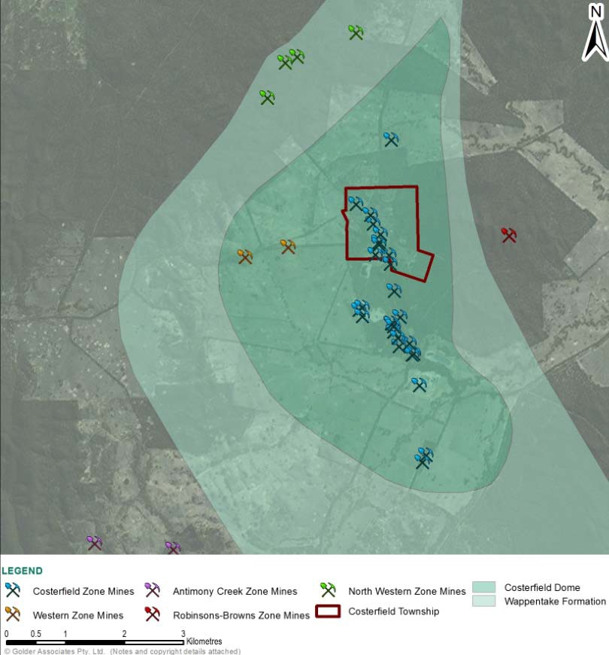

Figure 4: Five primary zones of mineralisation, as indicated by the presence of historic mines

The Ore
Mineralised zones within the Costerfield Formation typically consist of quartz veins and adjacent altered host rocks, which contain sulphide minerals. The principal sulphide minerals present are stibnite (Sb2S3), pyrite (FeS2) and arsenopyrite (FeAsS). There are also minor occurrences of chalcopyrite (CuFeS2), sphalerite (Zn,Fe)S), gelana (PbS) and aurostibite (AuSb2), (Mandalay Resources, 2012). Examples of mineral deposits in the Costerfield area are presented in Figure 5.

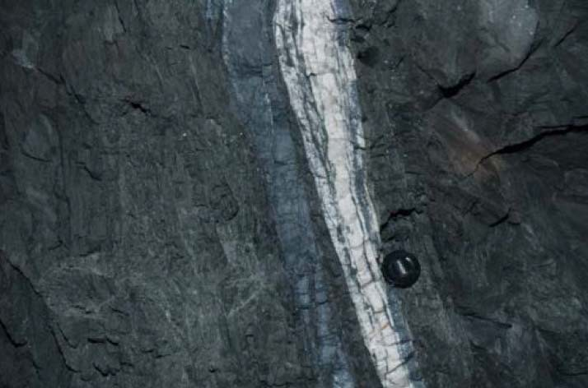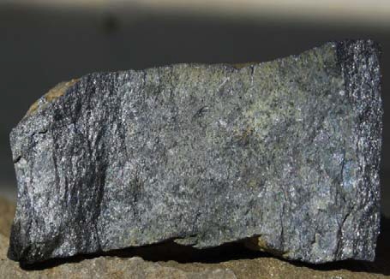
Quartz
Sulphide vein,
rich in stibnite

(a) Stibnite mineralisation, adjacent to quartz vein, at Costerfield. The lens cap is 67 mm in diameter
- Massive, fine grained, stibnite from Alison’s mine, Costerfield

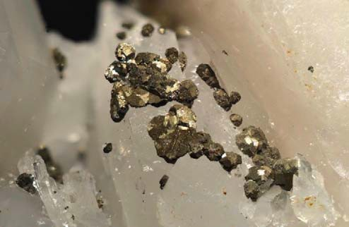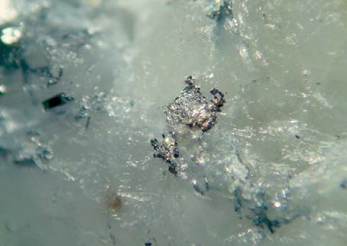
- Small pyrite crystals, from Augusta mine (d) Aurostibnite (from Cuffley Lode)
Figure 5: Examples of mineral deposits in the Costerfield area 1

The stibnite deposits in Costerfield are dissimilar to gold deposits found within the central Victorian Gold Mining Region, they formed at a different time under different geological conditions.
Costerfield has the largest known concentration of stibnite ore in Victoria (Phillips et al., 1996). The two next largest known concentrations of stibnite occur at Ringwood and Coimadai (Phillips et al., 1996). Low quantities of stibnite have also been found at other gold mining locations within the Melbourne zone, including Nagambie, Clonbinane and Whroo (Phillips et al., 1996), however antimony deposits at other mines within Victoria are not comparable to the quantity extracted at Costerfield.

Mineral Enrichment Halos
Stibnite mineralisation within Costerfield is thought to have occurred by the intrusion and solidification of low temperature deep igneous fluids, along existing faults in a host rock. The igneous intrusions typically contain a range of minerals and base metals such as antimony and gold.
Halos of metal enrichment (i.e. elevated metal concentrations) have been reported within rock immediately surrounding mineral ore deposits (Arne and House 2009). The findings of a geochemical

1 Images (a) sourced from SRK Consulting (2013).Images (b), (c), (d) sourced from www.mindat.org.com

study, of sub-surface soils (collected from the C-horizon) at Augusta and Brunswick Mine in Costerfield, reported dispersion halos of metal enrichment, around mineral deposits. The results of this geochemical study (undertaken by Department of Primary Industries, and reported by Arne et. al., (2008) and Arne and House (2009)) are summarised below:

      - Metal enrichment halos typically extend up to 50 metres from the ore deposit, characterised by antimony concentrations up to 50 mg/kg.

      - Low levels of antimony enrichment were reported greater than 140 metres from ore deposits.
      - Other elements (gold, molybdenum, copper, manganese, and bismuth) were also reported enriched within close proximity (typically within 10 metres) of ore deposits; however enrichment of these
metals was less consistent than that of arsenic and antimony.

      - The assessment indicated that mercury concentrations may also be elevated above background concentrations within enrichment halos in Costerfield, however data supporting this was limited and
mercury concentrations were commonly below or very close to laboratory detection limits.

      - Sulphur, carbon and calcium are also associated with metal enrichment halos.
A summary of the reported metal concentrations within ore, mineral enrichment halos and soils, in the Costerfield area are presented in Table 1. The soil data is further described in Section 2.3.
Table 1: Metal concentrations within Costerfield Ore, Enrichment Halos and Background in mg/kg
Element | Mineral Ore mg/kg1 | Concentration within enrichment halo in mg/kg2 (  enrichment halo extent in m) | Costerfield exploration lower threshold  concentration mg/kg2) | Average Concentration  within the earth crust mg/kg3
Antimony | 2400-100,000 | 50 (45) | 5 | 0.15-1
Arsenic | 132-954 | 150 (5) | 20 | 1.7-5
Gold4 | 1.55-19.9 | 0.135 (5) | < 0.005 | 0.001-0.005
Copper | 28-41 | 40 (70) | - | 14-100
Manganese | 392-795 | 800 (25) | - | 155-1549
Bismuth | 1.9-5.9 | 0.7 (10) | <0.7 | 0.0029-0.2
Molybdenum | <1 | 0.5 (10) | - | 1-15
Mercury | < 2 | - | - | 0.03-0.5
Notes:
- Mineral ore data provided to Golder by Mandalay resources, August 2014, data presented within Appendix B.
- Samples predominantly collected in the C horizon, data reported within Arne and House 2008 and Arne and House 2009. Data reported as the lower threshold concentration used to identify the presence of enrichment halo’s. Lower threshold concentrations not reported for all metals.
- Estimates of expected crustal abundance of metals (Smith and Huyck, 1999).
- Results for gold presented in g/tonne.

Concentrations of antimony, arsenic, gold and bismuth, within mineralisation halos around ore deposits in the Costerfield area, are significantly elevated compared to average concentrations of these metals within the earth’s crust.

Based on the lower concentration threshold, which is used during exploration to distinguish mineral enrichment halos from background conditions, background concentrations of antimony within soils outside of mineralisation halos are typically less than 5 mg/kg.

Soil

Soil Profile
Surface soils in the Costerfield area comprise of mine wastes (material which has been disturbed during mining activities) and natural soils (i.e. soils, which have not been significantly excavated, moved or contaminated by human activities). Examples of the soil types are shown in Figure 6.

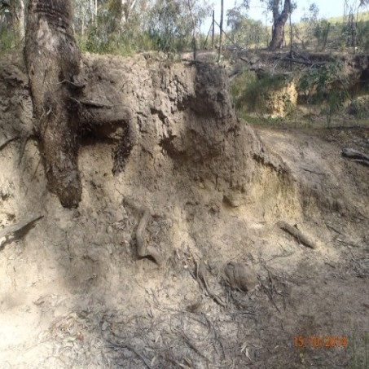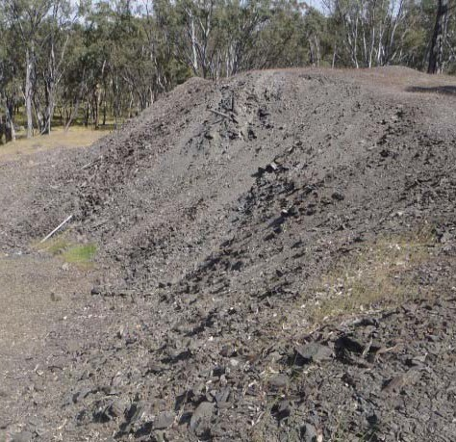

a) Shallow Weathered Costerfield Soils (Siltstone)
(b) Disturbed Costerfield Siltstone
– mine waste

Figure 6: Examples of Surface soils in the Costerfield area

Undisturbed, near surface soils in the Costerfield Township typically comprise Quaternary sediments and alluvial and colluvial soils eroded from the Silurian siltstones and sandstones of the Wappentake Formation, Dargile Formation, McIvor Sandstone and Costerfield Formation. The thickness of the alluvial and colluvial soils ranges from shallow deposits at the peak of the Costerfield Dome, to 6 m thick, near the Augusta Mine site (SRK Consulting, 2013). The alluvial and colluvial soils overlie the Costerfield Formation. The Costerfield Formation comprises siltstones of greater than 600 m thick.
Much of the natural soil profile within the Costerfield area has been modified by the following:

- Increased weathering due to land clearing and changes in surface water movement.
- Excavation of sub-surface soils and re-distribution at the surface.
- Mine processes (including crushing) leading to physical and chemical changes to soil and rock properties.

- Addition of mine wastes to the soil surface.
The Department of Environment and Primary Industries (DEPI), which is now part of DEDJTR has compiled soil, sediment and rock data collected within the Costerfield area and surrounds, for the purpose of mineral exploration (Arne and House, 2009).

In order to understand the distribution and concentration of antimony in the Costerfield area, Golder has extracted the DEPI data, collected within the Costerfield Dome area2, and separated the data into the following inferred soil units:

  - Shallow soils (0-30 cm) - comprising both disturbed and natural soils.
  - Inferred alluvial soils (30 cm to 6 m) - likely to comprise predominantly of alluvial soils of the Wappentake Formation, but may include disturbed soils/fill within the near surface and weathered
soils of the Costerfield Formation.

  - Bedrock (soils greater than 6 m below ground level) - inferred to be Costerfield siltstones.
Of the potentially enriched metals (listed in Table 1) antimony and arsenic were the only metals which had adequate depth data to undertake statistical assessment.
A summary of DEPI data for soil and bedrock samples collected from within the Costerfield Dome area is presented in Appendix B. A statistical summary of the data is presented in Table 2.
Table 2: Summary of DEPI soil and Bedrock data within the Costerfield Dome
Metal | Depth (m bgl) | Sample Count | Minimum (mg/Kg) | Maximum (mg/Kg) | Mean (mg/Kg)* | 95% Upper Confidence Limit (mg/Kg)*
Antimony | 0-0.3 | 4375 | 2 | 710,000 | 46.5 | 47.6
 | 0.3 to 6 | 272 | 2 | 10,000 | 9.4 | 10.5
 | > 6 | 50 | 4 | 950 | 27.7 | 29.1
Arsenic | 0-0.3 | 298 | 2 | 200 | 11.4 | 12.5
 | 0.3 to 6 | 272 | 2 | 999 | 10.2 | 11.3
 | > 6 | 50 | 2 | 251 | 10.4 | 11.9
* NOTE: The original datasets are skewed to the right, so the mean and confidence intervals were calculated on natural log- transformed data, and then transformed back to the original scale by inversing the log summary statistics.
The surface soils in the Costerfield area contain concentrations of antimony greater than the concentration within the underlying alluvial soils and greater than the expected concentration within mineral enrichment halos (as defined within Arne and House, 2009). This suggests that antimony has been added to the soil surface and is unlikely (at least in some areas) a result of natural soil enrichment associated with mineralisation.
The mean arsenic concentrations in the surface soils are comparable to concentrations within the underlying alluvial soils (0.3-6 m) and consistent with expected levels associated within mineral halos (as defined within Arne and House, 2009).

2 The area was defined based on the geological boundary of the Costerfield Dome presented as shown in Figure 4.

Metal Enrichment Patterns in Soil
Assessments undertaken by DEPI report that arsenic concentrations in Costerfield soils positively correlate with elevated antimony soil concentrations (i.e. where antimony concentrations are high, arsenic concentrations are also likely to be elevated) (Arne, 2009).
Where strong geochemical correlations are present, these relationships can be used to distinguish whether the soil has been disturbed or not (i.e. distinguish natural insitu material of the Costerfield Formation from mine waste soils). For example; natural undisturbed soils may have a different ratio of antimony to arsenic compared to material that has been subjected to antimony extraction, via mine processes. This theory of using geochemical indices to distinguish background metal concentrations from human inputs of contamination has been adopted within Australian legislation (NEPC, 2013).
Golder has assessed correlations between antimony and other soil parameters within the DEPI data set. The assessment results indicate that:

- Antimony concentrations in soil moderately correlate with arsenic concentrations.
- Arsenic concentrations in soil positively correlate with iron concentrations.
- Antimony concentrations in soil were poorly positively correlated with iron concentrations.
These observed correlations provide an indication of potential relationships which may assist in understanding the origin of the material (i.e. whether it has undergone mineral extraction processes). However due to high variation in the dataset, the current information does not provide a conclusive means for distinguishing soils of natural mineral enrichment from mine waste.
Other indicators, such as particle size and the presence of processing chemicals may also be used as indicators mine processing.

Hydrogeological Setting

General
The Costerfield township is located in the western extent of the Goulburn Broken Catchment Region, which extends from Heathcote to Mt Buller in an East West direction and from Marysville to the Murray River in a north south direction.
The local groundwater systems consist of two aquifers; the near surface perched alluvial aquifer and the deeper regional aquifer, within the Costerfield Formation.
The near surface perched alluvial aquifer is fed by soaks and surface water systems and is laterally discontinuous. It occurs sporadically within the near surface alluvial silts, sands and gravels of the Wappentake Formation. The depth of groundwater within the perched alluvial aquifer is typically less than 4 m below the ground level (SRK Consulting, 2013). The perched alluvial aquifer is likely to connect surface water features, on a local scale, but is unlikely to be connected to the deeper regional aquifer (SRK Consulting, 2013).
The deeper regional aquifer is present within the Costerfield Siltstones. The depth of groundwater within the deeper regional aquifer is typically greater than 20 metres from the natural surface (SRK Consulting, 2013). Groundwater is predominantly transmitted through fracture systems and faults and as such is highly variable in yield and quality.
Regional groundwater typically flows in a northerly direction eventually flowing into the deep lead system and the Murray Darling System (SRK Consulting, 2013). Piezometer results support the northerly groundwater flow direction (SRK Consulting, 2013).

The fault structures in the Costerfield Formation strike north. Groundwater drawdown, associated with mine works has a strong north south orientation, likely associated with the strike direction (SRK Consulting, 2013).
The total dissolved solids (TDS) content of groundwater in the area of the site is expected to be in the range of 3,501 – 13,000 mg/L, indicating moderately saline conditions.
A review of groundwater bores undertaken using the Visualising Victoria’s Groundwater database indicated that 46 registered groundwater bores are within 5 km of the township. The location of these bores is shown in Figure 7 below. Bores were listed for the following purposes:

- 17 registered as non-groundwater bores.
- 14 registered for investigation or observation.
- 4 domestic bores, three located north of the township and 1 located south of the township.
- 1 registered for irrigation, located between the Augusta Mine (where groundwater is being actively dewatered for mining purposes) and Brunswick mine. Construction details indicate that the bore is
75 m deep and therefore screened within the deeper regional aquifer.

- 3 registered for industrial use at or near the current mining operation.
- 7 for unknown use.
Data collected by Visualizing Victoria indicates that yield rates from stock bores (at depths of 30 to 50 meters) within the Costerfield area varies from approximately 0.25 to 2.7 litres per second, with greater yields within areas of high sand content.
It is noted that groundwater and surface water extraction may occur at additional locations, during unlicensed water extraction processes. During Golder’s discussions with property owners in the area in late 2014, it was indicated that residents typically do not extract groundwater for drinking or recreational use.

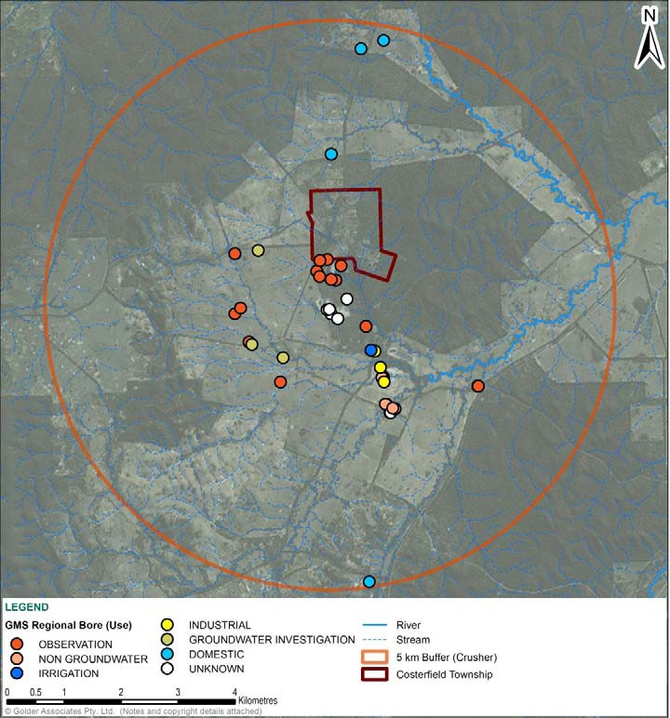
Figure 7: Groundwater Bores within the Costerfield area

Dewatering
Dewatering works at the Augusta Mine have created a cone of depression in the regional water table in the vicinity of the mine workings at approximately 100 m from the surface at its lowest point (Figure 8).
Current and historical mine processes including dewatering, water storage and discharge of treated water to surface water is likely to have had a significant influence on local hydrogeology.
In addition, dewatering, during mining activities, has the potential to cause oxidation of the bedrock. Oxidation of rock, high in sulphides, may cause chemical changes, which result in increased metal mobility (i.e. movement in the environment).
Current water management practices at the Augusta mine are discussed in Section 3.5.

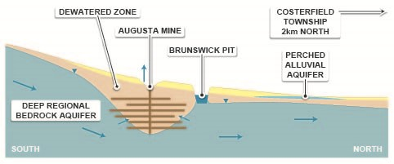

Figure 8: Conceptual groundwater flow, showing influence of dewatering at Augusta Mine

Figure adapted from SRK Consulting (2013).

Surface Water
The Costerfield area is interlaced with a network of shallow water ways and tributaries that feed into the Wappentake Creek system, which runs in a north easterly direction, south of the Costerfield Township and culminating in the Goulburn River.
Tin Pot Gully is a minor creek bed running roughly parallel to the Heathcote-Nagambie Road in a southerly direction, through the Costerfield township. Tin Pot Gully Creek flows into Wappentake Creek approximately 500 m south-east of the present day Augusta Mine site.
Multiple alluvial streams were explored in the early days of mining in the area along the Tin Pot Gully Creek and surrounds, resulting in significant disturbance of local waterways. In addition, it is likely that during historic mining activities, mine wastes, such as tailings, would have been released to surface water features with little or no pre-treatment.

HISTORY OF THE COSTERFIELD AREA
The following sections describe historical activities which have occurred in the Costerfield area, which may have resulted in contamination of the environment, particularly relating to disturbance of soil/rock and the movement of soil and mine wastes. These activities have included mining, agriculture and residential development.
The history of Costerfield is summarised on the timeline presented in Figure 9.

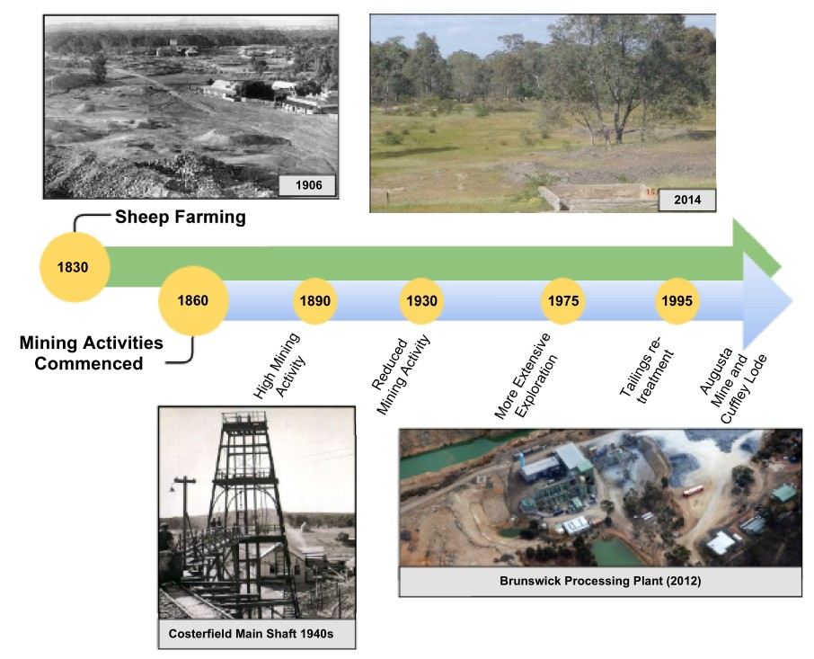
Costerfield Township
Costerfield Main Shaft

Figure 9: Timeline of historical activities in Costerfield

Settlement of Costerfield
A review of documents regarding settlement of Costerfield and historical activities within the area indicates the following:

- Prior to the 1840’s low intensity farming occurred in the greater Costerfield region. Most of the land around Costerfield was licenced to a single farmer as part of the Campaspe Plains Sheep run,
extending 45,000 acres (Context Pty Ltd, 2009). During the 1840’s Campaspe Plains was subdivided into a series of smaller runs (Context Pty Ltd, 2009).

- The town of Costerfield was developed in the 1860’s entirely based on the presence of mining activities (with the name of the town derived from Coster and Field, who first claimed the presence of
stibnite and gold within the area).

- The population of Costerfield has been through periods of boom and bust associated with the mine activities, however even during high mining production periods, the population of miners within
Costerfield was small (120 men were employed at the Costerfield mines during 1863) compared to the thousands of prospectors present in Heathcote and other gold mining centres, such as Bendigo

and Castlemaine (Whitelaw, 1926 and Bannear, 1998). The population of Costerfield and commercial development has decreased since the peak mining period in the early 20th Century.

- Residential and commercial infrastructure within the town has been limited, with the predominant buildings in the centre of the town comprising the “Antimony Hotel” (Figure 10), the town hall and the
post office (built in 1863) (Context Pty Ltd, 2009). Historical maps of the town (as shown in Figure
19) show that a sports reserve, tennis courts, two churches, a state school, a potter and a piggery were present within Costerfield in 1926.

- The school in Costerfield was constructed in the 1870’s and opened in 1875. Ten students were reported to attend the school in 1894 (The McIvor Times, Dec 1894). The school grew in the 1910-
1920’s with additional class rooms developed. However, as mining activities diminished following the 1940’s and the town population decreased, the original school building was removed in 1963 (Context Pty Ltd, 2009).

- Residential development has remained low, with few new buildings present within the area post the 1970’s.

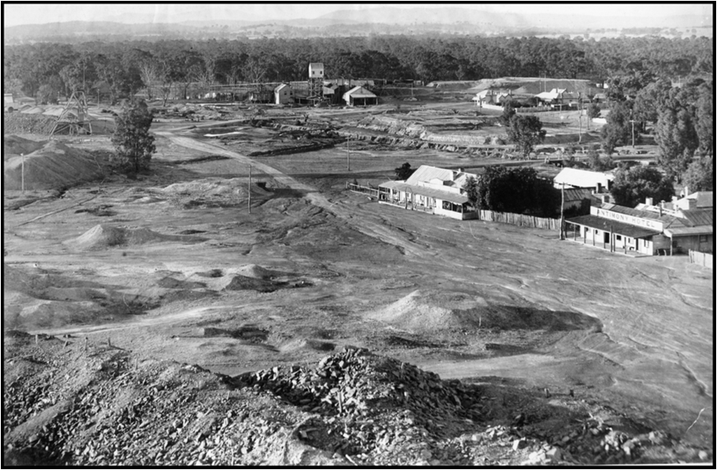
Minerva Mine Shaft

Water diversion channel

The Antimony Hotel

Historical Main Street

Mine tailings and mullock heaps

Figure 10: Costerfield Township, 19063

3 Photo published by Anne Bradley, Pioneers of Costerfield 2009, looking South towards the Minerva Mine. Large stockpiles of tailings shown within the town centre. Photo taken from the Costerfield Main Mine.

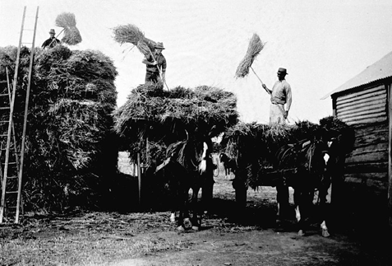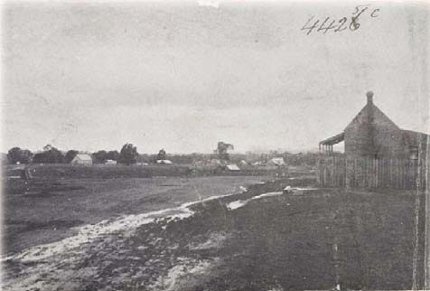
Figure 11: (a) Men creating hay bales in Costerfield, 19304; (b) Residential development within the Costerfield Township (photo likely taken between 1900s and 1940s)

Regional Mining Activities
Mining within the regional area of Costerfield-Heathcote commenced in the 1850’s. The discovery of alluvial gold near Heathcote attracted over 16,000 prospectors and miners to the town by 1852.
Gold mining activities initially commenced using pans, puddling machines, and sluicing (Figure 12). Mining activities in Heathcote were predominately for extraction of gold.

4 Photo sourced from Museum of Victoria

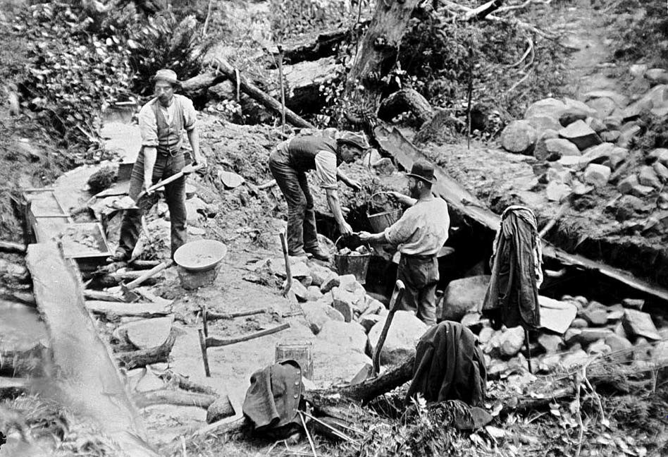
Diverted Water
Sluice Box
Figure 12: Example of miners sluicing for Gold at Tarnagulla, Central Victoria, 18805

Sluicing methods typically comprised diversion of water through a sluice box, to separate heavy materials from fines. As such, historical mining activities resulted in excavation of multiple water channels, diversion of creeks and stockpiling/relocation of sluiced material.

Mining in Costerfield
Mineral ore deposits were first officially reported in the Costerfield area in 1860 (Whitelaw 1926) when a shepherd informed prospectors (Youle, Coster and Field) of a white surface outcrop projecting 4 feet out of the ground. The outcrop comprised an oxidised heavy lead-grey mass of stibnite (antimony sulphide), inside which gold was visible (Whitelaw, 1926). The outcrop was located at what is now known as the Costerfield Main Reef.
The discovery of the stibnite outcrop in the 1860’s fuelled extensive exploration and mining of both gold and antimony within Costerfield, uncovering multiple ore enriched quartz veins.
Over 20 mine and shaft sites have been identified within the Costerfield area, many of which are located adjacent to the Costerfield anticline.
Historic mining occurred by both open cut and underground mining and was most productive during two periods, 1860 to 1883 and 1904 to 1925, with only intermittent small scale production during 1934 to 1950.

5 , photo Reg No. MM 001203, sourced from Museum of Victoria

Historic mining techniques had limited capacity to recover antimony. As mineral extraction techniques have improved, several attempts have been made to re-treat historical tailings in the area.
In 1926 a company “Costerfield Antox Company” purchased the Costerfield mine area. The Costerfield Antox Company extracted metals from tailings and manufactured antimony products including paints. The manufacture of paints is expected to have been undertaken near Minerva mine. During 1995, a processing plant was constructed for the re-treatment of tailings and the oxide portion of the mine wastes at the Brunswick open pit mine (Mandalay Resources, 2012).
Since 1970’s the Costerfield area has undergone more extensive exploration, including geochemical sampling and drilling, resulting in the discovery of the Augusta deposit in 1975 and the Cuffley Lode in 2011, located less than 500 metres north of the Augusta mine.
Remnants of the historical mine activities, including concrete footings, sheds, chimneys and tailings remain within the Costerfield Township (See Figure 13).

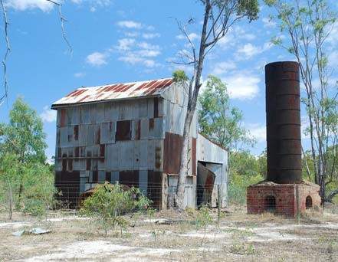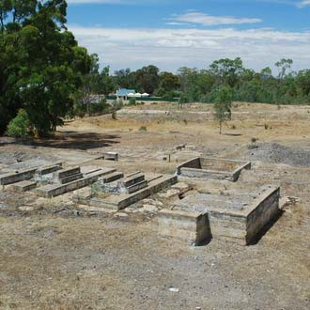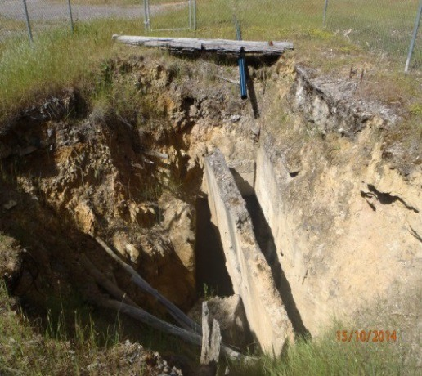

- Remnants of corrugated iron battery shed & iron chimneystack, at Bombay mine
- Remnant footings at Costerfield Main Shaft
- Remnants at the Costerfield Main Shaft

Figure 13: Remnants of historical mine infrastructure

Mining Processes
Mine processes for extraction of gold/antimony are summarised in Figure 14, below.

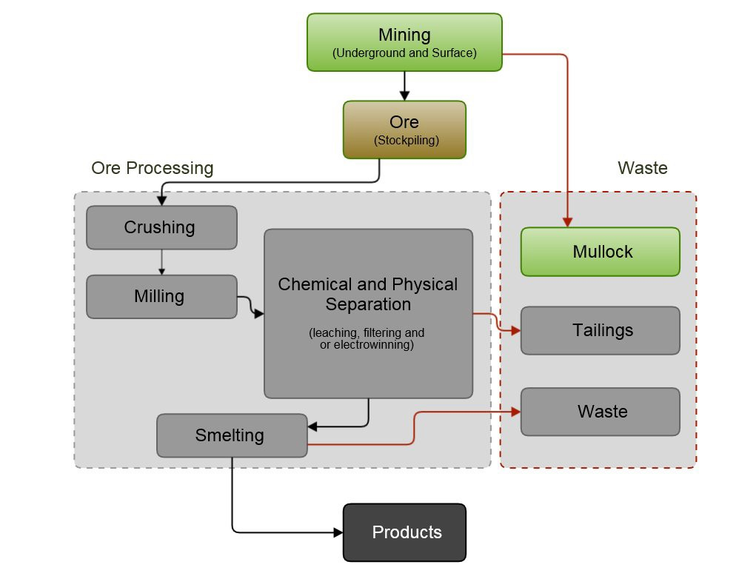

Figure 14: Typical Mine Processes and wastes generated

The mineral extraction processes recorded within the Costerfield area (as described by Bannear (1993)) are summarised in

Table 3. A summary of periods of use and extraction processes utilised at the main antimony mines within Costerfield is presented in Table C1, Appendix C. Additional processing facilities or processing methods may have been used, without being reported within the reviewed information.

Table 3: Summary of Historic Mining Processes within Costerfield
Summary of Process | Occurrence at Costerfield
Crushing: machines known as crushers, stamp mills, or stamp batteries, are used to pulverise the rock. | Battery crushers were used at many of the mine sites within Costerfield and were historically run by steam powered engines. The need to fuel steam engines lead to extensive felling of trees within regional Victoria.  Diesel engines were typically used to generate crushing machinery following the 1930’s.  Water wheels were used to generate crushing machinery at Robinsons Reef.
Ball Milling: typically a rotating horizontal cylinder containing steel balls, referred to as a “Ball Mill” is used to further crush rock/sands, to create a fine powder or slurry. | Ball milling is likely to have occurred at several of the mine site. Two ball mills are currently used at the Brunswick processing facility.
Roasting: heating of material to oxidise sulphur and organic carbon. | Roasting is likely to have occurred at many of the mine sites in Costerfield, including the Costerfield Main Mine. Roasting was also historically used to burn off antimony (reducing antimony content assisted with the effectiveness of gold extraction).
Leaching: chemical solvents (commonly cyanide) are used to dissolve the gold and antimony. | Cyaniding has occurred at many of the mine sites in Costerfield. At the Bombay site there are records of cyaniding and precipitating gold, using zinc. Zinc powder has historically been used to combine with the cyanide, assisting the precipitation of gold. Lead nitrate may have been used to activate the zinc dust during this process or as an accelerator in the cyaniding  process. The remnants of the cyanide works remain at the Bombay mine site and Tait’s shaft.
Refining: removal of other metals, such as silver from gold (often via chlorination). | It is reported that chlorination plants were used for metal extraction at Taits shaft, Bombay mine, and Morning Star mines.
Filtering and or stripping | Amalgamation of gold with mercury (also referred to as quicksilver) was used unsuccessfully for a short period at the Minerva mine and Bombay mine due to “mercury loss” (Bannear, 1993).
Electrowinning: recovery of the gold/antimony from the leaching chemicals using electrical current. | Electrowinning processing facilities are currently present at the Brunswick processing plant.
Smelting: melting of the recovered metals, separation using flux chemicals and pouring of molten gold/antimony into solid bars or moulds. | Smelting occurred at multiple locations across the Costerfield mine fields including the Minerva and the Bombay mine.
  - Distribution of Mine Wastes
Mining processes produce wastes, comprising material of different particle size and chemical composition, including the following:

- Mullock and overburden rock generated during the excavation of the mine and physical separation of the ore from the host rock.

- Tailings comprising coarse to fine grained particles, generated from the crushing and milling of material, which may contain chemicals used for metal extraction.

- Liquid wastes and slurries comprising fine particles and potentially chemicals used during the extraction process.

- Atmospheric emissions comprising gases and fine particles associated with crushing, roasting, and or chemical processing of material.

The Costerfield Township was built in the center of the mining activities, with the historical main street running north to south, adjacent to many of the mine shafts and tailings stockpiles (Figure 15).

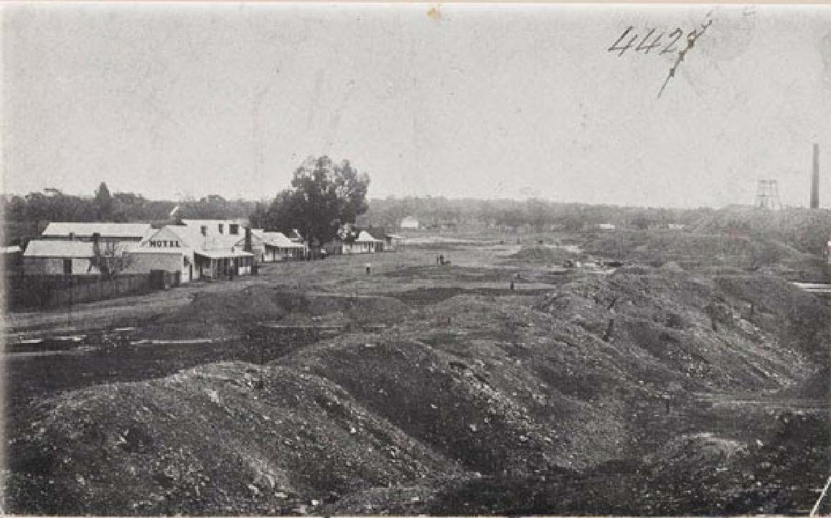
Costerfield Main Mine
Historical Main Street
Tailings and Mine
Figure 15: Costerfield township and mine tailings
Photo taken looking north towards the Costerfield Main Mine down the former main road, estimated within the 1900s to 1940s.

Mining processes within the Costerfield area have included hauling of mine material and extensive stockpiling of mine waste materials. A map showing the distribution of mine waste in 1926 is presented below.

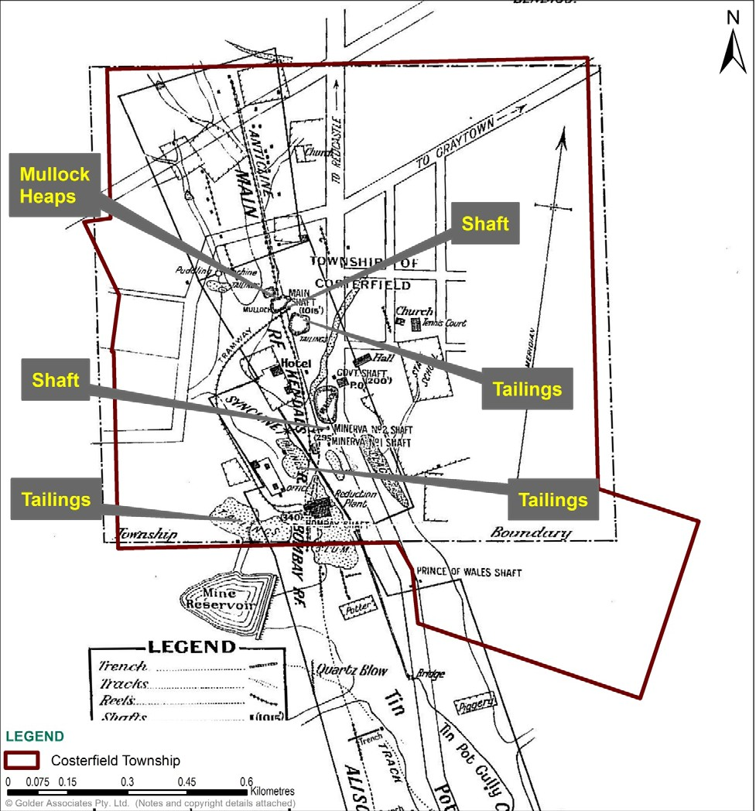
Figure 16: Location of Mine waste, including tailings, within the township of Costerfield during 1926

Many of the mine tailing stockpiles, present in 1926, are still present within the Costerfield Township. The current distribution of tailings is further described in Section 4.0.

Current Mining Activities
The Costerfield mine area has had a large number of different operators since 1860. Mine operations in the Costerfield area are currently owned by Mandalay Resources and are currently limited to the Augusta mine and Cuffley Lode as presented in Figure 17 below.

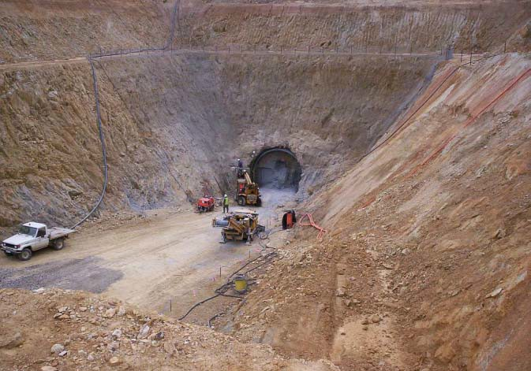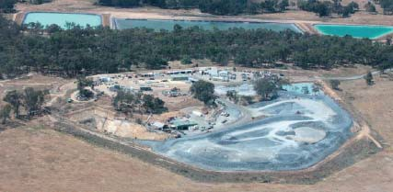
(a) Augusta Underground Mine (b) Augusta Mine, aerial view
Figure 17 (a) Augusta Underground Mine 6(b) The Augusta Mine Site groundwater evaporation ponds shown in top of photo7

Ore from the Augusta mine and Cuffley Lode is transported to the Brunswick Processing Plant, Figure 18, for processing. The processing plant produces gold and antimony sulphide concentrate, which is shipped offsite to external smelters (SRK Consulting, 2013).
Excess waste rock from the Augusta mine is stockpiled at the Augusta mine site, Brunswick tailings facility and the Bombay Tailings Facility. The waste rock is proposed to be used to fill the box cut and cap the tailing storage facility at the end of the mine’s life (verbal communications, with Mandalay Resources, November 2014).

6 Sourced from http://adriancummins.com/projects.html
7 Sourced from Mandalay (2012)

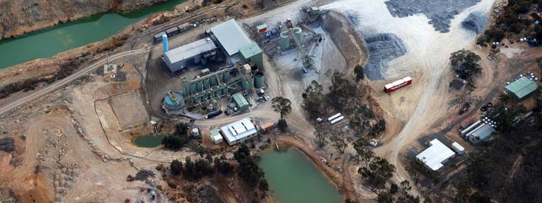
Former Open Mine Pit
Crushing
and Milling
Catchment Dam
Figure 18: The Brunswick Processing Plant (Mandalay Resources, 2012)

The Brunswick Processing Plant comprises a two-stage crushing process, two milling stages in series, with closed circuit classification and gravity concentration. The flotation circuit produces antimony-gold flotation concentrate (SKR Consulting, 2013). The flotation tailings are sent to an onsite tailings storage facility. Flotation processes typically use chemical conditioning agents and intense agitation and/or sparging of the crushed ore slurry to produce mineral rich foam concentrate.
A facility for cyanide gold dissolution and adsorption followed by elution, electrowinning and smelting to produce bullion also exists within Brunswick Processing Plant, however this facility was decommissioned in 2011 (Snowden, 2012). Active mines within Costerfield area no longer use cyanide or have cyanide stored onsite, other than within tailings dam deposits from historical use (Snowden, 2012).

Water Management
Dewatering is currently undertaken at Augusta Mine and Cuffley Lode. The current rate of extraction of groundwater from around the Augusta mine is about 600 mega litres per year; removal of groundwater within the mine is undertaken at a rate of 19 litres per second (SRK Consulting, 2013 and Personal Communications with Mandalay Resources, November 2014).
Mine water is pumped from the underground Augusta mine to a disused open pit mine, the Brunswick Pit, and to evaporation ponds adjacent to the Augusta mine facilities. It is understood that Mandalay is not permitted to discharge untreated groundwater from the mine site.
In the past, emergency haulage of water to the Heathcote Mine Open Pit and an unsuccessful trial of reinjection of water to the deep aquifer via the Bombay shaft have been permitted for control of water levels. In addition, groundwater, town water and reverse osmosis treated water have been used for dust suppression. Groundwater is no longer used for dust suppression at Mandalay Resources’ mines, except within the Brunswick Processing Plant.
During August 2014, a reverse osmosis water treatment system was installed to treat groundwater prior to discharge to surrounding creeks. Also, construction is currently underway for additional evaporation ponds at an area of land known as Splitters Creek to increase the quantity of groundwater evaporated (Personal Communication with Mandalay Resources, November 2014).

4.0 WALKOVER OF THE COSTERFIELD AREA
A site walk over of the Costerfield area was undertaken to support the desktop review. The purpose of the site walkover was to assess the current condition of areas of historical mining, specifically the distribution of tailings and mine waste materials. The walkover was undertaken by an engineering geologist from Golder on 15 October 2014.
Selected field observations are provided in Appendix D. Historical mining waste was observed within the Costerfield area. Some revegetation has occurred, but in general vegetation is sparse and mining waste is visible at the ground surface. Some present day unsealed roads traverse through areas that were formerly (and likely are currently) underlain by mining waste. Locations at which fine grained materials, inferred to be historical mine tailings, are currently visible in some areas as presented in Figure 19. Many of the tailings locations observed are consistent with indications on the 1926 map of Costerfield (Figure 16). At some locations, mainly south of Costerfield, it appears that tailings may have been removed (possibly reprocessed), and some areas rehabilitated.
In addition to sites within the immediate vicinity of Costerfield, a field traverse was undertaken west from Costerfield towards Robinsons Reef and Brown’s Diggings. These are within sparsely vegetated areas. Evidence for mining activity remains including dams, inferred mine waste and channels. A traverse was also undertaken towards the west of Costerfield towards the West Costerfield Reef. This is a sparsely vegetated area, with similar evidence of historical mining as was observed to the east of Costerfield.

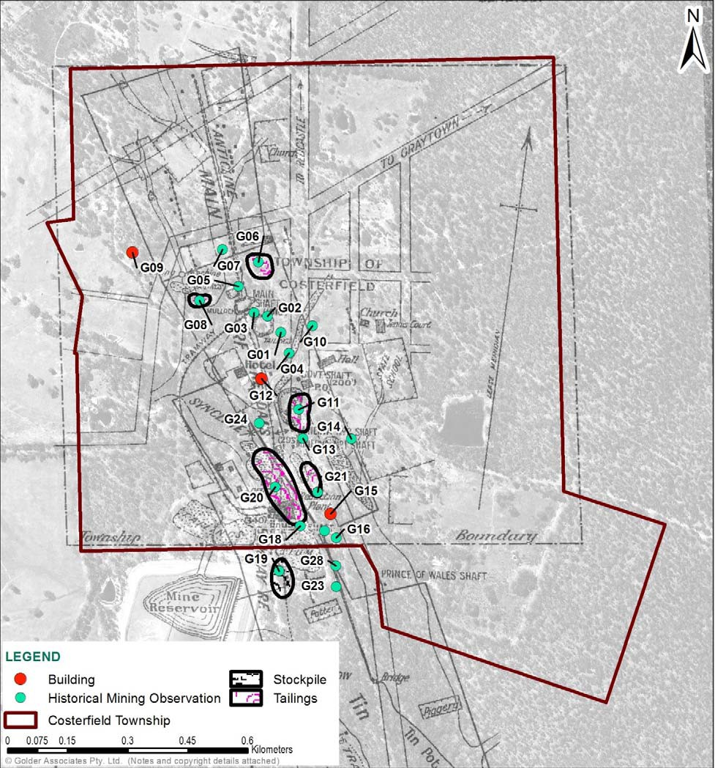
Figure 19: Site observations during walkover of the Costerfield area

Selected field observations (numbered G01 to G28) are described in Appendix D.

POTENTIAL SOURCES OF ANTIMONY AND RELATED CHEMICALS IN THE ENVIRONMENT
The purpose of this desktop review is to support the development of a comprehensive health risk assessment by providing an understanding of the nature, transport and distribution of antimony and related chemicals in the environment. Although focused on antimony, the human health risk assessment will aim to consider potential cumulative exposure to other potential chemicals of interest that may be present with antimony in the Costerfield area. The following sections describe the process undertaken to identify the potential chemicals of interest and associated sources of antimony and related chemicals to the environment.

Identification of Potential Chemicals of Interest
Based on the desktop review, Golder has reviewed related chemicals of interest, in addition to antimony, which may require consideration in a comprehensive human health risk assessment.
A limited environmental assessment of Mandalay’s processes (undertaken by Snowden, 2012) reported that potential contaminants to the environment associated with the Costerfield mines may include antimony (from stibnite), arsenic from (arsenopyrite), cyanide (from historical processing) as well as lead (lead nitrate), caustic soda, acids and other flotation reagents used in the gold extraction process (Snowden, 2012). Current data on the composition of tailings is limited. Tailings from different areas and different mine periods are likely to vary in metal concentrations.

Golder has undertaken a process to identify which of the identified chemicals are of potential concern, in particular with regard to potential health risks to residents within the Costerfield area. This process is presented in Appendix E. In summary, based on the potential sources of chemicals in the environment and the reviewed soil and ore data (Section 2.2.2), antimony and to a lesser extent arsenic are considered the key chemicals of interest for the purposes of assessment of human health risks.

Identification of Sources of Antimony and Related Chemicals
The chemicals associated with each of the potential sources of antimony are presented in Figure 20. The extensive distribution of mine wastes (particularly tailings) within Costerfield is likely a significant source of antimony and associated chemicals in the environment.

• antimony, arsenic, manganese, copper, gold, bismuth
Ore
• cyanide, chlorine, mercury, lead, zinc, floatation agents, acids and alkalis
Mine Processes
• antimony, arsenic, cyanide, mercury, lead, zinc
Mine Wastes
Figure 20: Source of potential contamination and associated chemicals of interest

Some materials used in a rural agricultural and residential setting may include antimony (such as lead shot from shooting and batteries). However, these sources of antimony are likely to be localised and/or sparsely distributed in the environment. Farming and residential development within the Costerfield area is unlikely to have significantly contributed to the antimony load within the local environment.

6.0 ANTIMONY BEHAVIOUR IN THE ENVIRONMENT
Typical antimony concentrations in the environment are low (Table F1, Appendix F), however they may be enriched in areas (i.e. mineral halos) associated with antimony mineralisation.
Antimony ore deposits in the Costerfield are have formed from the solidification of igneous intrusions (further described in Section 2.2.3) and are typically stable unless disturbed (i.e. change to the pH or redox of the environment).
Mine processes may alter the behaviour of antimony in the environment, including the mobility of antimony. The behaviour of antimony within the environment is summarised in the following sections and in Figure 21.

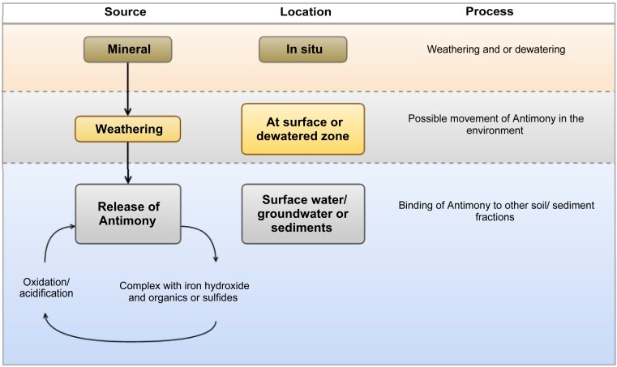

Figure 21: Simplified schematic of antimony behaviour within the environment

The chemical behaviour of antimony in the environment is described below. In soils:

- Antimony forms strong bonds with iron oxides (in aerobic ligands (in anoxic9 conditions) (Filella et al.2002).
8
conditions), and/or sulfides and organic

- Antimony typically has low mobility in the environment, except under highly oxidizing conditions (Wilson 2010).

Within mineral deposits:

- The weathering (oxidation
10
) of stibnite mineral deposits commonly results in the formation of

antimony oxides and iron oxides, which have limited mobility within the environment (Wilson, 2010).

- Dewatering of insitu mineral deposits (i.e. during mine activities) may result in oxidation of metal sulphides. Oxidation of metal sulphides can cause generation of acidity and subsequent increase
metal mobility. However, the presence of natural pH buffering chemicals, such as calcium, can mitigate soil/rock acidification.
In aquatic environments:

- Antimony is present as a result of rock weathering, soil runoff and anthropogenic activities.

8 Aerobic definition: requiring atmospheric oxygen in order to liver and grow.
9 Anoxic definition: lacking oxygen.
10 Oxidation definition: any chemical reaction that involves atoms or molecules losing electrons.

- Dissolved antimony in water commonly binds to iron oxides, reducing its mobility and transport.
Elevated antimony concentrations have been reported within streams and groundwater associated with antimony mines (Ashley et al., 2003).
Antimony concentration and mobility within mine wastes is likely to vary based on the mine processes undertaken, the grain size and a particle surface area, and environmental conditions. Limited data provided by Mandalay Resources (August 2014) reported typical antimony concentrations in the extracted ore (39,100 mg/kg), tailings (2,150 mg/kg) and waste rock (170 mg/kg).
Soil/rock naturally enriched in antimony is also commonly enriched with arsenic (Craw, 2004). Antimony and arsenic have similar chemical properties, where by the mobility of arsenic in the environment is driven by pH and redox potential (Wilson, 2010). Similar to antimony, arsenic (+3) is typically immobilised by sulfides, and arsenic (+5) is immobilised by binding to clays and forming bonds with iron oxides. Studies from surface water released from antimony mines in New South Wales, indicate that antimony is likely to
precipitate11 out of solution more readily than arsenic (Ashley et. al. 2003).

REVIEW OF SOURCE-PATHWAY-RECEIVING ENVIRONMENT
To assist in understanding the distribution of antimony and arsenic within the Costerfield area, Golder has identified the following:

- Source Materials - sources of antimony (and related chemicals) in the Costerfield area.
- Transport pathways - the potential pathways in which antimony (and related chemicals) may be re- distributed, moved or dispersed from the original source into the broader environment.

- Receiving environment – environmental media which have or may receive added antimony and associated chemicals.

Understanding potential linkages between sources of antimony and associated chemicals, pathways and the receiving environment can assist in assessing potential for exposure by occupiers or users of environment.

Source Materials
The key sources of antimony and associated chemicals in the Costerfield area are the result of antimony rich ore materials naturally present in soils and bedrock along with mine wastes that have redistributed within the landscape over the last 150 years.
The source materials can be present in many forms as described below:

- Overburden (i.e mullock) - material removed during excavation works (not significantly enriched in metals).

- Ore - is mined rock that contains sufficient mineralised zones that antimony can be economically extracted from the rock.

- Tailings - medium to fine grained materials remaining following ore extraction (may contain chemicals associated with mine processes).

11 Precipitate definition: a substance that has been chemically removed from solution by precipitation.

- Processing Wastes – includes;
- Mine slag - coarse grained materials derived following smelting of material, likely chemically altered (i.e. oxidised) during mine processes.
- Dust and atmospheric emissions - associated with mine processes (i.e. ventilation exhaust from material processing).
- Waste waters - may contain elevated concentrations of metals and mine processing chemicals.

Transport Pathways
Current and historical mining activities, including the storage and transportation of mine waste materials have the potential to add chemicals, including antimony, to the environment. The reviewed historical information provides a summary of mineral extraction processes used within the Costerfield area. The locations of where many of the mine processes occurred are currently not confirmed.
The potential release mechanisms and transport/migration pathways for antimony and associated chemicals from the identified source materials include:

- Dust - generated from wind erosion of exposed material (i.e. tailings), crushing of mined materials, vehicle driving on unsealed roads or dirt bikes driving on mine waste stockpiles.

- Airborne emissions – generated from roasting, crushing and chemical processes, resulting in deposition on surface soils.

- Surface runoff - typically generated from rainfall on stockpiled mine materials
- Infiltration - typically by rainwater through mine wastes, into subsurface soils and the underlying the bedrock, and/or groundwater. In addition, potential infiltration through oxidised bedrock, associated
with lowering of groundwater levels, resulting in chemical mobilisation of metals and infiltration into groundwater.

- Transport through groundwater (advection / dispersion) - into surface water bodies.
- Use of groundwater or surface water (including drinking, recreational use or irrigation).
- Potential uptake in plants and animals is possible; however antimony does not biomagnify through food chains.

Receiving Environment
Areas and environmental features which may experience added antimony concentrations due to migration of metals from mine wastes and or undisturbed mineralised material include:

- Surrounding surface soils - including agricultural, residential and forested areas.
- Surface water features - such as creeks, dams and rivers.
- Groundwater – shallow and deeper aquifers (perched alluvial aquifer and the deeper regional aquifer)

A schematic summarising the linkages between sources of antimony and the identified transport pathways and the potential receiving environment is presented in Figure 22.

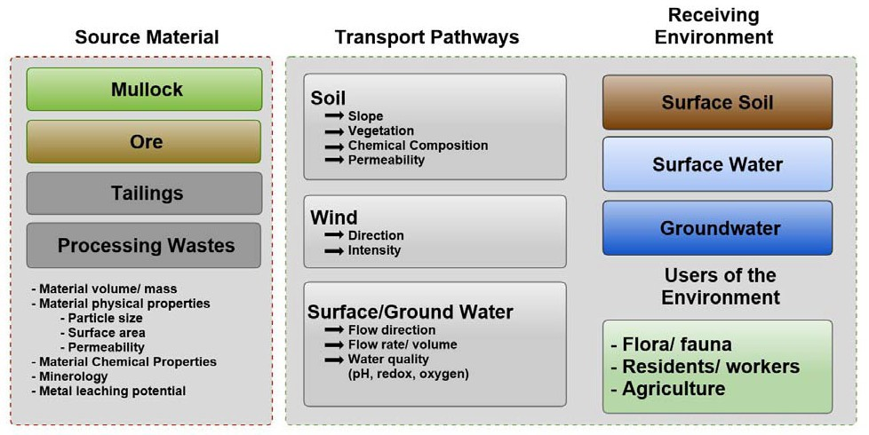

Figure 22: Schematic of linkages between sources and the receiving environment

Source, Pathway and Receiving Environment Linkages
Based on the reported metal concentrations and extensive history of soil disturbance in the Costerfield area, the key sources of antimony in excess of typical background conditions at the soil surface are mine wastes. Mine waste materials including tailings are distributed within the town; and much of this material has been exposed to weathering over the past 150 years. Mine wastes vary in metal content and particle size (from waste rock to slum, and particulates emitted from roasting of material and ventilation during processing). Weathering and dust generation is likely to be greater from fine grained mine wastes (such as tailings) compared to coarse large mine wastes (such as overburden).
The concentration of metals is typically greatest within the fine fractions of soils. Metal concentrations within dust generated from mine tailings may be proportionally greater than within the general tailings comprising a range of texture material classes.
In addition, added contaminants may be present within mine wastes due to mineral ore extraction processes.
Key pathways for movement of antimony (and related chemicals) in the environment which are likely to have influenced the distribution of antimony impacts include; direct movement of soil via trucking and hauling of ore and mine waste, and indirect secondary movement, via dust deposition, run off, or infiltration into surface water or groundwater. Other activities which generate dust (such as riding dirt bikes on tailings stockpiles) may increase migration of antimony.
Historic mine activities (by direct deposition and indirect run off) are likely to have resulted in release of antimony and related chemicals to surface water, which may have resulted in deposition of antimony hydraulically down gradient of the Costerfield area.
Current and historic dewatering activities may oxidise stibnite leading in the potential release of antimony and related chemicals to groundwater. Surface water and groundwater may act as a pathway for antimony movement beyond the Costerfield area. Golder has not undertaken chemical assessment of groundwater or surface water within the Costerfield area.

8.0 CONCLUSIONS AND RECOMMENDATIONS
Golder was engaged by DEDJTR to undertake this desktop review of the nature, transport and distribution of antimony and related chemicals in the Costerfield area, as part of a series of staged environmental assessment to support the development of a comprehensive human health risk assessment. The results of this desk top review have provided an improved understanding of the likely sources and pathways of antimony distribution within the Costerfield area. The conclusions of this assessment are summarised by answering the following key questions defined for the review.

What are the sources of antimony in the Costerfield area?

The main source of antimony in the Costerfield area is mineralised zones of sulphide minerals such as stibnite and adjacent altered host rocks of the Costerfield Formation. Mining activities have resulted in the relocation (and in some cases) concentration of antimony in the Costerfield environment.

What is the distribution of antimony and related chemicals within the Costerfield area?

During historic mining activities, mine wastes have been distributed widely within the township and across the landscape. There may also be some local point sources of chemicals in the Costerfield environment primarily related with processing and/or extraction of antimony and gold. Early processing occurred around waterways leading to direct discharges without containment. Potential mining related chemicals include manganese, copper, gold, bismuth, lead, mercury, zinc, chlorine, floatation agents, acids, alkalis and cyanide. These chemicals may also be present within mining areas of Costerfield.

How do antimony and related chemicals behave in the environment?

The concentration and mobility of antimony and related chemicals within mine wastes can be influenced by mine processing, the particle sizes within the wastes, and the prevailing environmental
conditions. The weathering of antimony containing minerals commonly results in the formation of metal oxides which have limited mobility within the environment except under highly oxidised conditions.
Therefore the physical size of antimony containing particles and land disturbance practices have a significant influence on its redistribution in the environment following the initial relocation of mine waste to the land surface.
Golder has not undertaken chemical assessment of groundwater or surface water within the Costerfield area, however, oxidation of mineralised rock, during dewatering activities, could potentially result in mobilisation of antimony into the environment.

What further assessment or information is required to assess risks to human health, associated with exposure to antimony and related chemicals?

Further soil assessment should be considered to understand the distribution of antimony and related chemicals within the Costerfield area, specifically in those areas where mine wastes are present at the surface. Golder is currently undertaking soil assessment at selected residential properties and road reserves.
To assist in understanding the potential risk of antimony and related chemicals to human health and the environment, the following further information is considered important:

- Arsenic and antimony leachability (mobility) within different mine wastes (particularly tailings and dewatered mineralised zones).

- Arsenic and antimony impacts to groundwater and surface water. EPA has been commissioned to review the water (surface and groundwater) management issues. The EPA findings will also inform
the HRA.

- Arsenic and antimony bioaccessability and bioavailability (for humans, flora and fauna). The bioaccessibility and bioavailability of antimony and related chemicals are typically limited in the
environmental media. Investigations will inform the HRA.

9.0 LIMITATIONS
Your attention is drawn to the document - “Limitations”, which is included in Appendix A of this report. The statements presented in this document are intended to advise you of what your realistic expectations of this report should be. The document is not intended to reduce the level of responsibility accepted by Golder, but rather to ensure that all parties who may rely on this report are aware of the responsibilities each assumes in so doing.

10.0 REFERENCES
Ashley, P. M., Craw, D., Graham, B. P. & Chappell, D. A. (2003). Environmental mobility of antimony around mesothermal stibnite deposits, New South Wales, Australia and Southern New Zealand. Journal of Geochemical Exploration, 77, 1-14.
Ashley, P. M., Craw , D., Tighe, M. K. & Wilson, N. J. (2006). Magnitudes, spatial scales and processes of environmental antimony mobility from orogenic gold-antimony mineral deposits, Australasia. Environmental Geology, 51, 499-507.
Arne, D.C., House, E., Lisitsin, V (2008) Lithogeochemistry haloes surrounding central Victorian gold deposits: Part 1 – Primary Alteration, Gold Undercover Report 4, Department of Primary Industries, February 2008.
Arne, D.C., House, E., (2009) Lithogeochemistry haloes surrounding central Victorian gold deposits: Part 2 – secondary dispersion, Gold Undercover Report 16, Department of Primary Industries, June 2009.
Arne, D.C, (2009). Compilation of open-file surface geochemical data from Bendigo 1:250 000 map sheet and adjacent Area, Victoria, Gold Under Cover Report 20, Department of Primary Industries, July 2009
Arne, D.C., House, E., Lisitsin, V (2012), Gold Undercover, Lithogeochemical haloes surrounding central Victorian gold deposits: Part 1 – Primary alteration Golder Undercover Report 4, Department of Primary Industries, February 2012.
Bannear, David (1993). North Central Goldfield Project, Historic Mining Sites in the Heathcote (Waranga South) Mining District, Part Two Site Gazetteer, Department of Conservation and Natural Resources, North West Area, May 1993.
Craw, D. & Campbell, J. R. (2004). Tectonic and structural setting for active mesothermal gold vein systems, Southern Alps, New Zealand. Journal of Structural Geology, 26, 995-1005.
Context Pty Ltd (2009). History of the Shire of McIvor, Heritage Citation Report, City of Greater Bendigo, December 2009.
Edwards, J., Wohlt, K.E., Slater, K.R., Olshina, A., and Hutchinson, D.F. (1998). Heathcote and parts of Woodend and Echuca, 1:100 000 map area geological report. Geological Survey of Victoria Report 108.
Federation University (2014) Visualizing Victoria Groundwater, accessed at http://www.vvg.org.au/, during October 2014.
Filella, M. Belzile, N. and Chen, Y, W. (2002). Antimony in the environment: a review focused on natural water. Earth-Science Reviews, 57, 125-176.
Mandalay Resources (2012). Costerfield Operations, Sustainability Report, 2012, committed to sustainable development.
Masscheleyn P. H., Delaune, R. D. & Patrick, W. H. (1991). Effect of redox potential and pH on arsenic speciation and solubility in a contaminated soil. Environmental Science & Technology, 25, 1414-1419.
National Environment Protection Council (NEPC) 2013. Australian Amended National Environment Protection Council National Environment Protection (Assessment of Site Contamination) Measure (NEPM) 1999, as Amended 2013, Prepared by the Office of Parliamentary Counsel, Canberra.
Onidhi, H., Sandell, E.B, (1995). Notes of the geochemistry of antimony. Geochimica et Cosmochimica Acta 8, 213-221.
Panno, S. V., W. R. Kelly, A. T. Martinsek and K. C. Hackley (2006). Estimating Background and Threshold Nitrate Concentrations Using Probability Graphs. Ground Water 44 (5): 697-709.

Phillips, G. N., Hughes, M. J., (1996). The geology and gold deposits of the Victorian gold province, Ore Geology Reviews, Volume 11, Issue 5, pages 255-302, November 1996
Reimann, C. and R. G. Garrett (2005). Geochemical background—concept and reality. Science of The Total Environment 350(1–3): 12-27.
Smith K.S., Huyck H.L.O. (1999). An Overview of the Abundance, Relative Mobility, Bioavailability, and Human Toxicity of Metals. Reviews in Economic Geology, Volumes 6A and 6B, 1999.
Smith, E. Weber, J. & Juhasz, A. L. (2009). Arsenic distribution and bioaccessibility across particle fractions in historically contaminated soils. Environmental Geochemistry and Health, 31, 85-92.
Snowden (2012). Mandalay Resources Corporation: Costerfield (Augusta) Gold-Antimony Mine: Mineral Resource and Mineral Reserve Estimate, Project No. 03151, NI 43-101 Augusta Deposit, Costerfield, Victoria, Australia, March 2012.
SRK Consulting (2013). Mandalay resources Corporation, Costerfield Operation Victoria, Australia, Preliminary Economic Assessment, 31 July 2013.
Tiller, K.G., (1992). Urban soil contamination in Australia. Australian Journal of Soil Research 30, 937-957
VandenBerg A. H. M., Willman, C. E., Maher, S., Simons, B. A., Cayley, R. A., Taylor, D. H., Morand, V. J., Moore, D.H., Radojkovic, A. (2000). The Tasman Fold belt System In Victoria. Geological Survey of Victoria Special Publication.
Whitelaw, H. S., (1926). The Costerfield Auriferous Antimony Veins, (with plans and sections), Bulletins of Geological Survey of Victoria, No. 50. Department of Mines, Victoria, 1926.
Wilson, S. C., Lockwood. V., Ashley, P. M. & Tighe, M. (2010). The chemistry and behaviour of antimony in the soil environment with comparisons to arsenic: A critical review. Environmental Pollution, 158, 1169-1181.
William C.E, (2010). Gold Undercover, Summary of geological findings, exploring for buried gold in northern Victoria, Gold Undercover Report 24, Department of Primary Industries, February 2010.
Golder Reports
Golder (2014). Rapid Health Assessment and Preliminary Report on Monitoring Program Based Information and Data Available to 15 June 2014, Golder ref: 147613051-001-R-Rev3, dated 20 June 2014.

Report Signature Page

GOLDER ASSOCIATES PTY LTD

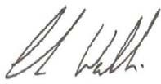

Hannah Dannatt Christian Wallis
Environmental Scientist (CPSS) Principal Environmental Scientist (CPSS)

HGD/CJW/BD/hgd

A.B.N. 64 006 107 857

Golder, Golder Associates and the GA globe design are trademarks of Golder Associates Corporation.

j:\env\2014\1413212 - costerfield\correspondence out\1413212-002-r-phase1\1413212-002-rev0_desktop\1413212-r-002-rev0.docx

APPENDIX A

Limitations

LIMITATIONS

This Document has been provided by Golder Associates Pty Ltd (“Golder”) subject to the following limitations:

This Document has been prepared for the particular purpose outlined in Golder’s proposal and no responsibility is accepted for the use of this Document, in whole or in part, in other contexts or for any other purpose.

The scope and the period of Golder’s Services are as described in Golder’s proposal, and are subject to restrictions and limitations. Golder did not perform a complete assessment of all possible conditions or circumstances that may exist at the site referenced in the Document. If a service is not expressly indicated, do not assume it has been provided. If a matter is not addressed, do not assume that any determination has been made by Golder in regards to it.

Conditions may exist which were undetectable given the limited nature of the enquiry Golder was retained to undertake with respect to the site. Variations in conditions may occur between investigatory locations, and there may be special conditions pertaining to the site which have not been revealed by the investigation and which have not therefore been taken into account in the Document. Accordingly, additional studies and actions may be required.

In addition, it is recognised that the passage of time affects the information and assessment provided in this Document. Golder’s opinions are based upon information that existed at the time of the production of the Document. It is understood that the Services provided allowed Golder to form no more than an opinion of the actual conditions of the site at the time the site was visited and cannot be used to assess the effect of any subsequent changes in the quality of the site, or its surroundings, or any laws or regulations.

Any assessments made in this Document are based on the conditions indicated from published sources and the investigation described. No warranty is included, either express or implied, that the actual conditions will conform exactly to the assessments contained in this Document.

Where data supplied by the client or other external sources, including previous site investigation data, have been used, it has been assumed that the information is correct unless otherwise stated. No responsibility is accepted by Golder for incomplete or inaccurate data supplied by others.

Golder may have retained subconsultants affiliated with Golder to provide Services for the benefit of Golder. To the maximum extent allowed by law, the Client acknowledges and agrees it will not have any direct legal recourse to, and waives any claim, demand, or cause of action against, Golder’s affiliated companies, and their employees, officers and directors.

This Document is provided for sole use by the Client and is confidential to it and its professional advisers. No responsibility whatsoever for the contents of this Document will be accepted to any person other than the Client. Any use which a third party makes of this Document, or any reliance on or decisions to be made based on it, is the responsibility of such third parties. Golder accepts no responsibility for damages, if any, suffered by any third party as a result of decisions made or actions based on this Document.

GOLDER ASSOCIATES PTY LTD GAP Form No. LEG 04 RL 1

ANTIMONY IN THE COSTERFIELD AREA

APPENDIX B

Soil and Ore data

  - INTRODUCTION
An initial review of existing and publically available soil data was undertaken to support the desktop review of soil geochemistry in Costerfield. The initial review was limited to data for antimony, arsenic, and gold.

  - Data sets
Two sources of soil chemistry data were reviewed:

- Department of Primary Industries (DPI) dataset of geochemical results across central Victoria,
containing 73,812 samples that were tested for the following metals: gold (Au), silver (Ag), arsenic (As), antimony (Sb), mercury (Hg), tungsten (W), aluminium (Al), calcium (Ca), iron (Fe) and manganese (Mn). It’s noted that the DPI is now referred to as the Department of Economic Development, Jobs, Transport and Resources (DEDJTR).
- Mandalay ore data from August 2014, containing 20 samples (10 ore samples and 10 low grade samples) analysed for the following metals gold (Au), silver (Ag), aluminium (Al), arsenic (As), boron
(B), barium (Ba), beryllium (Be), bismuth (Bi), cadmium (Cd), cobalt (Co), chromium (Cr), copper (Cu), iron (Fe), mercury (Hg), potassium (K), magnesium (Mg), manganese (Mn), molybdenum (Mo), sodium (Na), nickel (Ni), phosphorus (P), lead (Pb), sulfur (S), antimony (Sb), selenium (Se), tin (Sn), strontium (Sr), titanium (Ti) (attached as Attachment A).

  - METHODOLOGY
  - DEPI Data
    - The DPI spreadsheet was imported into GIS software (ESRI ArcMap), and the samples were plotted using the coordinate fields (in datum GDA94, projection MGA zone 55), using:
      - Easting = [GDA94_55_East]
      - Northing = [GDA94_55_North]
    - The DPI samples that intersect the Costerfield Dome (presented as Figure 2.93 in VandenBerg et al. (2000) were export to a [.csv] file and import to R (code attached).
    - The dataset was prepared for analysis by:
      - Converting zero results to ‘NA’
      - Removing negative symbols. It is assumed that negative symbols represent results reported as less than the laboratory limits of reporting (i.e. <). The negative results were converted to absolute values (e.g. ‐2 changed to 2).
    - The results were then grouped by into five sample depth classes:
      - All samples (_a)
      - Shallow samples: <= 30 cm depth (_s)
      - Intermediate samples: >30 cm & < 600 cm depth (_i)
      - Deep samples: >= 600 cm depth (_d)
      - Samples without a recorded depth (_NA)
    - Summary statistics and density plots were generated for each depth class.

    - Inspection of the initial summary statistics and density plots indicated that the Sb, As and Au results were not normally distributed, and were skewed to the right. So to assist with the review, these parameters were log transformed and the statistics and plots were re‐exported.

  - Mandalay Ore Data
Summary statistics were calculated for the Ore data using the following formula in Microsoft excel:

- #Results = Count( )
- Minimum = Min( )
- Maximum = Max()
- Median = Median()
- Mean = Average()
- SE.mean = [#Results]/Sqrt([std.dev])
- std.dev = STDEV()

No transformation or data cleaning was undertaken for the Mandalay ore data.

  - FINDINGS
  - DPI Data
Density histogram plots for the log transformed dataset are presented in Figure 1, and summary statistics are presented in Table 1.

It is noted that the plot for antimony (Log(Sb)) indicates that the distribution of intermediate results differs to the distribution of the shallow, and deep samples.

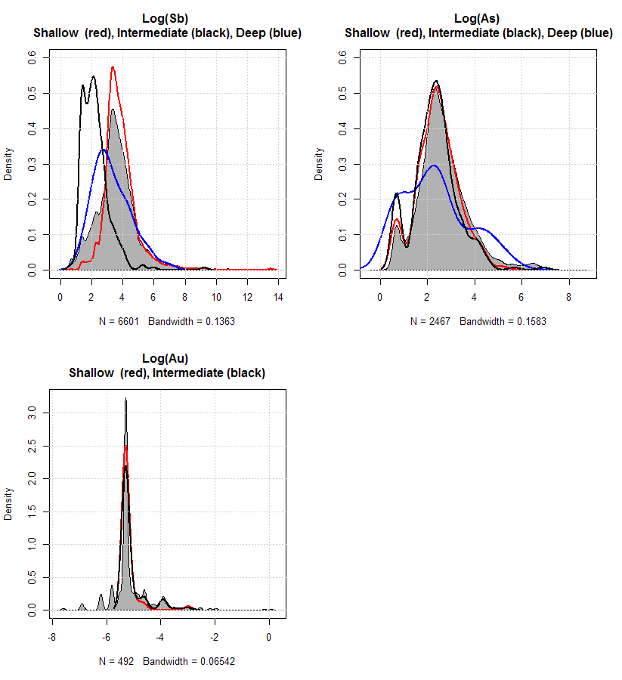
Figure 1: Density Histogram Plots for Log Transformed DPI data in the Costerfield Dome.

Table 1: Summary Statistics for DPI Data

Metal | Depth | #Results | Min | Max | Median | Mean | Standard Error of the mean | Confidence Interval for the mean (0.95) | Standard deviation | 95%ile
As | All | 2467 | 1 | 4100 | 12 | 35.7 | 2.63 | 5.15 | 130 | 93.85
As | Shallow | 298 | 2 | 200 | 10 | 17.1 | 1.19 | 2.33 | 20.5 | 50.75
As | Int. | 272 | 2 | 999 | 10 | 19.4 | 3.87 | 7.63 | 63.9 | 57.25
As | Deep | 50 | 2 | 251 | 10 | 28 | 6.77 | 13.6 | 47.9 | 119.5
As | NA | 1847 | 1 | 4100 | 13 | 41.3 | 3.44 | 6.75 | 148 | 116.7
As(log) | All | 2467 | 0 | 8.32 | 2.48 | 2.66 | 0.0218 | 0.0427 | 1.08 | 4.542
As(log) | Shallow | 298 | 0.693 | 5.3 | 2.3 | 2.43 | 0.0516 | 0.101 | 0.89 | 3.926
As(log) | Int. | 272 | 0.693 | 6.91 | 2.3 | 2.32 | 0.0576 | 0.113 | 0.95 | 4.05
As(log) | Deep | 50 | 0.693 | 5.53 | 2.3 | 2.34 | 0.194 | 0.39 | 1.37 | 4.8
As(log) | NA | 1847 | 0 | 8.32 | 2.56 | 2.75 | 0.0257 | 0.0504 | 1.1 | 4.76
Au | All | 492 | 0.0005 | 1.09 | 0.005 | 0.012 | 0.00284 | 0.00558 | 0.063 | 0.023
 |  |  |  |  |  | 4
Au | Shallow | 51 | 0.005 | 0.05 | 0.005 | 0.006 | 0.000887 | 0.00178 | 0.00634 | 0.008
 |  |  |  |  |  | 16
Au | Int. | 187 | 0.005 | 0.05 | 0.005 | 0.007 | 0.000476 | 0.000939 | 0.00651 | 0.02
 |  |  |  |  |  | 13
Au | NA | 254 | 0.0005 | 1.09 | 0.005 | 0.017 | 0.00547 | 0.0108 | 0.0872 | 0.029
 |  |  |  |  |  | 4
Au(log) | All | 492 | ‐7.6 | 0.0862 | ‐5.3 | ‐5.12 | 0.035 | 0.0689 | 0.777 | ‐3.772
Au(log) | Shallow | 51 | ‐5.3 | ‐3 | ‐5.3 | ‐5.21 | 0.0485 | 0.0974 | 0.346 | ‐4.836
Au(log) | Int. | 187 | ‐5.3 | ‐3 | ‐5.3 | ‐5.11 | 0.0337 | 0.0666 | 0.461 | ‐3.91
Au(log) | NA | 254 | ‐7.6 | 0.0862 | ‐5.3 | ‐5.11 | 0.0624 | 0.123 | 0.995 | ‐3.54
Sb | All | 6601 | 1.29 | 710000 | 35 | 831 | 244 | 478 | 19807 | 350
Sb | Shallow | 4375 | 2 | 710000 | 40 | 944 | 363 | 711 | 23999 | 285
Sb | Int. | 272 | 2 | 10000 | 8 | 51.2 | 36.8 | 72.4 | 606 | 40
Sb | Deep | 50 | 4 | 950 | 20 | 67.6 | 20.5 | 41.3 | 145 | 233.8
Sb | NA | 1904 | 1.29 | 182070 | 19 | 702 | 139 | 272 | 6060 | 945.55
Sb(log) | All | 6601 | 0.255 | 13.5 | 3.56 | 3.61 | 0.0168 | 0.033 | 1.37 | 5.858
Sb(log) | Shallow | 4375 | 0.693 | 13.5 | 3.69 | 3.84 | 0.016 | 0.0313 | 1.06 | 5.652
Sb(log) | Int. | 272 | 0.693 | 9.21 | 2.08 | 2.24 | 0.0539 | 0.106 | 0.889 | 3.69
Sb(log) | Deep | 50 | 1.39 | 6.86 | 3 | 3.32 | 0.171 | 0.344 | 1.21 | 5.5
Sb(log) | NA | 1904 | 0.255 | 12.1 | 2.94 | 3.29 | 0.0415 | 0.0813 | 1.81 | 6.852

Table 2: Summary Statistics for Mandalay Ore Data

 | #Results | min | max | median | mean | Standard Error | Standard
 |  |  |  |  |  | of the mean | deviation
Au (g/t) | 20 | 1.55 | 19.9 | 4.82 | 6.16 | 1.1 | 4.918098
As (ppm) | 20 | 132.36 | 954.49 | 480.27 | 533.13 | 47.97 | 214.5471
Sb (%) | 20 | 0.24 | 10 | 2.14 | 2.57 | 0.46 | 2.065247

  - REFERENCES
Arne D.C., 2009 Compilation of open‐file surface geochemical data from Bendigo 1:250 000 map sheet and adjacent areas, Victoria. GeoScience Victoria Gold Undercover Report 20. Department of Primary Industries. (DPI Data)

Place, A., A.Place@mandalayresources.com.au (2014). Updated ICP results. [email] Message and attachment (ICP testwork AUG14.xlsx) to Thornton, C. (Colin.Thornton@dsdbi.vic.gov.au). Sent 27 August 2014. Mandalay Resources. (Mandalay Ore Data)

Attachment A: Mandalay Ore Data (August 2014)

APPENDIX B
Soil and Ore Data

Attachment A: Mandalay Ore Data August 2014

Analyte | Limit of Reporting | Units | OREGrade 1 | OREGrade 2 | OREGrade 3 | OREGrade 4 | OREGrade 5 | OREGrade 6 | OREGrade 7 | OREGrade 8 | OREGrade 9 | OREGrade 10 | LOWGrade 1 | LOWGrade 2 | LOWGrade 3 | LOWGrade 4 | LOWGrade 5 | LOWGrade 6 | LOWGrade 7 | LOWGrade 8 | LOWGrade 9 | LOWGrade 10
Au |  | g/t | 2.65 | 2.45 | 9.90 | 7.30 | 7.25 | 5.60 | 19.90 | 2.08 | 5.13 | 1.55 | 6.35 | 5.80 | 6.23 | 3.90 | 18.40 | 3.23 | 2.13 | 4.43 | 4.35 | 4.50
Ag | 0.5 | ppm | <0.5 | <0.5 | <0.5 | <0.5 | <0.5 | <0.5 | <0.5 | <0.5 | <0.5 | 0.5 | <0.5 | <0.5 | <0.5 | <0.5 | <0.5 | <0.5 | <0.5 | <0.5 | <0.5 | <0.5
Al | 0.01 | % | 0.16 | 0.16 | 0.19 | 0.18 | 0.19 | 0.14 | 0.18 | 0.15 | 0.16 | 0.17 | 0.18 | 0.18 | 0.19 | 0.14 | 0.19 | 0.14 | 0.18 | 0.17 | 0.18 | 0.13
As | 1 | ppm | 783 | 954 | 440 | 724 | 536 | 410 | 324 | 736 | 443 | 293 | 379 | 274 | 583 | 630 | 454 | 479 | 760 | 482 | 132 | 846
B | 5 | ppm | 18 | 15 | 16 | 15 | 17 | 16 | 16 | 20 | 21 | 25 | 14 | 12 | 13 | 20 | 16 | 15 | 14 | 11 | 8 | 10
Ba | 10 | ppm | 49 | 47 | 57 | 49 | 45 | 48 | 51 | 43 | 48 | 45 | 48 | 41 | 48 | 44 | 53 | 50 | 54 | 41 | 41 | 36
Be | 2 | ppm | <2 | <2 | <2 | <2 | <2 | <2 | <2 | <2 | <2 | <2 | <2 | <2 | <2 | <2 | <2 | <2 | <2 | <2 | <2 | <2
Bi | 0.2 | ppm | 3.9 | 3.5 | 4.3 | 4.0 | 2.8 | 3.9 | 4.9 | 3.1 | 5.5 | 2.5 | 4.7 | 4.2 | 3.2 | 1.9 | 5.9 | 5.4 | 2.7 | 3.6 | 3.9 | 4.1
Cd | 2 | ppm | <2 | <2 | <2 | <2 | <2 | <2 | <2 | <2 | <2 | <2 | <2 | <2 | <2 | <2 | <2 | <2 | <2 | <2 | <2 | <2
Co | 2 | ppm | 12 | 12 | 12 | 13 | 14 | 13 | 14 | 10 | 12 | 11 | 13 | 13 | 13 | 13 | 13 | 12 | 14 | 15 | 14 | 14
Cr | 5 | ppm | 6 | 8 | 8 | 7 | 7 | 6 | 7 | 8 | 7 | 6 | 7 | 8 | 7 | 6 | 7 | 6 | 6 | 5 | 9 | 5
Cu | 1 | ppm | 33 | 35 | 31 | 35 | 32 | 34 | 35 | 28 | 32 | 34 | 33 | 33 | 35 | 35 | 41 | 31 | 36 | 32 | 30 | 32
Fe | 0.01 | % | 4.52 | 4.58 | 4.45 | 4.80 | 4.61 | 4.75 | 4.76 | 4.21 | 4.38 | 4.14 | 4.79 | 4.96 | 4.88 | 4.73 | 4.63 | 4.75 | 4.70 | 4.67 | 4.76 | 4.64
Hg | 2 | ppm | <2 | <2 | <2 | <2 | <2 | <2 | <2 | <2 | <2 | <2 | <2 | <2 | <2 | <2 | <2 | <2 | <2 | <2 | <2 | <2
K | 0.01 | % | 3.18 | 3.10 | 2.71 | 2.72 | 3.16 | 2.41 | 2.92 | 2.24 | 2.25 | 2.59 | 3.01 | 3.06 | 3.05 | 2.56 | 3.60 | 2.86 | 2.89 | 3.38 | 2.84 | 3.16
Mg | 0.01 | % | 0.52 | 0.52 | 0.53 | 0.53 | 0.52 | 0.52 | 0.52 | 0.52 | 0.52 | 0.52 | 0.53 | 0.53 | 0.52 | 0.51 | 0.52 | 0.53 | 0.51 | 0.51 | 0.53 | 0.53
Mn | 1 | ppm | 537 | 392 | 516 | 506 | 502 | 497 | 529 | 489 | 615 | 499 | 627 | 645 | 772 | 747 | 794 | 537 | 795 | 720 | 550 | 561
Mo | 1 | ppm | <1 | <1 | <1 | <1 | <1 | <1 | <1 | <1 | <1 | <1 | <1 | <1 | <1 | <1 | <1 | <1 | <1 | <1 | <1 | <1
Na | 10 | ppm | 94 | 85 | 53 | 98 | 53 | 52 | 39 | 85 | 65 | 79 | 68 | 71 | 56 | 59 | 87 | 84 | 80 | 31 | 52 | 50
Ni | 2 | ppm | 38 | 40 | 38 | 40 | 39 | 38 | 40 | 33 | 36 | 36 | 39 | 42 | 41 | 38 | 42 | 38 | 42 | 43 | 47 | 42
P | 10 | ppm | 424 | 483 | 457 | 504 | 531 | 437 | 450 | 386 | 450 | 468 | 474 | 533 | 497 | 529 | 477 | 487 | 462 | 482 | 471 | 416
Pb | 1 | ppm | 29 | 25 | 25 | 23 | 17 | 21 | 20 | 22 | 31 | 19 | 18 | 18 | 24 | 23 | 29 | 23 | 24 | 17 | 12 | 14
S | 0.01 | % | 5.05 | 2.06 | 2.71 | 2.07 | 2.17 | 2.29 | 2.09 | 2.48 | 3.54 | 4.39 | 0.92 | 0.94 | 1.52 | 2.59 | 1.89 | 1.45 | 1.60 | 0.97 | 0.45 | 0.94
Sb | 0.01 | % | 1.14 | 1.28 | 2.04 | 5.00 | 3.24 | 2.48 | 2.50 | 0.99 | 0.24 | 1.01 | 3.17 | 1.85 | 4.06 | 2.21 | 10.00 | 1.70 | 1.71 | 2.44 | 2.16 | 2.11
Se | 5 | ppm | <5 | <5 | <5 | <5 | <5 | <5 | <5 | <5 | <5 | <5 | <5 | <5 | <5 | <5 | <5 | <5 | <5 | <5 | <5 | <5
Sn | 5 | ppm | <5 | <5 | <5 | <5 | <5 | <5 | <5 | <5 | <5 | <5 | <5 | <5 | <5 | <5 | <5 | <5 | <5 | <5 | <5 | <5
Sr | 1 | ppm | 96 | 96 | 94 | 106 | 68 | 90 | 95 | 112 | 108 | 75 | 80 | 80 | 131 | 137 | 78 | 107 | 82 | 59 | 51 | 68
Ti | 0.01 | % | <0.01 | <0.01 | <0.01 | <0.01 | <0.01 | <0.01 | <0.01 | <0.01 | <0.01 | <0.01 | <0.01 | <0.01 | <0.01 | <0.01 | <0.01 | <0.01 | <0.01 | <0.01 | <0.01 | <0.01
j:\env\2014\1413212 ‐ costerfield\correspondence out\1413212‐002‐r‐phase1\1413212‐002‐rev0_desktop\1413212‐r‐002‐rev0‐appendix b.docx

13 March 2015
Project No. 1413212‐002‐R‐Rev0 6/6

APPENDIX C

Summary of Mine Processes

Table C1: Summary of key mine sites and ore extraction processes undertaken in Costerfield derived from Bannear 1993.

Mine | Summary of Processes
Costerfield mine | Mining commenced in 1860.  Initial processing focussed on extraction of gold, using crushing and smelting.  Works to retreat tailings to extract antimony and remaining gold commenced in 1869. Post 1894, improved chlorination methods were used to treat the mine tailings.  During 1905, tailing ore extraction included roasting and cyanidation within above and underground tanks.  In 1926 the “Costerfield Antox Company” purchased the Costerfield mine area and commenced processes to extract metals from tailings and manufacture antimony products including paints (understood to have been undertaken near Minerva mine). In 1934, mining resumed under the Gold Exploration and Finance Company at the Costerfield main shaft.  In 1935 three diesel engines were purchased to power crushing and smelting machinery and assist dewatering machinery.
Bombay mine site | Mining had commenced by 1864 using battery crushers.  During the late 1800’s the use of quicksilver (mercury) to extract gold was trailed, but was unsuccessful due to antimony interferences.  In 1893 large boilers were installed to drive two engines, one for the battery and one for the pump, to support dewatering.  In 1904 a milling and cyanide plant was erected to treat tailings, including use of furnace and many cyanide vats (comprising galvanized iron vats held in concrete cells). Zinc was used for metal precipitation.  Post the 1920’s works at the Bombay mine site mainly comprising treatment of tailings using cyanide.
Minerva Mine | Mining had commenced by 1861. A crusher and furnace where on site. The furnace was used for calcining of tailings without mercury (mercury use was trialled, but was ceased due to excess loss of mercury).  Costerfield Antox Mining Co. owned the site in 1926. It is thought to have included onsite use of antimony in the production of paint products. A galvanized shed expected to comprise historical paint manufacturing process remains at the site.  Site was a rubbish disposal depot in 1993.
Alison Mine | Mining commenced in 1869. Processing works included crushing, smelting and chlorination. A large furnace was present within the mine area. Steam engines were used to power mine machinery.
South Costerfield/ Taits Shaft | Mining commenced in south Costerfield in 1870, including mining of Taits’ Shaft. Onsite processing included a 10 head battery and steam powered smelting furnaces, using chlorination processes. Post 1898 a cyanide plant was used to treat tailings from the battery. The remnants of the cyanide works remain at the Bombay mine site and Tait’s shaft.
Robinson’s reef mine | Robinson’s Reef was discovered in 1881. The reef was located approximately 2.5 Km east of Alison’s mine. Onsite processing included a crushing battery. A large dam was dug to hold water used for running the crushing/stamping machinery. Works at Robinsons reef stopped by 1990.
Brunswick open cut mine | Large scale gold mining was resumed in Costerfield in 1995, after a long period of inactivity over the preceding 30 years. The resumption in mining coincided with the opening of the Brunswick open cut mine in 1995, at the location of the former Brunswick shaft mine. Production at the Brunswick open cut mine was stopped in 2009.  A processing plant remains active adjacent to the Brunswick open cut mine. The plant comprises a two stage crushing circuit, two ball mills in series, with classification and

Mine | Summary of Processes
 | gravity concentration in closed circuit (Mandalay, 2012).
Augusta Mine | Ore at the Augusta mine was discovered in 1970. An underground mine was commenced at Augusta in 2006. Increased mining at depth and increased regional rainfall resulted in excess water being extracted from the Augusta mine.  During 2012 two additional evaporation ponds were constructed to handle excess groundwater.  Mining is currently underway at Augusta mine.  Materials are currently processed at the Brunswick Processing plant circuit (Mandalay, 2012).
Cuffley Lode | In 2011 a new ore body was identified, less than 500 metres north of the Augusta mine, called the Cuffley lode. Mining of the ore of Cuffley lode has also commenced.  Materials are processed at the Brunswick Processing plant circuit (Mandalay, 2012).

APPENDIX D

Photographs from Costerfield Walkover

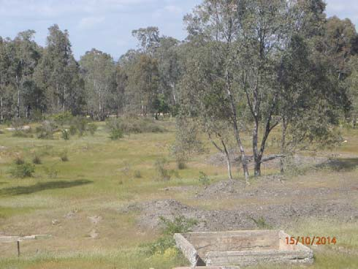
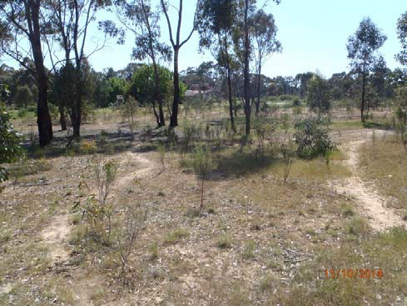

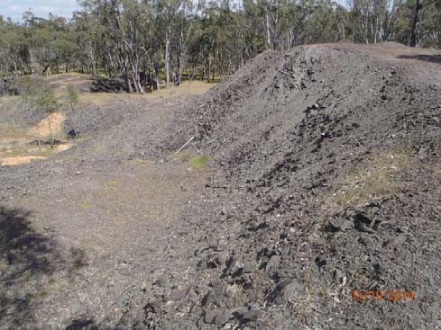
Select photographs and field observations made during site walkover.

Locations | Notes | Photos
G01, G02, G03, G05 | A number of mullock heaps surround the location of the former Costerfield main shaft. There appears to have been some disturbance to the mullock heaps and evidence of material having been removed. The mullock is a coarse, gravel to cobble sized material.  Photo– Mullock heap near Costerfield Main Shaft.
G04 | Former tailings area immediately south of the Costerfield main shaft. Low lying area, comprised of hummocky ground. Fine grained materials (possible tailings) visible at ground surface. Corresponds with area mapped as tailings on 1926 map.  Photo – View south across former tailings area, taken from Costerfield Main Shaft.
G06 | Area of sparse vegetation underlain by fine grained soil, immediately north of Costerfield main shaft. Soil appears to be fill and may be historical mine waste. Sparse vegetation growing in this area.  Some trail bike tracks across area.  Photo view north across inferred mine waste/tailings area.

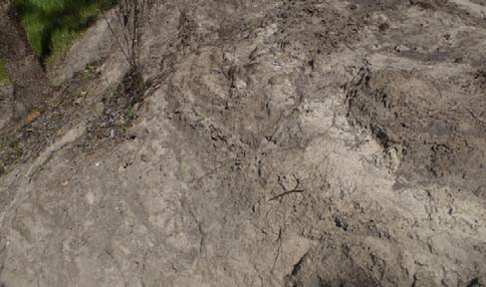
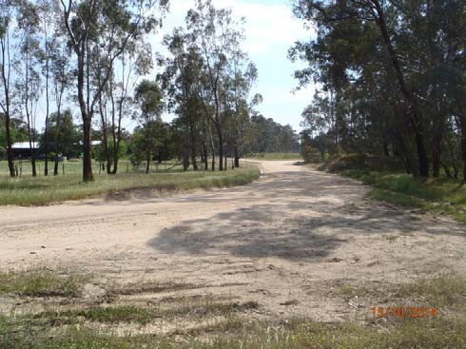
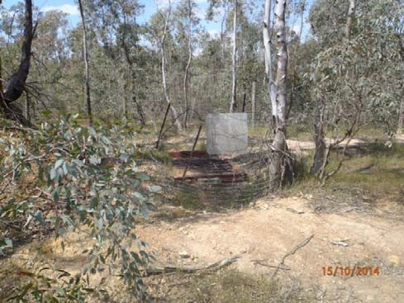

Locations | Notes | Photos
G08 | Heap of fine grained material inferred to be tailings. Heap about 2 m high and 30 m diameter with sparse vegetation. Corresponds with area mapped as tailings on 1926 map.  Trail bike tracks present on heap and evidence of erosion.  Photo – close up of inferred heaped tailings material.
G12 | The former main street of Costerfield is roughly aligned to a current road alignment. The road is unsealed and comprised of fine grained material. Historical photos show this area to be formerly underlain by mining waste.  Photo – View north along former main street of Costerfield.
G13 | Area to the south of the Minerva shaft is shown on the 1926 plan as underlain by tailings and other mine waste. This area is now revegetated with sparse vegetation. Fine grained soil exposed at surface, some of which appears to be tailings material and some of which appears to be a result of recent rehabilitation.  Photo – View south with Minerva No 2 shaft in foreground.

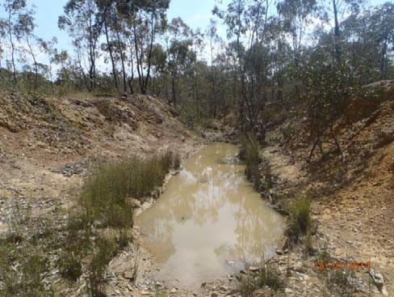
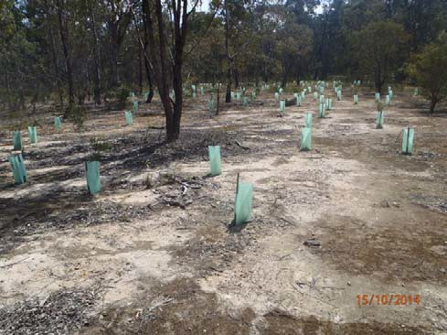
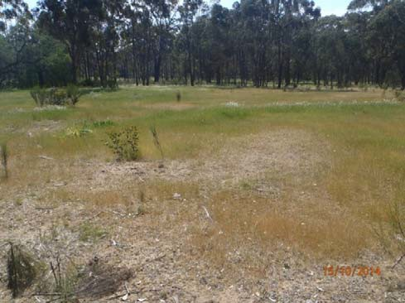

Locations | Notes | Photos
G17 | Diversion channel near former Bombay Mine. Fine grained material, inferred mining waste is exposed at various locations along the channel.  Photo – View north along diversion channel.
G20 | Area mapped as tailings on 1926 map. Appears to have been rehabilitated by placement of soil and revegetation.  Photo – View to west across former tailings area near Bombay mine.
G25 | Former tailings area to north of Bombay Mine. Fine grained material exposed at surface, no significant vegetation. Appears to be some recent fill placed over this area.  Photo – view north over former tailings area.

APPENDIX E

Selection of Chemicals of Interest

  - IDENTIFICATION OF CHEMICALS OF INTEREST
The objective of the desktop review is to provide information to support the understanding of the nature, transport and distribution of antimony and related chemicals in the environment. This appendix provides a logical approach (decision framework) for identification of chemicals of interest (CoI).
The decision framework and data screening steps outlined in this document are site specific and were designed with regard to the evaluation methodology summarised by the US EPA in Selecting Exposure Routes and Contaminants of Concern by Risk-Based Screening (1993).
Consistent with the desktop report the CoI evaluation focusses on antimony and related chemicals. The relevant considerations in selecting CoI include:
    - What is in the stibnite ore currently mined in Costerfield?
    - Is the element related to historical mining?
    - What common elements are suitable for assessing the potential for naturally occurring elevated concentrations of target compounds?
    - Which elements are potentially associated with materials used for roofs and tanks? A tiered screening process was applied to define the list of CoI and is presented below:
- What is in the Ore:
Information was provided by Mandalay Resources relating to elemental metal composition of the ore (referred to as crusher run data). The crusher run data contained compositional data for 28 elements which are listed in Table 1.
Table 1: Crusher Run Elements
1 | Gold (Au) | 8 | Bismuth (Bi) | 15 | Potassium (K) | 22 | Lead (Pb)
2 | Silver (Ag) | 9 | Cadmium (Cd) | 16 | Magnesium (Mg) | 23 | Sulfur (S)
3 | Aluminium (Al) | 10 | Cobalt (Co) | 17 | Manganese (Mn) | 24 | Antimony (Sb)
4 | Arsenic (As) | 11 | Chromium (Cr) | 18 | Molybdenum (Mo) | 25 | Selenium (Se)
5 | Boron (B) | 12 | Copper (Cu) | 19 | Sodium (Na) | 26 | Tin (Sn)
6 | Barium (Ba) | 13 | Iron (Fe) | 20 | Nickel (Ni) | 27 | Strontium (Sr)
7 | Beryllium (Be) | 14 | Mercury (Hg) | 21 | Phosphorus (P) | 28 | Titanium (Ti)

The CoI within the ore were defined with the following steps:

  - Step 1 - Below the Limit of Detection
Those elements which are typically detected at concentration below or at the laboratory limit of detection (where the limit of detection is not greater than respective guideline value) are not considered CoI. These include; Ag, Be, Cd, Hg, Mo, Se, Sn, Ti. All other 20 elements are considered in Step 2.

  - Step 2 - Essential Elements
Elements essential to life which are natural constituents of biofluids (Fe, K, Mg, Na, P, S) are not considered as CoI given that humans have homeostatic mechanisms to process these substances and thus they are not of interest in human health risk assessments. Based on the Cramer decision tree for toxicants, all normal constituents of the body are considered a low priority for investigation (Cramer and Ford 1977; EC 2011; EFSA 2012).

  - Step 3 - Below HIL Guidelines
Elements present in the ore at concentrations above the Australian health investigation levels (HIL Residential A) for soil (NEPM 2013) are further considered in Step 4. Elements below the HIL that do not meet any of the other criteria for selection are not considered CoI (B, Cr, Cu, Mn, Ni, Pb).

  - Step 4 - Less than Average Crustal Abundance
Elements present in the ore present at concentrations within or below the estimated crustal abundance ranges defined by Smith and Huyck (1999) and do not meet any of the other criteria for selection are not considered further (Al, Au1, Ba, Co, Sr).
Mandalay Resources have advised that elements present in the ore do not concentrate in soil waste streams above typical ore concentrations. Therefore the concentrations, compared against HILs in Step 3 and crustal abundance in Step 4, are not expected to increase with processing.

    - CoI identified from the ore are antimony, arsenic and bismuth:Antimony - present in ore at concentrations elevated above crustal abundance range;

    - Arsenic - present in ore at concentration greater than NEPM HIL; and
    - Bismuth - present in ore at concentration elevated above crustal abundance range.
- Is the metal related to historical mining?
A preliminary desktop assessment of potential sources of contamination to the environment, associated with historical activities, within the assessment area has been undertaken. The CoI associated with ore processing are summarised in Table 2.
Table 2: Historical Activities and Additional CoI
Process | Occurrence at Costerfield | Resulting CoI
Precipitation of gold | Cyaniding has occurred at many of the mine sites in Costerfield. At the Bombay site there are records of cyaniding and precipitating gold with zinc. Zinc “dust” has historically been used to combine with the cyanide, assisting the precipitation of gold (Bannear 1993). Lead nitrate may have be used to activate the zinc dust during this process or as an accelerator in the cyaniding process. | Cyanide, lead and zinc
Amalgamation of gold with mercury | Whether mercury was used in a closed or open processing system at Costerfield, is not mentioned specifically within the reviewed documents, however it was reported that mercury was used unsuccessfully for a short period at Minerva mine and Bombay mine due to “mercury loss” (Bannear 1993). | Mercury

CoI based on findings of the preliminary desktop assessment are mercury, lead, cyanide and zinc.

- What common earth metals are suitable for assessing the potential for naturally occurring elevated concentrations of target metals?

  - Iron and manganese are common earth metals that may assist with the assessment of the spatial distribution of the source of antimony and arsenic in the environment.

CoI for assessing the potential for naturally occurring elevated concentrations of target metals are iron and manganese.

- Which metals are potentially associated with roofs and tanks?

  - Cadmium, copper, lead and zinc are metals that may be present in tank water due to roofing, guttering and pipework materials (CSIRO 2008; Enhealth 2010; Andra et al. 2014).

1 Gold is expected to be removed from the ore to within or below the crustal abundance range.

CoI associated with roofs and tanks are cadmium, copper, lead and zinc.

- Metals relevant to health assessment due to their potential for accumulation in the food chain?

  - In addition to mercury and cadmium (previously selected), nickel also has the ability to accumulate through the food chain and is considered potentially relevant to human health
cumulative risk assessment.

CoI associated with accumulation potential are cadmium, mercury and nickel.

An additional screening step for CoI was included to ensure the chemicals are of relevance to human health.
Bismuth was further examined to determine if it was relevant to human health and thus relevant to further works.
A worldwide search of health based soil guidelines for bismuth did not identify any values indicating that it is not a priority soil contaminant.
Bismuth (as bismuth, oxide, hydroxide and sulphide forms) has been registered and assessed by a leading chemical evaluation agency - the European Chemicals Agency (ECHA). ECHA is the driving authority for implementation of chemicals legislation in the EU for the benefit of human health. A dossier dossiers providing information on potential human health hazards and risks posed by bismuth is available from ECHA. The following is a summary of relevant conclusions made by ECHA on bismuth:

  - ECHA has classified bismuth (as bismuth, oxide, hydroxide and sulphide forms) as non- hazardous.

  - The ECHA dossier describes a derived no effect level (DNEL i.e. dose at which no adverse health effects occurred) for chronic exposure to bismuth. The DNEL (systemic effects) for long
term exposure via oral ingestion is 13.3 mg/kg body weight /day. Using a standard regulatory calculator for deriving soil health investigation levels in Australia (ASC NEPM Toolbox HIL calculator.) the soil screening value is 25,000 mg/kg. This concentration is four orders of magnitude greater than the maximum reported soil concentration (5.91 mg/kg).

On this basis bismuth was not considered as a CoI.

The final chemicals of interest and the relevant sampling media are listed in Table 3 below.
Table 3: CoI Identified for Next Phase of Works
Chemical of Interest |  | Recommended Analytical Schedule
 |  | Soil | Water | Sediment | Air | Eggs | Lamb
1 | Antimony | ✓ | ✓ | ✓ | ✓ | ✓ | ✓
2 | Arsenic | ✓ | ✓ | ✓ | ✓ | ✓ | ✓
4 | Copper | ✓ | ✓ | ✓ | ✓ | ✓ | ✓
5 | Cyanide1 | ✓ | ✗ | ✗ | ✗ | ✗ | ✗
6 | Iron | ✓ | ✓ | ✓ | ✓ | ✓ | ✓
7 | Lead | ✓ | ✓ | ✓ | ✓ | ✓ | ✓
8 | Manganese | ✓ | ✓ | ✓ | ✓ | ✓ | ✓
9 | Mercury | ✓ | ✓ | ✓ | ✓ | ✓ | ✓

Chemical of Interest |  | Recommended Analytical Schedule
 |  | Soil | Water | Sediment | Air | Eggs | Lamb
10 | Zinc | ✓ | ✓ | ✓ | ✓ | ✓ | ✓
11 | Cadmium | ✓ | ✓ | ✓ | ✓ | ✓ | ✓
12 | Nickel | ✓ | ✓ | ✓ | ✓ | ✓ | ✓
✓- recommended for analysis ✗ - not recommended for analysis
1 Cyanide is recommended for analysis in soils only as it is considered unlikely to be present in other matrices based on historical use and low potential for bioaccumulation.

References
Andra S.S., Makris K.C., Charisiadis P., Costa C.N. (2014). Co-occurrence profiles of trace elements in potable water systems: a case study. Environ Monit Assess (2014) 186:7307-7320
Bannear, David 1993, North Central Goldfield Project, Historic Mining Sites in the Heathcote (Waranga South) Mining District, Part Two Site Gazetteer, Department of Conservation and Natural resources, North West Area, May 1993.
Cramer G.M., Ford R.A. (1977). Estimation of Toxic Hazard - A Decision Tree Approac. Fd Cosmet. Toxicol. Vol. 16. pp. 255-276. Pergamon Press 1978.
CSIRO (2008). Lead and other heavy metals: common contaminants of rainwater tanks in Melbourne. Magyar M.I., Mitchell V.G, Ladson A.R., Diaper C., Water Down Under (2008), ISBN 0-858-25735-1.
EC (2011). Analysis of the Cramer classification scheme for oral systemic toxicity - implications for its implementation in Toxtree. European Commission, EUR 24898 EN.
ECHA (2014). Registered substances information: Bismuth. Accessed from the European Chemicals Agency website November 2014: http://echa.europa.eu/web/guest/information-on-chemicals/registered-substances
EFSA (2012). Scientific Opinion on Exploring options for providing advice about possible human health risks based on the concept of Threshold of Toxicological Concern (TTC). European Food Safety Authority (EFSA), Parma, Italy. 02 July 2012
Enhealth (2010). Guidance on use of rainwater tanks. Commonwealth Australia 2010. Accessed October 2014 from: http://www.health.gov.au/internet/main/publishing.nsf/Content/0D71DB86E9DA7CF1CA257BF0001CBF2F/$ File/enhealth-raintank.pdfNEPM (2013). National Environment Protection (Assessment of Site Contamination) Measure 1999, Volume 2, Schedule B1.
Smith K.S., Huyck H.L.O. (1999). An Overview of the Abundance, Relative Mobility, Bioavailability, and Human Toxicity of Metals. Reviews in Economic Geology, Volumes 6A and 6B, 1999.
USEPA (1993). Selecting Exposure Routes and Contaminants of Concern by Risk-Based Screening. Region III Technical Guidance Manual for Risk Assessment. Hazardous Waste Management Division Office of Superfund Programs, January 1993.

j:\env\2014\1413212 - costerfield\correspondence out\1413212-002-r-phase1\1413212-002-rev0_desktop\1413212-r-002-rev0-appendix e.docx

APPENDIX F

Antimony in the Environment

Typical Antimony Concentrations

Environment | Concentration | Reference
Dissolved Sb in unpolluted waters | <1 ug/L | Filella et al., 2002a
Mean crustal average | 0.2 mg/kg | Onishi and Sandell, 1955
Aerosols over remote oceans | Typically <0.1 ngm3 | Fiella 2009
Aerosols over industrial areas | 2-3 ngm3 | Fiella 2009
Basalt rock | 015 mg/kg | Onishi and Sandell, 1955
Granitic rocks | 0.2 mg/kg | Onishi and Sandell, 1955e
Shale | 1-2 mg/kg | Onishi and Sandell, 1955
Australian Soils | 4-44 mg/kg | ANZECC 1992 soils

Golder Associates Pty Ltd
Building 7, Botanicca Corporate Park 570 – 588 Swan Street
Richmond, Victoria 3121 Australia
T: +61 3 8862 3500

