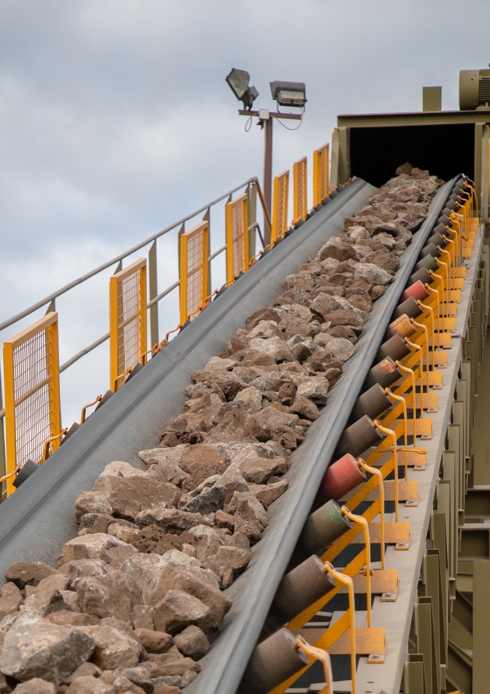

Initial Site Meetings
INFORMATION FOR WORK PLANS AND WORK PLAN VARIATIONS

Contents
2
- Objectives of Site Meeting 3
- Conducting a Site Meeting 5
  - Preparing the site meeting 6
  - Conducting the site meeting 6
- Post Site Meeting 7
Appendices 9
Appendix A - Initial Proposal Information Form 10
Appendix B - Sample Site Meeting Agenda 14
Appendix C - Potential Site Meeting Questions 17
Appendix D - Key Co-regulators 20

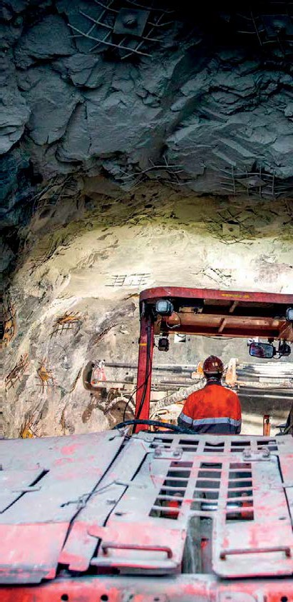

Objectives of Site Meeting

An initial site meeting is a key step in the development of your proposal.

The objective of the site meeting is to discuss issues and requirements with the relevant agencies, so you can draft your work plan to successfully gain any required approvals and/or permits.

The site meeting aims to bring you together with all the agencies whose areas of responsibility are potentially affected by your proposal, council and Earth Resources Regulation (ERR). The agencies fall into two groups:
- Statutory referral authorities except for VicRoads in relation to traffic matters.
- Other relevant non-statutory referral agencies that ERR considers necessary to aid in making its decision.
The purpose of the site meeting is to provide an opportunity for the relevant agencies to understand the potential impacts of your proposal on their area of responsibility,
and for you to understand the requirements of each authority, agency, ERR and council so that you can address these issues during development of your work plan documentation.
You are strongly encouraged to undertake an initial site meeting, otherwise you may encounter lengthy delays in the process and risk refusal of your work plan due to the objection of a referral authority.
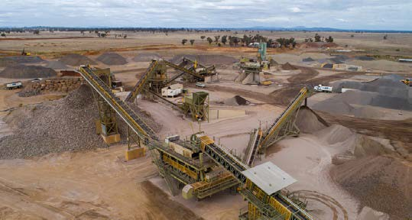
At the meeting, each representative will be invited to point out their requirements regarding the proposed activity as required by relevant legislation, guidelines, or policies. The site meeting is the starting point for ongoing discussions with you and further advice may be provided at a later date.
The council must make an informed decision on the need, or otherwise, for a planning permit. This decision must be provided in writing before a work plan is submitted
If council determines that a planning permit is required for your proposal, the work plan submission will ultimately be referred to referral authorities. Referral authorities may respond in one of three ways:
- they do not object
- they do not object subject to conditions or
- they object.
Note: The Department must not make a decision on the work plan that is inconsistent with advice from a referral authority. As such the work plan must be refused if a referral authority objects.
There is no option for referral authorities to require further changes to a work plan after it is referred. Therefore, it
is very important that your work plan addresses all the material concerns of the referral authorities before it is referred to them. This makes the discussions at the initial site meeting very important for the ultimate approval of the work plan.
If Environment Protection and Biodiversity Conservation Act 1999 (EPBC) listed species are involved, an off-set plan should be discussed with the relevant referral authorities, this may include the Commonwealth and State Authorities.
4

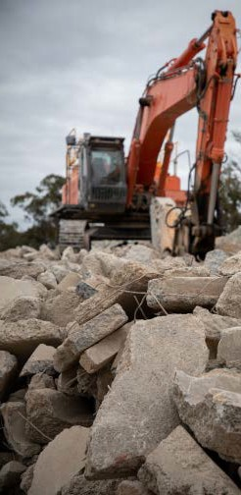

Conducting a Site Meeting

Preparing the site meeting

It is your responsibility to organise and conduct the initial site meeting.

ERR generally recommends that the meeting is arranged four weeks in advance to ensure that the various representatives from the agencies and regulators and agencies are available.

Initial Proposal
When commencing the work plan for new work and variations, you should complete and submit an initial proposal to Earth Resources Regulation (ERR). The initial proposal will contain key information and documents relating to the work plan, including:
- Summary of Operation
- Geotechnical Risk Zones (if applicable)
- Geotechnical Preliminary Assessment (if applicable)
- Proximity to Dwelling/s Advice (if applicable)
- Planning Advice (if applicable)
- Planning Property Report
- Land Title Documentation
Refer to Appendix A to view complete list of information required for the initial proposal.
Based on the initial proposal information provided, ERR will determine and provide to you a list of the referral agencies and municipal councils that should be invited to attend the initial site meeting.
You are encouraged to share the contents of the initial proposal with the attendees prior to the site meeting.

Types of Site Meetings
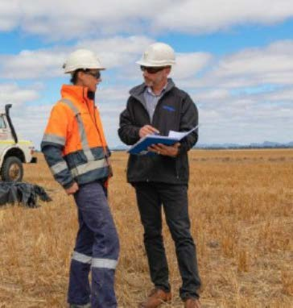
Site meetings can be held at the proposed site or virtually, using photos and videos of the site and video conferencing software. In some cases, an initial virtual site meeting may be held which is followed by a visit to the site by one or more regulators to substantiate or collect further information.
ERR will be able to advise the type of site meeting that will be most appropriate. Virtual site meetings can be easier to schedule but may limit the advice that agencies can provide and the observation of important issues (i.e. native vegetation).

Site Meeting Attendance
This process also applies for applications not requiring statutory endorsement, which ERR will refer to relevant agencies for consideration prior to making a decision.
In addition to providing the Agency Consultation Checklist, ERR will:
- provide details of ERR staff that are recommended to attend the initial site meeting. Including representatives from:
- the Assessments Team (who will be overseeing the application)
- the Compliance Team
- Stakeholder Engagement Team, depending on the proposal
- the Technical Services Team, depending on the issues and complexity of the proposal and
- suggest possible dates for the meeting to be held given ERR staff availability.
Early engagement with ERR, relevant referral authorities, other agencies and council is key to the efficient assessment of your proposal.
Refer to Appendix C for a summary of the role and areas of interest for some of the key agencies and regulators that you may be engaging as part of the work plan approvals process.

Conducting the site meeting
At the initial site meeting you should initiate discussions with the representatives of the agencies and regulators to clarify their requirements and resolve any potential issues. A sample agenda and a list of potential questions that may be discussed at the initial site meeting is provided in the appendix.
You should record the meeting minutes and capture any actions or outcomes arising from the site meeting.

6
The appointed ERR Officer will review your initial proposal and provide you with an Agency Consultation Checklist with the contact details for all the relevant referral agencies and authorities. The purpose of this checklist is to identify which parties you should invite to an initial site meeting to discuss the proposal.

Post Site Meeting

You should record key outcomes of the initial site meeting and circulate them to all invitees.
8

The record should include:
- a list of attendees (and those who were an apology)
- a brief summary of the project as described during meeting
- key discussion points and/or issues raised (by each agency)
- key actions and next steps.
You should notify your nominated ERR Assessments Officer if any agencies provide further advice regarding their requirements for a work plan after the meeting.
You may be required to undertake additional work (e.g. surveys, investigations, or assessments) as a result
of comments provided during the meeting. You are responsible for consulting with the relevant stakeholders to ensure that your additional work meets their specific requirements.
ERR recommends that your work plan is submitted as soon as practicable after the initial site meeting. If there is a long gap between the site meeting and work plan submission, you are advised to consider a follow-up engagement with ERR and other agencies to ensure any previous advice is still relevant and current.
While preparing your work plan, you should progress applications for any other licences or approvals required prior to seeking approval or statutory endorsement under the MRSDA from ERR.

Appendices

Appendix A - Initial Proposal Information Form

1. Information required
New work plan:
Provide a brief description of the proposed operation
Work plan variation:
Provide a brief description of the current operation and proposed new work
Administration
Applicant  (Individual / Company) | Name and contact details
Consultant  (Individual / Company) | Name and contact details
Landowner | Name and contact details
Site Address | Address of the proposed or existing site
Municipality (Council) | Municipality the proposed or existing site is located in
Land status | ☐ Private Land  ☐ Crown Land  ☐ Private and Crown Land
Licence or extractive industry Work Authority ID (existing sites)
CoP / Work Plan / Variation | ☐ CoP Code of Practice  ☐ Extractive industry work authority application/work plan new  ☐ Mineral industry/work plan new  ☐ Code of practice  ☐ Work plan variation  ☐ Work authority variation
General
Mineral or Stone Type | Describe
Method of Extraction / Processing | Describe
Annual Production Estimation (tonnes) | Describe
Water Supply / Use (e.g. dust management) | Describe
Discharge Required | Surface water / groundwater / mine water - describe  Guidelines for the Management of Water in Mines and Quarries
Importation of Material | To undertake rehabilitation OR other e.g. recycling – describe  Imported Materials Management Guidelines
Landfill | Land intended to be used for land fill at a future date – describe
Code of Practice
Operation includes | ☐ Containment dams (water/slimes/tailings)  Environmental Guidelines for the Management of Small Tailings Storage Facilities  Guidelines for the Design and Management of Tailings Storage Facilities  ☐ Groundwater interception / dewatering  ☐ Waterways interception / removal  ☐ Native vegetation onsite (if known)  ☐ Areas of cultural heritage sensitivity  ☐ Historic inventory or registered sites
Work Plan
Excavation Depth | AHD RL and depth in meters
Batter Profile | Describe
Benching Profile | Describe
Mine access (shaft/adit/decline) | Describe if applicable
Mine Depth | Describe if applicable
Above Ground Operations Includes | ☐ Containment dams (water/slimes/tailings)  Environmental Guidelines for the Management of Small Tailings Storage Facilities  Guidelines for the Design and Management of Tailings Storage Facilities  ☐ Groundwater interception / dewatering  ☐ Waterways interception / removal  ☐ Native vegetation onsite (if known)  ☐ Blasting  Ground Vibration and Airblast Limits for Mines and Quarries  ☐ Areas of cultural heritage sensitivity  ☐ Historic inventory or registered sites
Below Ground Operations Includes | ☐ Groundwater interception / dewatering  ☐ Tailings disposal  ☐ Blasting
Map
A map/s showing:
- Scale
- North arrow
- Key
- The tenement boundary (licence / work authority)
» for a work authority variation please show the current and proposed extent
» for a work authority (new or variation), the map must include coordinates (easting and northing) for each corner defining the work authority area. The co-ordinates must be provided in MGA (Map Grid of Australia, GDA94 datum), Zone 54 (west of state) or Zone 55 (centre and east of state)
- The extent of the activity footprint (e.g. extraction area, hardstand, haul roads, stockpiles, bunds). Note, if the activity footprint is changing due to a work plan variation, please show the current and proposed extent
- The extent of the indicative Geotechnical Risk Zone (GRZ) (open pit mining only)
- Any relevant landform feature (e.g. river) and / or infrastructure (e.g. wind turbine, railway, pipeline, roads).
2. Geotechnical Risk Zone (GRZ) Open Pit Mines Only excluding CoP
Please assess the indicative GRZ and show the extent of the GRZ on the location map, or additional map. Guidance is provided in section 3.1 of the Guidance Material for the Assessment of Geotechnical Risks in Open Pit Mines.
3. Geotechnical Preliminary Assessment Extractives Industry Only excluding CoP
Please assess and describe the applicable terminal and rehabilitated slope categories. Guidance is provided in section
3.1 of the Geotechnical Guideline for the Extractives Industry.
4. Proximity to Dwelling/s Advice for Mining or Mineral Exploration Industry ONLY
Please determine the distance to any existing* dwelling house, a building that is used primarily, or is intended, adapted or designed to be used primarily as a residence or be used for small-scale commercial activities. Select any of the following that applies:
Prohibited Areas
☐ Allotment of 0.4 ha or less with a dwelling house and the boundary of the allotment is located less than <100m from
the proposed area of mining or mineral exploration work; or
☐ Allotment is larger than >0.4ha and dwelling house is located less than <100m from the proposed area of mining or
mineral exploration work, measured from a distance of 25m from the outer edge of any eave forming part of the
dwelling house; or
☐ Proposed mining or mineral exploration work is less than <100m below a dwelling house.
NOTES
Consent from the owner of the land on which the dwelling house is located is required for any mining or exploration work proposed to be undertaken that includes the prohibited areas as prescribed under section s.45 of the Mineral Resources (Sustainable Development) Act 1990 (MRSDA).
* A dwelling house that existed before an approved work plan is or was registered in respect to the licence.
5. Planning Advice for Work Plan Variations ONLY
Consult with council and provide advice on which of the following applies to the proposed changes to the operation:
☐ No planning requirement; or
☐ Secondary Consent* will apply; or
☐ Amendment / re-issue of a planning permit is required.
☐ New (existing use rights applied previously)
☐ New (proposed expansion includes land parcels not included on the current planning permit)
☐ To be determined (Planning status advice not provided)

* The proposed variation only involves amendments to the endorsed plans/documents, as allowed under the planning permit, and does not conflict with or require amendment to the permit description or conditions.
In such cases, the proposed variation is minor, would not transform the planning permission to a development or use considered beyond the original approval, and/or would not require advertising.
6. Planning Property Report
Current report for all the properties included in the application/tenement area. Please ensure to include all pages.
The Planning Property Reports can be obtained, for free, from LANDVIC
7. Land Title Documentation
Current register statement for the certificate of titles, with a copy of plans, for all titles to be included in the tenement area. Most register statements do not include a map, this must be obtained. In addition, a confirmation of any depth limitation on the title/s is required.
The Land Title documentation can be obtained, for a fee, from LANDATA
8. RRAM Registration
Tenements are administered online through the Resource Rights Allocation and Management (RRAM) system. A tenement can be applied for by an individual or a company.
Work plans are prepared, lodged, assessed, endorsed and approved in RRAM. Information about using RRAM is located here: Licensing and Approvals
Existing/Past tenement holder | Current and past tenement holders have been pre-registered on RRAM. If you have not received your user name and log in details for RRAM, please email: RRAM.Support@ecodev.vic.gov.au
New tenement holder | Please register (individual / company) online at via the RRAM Business Portal. Manage Your Licence
Is an agent/consultant acting on your behalf? | An authorised agent or consultant can act on behalf of the account owner. If you are employing an agent or consultant to manage your tenement/s and/or prepare a work plan, please ensure that they are a registered RRAM user.
9. Work Plan Content
For up-to-date guidance on preparing a work plan or work plan variation that meets the requirements of the Mineral Resources (Sustainable Development) Act 1990 and associated Regulations refer to the relevant industry related guidelines on the Earth Resources website.
Work Plan Guidelines
10. Community Engagement
Demonstrated community engagement throughout a tenement’s duration is required. An appropriate process and plan for community engagement and consultation must be developed and initiated upon commencement of the work plan proposal.
For guidance on preparing a Community Engagement Plan refer to the Earth Resources website. Community Engagement Guidelines and Template

Appendix B - Sample Site Meeting Agenda

Site
Location (Address)
Date
Time

Attendees

 | Name | Position Title
Applicant
Consultant
ERR
Council
DELWP
EPA CMA
Aboriginal Victoria Heritage Vic Water Authority
Other
Note: the applicant/consultant will record key site meeting outcomes and circulate them to all invitees.

Agenda

 | Item | Who
1 | Welcome and introduction of attendees | Applicant/Consultant/All
2 | Roles and responsibilities  - Legislative process under the MRSDA  - Relationship of process with Planning and Environment Act 1987 | ERR Representative
3 | Proposal overview | Applicant/Consultant
4 | Site description | Applicant/Consultant
 | - Current use
 | - Geology
 | - Reserves
 | - Sensitive receptors
5 | Current approvals or licences in place | Applicant/Consultant

 | Item | Who
6 | Proposed extraction method  - Locations of equipment, dumps and dams (slimes/tailings)  - Blasting requirements  - Batter angles | Applicant/Consultant
7 | Proposed rehabilitation and end use | Applicant/Consultant
8  9  10  11 | Earth Resources Regulation (ERR) comments and requirements  - Work plan requirements  - Potential hazards and risks  » Member of the public  » Land, property and infrastructure  » Environment  - Surface water and groundwater  - Other management plans  » Blast management  » Ground control management  » Community engagement  » Rehabilitation  - Final landform and end use  - Other | ERR Representative
 | Council comments and requirements  - Planning permit requirements  - Road access and traffic management  - Community consultation | Council Representative
 | Department of Environment, Land, Water and Planning comments (DELWP) and requirements  - Planning overlays  - Flora and fauna reports  - Environment Protection and Biodiversity Conservation Act 1999 | DELWP Representative
 | Other regulator/agency comments and requirements  - EPA  - Local Catchment Management Authority  - First Peoples-State Relations (formerly Aboriginal Victoria)  - Heritage Victoria  » Heritage overlay  - Other | Agency Representatives

 | Item | Who
12  13 | Work plan assessment process  - Submitting the work plan  - Fees  - Assessment of work plan  - Further information  - Reassessment  - Statutory referral to Referral Authority and agency comment sought from other relevant agencies  - Statutory endorsement of work plan  - Planning permit  - Approval  - Application for work authority & rehabilitation bond  - Grant of work authority  - Start work | ERR Representative
 | Next steps | Applicant/Consultant

Appendix C - Potential Site Meeting Questions

The following questions or issues may be discussed at the initial site meeting. This checklist will help the Tenement holder identify the information to provide in the work plan.

Discussion Topic | Details
Extraction proposal | - What is the estimated life of the activity?  - What is the estimated/anticipated volume of resource per annum (output in tonnes or cubic metres)?  - What is the estimated volume of soils and overburden to be disturbed?  - What are the operating hours?
General location information | - What road(s) are proposed to be used for entering/exiting the activity area?  - Are there any known inherited issues as a result of past or current land use?
Blasting  Noise Dust  Community facility/private and public infrastructure  Aboriginal heritage  Historic heritage  Flora and fauna | - Will blasting take place? If so, is it possible that blasting related activity could cause vibrations/noise/fly rock at the boundary of (or beyond) the activity area impacting sensitive receptors or infrastructure, including pipelines?
 | - Is it likely that activity area-based noise will be heard at any sensitive receptor?
- Is it likely the operations will generate dust or spray that will be deposited or emitted outside of the activity area boundary?
- Is it likely the operations will generate any other substances as per the Guideline for Assessing and Minimising Air Pollution that will be emitted outside of the activity area boundary?
- Are there known above and below ground infrastructure (electricity networks, water mains, designated waters etc.) located near the activity area?
- Are there known public roads, bridges or train lines located near the activity area?
- Are there any areas of cultural heritage sensitivity or other protected areas in the proposed activity area?
- Are any caves or dunes identified in the activity area?
- Is a cultural heritage management plan (CHMP) required?
- Does the activity area contain places, sites or objects on the:
» Heritage overlay of the relevant planning scheme
» Victorian Heritage Register
» Victorian Heritage Inventory?
- Are there historical heritage sites, structures or artefacts that must be retained as part of the post closure landform?
- Is any flora or fauna, including native vegetation, within the activity area to be removed or impacted?
- Are there weeds, pests or feral animals within the activity area, or from surrounding areas, that could impact rehabilitation activities and/or potential land uses after closure?

Discussion Topic | Details
Groundwater  Surface water  Dams | - What is the depth to groundwater and water quality objectives defined in the Environment Refence Standard (ERS)? (See also Using SEPPS and WMPs in the new environment protection framework guide)  - Where are nearest groundwater users or groundwater sensitive ecosystems?  - Will de-watering be required (e.g. lowering the groundwater levels), or will the activity pit intersect the water table?  - Will there be any potential effects on existing groundwater quality, and are there third-party users of groundwater surrounding the activity?  - Are there groundwater-dependent ecosystems located within the specified distances surrounding the activity area?  - Is the activity within a Groundwater Restricted Quality Usage Zone, a Water Supply Protection area, or a Groundwater Management Area?
- What are the water quality objectives for the area as per the Environment Refence Standard (ERS)? (See also Using SEPPS and WMPs in the new environment protection framework guide)
- Where are nearest water users or water sensitive ecosystems?
- Are alterations to surface drainage required (e.g. waterway diversion) and if so, are they going to increase the potential for flooding of adjacent land?
- Are soil, overburden or proposed extracted materials (e.g. soils etc.) susceptible to erosion (e.g. caused by clearing of vegetation, problem soils)?
- Is there potential for soil and overburden stockpile to cause sedimentation outside of the activity boundary?
- Is the activity area located within a potable water catchment?
- Will there be water storages (e.g. settlement pond, water storage, evaporation pond, bio-retention basin, etc.) or slimes dams on the activity area?
- If yes, what is the type, area and embankment height of water storages or slimes dams?
- Will the storage or dam be located on a waterway?
- Will the dam receive runoff from a catchment upslope of the storage or dam?
- Will any of the above storages hold water that is unlikely to meet the Environment Refence Standard (ERS) guidelines for surface water or groundwater (or the ANZECC guidelines where a constituent is not specified)?
- Will any of the storages meet the criteria of a large dam in accordance with ANCOLD Guidelines? If yes, what is the type, area and embankment height of water storages or slimes dams and its possible consequence category?
- What impact could failure of a water storage or slimes dam have on public safety, infrastructure or the environment?

Discussion Topic | Details
Geotechnical  Environment – visual amenity (re overburden/ waste rock)  Waste  Fuel  Acid mine drainage  Radiation  Site rehabilitation | - How will slope instability affect public safety, public infrastructure or environmental elements?  - How can the site’s lithology/geology and structural geology impact on slope stability?  - E.g. are there any active faults, dykes or shear zones (including adverse jointing) which may affect slope stability?  - Is the overburden dispersive which may lead to long term erosion problems around the site?  - What influence may seismic activity in the area have on slope stability?  - Can elevated water levels in the batters have an impact on slope stability?  - Are there areas where a perched water table may exist?  - Could the proposed activity operation and excavation methods heighten the potential for slope instability, and would such instability have any impact outside the activity area?  - Are there any historical voids (old mine underground workings, shafts, etc.) within the activity area?  - Are there other adjacent land uses or features that could create triggers for land instability (e.g. neighbouring property performing blasting, surface water drainage near batter crest etc.)?  - Will there be any crest loading, which may affect slope stability, such as an overburden dump or plant equipment situated near the crest of the open pit?  - The geotechnical information that operators of quarries should include in their work plan is contained within the Geotechnical guideline for terminal and rehabilitated slopes – Extractive Industry Projects.
- Will stockpiles and overburden dump be located within the activity area?
- If yes, what is the volume of material and what is the proposed height of the largest stockpile/overburden dump?
- Will process wastewater be stored and treated within the activity area?
- Will the operations (extraction and processing) generate hazardous wastes (e.g. grease, oils, putrescible waste, and batteries)?
- Will fuel (e.g. petrol, diesel) or other chemicals/additives be stored within the activity area?
- Will refuelling, fuel storage and maintenance of machinery and equipment occur within activity area.
- Will acid sulphate soils be exposed/oxygenated during the proposed activities?
- Is there potential for sulphide minerals to be present or exposed during the proposed activity (such as from overburden, waste and remnant pit shells surfaces)?
 | - Is any part of the operation (extracted or processed material) going to be legally radioactive in accordance with the Radiation Act 2005?
- What is proposed for site rehabilitation and closure, and subsequent land use?
- What is proposed for pit batter rehabilitation?
- How will water storages and slimes dam facilities be rehabilitated?
- What is proposed for surface water drainage and discharge from the activity area?
- What land management or maintenance activities will be required after closure?

Appendix D - Key Co-regulators

Co-regulator | Description | Area of interest
WorkSafe Victoria | WorkSafe Victoria (WorkSafe) administers and enforces the Occupational Health and Safety Act 2004 (OHS Act) and the Occupational Health and Safety Regulations 2007. This legislation places obligations on all Victorian workplaces to secure and eliminate risks to the health, safety and welfare of employees and other persons at work. It also aims to ensure that the health and safety of members of the public is not placed at risk by the conduct of undertakings by employers and self-employed persons. How WorkSafe and the Regulator work together is set out in a memorandum of understanding between the two organisations. | - Worker safety
Environment Protection Authority | The Environment Protection Authority (EPA) administers the Environment Protection Act 2017 (EP Act) which creates a legislative framework for environmental protection in Victoria. The EPA can also issue works approvals, licences  and permits. Earth Resources Regulation and the EPA have a memorandum of understanding that sets out a commitment to work together to enable the development of the earth resources industries (mines and quarries) while minimising adverse impacts on the environment and communities. | - Dust  - Dust, silt and clay on roads  - Erosion and Sedimentation  - Fuel, lubricants and hazardous materials  - Imported Materials  - Noise  - Rubbish  - Stormwater  - Encroachment  - Water discharge and groundwater impacts

Co-regulator | Description | Area of interest
Department of Environment, Land, Water and Planning (DELWP):  - Catchment Management Authority/Water Board or Water Supply Authority  - Native Vegetation  - Planning approvals  Heritage Victoria  First Peoples-State Relations (formerly Aboriginal Victoria)  Local Government | A memorandum of understanding between the Department of Environment, Land, Water and Planning (DELWP) and Earth Resources Regulation sets out how the two agencies will work together during the regulatory assessment process. DELWP has several functions relevant to site rehabilitation. These include:  - Native vegetation management – the removal of native vegetation is regulated by under the Victorian Planning Provisions. Applications should have regard to the DELWP publication: Guidelines for the removal, destruction or lopping of native vegetation. The Flora and Fauna Guarantee Act 1988 and Environment Protection and Biodiversity Conservation Act 1999 (Cwth) may also be triggered in certain instances.  - Ground and surface water management – applicants may need to get a licence from Catchment Management Authorities and Rural Water Corporations if the proposed operation is in the vicinity of specific supply water catchment areas. Licences will also be required for water use during operations or for rehabilitation purposes.  - Crown land – Victoria’s Crown land is managed by several entities including the Crown Land Manager, Parks Victoria, and Catchment Management Authorities. Depending on the location and nature of the proposed quarry or mine, these entities may have a regulatory role.  - Planning approvals – for quarrying or mining activity to be approved, a planning permit or an environment effects statement (EES) is required. The Minister for Planning determines whether an EES is required. The Ministerial Guideline for assessment of environmental effects under the Environment Effects Act 1978 sets out the EES process. If an EES process is conducted a planning permit is not required. | DELWP  - Fire  - Native Vegetation  - Crown Land  Catchment Management Authority/ Water Board or Water Supply Authority  - Erosion and Sedimentation  - Stormwater  - Changes in footprint  - Reduction in setbacks from a waterway  - Site operation (stockpiling)  Native Vegetation  - Pests, weeds and diseases  - Native Vegetation Planning approvals  - Planning
 | Heritage Victoria administers the Heritage Act 2017 and makes recommendations to the Heritage Council on what places and objects should be placed on the Heritage Register. Heritage overlays are administered by local government under the Planning and Environment Act 1987. | - Heritage
 | First Peoples-State Relations (formerly Aboriginal Victoria) administers the Aboriginal Heritage Act 2006. This Act requires licensees and work authority holders to prepare  a Cultural Heritage Management Plan if there is a high impact activity taking place in an area of cultural heritage sensitivity. | - Aboriginal Heritage
 | Local government is the responsible authority for issuing planning permits under the Planning and Environment Act 1987. Planning permits usually contain rehabilitation related requirements and are required in the absence of an EES. | - Amenity  - Dust  - Dust, silt and clay on roads  - Noise  - Planning permissions  - Local-specific protection policies  - Rehabilitation processes  - Traffic management and truck movements

