Latrobe Valley Regional
Rehabilitation Strategy

Regional Geotechnical Study
REHABILITATING THE LATROBE VALLEY’S COAL MINES
The Latrobe Valley’s three brown coal mines – Hazelwood, Yallourn and Loy Yang – have fuelled most of Victoria’s electricity generation since 1924. Hazelwood closed in 2017 and Yallourn and Loy Yang are planned to close by 2032 and 2048 respectively. Each of the Latrobe Valley brown coal mine operators are required to develop a plan to rehabilitate the mine sites in order to achieve a safe, stable and sustainable landscape once mining activity ceases.

BACKGROUND
A reopened inquiry into a coal fire that burned for 45 days at Hazelwood in 2014 found that using water to create ‘pit lakes’ in the areas where coal has been mined is likely to be the most viable way to achieve safe and stable rehabilitation of the mines. However, the Inquiry recognised that significant knowledge gaps existed in relation to the feasibility of this rehabilitation option and recommended further investigations be carried out.
These investigations – geotechnical, water and land use planning studies – have been undertaken as part of the Victorian Government’s preparation of the Latrobe Valley Regional Rehabilitation Strategy (LVRRS).
The studies, which were carried out by technical specialists from 2017 to 2019, considered the regional benefits and risks associated with stabilising the mine pits (or voids) by creating full or partial pit lakes.
The Strategy provides information on the:
- regional risks that need to be considered and addressed in rehabilitation plans
- feasibility of using water if required for safe, stable and sustainable rehabilitation and
- possible future land uses for the rehabilitated sites in a regional context.

ACHIEVING A SAFE AND STABLE LANDFORM FOR THE LONG TERM

Latrobe Valley Regional Geotechnical Study
Active engineering controls such as groundwater pumps, surface water diversions and extensive monitoring
systems are required to maintain safe operating conditions at the Latrobe Valley coal mines.
Coal mining has created land movement since it began in the Latrobe Valley. This has ranged from small, continuous movement of mine walls (known as batters) to several major batter failures extending beyond the mine crest. Exposed coal has caught fire a number of times, causing impacts to communities and the mines, most notably during the 2014 Hazelwood Mine Fire.
As part of the Latrobe Valley Regional Rehabilitation Strategy, the Victorian Government commissioned a Regional Geotechnical Study. Specialists investigated the stability and fire risks associated with the coal mine voids, whether these risks could be mitigated by filling the voids with water to a level that achieves stability (referred to as the pit lake rehabilitation option) and whether filling the voids with water could result in adverse ground movement impacts within and around the mines.

The Latrobe Valley with mine voids and mining licence boundaries identified
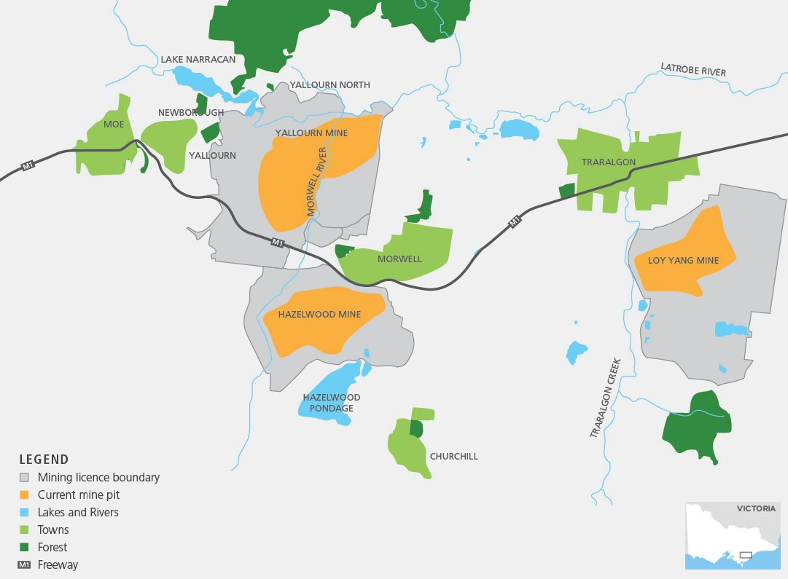

KEY FINDINGS
Mining induced ground movements of significance to rehabilitation are identified to be:
- Block sliding
- Sinkhole formation
- Floor heave
- Subsidence
Each of these movement types can occur separately or together depending on the conditions prevailing in the mine. While block sliding typically results in rapid movements after onset, sinkhole formation, floor heave and subsidence are all longer time processes that occur over weeks to decades.
Passive controls that avoid the need for ongoing action in managing risks from these ground movements and coal ignition are identified as the preferred option for rehabilitation; this is achieved through landform design. Passive design elements include the use of sediments and water to stabilise mine floors and batters, and covering coal (e.g. with soil) to prevent coal ignition by external sources.

STABLE FLOORS AND BATTERS
The Regional Geotechnical Study found that:
- The pit lake rehabilitation option can achieve a safe, stable and sustainable landform through a largely passive control by:
- Providing a counterweight to upward pressures from aquifers below each mine, thereby preventing instability caused by ‘floor heave’ and eliminating the current need to pump large quantities of groundwater
(around 30 GL/year in total, across all three mines) from the aquifers to maintain stability.
- Increasing lateral pressure to stabilise batters, thereby reducing the current need to actively control batter movement through groundwater drainage and surface water management.
- Extended fill times arising from limited water availability, or not filling to a level that provides the required counterweight for lateral pressures, present stability challenges that would need to be actively managed.
- Minimisation of seepage inflow through the management of surface waters and coal cover materials, in addition to coal groundwater pressure control through drainage boreholes, may be required to maintain low ground movement risks. Controls will be required during the filling period and potentially on an ongoing basis for any coal batters extending above the final water level.
- Areas outside of the pit requiring ongoing management and/or planning controls would be reduced compared to current requirements if water levels are at or above the minimum required to achieve counterweight to future vertical and horizontal groundwater pressures.
- Ground movements will occur in response to filling a mine with water, due to a ‘lake loading’ effect. These are not expected to have adverse impacts but will need to be monitored to ensure that if any impacts arise to existing and future infrastructure, they are addressed as part of the mine rehabilitation process.

GROUND SUBSIDENCE AND REBOUND
The Regional Geotechnical Study found that:
• Groundwater extraction for mine stability has led to gradual land subsidence across the region.
• If groundwater extraction for mine stability control can be stopped following mine rehabilitation, land surface rebound is expected. The magnitude of the rebound is expected to be less than the subsidence that has
occurred and it is anticipated that this rebound would occur gradually over many decades and relatively evenly across the region. This is an area that requires further consideration as part of rehabilitation planning.

MANAGING FIRE RISK
The Regional Geotechnical Study found that:
- Coal fire risk is best managed by covering exposed coal.
- If water is provided for ground stability control it would cover large areas of exposed coal. As such, active controls
on fire risks would be significantly reduced for the final rehabilitated landform if the water levels required to passively control ground movement are achieved.
- Coal coverage above the water linecan be achieved by providing a suitable soil-vegetation cover system that is resistant to erosion. As no soil cover system will be completely resistant to erosion a long-term cover maintenance
plan is likely to be required.
- Extended fill times arising from limited water availability present stability challenges and fire risks (due to the extended period of exposed coal) that would need to be actively managed, compared to a shorter fill time.
- If final water levels vary, a zone of exposed coal may occur between the water level and the soil-vegetation cover at or above the maximum water level. Assessment will be needed of the fire risks arising from the exposed coal
and a suitable fire risk management plan developed.

CONSIDERATIONS FOR REHABILITATION PLANNING
The study highlights that water can provide an effective resource to support the long-term rehabilitation of the mine voids that reduces the need for ongoing active management of ground movement and fire risk. The study also shows that there are issues that remain unresolved at the present time in relation to water level fluctuations, spontaneous combustion, seismic risk,
lake loading and ground surface rebound.
Further explanations are provided in the Latrobe Valley Regional Rehabilitation Strategy Regional Geotechnical Study Synopsis Report and LVRRS.

CONTACT US
For further information, you can find a copy of the Latrobe Valley Regional Rehabilitation Strategy and related factsheets online at earthresources.vic.gov.au/lvrrs or by contacting the LVRRS Project Team via email at lvrrs@ecodev.vic.gov.au or on (03) 5184 2000.

