Helping Victoria Grow
Extractive Resources Strategy

Department of Economic Development, Jobs, Transport and Resources
Victorian government

Acknowledgements
The Department acknowledges the contributions to the development of this Strategy made by the Extractive Industries Taskforce, local and state government agencies and community interest groups.
Photo credits
The Department is thankful to the following contributors of photographs for this document:
- Adelaide Brighton Ltd
- Ben Wrigley
- CATCON - Civil Engineering
- City of Greater Bendigo
- Conundrum Holdings
- CONVIC
- Development Victoria
- Goulburn Valley Waste and Resource Recovery Group
- Hanson Heidelberg Cement Group
- HiVis Pictures
- T.C.L.
© The State of Victoria Department of Economic Development, Jobs, Transport and Resources, June 2018
This work is licensed under a Creative Commons Attribution 4.0 International licence. You are free to re-use the work under that licence, on the condition that you credit the State of Victoria as author. The licence does not apply to any images, photographs or branding, including the Victorian Coat of Arms and the Victorian Government logo. To view a copy of this licence, visit http://creativecommons.org/licenses/by/4.0/
Printed by Impact Digital – Brunswick
Designed by Jacobs
ISBN 978-1-925734-27-0 (Print)
ISBN 978-1-925734-28-7 (pdf/online/MS word)
Disclaimer
This publication may be of assistance to you but the State of Victoria and its employees do not guarantee that the publication is without flaw of any kind or is wholly appropriate for your particular purposes and therefore disclaims all liability for any error, loss or other consequence which may arise from you relying on any information in this publication.
Accessibility
This document is also available in PDF and accessible Word format at energyandresources.vic.gov.au/earth-resources.

Contents
Ministerial Foreword 5
Overview 7
This Extractive Resources Strategy 11
Key Challenges and Opportunities 14
Demand for Extractive Resources 14
Supply of Extractive Resources to meet current and future demand 28
Resource supply locations across Victoria 29
Regulatory and Planning Context 34
Summary of Key Challenges 39
Meeting the Challenges: Strategy Actions 41
Resource and Land Use Planning 42
Transport and Local Infrastructure Planning 48
Efficient Regulation 51
Confident Communities 53
Environmental Sustainability 55
Innovative Sector 58
Summary of short, medium and long term actions 60
Monitoring and Evaluation 64
Further Information 65
Appendix 1: Detailed Action Plan 66

Ministerial Foreword
Victoria is growing fast.
More people also want to live in Victoria. Our population
grew by 2.3 per cent last financial year – making Victoria
the fastest growing state in the nation.

With this growth comes demand for services and
pressure on our infrastructure. That’s why we’re building the projects both big and small that our state needs – and using local workers and products as we build.

A key ingredient for all this new infrastructure currently lies beneath our ground. We must act now to secure our extractive resources: the sand, rock, clay and gravel that will be used to make the bricks, concrete, buildings and better roads of tomorrow. Otherwise, we risk building over these crucial resources and they will become inaccessible.

Transportation of extractive resources is expensive. We need to plan ahead, now, to source quarry materials near to where they will be used, to keep down the cost of transportation and, consequently, the cost of construction. The last thing we want is to need to import our extractive resources from further afield in the future. This will raise the cost of housing and other infrastructure for all Victorians. Longer transportation distances increase the impact on our roads, our communities and our environment.

We need to secure Victoria’s extractive resources now to ensure they are available for current and future generations. That’s why we have developed Victoria’s first Extractive Resources Strategy. The priorities of the strategy are to implement much-needed improvements to the Earth Resources Regulator and undertake longterm resource, land use and transport planning. We will also take actions to ensure local communities are better
informed and engaged in quarry planning and able to participate in decision making. We are also planning for the long-term rehabilitation of quarry sites and their integration back into the community landscape.

This new strategic approach will help to secure access to critical materials to build our future homes and infrastructure affordably. We expect this will give more certainty for industry and communities as Victoria continues to grow.

Tim Pallas MP
Minister for Resources

Overview
Victoria is growing rapidly. Our population is forecast to exceed 10 million people by 2050. We need extractive resources to build new housing, roads, rail lines, hospitals, schools and other public infrastructure to accommodate and service this significant population growth.
The construction materials relied upon by Victorians such as concrete, bricks, asphalt, paving, road base and aggregates are made from stone, sand, clay and other resources extracted from quarries across Victoria. These raw resources are the foundation of our built environment, contributing to Victoria’s economic development, liveability and the wellbeing of our communities.
The extractive resource sector underpins our $23 billion building and construction industry. Maintaining cost competitiveness for construction is critically important for Victoria’s future economic growth. Currently, our 535 quarries produce around 50 million tonnes of stone, limestone, sand and gravel each year, generating $786 million at the ‘quarry gate’.
In 2016, demand for extractive resources in Victoria was expected to double to 2050 as a result of ongoing growth in residential and commercial development, our community infrastructure, and transport and utilities infrastructure.
In 2018, demand for extractive resources in Victoria has been tracking at levels higher than previously forecast due to the ramp up in major transport infrastructure investment, while underlying housing demand remains strong. If this high demand trend persists, total extractives production is expected to increase to more than 100 million tonnes per annum by 2050, more than doubling annual production compared to 2016 levels.
While demand for extractive resources is at an all-time high, previously anticipated resource supplies have not all come to fruition or are restricted due to delays in approval processes, strong competition for land or restrictions on existing quarry operating conditions.

Victoria’s high demand for extractive resources and emerging supply shortfalls are creating an urgent need for the Government to take immediate action to secure the high-quality resources needed to meet Victoria’s current and future infrastructure and affordable housing requirements.
We need immediate action and a long-term approach to ensure supply and keep construction costs down
Extractive resources are high volume, heavy, low value materials that are ideally extracted close to where they are needed to minimise transport costs as well as social and environmental impacts.
High quality extractive resources are finite and only exist in areas of favourable geology.
If we fail to ensure that a sufficient supply of extractive resources is available within close proximity to our growth areas and infrastructure projects, the cost of constructing houses and infrastructure will likely rise. This can lead to more expensive and potentially fewer infrastructure projects for Victorians. Impacts on transport infrastructure will rise, and greenhouse gas emissions and other environmental impacts will increase.
The extractives sector is facing increasingly lengthy and complex approval processes, uncertain outcomes, and transition issues as new policy and reforms such as risk-based work plans are implemented. In the current context of high infrastructure investment and population growth in Victoria, there is a degree of urgency for the Government and industry to find better ways to streamline and expedite approval processes, without compromising environmental and community standards.
There is also evidence that land containing strategic extractive resources is being ‘sterilised’ by other competing land uses while production from some existing quarries is being restricted due to the encroachment of incompatible land uses into buffer areas.
Planning decisions made today that do not sufficiently consider the importance of securing strategic extractive resources are likely to mean increased costs on the community, industry and government for generations to come. Opportunities may also be missed to shape new post-quarry landforms that provide long term benefits for communities, such as water storages, artificial wetlands and outdoor recreational facilities.
Effective and integrated resource and land use planning is required to identify the areas that are most suitable for resource extraction, taking account of other complementary and competing land use values such as cultural heritage, biodiversity, landscapes and housing. This approach needs to be underpinned by the implementation of contemporary quarrying practices and robust regulation to safeguard public health and environmental quality, as well as building the confidence of the community.
We have an opportunity to proactively plan for the development of extractive resource projects to meet the future housing and the essential infrastructure needs of all Victorians.
Supporting low-cost infrastructure and affordable housing projects.
The Government will invest $15.7 million over 2 years to adopt a proactive approach to addressing Victoria’s growing extractive resources needs for the Government’s record infrastructure investment. This includes funding for the earth resources regulator to manage demand pressures and deliver regulatory reforms and funding for strategic resource assessments and land use planning in collaboration with local governments, an extractives geoscience program, and improved community and industry engagement.

This Extractive Resources Strategy
The Victorian Government has developed this Helping Victoria Grow: Extractive Resources Strategy (‘Strategy’) to help ensure that high quality extractive resources continue to be available at a competitive price to support Victoria’s growth.

This Strategy builds upon key insights into challenges and opportunities for the extractives sector gleaned from extensive engagement with industry in 2016 and subsequent discussions with local councils and key stakeholders during 2017.

This Strategy looks ‘beyond the quarry gate’ to recognise the interactions between a quarrying operation and its surrounding landscape. It applies across the whole quarrying life cycle, from exploration for new extractive resources through to innovative end land uses for quarries. Applying a holistic view provides for an integrated approach to managing the social, environmental and economic impacts of the extractives industry.

The objectives of this Strategy are to:
- Take immediate short-term action to ensure a sufficient supply of extractive resources is available to meet Victoria’s immediate infrastructure construction requirements
- Provide secure and long-term access to extractive resource areas of strategic importance to the State
- Maintain and improve Victoria's competitiveness and provide greater certainty for investors in the extractives sector
- Prioritise and implement improvements to streamline regulatory approval processes in the short-term
- Raise community understanding about the role of extractive resources in supporting Victoria’s growing population and build confidence in the regulatory performance of the sector
- Encourage leading-practice approaches to sustainability, environmental management and community engagement
- Encourage and support innovation in exploration, extraction and the end use of landforms after quarrying.
This Strategy includes priority actions for implementation in the short, medium and longer term under six broad themes. It will be supported by an implementation plan setting out further detail, timelines and responsibilities to deliver this Strategy.

Themes of the Helping Victoria Grow: Extractive Resources Strategy:
- Resource and land use planning – Strengthening the security of future extractive resources through improved forward planning for resources and land use
- Transport and local infrastructure planning – Informing freight transport and infrastructure planning for the delivery of quarry resources to market
- Efficient regulation – Helping to build greater industry certainty, confidence and investment in the sector
- Confident communities - Building community awareness and acceptance in the extractives sector
- Environmental sustainability – Promoting sustainability and environmental stewardship in the sector
- Innovative sector – Promoting innovation in the sector, including facilitating innovative end land use for quarries post-closure

Our top three actions
All of the actions outlined in this Strategy are important for achieving the overall objectives. The following three actions are prioritised for immediate attention so that other related actions may in turn proceed. These are:
Updating mapping to refine areas for future potential extractive industries, including implementing the Strategic Extractive Resource Areas Pilot Project
Implementing the recommendations set out in the Commissioner for Better Regulation’s Report on Earth Resources Regulation – Continuous Improvement Project
Revising short term supply and demand forecasts to reflect the recent increase in population growth and the Government’s investment in new infrastructure.

Key Challenges and Opportunities

Demand for Extractive Resources
Demand for extractive resources in Victoria is growing rapidly.
In 2016 the Victorian Government released the Extractive Resources in Victoria, Demand and Supply Study 2015-2050 (‘Demand and Supply Study’), which showed that the demand for extractive resources is expected to nearly double by 2050 (from 47 million tonnes in 2016 to 88 million tonnes in 2050) (Figure 1).

Given the potential for significant year-on-year variations in the production and use of extractive resources across the construction industry, the Demand and Supply Study recommended a range of demand scenarios be taken into consideration in future policy decisions and planning (Figure 2).

Figure 1: Low, high and baseline scenario forecasts (EY (2016) in Demand and Supply Study (PwC, 2016)

Baseline 2015 - 46.4 2026 - 55.8 2050 - 87.8
High Demand Scenario 2015 - 55.7 2026 - 67.0 2050 - 105.3
Low Demand Scenario 2015 - 37.1 2026 - 44.7 2050 - 70.2

In 2018 there is evidence that demand for extractive resources is tracking even higher than the previously forecast ‘high’ demand scenario (Figure 3). This unprecedented demand is due to the ramp up in major transport infrastructure investment while underlying housing demand remains strong.

Registrations of trucks that transport resources in Victoria are also up, indicating extractive resources production and transportation is growing (Figure 4).
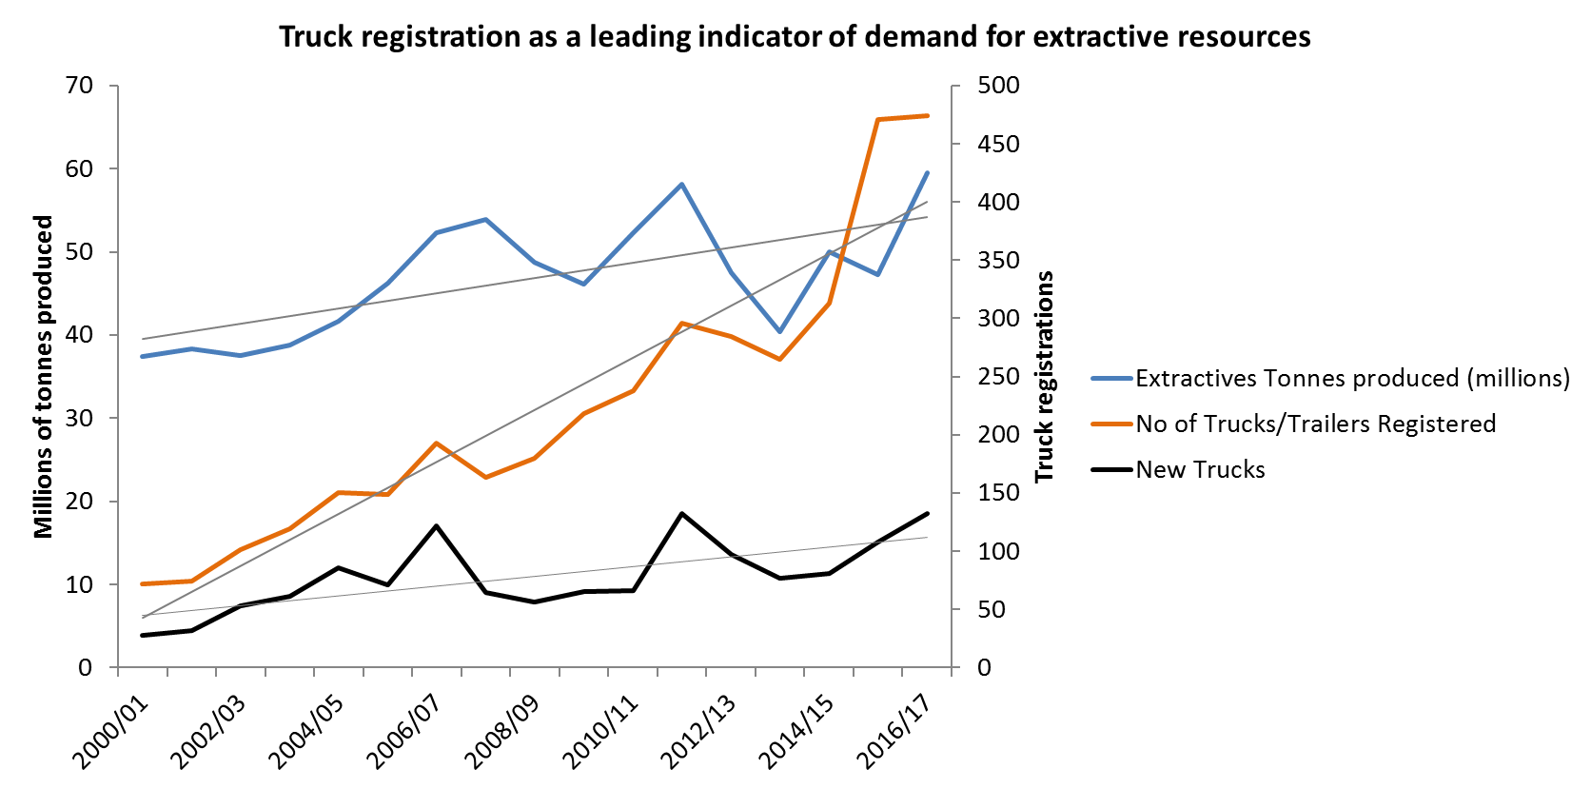

If this high demand trend persists, total extractives production would be expected to increase to more than 100 million tonnes per annum by 2050, more than doubling the 2016 annual production levels.

Key drivers and locations of demand for extractive resources.
Construction activities that drive the consumption of extractive resources are:
Residential development, including suburban houses and inner-city apartments. This sector currently accounts for more than 50 per cent of Victoria’s demand for extractive resources
Non-residential development such as commercial, retail and industrial development, hospitals, schools and community buildings
Transport infrastructure construction such as new roads, road maintenance and rehabilitation works, bridges, railways, cycle paths and airports
Energy and utilities infrastructure construction such as water treatment plants and wind farms.
Plan Melbourne predicts that between now and 2050, 1.6 million new homes will need to be built in Melbourne alone to house our growing population.
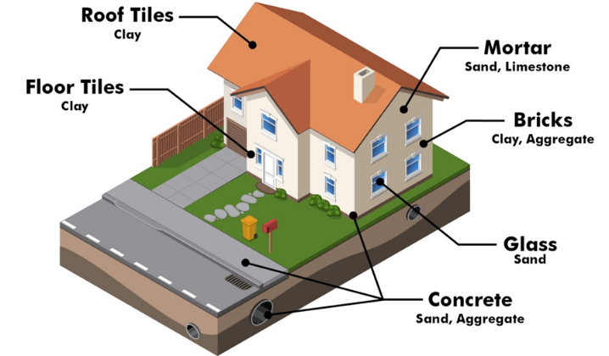
Infill development across Melbourne is forecast to become the largest contributor to demand by 2050. This includes redevelopment sites for housing, as well as strategic urban renewal projects such as Fishermans Bend, the Arden Macaulay Precinct, and the Berwick Health and Education Precinct (Figure 5).

The Demand and Supply Study found that this demand will come from growth in central and fringe areas of metropolitan Melbourne (particularly in the local government areas of Melbourne, Wyndham, Casey, Whittlesea and Melton) and the growing regional centres such as Ballarat, Greater Geelong, Greater Bendigo and Wodonga (Figure 6).
Given this demand, Figure 7 shows areas with potential shortfalls in 2026, with darker-shaded regions representing local government areas with larger potential shortfalls. These shortfalls are expected to worsen by 2050 if appropriately located and sized resource deposits are not secured.

Forecast drivers of demand for extractive resources over time
The Victorian Government’s major infrastructure pipeline includes $45 billion of investment to deliver the infrastructure that our growing state needs (Figures 8).

Victoria’s current program of Major Infrastructure Projects
Key projects include:
Metro Tunnel to run for nine kilometres beneath Melbourne’s CBD and beyond, including five new underground stations to accommodate new high-capacity trains
North East Link to create an essential freeway connection between Melbourne’s north and east
Level Crossing Removal Program to remove Melbourne’s 50 most dangerous railway level crossings
West Gate Tunnel Project to provide quicker and safer journeys to the western suburbs, Geelong and Ballarat, and to take thousands of trucks off residential streets
Regional Rail Revival Program to improve infrastructure and services on regional rail lines across Victoria
School buildings program, including 70 new schools for Victoria.

Extractive Resources required for the Metro Tunnel Project
The Metro Tunnel alone is expected to require more than:
480,000 cubic metres of ready-mix concrete
160,000 tonnes of other extractive materials
More than 30,000 square metres of precast concrete panels

Emerging trends that may impact extractive demand projections
By 2050, the proportion of overall consumption of extractives attributable to residential development is expected to drop from more than 50 per cent today to 39 per cent as commercial, transport, energy and utilities construction all increase their relative share of total extractives demand (Figure 9).
There are a range of factors that can affect demand projections over time, including changes in construction demands, growth in the use of recycled materials in construction and an increase in imported resources.

Changes in construction demands
The production of extractive resources relies on its relationship with construction activities and population and economic growth expectations. Changes in macro-economic demand drivers may influence construction demand, such as:
Population and household growth influencing residential housing construction
Employment growth influencing non-residential construction (such as office, retail and industrial)
Public and private sector investment in the size and scale of large infrastructure projects.

Government policy direction strongly influences construction activity – particularly in the energy, utilities and transport sectors.
Victorian renewable energy commitments will contribute to the growing demand for construction materials in order to facilitate the installation of renewable energy infrastructure across the State.

Renewable Energy
The Victorian Government has committed that by 2025, 40 per cent of our electricity will be generated from renewable energy. Renewable energy sources, such as windfarms, will increase demand for extractive resources – particularly in regional areas – as new wind farms and other new energy infrastructure is built.
A typical wind farm turbine requires around 586 cubic metres of concrete (sand, aggregate and cement) for its foundation. Additional concrete and gravel is required for access tracks, hardstand areas and substations (Figure 10). A 100-turbine wind farm could require over 490,000 tonnes of extractive resources.

Growth in the use of recycled materials in construction
Increases in the use of recycled materials as a substitute for extractive resources may reduce demand for virgin extractive resources. For example, reclaimed asphalt can be used in the required mix to manufacture asphalt. Approximately 15 per cent of the asphalt currently consumed today consists of reclaimed asphalt which could increase to 30 per cent within 20 to 30 years.
Road construction specifications may also change, allowing lower quality, but fit for purpose material to be used on certain light-use roads. This helps to conserve scarce, higher quality extractives for strategic projects requiring higher standards of material.

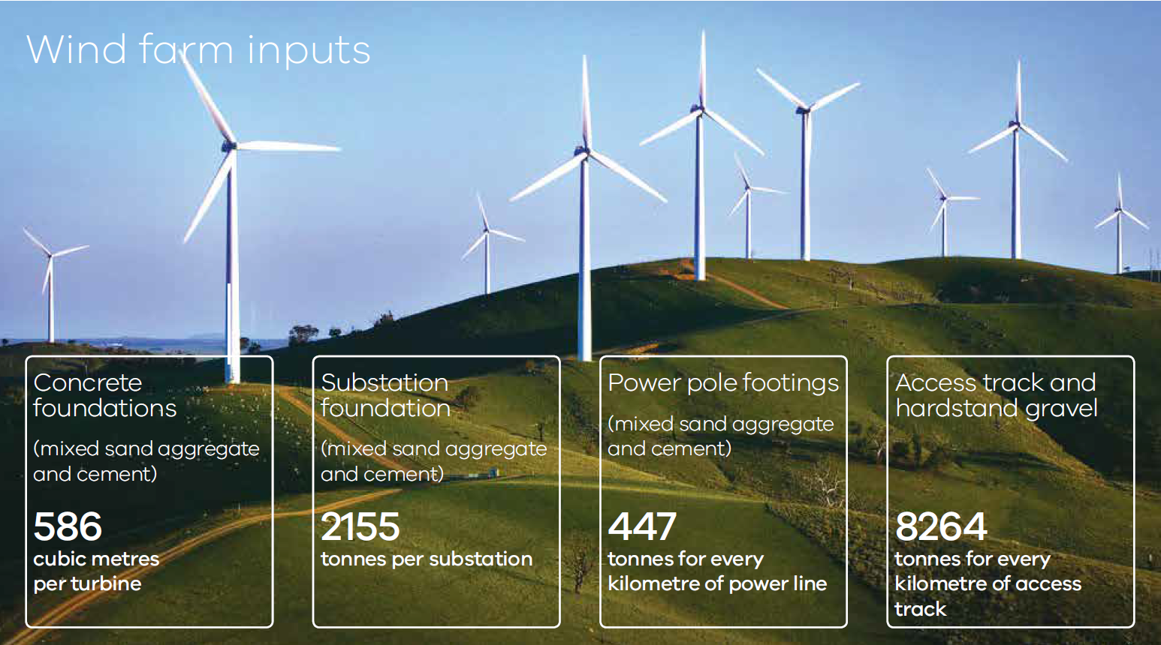
Technological development and trends in construction materials
Innovation and changes in construction materials may also affect demand. For example, plastic road materials are being trialled across the globe as an innovative and sustainable solution to replace concrete. Currently, plastic roads are mostly being considered for access surfaces such as bike lanes and footpaths. This may change as technological advancements are made.
Increase in imported resources
The importation of finished products may also reduce the demand for some extractive resources. Most building façade-related products are currently sourced from outside Australia. This may reduce the quantity of (glass) sand extracted in Victoria. This trend may also apply to other products, with some companies sourcing clinker (a raw material to produce cement) from China. Ultimately, this trend may impact the quantities of extractive resources required to produce cement in Australia.
Adapting to a changing climate
Increased or changing demand for extractive resources arises from the need to deal with impacts of a changing climate (for example, construction of sea walls in coastal areas and increased maintenance or early replacement of infrastructure).

Supply of Extractive Resources to meet current and future demand
The extractives supply industry in Victoria has a variety of participants. These include farmers quarrying small volumes for their day to day needs, small businesses supplying local markets and large multinational businesses producing specialist industrial material. The extractives industry in Victoria is generally considered to be competitive, with around 75 per cent of the State’s production produced by 20 companies.

Victoria currently has a competitive advantage with access to high quality resources close to markets. This means public infrastructure, housing and private sector development can be built more cost efficiently. For example, Melbourne’s extractive resources are approximately one third cheaper than Sydney’s supply, which flows through to cheaper development costs for Melburnians.

Snapshot: Extractives industry structure in Victoria
The extractives industry in Victoria is generally considered to be competitive, with nearly 500 companies holding over 800 work authorities in the State. Around 75 per cent of the State’s production comes from 20 companies, with around 55 per cent of production concentrated in four major companies and their subsidiaries. These larger producers tend to operate on a national scale, employing hundreds of people with millions of dollars in operating income generated from a large number of quarries. Smaller producers are often independent or family-owned businesses which may operate only a few quarries. They tend to focus on a local market and run on lower margins.

To meet demand in the future, we need to ensure that existing quarries continue to operate and that a substantial number of new quarries become operational in the short to long-term. The future supply of extractive resources close to where they are needed is important to keep transportation costs down for the materials used in public and private infrastructure projects and other economic development.
The Demand and Supply Study found that 34 per cent of demand for extractives in 2050 will need to be sourced from quarries not yet built or planned, due to forecast resource exhaustion. If demand remains at the current high levels, more quarries will be needed to address emerging shortfalls.

Resource supply locations across Victoria

Extractive Industry Interest Areas
Extractive Industry Interest Areas (EIIAs) were established in the 1990s by the Geological Survey of Victoria. This followed an assessment of land where extractive industry operations were more likely to be established, both for reasons of resource availability and where there are potentially fewer land use planning constraints. EIIAs are recognised in Plan Melbourne and Regional Growth Plans to signal the importance of stone and sand extraction to support growth areas.

Why were Extractive Industry Interest Areas established?
EIIAs were established to raise awareness that extractive industry is a potential land use and facilitate the protection (from competing land uses) of stone resources within the Melbourne Supply Area and other regional centres around Greater Geelong, Ballarat, Latrobe and Bendigo.
EIIAs sought to do this by:
- Providing a basis for the long-term protection of stone resources from sterilisation by inappropriate land uses
- Providing a basis for ensuring the long-term availability of stone resources for use by the community at a minimal detriment to the environment
- Assisting in considering extractive industry values in long term strategic planning as well as local strategy plans
- Ensuring that planning or responsible authorities consult with all relevant agencies about land use proposals which may impact on the reduction of stone resources within these areas
- Creating an awareness that extractive industry is a potential land use in these areas.

The current system of EIIAs, although identified in the land planning system, do not currently provide a clear mechanism to secure extractive resources of strategic importance to the State. EIIAs also require ongoing review and refinement as demand for resources increases and other land use pressures emerge. In some cases, an area previously identified as an EIIA has seen opportunities for extractive industries substantially reduced or eliminated altogether due to new housing developments or sterilisation by other land uses such as small farmlet subdivisions or other planning decisions and policy overlays.

Critical Supply Local Government Areas
The Demand and Supply Study identified the most important local government areas to help ensure the cost-effective supply of extractive resources in Victoria. These local government areas were determined based on the following criteria:
- Threatened resource type – resource types that are in short supply across the State
- Resource depletion – supply of resources is unable to meet allocated demand due to exhaustion of reserves
- Significant production – strong supply locations supporting the State’s future development
- Resources important to Melbourne – resource locations that support strong demand in Greater Melbourne.
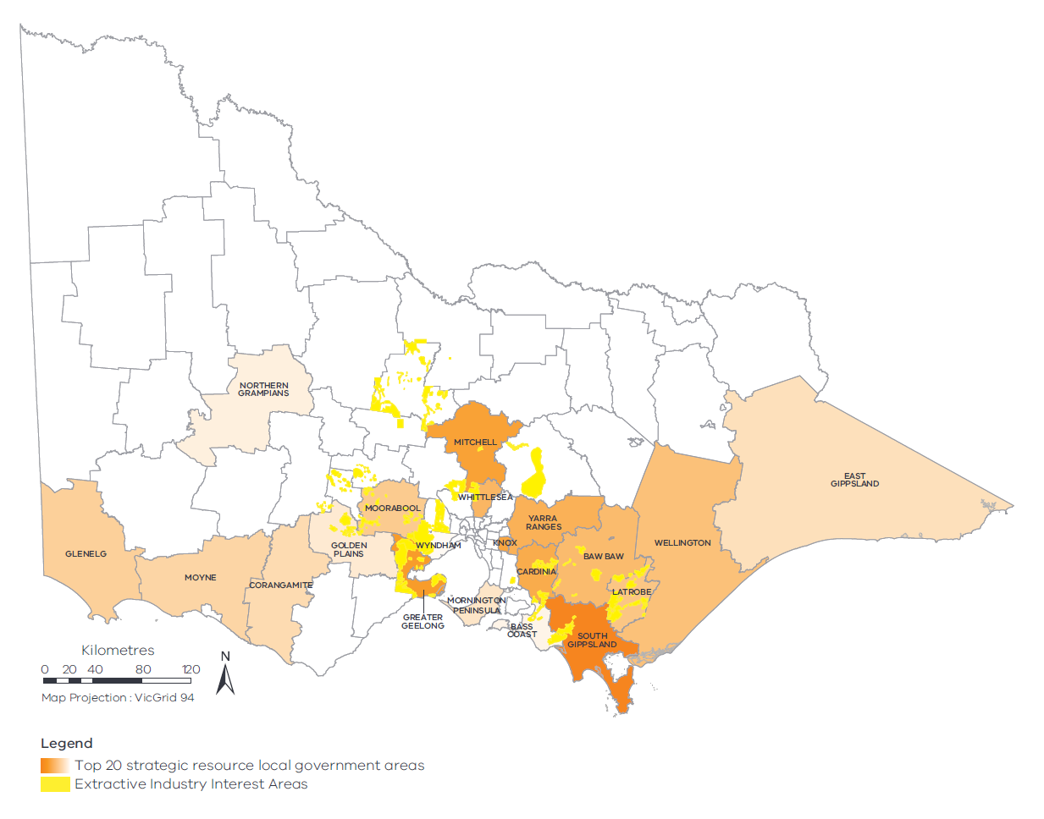
As Melbourne and Victoria’s regional cities grow outwards, land that previously buffered quarry operations from local communities is increasingly being used for urban development. Many established operating quarries are now under pressure from incompatible land uses, hindering operations and ending extraction prior to planned resource exhaustion.
Development and land fragmentation has occurred over the top of as-yet undeveloped extractive resources, thereby preventing these resources against future exploration. Again, this issue limits state-wide supply of extractive materials.
An analysis undertaken in 2018 of quarry approvals has shown that only a quarter of quarry applicants have been able to secure necessary approvals in the past two years to carry out new production. This indicates there is likely to be even less supply coming on line in some critical districts over the next five years compared to what industry had been anticipating in 2015.

Regulatory and Planning Context
A robust suite of legislation is in place to regulate the extractives sector, with the Mineral Resources (Sustainable Development) Act 1990 (MRSDA) providing the main legislative framework for the extractives industry in Victoria.
The purpose of the MRSDA is to encourage economically viable extractive industries which make the best use of, and extract the most value from, resources in a way that is compatible with the economic, social and environmental objectives of the State.
Industry takes into consideration a range of factors that affect long-term investment decisions including the quality and the availability of the resource, demand, access, and the timing and costs associated with approvals and regulation.
Industry has reported that lengthy and complex approvals processes involved in licencing of new resource reserves and variations of conditions of existing work authorities affects investment in new and expanded quarries. Though industry carries the immediate cost of lengthy and uncertain approvals processes, ultimately the Victorian community bares these costs through increased construction costs.
Industry has reported that currently, the average time taken to process a work plan approval (including time associated with approvals provided by various Government agencies) is 3.5 years. Whilst it is important that extraction is safe and sustainable, and approvals do not compromise these factors, excessive time delays limit industry’s ability to respond to market demand and could give rise to localised resource shortfalls and subsequent price spikes.
Figure 12 illustrates the key stages for processing simple and straightforward quarry applications. Some extractive industry projects are assessed under the Environmental Effects Act 1978, which requires the proponent to prepare an Environmental Effects Statement for assessment by the Minister for Planning.
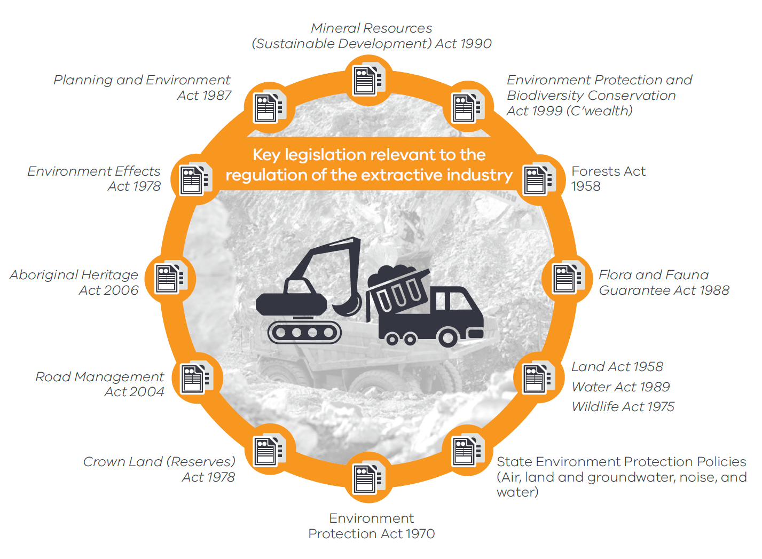

As part of the Demand and Supply Study, industry operators were asked to nominate issues constraining expansion of existing work authorities. Over 14 per cent of respondents identified the Earth Resources Regulator work plan approval process as an issue limiting expansion of their work authorities.
The responses in Figure 14 illustrate the proportion of respondents that indicated the issue affected them – hence numbers do not total 100 per cent.

Planning
The importance of the extractive industry to Victoria is recognised in general terms in Victoria’s planning schemes. The State Planning Policy Framework sets out:
The need to secure resources and encourage exploration and extraction
Where and how buffers should be applied
The need to consider policy documents such as EIIAs in planning decisions.
Despite acknowledgement in the planning system of the importance of extractive resources, the sterilisation of our extractive resources by the encroachment of urban development, rural subdivision, and establishment of other sensitive land uses can still occur. Some EIIAs around Melbourne have been built over or are at risk of encroachment from urban development.
Strategic planning policy, decisions that facilitate urban development and other land uses also influence the performance of the extractive resources sector. Some of these constraints may reduce the availability of extractive resources in particular areas into the future.
Key strategic planning policies which balance the growth of our urban areas include:

Plan Melbourne
Plan Melbourne recognises the importance to the Victorian economy of the availability of a reliable supply of extractive resources within transport proximity of areas of high demand. Plan Melbourne recognises the need to identify and safeguard strategic extractive resources through the planning system from incompatible land use and development over preservation of extractive resources.

Growth Corridor Plans
These are high level integrated land use and transport plans for the development of Melbourne’s Growth Corridors over the next 30 to 40 years. Planning for communities in the growth corridors is undertaken through the Precinct Structure Plan process. The Growth Corridor Plans recognise the role of existing extractive operations, but are silent regarding EIIAs or proposed new quarries. This has led to some uncertainty regarding whether extractive industry or urban development should take precedence in some locations when a Precinct Structure Plan is undertaken.

Regional Growth Plans
Together with Plan Melbourne, Regional Growth Plans form the strategic land use plans for Victoria. EIIAs were incorporated into the Regional Growth Plans with the aim to guide planning authorities’ consideration of identified extractive resources during any future strategic planning.

Urban infill
Projects including Arden-Macaulay and Fishermans Bend Urban Renewal Areas and recent approvals in the growth areas such as the Rockbank Structure Plan and the Werribee Employment Precinct will contribute to future medium to high-density urban development.

Smart Planning
The Victorian Government through its Smart Planning program is simplifying and improving the operation of the planning system to make it more efficient and responsive for proponents.
The Victoria Planning Provisions are the planning policies and controls upon which all land use planning decisions are made.
Proponents of extractive industry projects will benefit from the Smart Planning program’s aims to both simplify and improve the operation of the Victoria Planning Provisions. This, combined with the actions outlined in this Strategy such as the Strategic Extractive Resource Areas and the implementation of the Government’s Continuous Improvement Program, will lead to a better business climate that supports investment in extractive industry projects.

Summary of Key Challenges
Land use planning decisions affecting locally sourced supplies of extractive resources can result in supply having to be imported from further afield. Resource production from quarries in Victoria may not be sufficient to supply future demand leading to ongoing upward pressure on prices. These factors have the potential to flow through to higher construction and road maintenance costs that ultimately affect all Victorians.
Regulatory performance in the sector has not met community and industry expectations. The length and complexity of processes to obtain a work plan limits industry’s ability to respond to market demand and could give rise to localised resource shortfalls and subsequent price spikes.
Another consistent challenge for operating quarries and key resource areas is that, in most cases, significant quarry sites and resource areas are not adequately identified nor protected by Victoria’s planning schemes. The current EIIAs, while identified in the land planning system, do not provide a binding mechanism to secure extractive resources of strategic importance to the State.
Land encompassed by EIIAs has also come under increasing pressure from competing uses, which in some instances has caused sterilisation of opportunities for development of extractive industries. A refresh of the EIIAs would allow excision of areas considered unsuitable for development of extractive industries, while redefining the remaining areas based on resource characteristics that are of value to the Victoria.
Local councils often report that it is difficult to develop and maintain capabilities and corporate knowledge about the processes for assessing applications affecting quarrying activities because of the complexity of guidance around extractive resources in the planning system. Equally, applications for quarry planning permits are made less frequently than other application types in most councils.
The data currently available to land planners and decision makers also does not usually take into account regular updates and ongoing comprehensive analysis and reporting of the supply and demand balance. Having better data available would allow for better planning and prioritisation to ensure the supply of suitable quality and quantity of extractive resources is available.

Meeting the Challenges: Strategy Actions

This Strategy is structured around six broad areas for action.
Securing strategically important extractive resource areas is vital for Victoria’s future growth. Together with major transport and infrastructure planning, efficient regulation and greater certainty in the approvals processes, community confidence in the sector and a new focus on environmental sustainability and innovation will be key.
Outcomes and priority actions under each theme are discussed in the following sections. A summary of Strategy Actions is located at Figure 15, with further details to inform the Implementation Plan for the Strategy in Appendix 1.

Resource and Land Use Planning

Outcomes
Through better identification of strategic resources and better land use planning, we aim to:
Identify and secure existing and future strategic extractive resources
Facilitate open and transparent dialogue with local councils, industry communities and planning agencies
Improve understanding of the extractive resources needed to support long-term growth within Victoria.

Priority Actions
We will help secure future extractive resources by taking immediate action to:
Refresh the EIIAs to delineate areas of importance to the State and recognise these within the planning system
Conduct a pilot Strategic Extractive Resource Area project in partnership with local government
Revise short-term supply and demand forecasts, including updated data on infrastructure investment, population growth forecasts and industry survey data
Engage early and often with stakeholders on key strategic planning initiatives (e.g. Plan Melbourne, Land Use Framework Plans) to inform these processes about the location and importance of critical extractive resources
Build a better understanding of the economic case for securing strategic extractive resources, including by developing a dynamic economic model that assesses the demand and supply of extractive resources on a spatial and temporal basis across the State.

Key Issues

Refresh Extractive Industry Interest Areas
EIIAs remain an important and current evidence-base for informing planning decisions in relation to extractive industries and other land uses. By refreshing these areas and refocusing them on extractive resources of State importance, these resources will be afforded greater recognition in the planning system. This is an immediate action that will shorten the timeframe developers endure to identify suitable land and gain necessary approvals, with the aim of addressing short-term supply limitations.

Strategic Extractive Resource Areas – Concept and Pilot
Though the Victorian planning system recognises some important extractive resource areas, it has not always been possible to prioritise extraction and effectively prevent encroachment upon these resources to date. The current EIIAs, as identified in the land use planning system, are too extensive, not consistent with other Government strategic planning documents, and do not provide a binding mechanism to secure extractive resources of strategic importance.
To help address this, the Victorian Government has developed the concept of Strategic Extractive Resource Areas, which it is currently piloting in two key extractive resource locations in partnership with Wyndham City Council and South Gippsland Shire Council (Figure 14).

Strategic Extractive Resource Areas Pilot Project: Snapshot
Purpose: The Strategic Extractive Resource Areas Pilot Project aims to trial mechanisms available within Victoria’s existing planning system that could be applied to recognise and secure strategic extractive resource areas within local government areas.
Outcome: The Pilot Project will lead to securing extractive resources of strategic importance for the construction of public infrastructure, affordable housing and private sector development now and in the future.
Key Components: The Pilot Project will include:
- Conducting geological investigations to identify and map the highest quality rock and sand resources
- Preparing a landscape inventory to identify key natural, cultural and existing land use values, and transport networks, to inform the selection of areas suitable for resource development
- Undertake economic analysis to inform an overall ‘net community benefit’ assessment to determine the optimum or ‘on balance’ strategic resource area locations
- Examining and implementing suitable strategic land use planning instruments to secure access to the identified resource areas
- Engaging with local communities to inform the overall approach
Timing: The pilot project is expected to take 12 to 18 months to complete.
Initial pilot council partners:
- Wyndham City Council – peri urban Melbourne, hard rock
- South Gippsland Shire Council – regional pilot, sand

The partnership with Wyndham City Council aims to secure the supply of hard rock resources close to Melbourne. The Wyndham local government area is one of the largest producers of hard rock in Victoria with multiple stone quarries along its western growth front. The Wyndham City Council pilot project provides an immediate opportunity to test planning instruments for securing existing strategic extractive resources which interface with urban development.
The South Gippsland pilot project will help secure the Nyora sand resource in the north-western area of the South Gippsland local government area. The pilot is expected to involve collaboration with adjacent councils that share the strategic sand resources (Cardinia and Bass Coast).
Strategic Extractive Resource Areas will be identified based on geological studies showing significant resources, an assessment of surrounding natural, cultural and existing land uses, supporting transport networks and proximity to markets. Once identified, they will be built into the land planning system to ensure that consideration is given to Strategic Extractive Resource Areas in planning decisions. Identification of these areas may happen alongside similar Government projects to identify and secure other strategic resources such as agricultural land.
The pilot project will involve engagement with local communities, industry and government stakeholders to develop an understanding of natural, cultural and existing land use values and transport networks to inform the selection of areas suitable for resource development. State and local governments will work together to research and map the geology of selected areas and determine suitable land planning mechanisms to recognise Strategic Extractive Resource Areas that will appropriately secure the resource.
Informed by the pilot project, the Government will progressively roll out Strategic Extractive Resource Areas in suitable areas across Victoria. The establishment of Strategic Extractive Resource Areas will be underpinned by quality data which is easily accessible by state and local governments, industry and the community.

Strategic engagement
Engaging with strategic planning processes that set future directions for land use, such as that done during the Plan Melbourne implementation and development of regional growth plans, will help to ensure that the state-significant strategic extractive resources are recognised and can be secured for future use. Through all these processes, we need to make sure we are engaging early and with the best available information to inform decisions that will impact on the future availability of strategic extractive resources.
This will include not only engaging in the development of specific Strategic Extractive Resource Areas, but also continuing to ensure land planners are aware of identified key extractive resources (such as those located in EIIAs and in critical supply local government areas) so as to avoid sterilisation of significant and limited resources.

Up to date supply and demand data needs to be available to inform land planning decisions
By improving knowledge about the sector, including the provision of accurate supply and demand data and economic information, we will be in a better position to inform planning and regulatory decisions.
To better predict and adjust forecasts according to changes in the demand and supply of extractive resources, we will partner with industry to implement improvements in the way we collect, report and account for the resources available or planned for future use. This will allow the Government and planners to make better and more timely decisions on priorities and approvals.

To inform future planning decisions, the Government will also build a better understanding of the economic case for securing strategic extractive resources, including by developing a dynamic economic model to assess the demand and supply of extractive resources on a spatial and temporal basis across the State.

Once in place, Strategic Extractive Resource Areas will help to provide certainty to industry, local and state governments and the community.

Transport and Local Infrastructure Planning

Outcomes
By informing transport and local infrastructure planning, we aim to:
- Determine transport impacts and network development needs to support the forecasted significant growth in the extractive resources industry
- Improve the efficiency of transporting heavy construction materials
- Improve network capacity, access and productivity of heavy vehicles transporting construction materials.

Priority Actions
To better inform transport and local infrastructure planning for extractive resources, we will:
- Improve data collection and sharing to better inform the development of transport strategies and plans to recognise critical transport networks of extractive resources
- Encourage development of dedicated quarries close to new major regional infrastructure projects
- Review existing contributions made by the extractives industry to address local infrastructure impacts.

Key Issues

Improve data collection and sharing to better inform extractive resource transport networks in transport and infrastructure plans
Transportation of extractive resources is expensive. The greater the distance between a quarry and the point of use, the higher the cost to the construction industry and ultimately to Victorians.
Additional travel distances also have social and environmental impacts on the broader community. Benefits from reducing travel distances include increased road safety, reduced traffic congestion and road damage, protection of amenity in local areas, and fewer greenhouse gas emissions.
Proactive transport planning is needed to ensure efficient routes from quarries to market. As quarries are exhausted close to current areas of demand and new areas of demand emerge in the future, new road infrastructure or upgrades may be required to enable prompt and reliable delivery of these materials.

The Demand and Supply Study found that between now and 2050, Victoria will incur an additional $2 billion in costs for every additional 25 kilometres that extractive resources will need to travel to reach their destination.

The heavy construction materials industry is a key player in Victoria’s transport industry with quarry materials, cement and premixed concrete making up 10 per cent of the tonne-kilometres travelled by freight vehicles on Victoria’s roads.

Encourage development of dedicated quarries close to new major regional infrastructure projects
Extensive transport distances can also be managed by encouraging development of dedicated quarries to support new major regional infrastructure projects. Quarries that are co-located with construction projects can minimise negative impacts associated with long distance travel. They also help to mitigate against local shortages of materials being available for other local projects or infrastructure programs. Major infrastructure projects in regional areas present the greatest opportunities for co-located quarries.

Local Quarries for Local Infrastructure
The Mount Mercer Wind Farm in Western Victoria utilised materials of a small co-located quarry for wind turbine foundations and access tracks.
The Stockyard Hill Wind farm – also in Western Victoria – will also utilise materials from a small co-located quarry.

Review existing contributions made by the extractives industry to address local infrastructure impacts
Vehicles carrying extractive resources have an impact on roads. Freight transport vehicles contribute to road maintenance through a number of government fees. Where regional roads are frequented by trucks carrying extractives, particularly for major projects, costs borne by industry (for example, developer fees and road contributions embedded in planning decisions) vary considerably and at times may be below those borne by local communities. A more consistent and fair collection and distribution of funds based on the actual use of the transport network is required.

Efficient Regulation

Outcomes
By implementing the Commissioner for Better Regulation’s Report on Earth Resources Regulation – Continuous Improvement Project, we aim to:
Ensure that the extractive resources regulatory framework is transparent, consistent, efficient and outcomes-focused
Increase regulatory certainty for investors and reduce timelines for approvals.

Priority Actions
The Government has developed the Getting the Groundwork Right – Better Regulation of mines and quarries: Implementation Plan to implement the recommendations of the Commissioner for Better Regulation. The Implementation Plan aims to:
Simplify the assessment processes for proposed quarries, while strengthening the regulatory focus on the most complex risks
Provide clearer information to industry and the community about regulatory processes and decisions
Improve coordination across the regulatory system, including through better engagement between the regulator and other regulatory authorities
Deliver modern approval and internal processes to enable timely and consistent decision making, and support industry compliance
Ensure laws and regulations governing the earth resources sector are fit for purpose, based on modern technologies and best practice regulatory and governance frameworks
Implement any regulatory changes needed to support the identification and protection of strategic extractive resources.

Key Issues
In recent years, the Victorian Government has taken steps to streamline the quarry operations approvals process without compromising social, economic and environmental outcomes. However, there is more to be done to give industry the confidence to make long-term investments for the benefit of all Victorians.
The Government’s new Implementation Plan will deliver much needed reform to Earth Resources Regulation. The Implementation Plan responds to ongoing feedback from industry that delays and uncertainty in regulatory approvals processes hindered production and supply of extractive resources.
By reforming our regulatory system, we can promote the attractiveness of the extractives sector and give operators the certainty they need for making investment decisions through administering a transparent, consistent and efficient regulatory framework. This promotes development and provides the community with confidence in decision making.
The security of strategic extractive resources can be bolstered by an efficient and responsive regulatory system. The Victorian Government is committed to creating an environment that enables industry to operate sustainably – both individually and as part the Victorian community.

Confident Communities

Outcome
By engaging with and supporting communities, we aim to enhance community awareness and acceptance of the extractive resources sector.

Priority Actions
We will:
- Engage with communities to raise awareness of the importance of quarries and ensure all stakeholders have easier access to earth resources information
- Support community capacity-building services to better enable participation in decision-making about quarries
- Help build the capacity of industry and councils to better engage with their communities.

Key Issues

Engage with communities
For extractive resources to continue to be available as Victoria grows, the extractives industry should work with the community to build a social licence to operate. The industry will be best placed to conduct extraction activities if it has the acceptance of local communities and affected stakeholders. To achieve this, Victorian communities should be engaged on the importance of extractives throughout all stages of the quarry lifecycle, and gain the confidence that quarry operations will be well managed. Strong and enduring relationships between industry and communities will be key to ensuring that supply of extractives meets demand.

Support community participation in decision-making
Engagement between communities, government and the extractives industry needs to be strengthened to ensure that each group has sufficient information about local projects to make informed decisions. Industry, state and local governments all have a distinct role to play in building communities’ understanding of the importance of extractive resources to daily lives.

Build industry and council capacity to better engage with communities
The extractive resources sector has the potential to bring economic, social and environmental benefits to local communities. Industry and the Government together must take a lead in fostering two-way communication with the community.

Environmental Sustainability

Outcomes
By taking an environmentally sustainable approach to the extractive resources industry, we aim to:
Support industry operators to be recognised as leaders in the sustainable development of resources
Reduce demand on virgin extractive resources by substituting them with recycled products where appropriate
Achieve zero net greenhouse gas emissions by 2050.

Priority Actions
To support environmental sustainability in the extractives sector, we will:
- Establish measures to help guide industry to continuously improve its environmental management to reflect leading practice
- Work with the extractives sector to reduce net greenhouse gas emissions consistent with the Victorian Government emission reduction and sustainability initiatives
- Improve the management of waste across the industry
- Develop a strategic approach to securing biodiversity offsets.

Key Issues

Leading practice in environmental management and sustainability
A healthy environment is the foundation of many of the productive activities that underpin our economy. In Victoria, a number of laws, policies and initiatives exist which set ambitious targets to ensure Victoria is on the path to sustainability. The Victorian Government is committed to improving the care and protection of the State’s environment, including through a number of interconnected initiatives focused on protecting biodiversity. Through this Strategy the Government will continue working across its departments and with industry to develop and implement innovative and meaningful approaches to biodiversity offsets, and environmental management more generally, for the extractives sector.

Reducing Emissions
The Victorian Government has committed to a target of zero net greenhouse gas emissions by 2050 for Victoria. This means that our greenhouse gas emissions will be reduced as far as possible. Any remaining emissions will be counteracted through activities such as planting more trees or capturing more carbon in the ocean and coastal ecosystems.
Every Victorian, including businesses operating in Victoria, has a part to play.
The extractive resource industry can play its part in achieving net zero emissions and improving Victoria’s environment by:
- Reducing consumption of energy, water and other auxiliaries in extraction and transportation
- Reducing emissions directly caused by extractive operations
- Reducing waste, maximising reuse, and where feasible playing a role in materials recycling
- Closing the loop on the quarry lifecycle by implementing innovative end land uses for exhausted quarries
- Continually striving towards better conservation of biodiversity and cultural heritage.
The falling costs of renewable energy technologies presents an opportunity for quarries with plants powered by electricity to reduce costs and emissions. Biofuels represent another potential opportunity for quarries as an alternative to diesel fuel used in operating plants, machinery and in transportation.

Waste reduction
Quarry wastes are a largely unavoidable by-product of the extraction and processing of aggregates. Minimising waste through improved quarry design and operation can lead to greater productivity and supply of product to the market.
Quarries can also play an important role in supporting materials recycling in Victoria by supplementing their product lines with recovered construction materials from demolished buildings and infrastructure. Victoria’s Market Development Strategy for Recovered Resources aims to support increased recycling by stimulating markets for recycled materials such as recycled concrete and bricks.

New road specifications use recycled materials
VicRoads has recently amended a range of product specifications to allow for the inclusion of recycled products such as crushed concrete and brick, glass fines and reclaimed asphalt pavement.
In December 2017 VicRoads announced it will invest $1 million towards identifying new opportunities to use recycled products.

Innovative Sector

Outcomes
By promoting an innovative extractives sector, we aim to:
Facilitate innovative end land use for quarries during operation and post-closure
Encourage innovative approaches to achieving environmental best-practices
Engage with industry and Victorian communities on the benefits of post-quarrying land uses that can be achieved through innovative planning and progressive rehabilitation
Capitalise on Victoria’s technology and innovation advancements.

Priority Actions
To support innovation in the extractives sector, we will:
Investigate the feasibility of short-life quarries
Investigate the feasibility of different innovative end-land use opportunities for quarries
Develop and deliver an innovative post-quarrying land use flagship project.

Key Issues
A healthy extractives sector requires continual innovation to respond to demand and to remain viable and successful.
Innovation and collaboration between operators, customers, end-users and research organisations will assist the sector to identify new opportunities, build on emerging capabilities and adopt new technologies to ensure it continues to grow and prosper into the future.

Investigate the feasibility of short-life quarries
In areas where future urban development is likely to extend, there is opportunity for strategic resources to be extracted ahead of urban development. Short life quarries coupled with innovative rehabilitation may assist in orderly sequencing of land uses.

Innovative end-land use opportunities for quarries
Innovation also has a central role in planning, design and implementing safe, stable and beneficial post-quarrying land forms and land uses. Post-quarrying land uses can enhance amenity and lifestyle for local communities, and also help to provide habitat for threatened species.
Quarries can make a valuable contribution towards enhancing networks of open space for use by local communities. This can be encouraged through long term open space planning coupled with quarry approvals that consider innovative end land use options.
This has been achieved already in significant cases both in Australia and overseas. For example, in New South Wales in the 1980s, the Government embarked upon an ambitious plan to transition old quarry sites in Penrith into major water-based recreational parklands. This delivered public and social benefits, including through the hosting of the 2000 Sydney Olympic Games rowing events.
We will support industry to plan for and implement innovative end land uses that are beneficial for the local community.

Case Study: From Quarry to Housing Development
Valley Lake is a 48 hectare residential housing estate in Melbourne’s north western suburbs which was completed in 2017. The site was formerly the Niddrie Quarry, which had supplied Melbourne with basalt since the 1940s. In 2000 redevelopment of the quarry site began. Today, the site comprises a new lake edge reserve featuring a 600 metre boardwalk and community barbeques and seating areas, sustainable wetlands, roads and other services for more than 500 homes. Valley Lake demonstrates that innovative planning can transform formerly valuable quarries into places that continue to meet Melbourne’s future housing and other community needs.

Summary of short, medium and long term actions

Resource and Land Use Planning
0-2 YRS
- Pilot Strategic Extractive Resource Area project in partnership with local government
- Interim protections and engagement on key strategic planning initiatives
- Promote critical resource local government areas and existing Extractive Industry Interest Areas
- Revise short term supply and demand forecasts impacted by infrastructure investment and population growth
- Build understanding of economic case for securing strategic extractive resources
- Improve data collection and sharing by improving the availability of, and access to, critical data on current and forecast production and available reserves, in order to inform strategic resource planning
- Continue to improve Victoria’s approach to strategic resource planning and management
- Progressively identify Strategic Extractive Resource Areas in priority local government areas
2-5 YRS
- Develop decision- makers’ knowledge and capabilities
- Update Victorian extractive resource demand and supply forecasts every five years
5 YRS +
- Ongoing engagement to ensure recognition of strategic extractive resources in critical state and regional plans and strategies

Transport and Local Infrastructure Planning
0-2 YRS
- Recognise critical extractive resource transport networks in Victorian Government transport and infrastructure plans
- Improve data collection and sharing
- Conduct an initial study into transport impacts and network development needs
- Encourage development of dedicated quarries close to new major regional infrastructure projects
  - YRS
- Review existing contributions made by the extractives industry to address local infrastructure impacts
- Conduct further studies into transport impacts and network development needs in priority extractive resource area and supply regions
5 YRS +
- Ongoing planning for freight transport and local infrastructure

Efficient Regulation
0-2 YRS
- Implement short and medium-term actions in the Getting the Groundwork Right – Better Regulation of mines and quarries: Implementation Plan
- Improve work approvals processes
- Inform the development and review of the Victorian Government’s planning and environment policies
- Assess the implications of Strategic Extractive Resource Areas to the regulatory approval process

2-5 YRS

- Implement the longer- term recommendations set out in the Getting the Groundwork Right – Better Regulation of mines and quarries: Implementation Plan.
- 5 YRS +
- Ongoing planning for freight transport and local infrastructure

Confident Communities
0-2 YRS
- Engage with communities to raise awareness of the importance of quarries
- Support community capacity-building services to better enable participation in decision-making about quarries
- Help build the capacity of industry to better engage with their communities, including by sponsoring industry community leadership awards
- 2-5 YRS and 5 YRS +
Ongoing support to industry and communities

Environmental Sustainability
0-2 YRS
- Establish measures to ensure industry continuously improves its environmental management
- Work with the extractives sector to reduce net greenhouse gas emissions
2-5 YRS

- Improve the management of waste across the industry, including by incorporating use of recycled materials
- Develop a strategic approach to securing biodiversity offsets, to make it more efficient for quarry proponents to use offsets
5 YRS +
- Continue to support environmental sustainability within industry

Innovative Sector
0-2 YRS
- Investigate the feasibility of short-life quarries
- Inform Melbourne’s open space planning
- Investigate the feasibility of different innovative end-land opportunities for quarries
2-5 YRS
- Develop and deliver an innovative post-quarrying land use flagship project
5 YRS +
- Promote innovation in the extractives industry

Monitoring and Evaluation
This Strategy will be implemented in partnership with industry, local councils and the Victorian community.
A complimentary implementation plan including key performance indicators will ensure this Strategy remains on track to meet its objectives. The implementation plan will assign key responsibilities for specific outputs to be produced with due dates, and will include measurable objectives against each outcome. Progress against the implementation plan will be monitored and reported on.
‘Health of the sector’ performance indicators will be used to monitor, evaluate and inform progressive refinements to the implementation plan to ensure that progress is made based on practical experience.

Further Information
Commissioner for Better Regulation, 2017, Getting the Groundwork Right – Better Regulation of mines and quarries ‘Earth Resources Regulation Continuous Improvement Project’

Department of Economic Development, Jobs, Transport & Resources, 2018, Getting the Groundwork Right: Implementation Plan ‘Getting the Groundwork Right: Implementation Plan’

Department of Economic Development, Jobs, Transport & Resources, 2017, Strategic Extractive Resource Areas – Victoria’s Existing Planning System, ‘Strategic Extractive Resource Areas – Victoria’s Existing Planning System’

Department of Environment, Land, Water and Planning, 2017, Plan Melbourne 2017-2050, Metropolitan Planning Strategy, ‘Plan Melbourne’

Department of Primary Industries, 2003, Melbourne Supply Area – Extractive Industry Interest Areas Review, ‘Melbourne Supply Area – Extractive Industry Interest Areas Review’

EY, 2016, Demand Analysis of Extractive Resources in Victoria, ‘Demand Analysis of Extractive Resources in Victoria’

PricewaterhouseCoopers, 2016, Extractive Resources in Victoria: Demand and Supply Study 2015-2050, ‘Extractive Resources in Victoria: Demand and Supply Study 2015-2050’

Appendix 1: Detailed Action Plan

Resource and Land Use Planning
Timeframe | Priority Actions for better transport and local infrastructure planning
0-2 yrs | Pilot Strategic Extractive Resource Area project in partnership with local government  The pilot project aims to secure extractive resources for the future in two local government areas identified has having extractive resources of strategic importance to the State.
0-2 yrs | Interim protections and engagement on key strategic planning initiatives  As well as the pilot, we will engage early and often with stakeholders implementing planning initiatives such as priority precinct structure plans, Plan Melbourne and regional growth plans, to help ensure that the State’s strategic extractive resources are recognised and can be secured for future use.
0-2 yrs | Promote critical resource local government areas and existing EIIAs
0-2 yrs | Revise short term supply and demand forecasts impacted by infrastructure investment and population growth  Update and publish supply and demand forecasts to identify immediate impacts from the roll out of significant public infrastructure investment and revised population growth in order to facilitate additional supplies of extractive resources into the market.
0-2 yrs | Build understanding of economic case for securing strategic extractive resources  Develop a dynamic economic model to assess the demand and supply of extractive resources on a spatial and temporal basis across the State, including geographical clusters of strategic importance for construction
0-2 yrs | Improve data collection and sharing by improving the availability of and access to critical data on current and forecast production and available reserves, in order to inform strategic resource planning  Review and implement options to improve the reporting by industry of reserve and production levels within existing work authorities as part of the annual reporting to the Earth Resources Regulator.
0-2 yrs | Continue to improve Victoria’s approach to strategic resource planning and management  Identify and review good practice policy frameworks across Australia and internationally to inform continual improvement of Victoria's strategic resource planning and management.
0-2 yrs | Progressively identify Strategic Extractive Resource Areas in priority local government areas  We will progressively introduce Strategic Extractive Resource Areas in suitable locations within key extractive resource supply councils around the State.  The implementation and roll out approach will be informed by findings of the pilot project, the Demand and Supply Study, updated data and ongoing engagement with industry, local governments and the community.
2-5 yrs | Develop decision-makers’ knowledge and capabilities  We will develop educational material and deliver workshops for local government and Victorian agencies to increase knowledge and skills for assessing and determining quarry applications.
2-5 yrs | Update Victorian extractive resources demand and supply forecasts every five years  We will update Victoria’s extractive resources demand and supply forecasts every five years, and monitor key factors influencing resource demand and supply to ensure our Extractive Resources Strategy responds to changes in the market.  Where there is justification for an intermediate review of demand and supply forecasts, we will conduct these reviews sooner than every five years.
5 yrs + | Ongoing engagement to ensure recognition of strategic extractive resources in critical State and Regional Plans and Strategies  We will work to ensure that strategic extractive resources are recognised in future updates to relevant state and regional plans (for example, future revisions of Plan Melbourne).

Transport and Local Infrastructure Planning
Timeframe | Priority Actions for better transport and local infrastructure planning
0-2 yrs | Recognise critical extractive resource transport networks in Victorian Government transport and infrastructure plans  We will inform the development of transport strategies and plans to recognise critical transport networks. The connectivity needed between Strategic Extractive Resource Areas and end-users will be used as a basis for determining critical transport routes and modes.
0-2 yrs | Improve data collection and sharing  We will improve data collection and sharing regarding the timing, frequency, volume and routes (actual and preferred) for transporting quarrying materials and products. This will be used to identify opportunities to improve transport efficiency and network performance.
0-2 yrs | Conduct an initial study into transport impacts and network development needs  We will undertake an initial study into the transport impacts and network development needs required to support the forecast significant growth in the extractive resources industry.
0-2 yrs | Encourage development of dedicated quarries close to new major regional infrastructure projects  We will consider a decision-making framework to expedite the approval process for short-term use quarries to support major regional infrastructure projects in order to reduce costs and other impacts upon local communities.
2-5 yrs | Review existing contributions made by the extractives industry to address local infrastructure impacts  We will evaluate the collection and distribution of fees and charges paid by transporters of extractive materials to inform a potential review of how extractive transportation vehicles contribute to the cost of local road maintenance and safety.
2-5 yrs | Conduct further studies into transport impacts and network development needs in priority extractive resource area and supply regions  Building on the initial transport study, we will undertake further studies into the transport impacts and network development needs required to support the forecast significant growth in the extractive resources industry.
5 yrs + | Ongoing planning for freight transport and local infrastructure  We will continue to inform transport and infrastructure planning for the efficient delivery of quarry resources to where they are needed.

Efficient Regulation
Timeframe | Priority Actions for better transport and local infrastructure planning
0-2 yrs | Implement short and medium-term recommendations set out in the Commissioner for Better Regulation’s Report on Earth Resources Regulation – Continuous Improvement Project  We will establish a Continuous Improvement Implementation Taskforce to improve the efficiency of the approvals process for two years to lead the development of cross-government decision making processes to ensure high priority quarrying projects are assessed efficiently and deliver timely benefits to Victorians.  We will also establish the Earth Resources Approvals Coordination Group to better streamline the approval process for quarries. The Group will:  Act as a clearing house for complex proposals and identify opportunities to tailor processes for strategically significant projects Increase regulatory certainty for investors and reduce timelines for approvals.  Examine the need to better incorporate into the planning system the strategic aspects of supply and demand for construction materials and the need for enhancing engagement across Government.
0-2 yrs | Improve work approvals processes  We will investigate options to streamline works approvals. In particular, we will improve alignment between the Mineral Resources (Sustainable Development) Act and planning approval.  We will also support industry’s to transition to risk-based work plans (where applicable), including by publishing updated environmental safety performance standards, amongst other initiatives, as they become available.
0-2 yrs | Inform the development and review of the Victorian Government’s planning and environment policies  We will take a proactive approach in informing the development and review of the Victorian Government’s planning and environment policies in areas such as planning, water and native vegetation.  We will investigate options to amend planning definitions to better account for the inherent variability in the operation of quarries over time associated with care and maintenance periods, variable market demand to supply of resources for construction projects, and the lead time to develop new quarries or a portfolio of quarries to meet future demand.
0-2 yrs | Assess the implications of Strategic Extractive Resource Areas to the regulatory approval process  We will use the findings of the Strategic Extractive Resource Areas pilot project to assess whether the regulatory approval process (new and existing Work Authorities) can be further streamlined.
2-5 yrs | Implement the longer-term recommendations set out in the Getting the Groundwork Right – Better Regulation of mines and quarries: Implementation Plan
5 yrs + | Continue to increase regulatory certainty for investors  We will continue to look for and implement ways to increase regulatory certainty for investors in the extractives industry in Victoria.

Confident Communities
Timeframe | Priority Actions for better transport and local infrastructure planning
0-2 yrs | Engage with communities to raise awareness of the importance of quarries  We will use the Strategic Extractive Resource Areas pilot project to test a range of different approaches to engaging with and communicating to local communities on the importance of quarrying operations.  We will help build the sector and councils’ capability to engage with communities regarding quarry operations by sharing engagement techniques and key messages that foster greater community confidence.  We will support industry operators and local community members by improving the governance arrangements for environmental review committees, including open forums.  We will also redevelop Victorian Government Earth Resources website to provide stakeholders with easier access to earth resources information.
0-2 yrs | Support community capacity-building services to better enable participation in decision-making about quarries  We will continue to help communities to actively engage in the process of approving quarrying projects. We will commence in the Bunyip North area to give the community a better understanding of the processes involved with quarry proposals and to participate in the assessment process.
0-2 yrs | Help build the capacity of industry to better engage with their community  We will sponsor industry community leadership awards in extractive resources. This will recognise and reward leading practice and innovation in community engagement and continue to invest in building the capacity of the industry to better engage with their community.
2-5 yrs  5 yrs + | Ongoing support to industry and community  We will continue to support industry and the community to build community awareness and acceptance of extractive industries.

Environmental Sustainability
Timeframe | Priority Actions for better transport and local infrastructure planning
0-2 yrs | Establish measures to ensure industry continuously improves its environmental management  We will review and update guidelines for quarrying projects, in consultation with industry, to reflect leading practice management of water and environmental resources and impacts.
0-2 yrs | Work with the extractives sector to reduce net greenhouse gas emissions  We will work with the quarrying sector to identify and apply Victorian Government emission reduction and sustainability initiatives.
2-5 yrs | Improve the management of waste across the industry, including incorporating use of recycled materials  We will support industry to adopt best practice approaches to minimising generation of extractive resource waste, and to play a role in supporting the recycling of recovered construction materials where feasible.  We will investigate the business case for co-location of recycling facilities within quarry operations.
2-5 yrs | Develop a strategic approach to securing biodiversity offsets to make it more efficient for quarry proponents to use offsets  We will work with industry to establish a coordinated strategic approach to identifying and securing native vegetation and other biodiversity offsets.
5 yrs + | Continue to support environmental sustainability within industry  We will continue to work with industry and consumers of extractive resources to develop the environmental sustainability of the extractives industry.

Innovative Sector
Timeframe | Priority Actions for better transport and local infrastructure planning
0-2 yrs | Investigate the feasibility of short-life quarries  We will conduct a study into the feasibility of short-life quarries in consideration of the costs and benefits they bring to industry and the community. The study will include consideration of issues such as fixed and mobile infrastructure and end-of-life quarry opportunities for improved long-term social benefits.
0-2 yrs | Inform Melbourne’s open space planning  We will inform the development of Melbourne’s forthcoming open space strategy to recognise opportunities to develop exhausted quarries as part of liveable open spaces for local communities.
0-2 yrs | Investigate the feasibility of different innovative end use opportunities for quarries  We will conduct a study into the feasibility of various innovative end uses for quarries in consideration of their costs and benefits to industry and the community. We will then engage communities and industry on innovative end-land use opportunities for quarries.
2-5 yrs | Develop and deliver an innovative post quarrying land use flagship project  We will develop and deliver a post-quarrying innovative land use flagship project. In partnership with industry, we will support research for a demonstration project to show how beneficial and productive post-quarrying land uses can be achieved through innovative planning and progressive rehabilitation.
5 yrs + | Promote innovation  We will continue to work with industry to develop and achieve innovative approaches to industry practice.

The high demand scenario assumed 20 per cent increase in demand drivers (population growth, Gross State Product) compared with available projections at the time of the data analysis (2015).

