Earth Resources Regulation
Interim Compliance Strategy
2021–2022

Table of contents
1 Authorisation 2
2 Introduction 2
2.1 Overview 2
2.2 Purpose 2
2.3 Our role 3
2.3.1 Role of the Compliance Team 3
2.3.2 Inspectors 3
2.3.3 Legislation 4
2.3.4 Ministerial Statement of Expectations 4
2.4 Working with other agencies and regulators 4
2.5 Working with the community 4
3 Strategic compliance objectives 5
3.1 Strategic compliance objectives 5
3.2 State-wide coordination 5
4 Regulatory approach 6
4.1 Risk-based 6
4.1.1 Priority risks 6
4.1.2 As Far as Reasonably Practicable 6
4.2 Proportionate and graduated 7
4.3 Consistent and fair 8
4.4 Transparent and accountable 8
5 Compliance approach 9
5.1 Supporting compliance 9
5.2 Monitoring compliance 9
5.3 Addressing non-compliance 10
5.3.1 Follow up 10
5.4 Enforcement actions 10
6 Priority Risk Areas 12

Authorisation
Title Interim Compliance Strategy 2021–2022
Issuing Division/ Branch Earth Resources Regulation
Date Effective 01 March 2021
Enquiries ERRFeedback@ecodev.vic.gov.au
 Contact 1800 366 356
Approved by Executive Director, Earth Resources Regulation

Introduction
Earth Resources Regulation regulates Victoria’s mining, quarrying, petroleum and recreational prospecting sectors.

Overview
Earth Resources Regulation recognises that public confidence in the earth resources sector and its regulator depends in large part on industry compliance. The regulator’s primary objective is to protect public safety, land, infrastructure and the environment in accordance with the laws applicable to the sector.
Earth Resources Regulation has initiated an exercise to refresh its compliance operating model with the aim to ensure that it addresses current and foreseeable risks and incorporates contemporary compliance practices, within the context of a significant increase in activity within the sector. The regulator will apply a risk-based tasking and coordination model that draws upon its regional knowledge and presence. This work involves considering the compliance operating models used by other comparable regulators in Victoria and interstate, drawing on independent specialist expertise and engaging with co-regulators, industry and the wider community.
This interim Compliance Strategy outlines how Earth Resources Regulation will apply its compliance approach, incorporating education and enforcement activities, in the interim.

Purpose
The intent of this strategy is to ensure that authority holders conduct their earth resources activities in a safe and environmentally responsible way by the regulator applying the available compliance tools ranging from education, notices, infringements and prosecution. The Compliance Strategy is published for three purposes:
- To inform all stakeholders of Earth Resources Regulation’s compliance priority risk areas and where additional focus will be applied
- To inform industry bodies and authority holders of how Earth Resources Regulation intends to encourage compliance and treat and deter non-compliance
- To ensure that Earth Resources Regulation compliance activities are undertaken in a fair, equitable and consistent manner
The Compliance Strategy is part of Earth Resources Regulation’s compliance framework (below figure 1). The framework is a series of high-level documents that inform how compliance activities are prioritised, coordinated and managed.
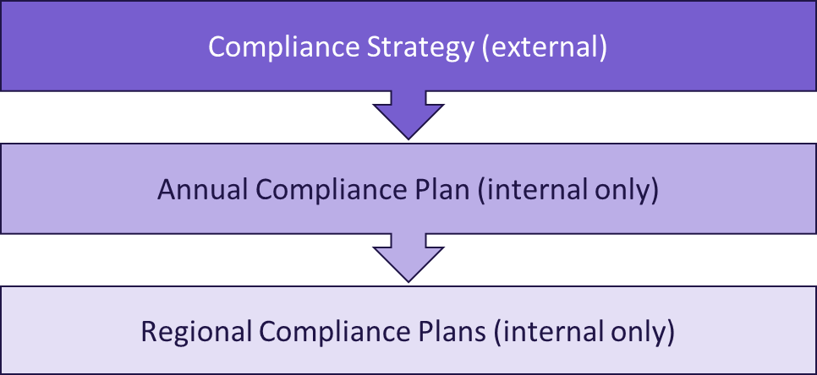
Figure 1. Earth Resources Regulation Compliance Framework
The Compliance Strategy is public document. The Annual Compliance Plan and Regional Compliance Plans are restricted for internal use, as these detail confidential information about the conduct of compliance activities.

Our role
Earth Resources Regulation is Victoria's regulator of exploration, mining, quarrying, petroleum, recreational prospecting and other earth resource activities.
Our role is to ensure that any potential risks posed to the environment, the public, land, property and infrastructure from earth resources activities are identified and eliminated or minimised as far as reasonably practicable. We do this by:
- Licensing, assessing and setting conditions for earth resource projects
- Educating operators in the earth resources sector and the wider community on regulatory requirements
- Informing industry compliance through the provision of codes of practice, guidance notes and technical guidelines
- Monitoring compliance with laws, including by working with co-regulators
- Enforcing laws

Role of the Compliance Team
The compliance team is responsible for monitoring compliance with laws and enforcing these to ensure that mine, quarry and petroleum operators fulfil their obligations under the relevant legislation.

Inspectors
The compliance team consists of Earth Resources Regulation Inspectors. Inspectors are empowered to carry out compliance activities under the legislation listed in part 1.2.3 of this strategy.
Inspector powers are defined under Part 9 of the Mineral Resources (Sustainable Development) Act 1990 (MRSDA) and Part 13 of the Petroleum Act 1998. In general terms, inspectors have the power to:
- Enter a work site and conduct inspections to monitor compliance with legislation, including sighting or copying documents
- Compel authority holders to take remedial action to rectify non-compliance
- Under the MRSDA, give a direction to an operator if the inspector reasonably believes that it is necessary to do so because of an immediate risk to public safety, the environment, land, property or infrastructure.
Authority holders and site occupiers are required to provide reasonable assistance to Inspectors.
Earth Resources Regulation Inspectors exercise their powers with a high degree of professionalism and impartiality. Additional information is available in Earth Resources Regulation’s Stakeholder Engagement Charter, available from the Earth Resources website.

Legislation
Earth Resources Regulation is responsible for monitoring compliance with the following legislation:
Legislation | Regulations
Mineral Resources (Sustainable Development) Act 1990 | Mineral Resources (Sustainable Development) (Extractive Industries) Regulations 2010  Mineral Resources (Sustainable Development) (Mineral Industries) Regulations 2013
Petroleum Act 1998 | Petroleum Regulations 2011
Offshore Petroleum and Greenhouse Gas Storage Act 2010 | Offshore Petroleum and Greenhouse Gas Storage Regulations 2011
Geothermal Energy Resources Act 2005 | Geothermal Energy Resources Regulations 2006
Greenhouse Gas Geological Sequestration Act 2008 | Greenhouse Gas Geological Sequestration Regulations 2009
Mines (Aluminium Agreement) Act 1961
Underseas Mineral Resources Act 1963
Extractive Industries (Lysterfield) Act 1986

Ministerial Statement of Expectations
This compliance strategy aligns with the Ministerial Statement of Expectations for the regulation of the earth resources sector.
Earth Resources Regulation produces an action plan for meeting the Statement of Expectations. This action plan and the associated Statement of Expectations are available from the Earth Resources website.
Earth Resources Regulation reports on its actions and performance against the Statement of Expectations each year.

Working with other agencies and regulators
Earth Resources Regulation has Memoranda of Understanding and agreements in place with co-regulators to enable a whole of government approach to regulation. These working relationships aim to provide authority holders with clear direction on regulatory requirements, assure transparency and support robust engagement with the industry. Earth Resources Regulation’s work with co-regulators aims to effect more efficient regulation and therefore reduce the regulatory burden on authority holders.
This joint regulatory landscape includes Earth Resources Regulation, Environment Protection Authority (EPA) Victoria, the Department of Environment, Land Water and Planning (DELWP), Parks Victoria (ParksVic), National Offshore Petroleum Safety and Environmental Management Authority (NOPSEMA) and WorkSafe Victoria. Other agencies we work closely with include Catchment Management Authorities (CMAs), water authorities, Fire Rescue Victoria (FRV), Emergency Management Victoria (EMV) and local councils

Working with the community
Earth Resources Regulation recognises that earth resources industry activities can have an impact on surrounding communities.
The concerns and observations of local communities, earth resources businesses and environment groups can provide information that is relevant to compliance programs. Community feedback and information about emerging issues and impacts is valuable. Earth Resources Regulation will investigate allegations of non-compliance; however, community concerns are just one input into compliance and enforcement programs.
Earth Resources Regulation must remain independent. Earth Resources Regulation expects authority holders to fulfil their duty to consult local communities to work through any potential or actual issues in good faith.
Additional information is available in Earth Resources Regulation’s Stakeholder Engagement Charter, available from the Earth Resources website.

Strategic compliance objectives

Strategic compliance objectives
Earth Resources Regulation’s compliance activities aim to:
identify and address potential risks to public safety, the environment, land, property and infrastructure
encourage an industry culture where authority holders take ownership of their own compliance
ensure effective and timely rehabilitation (including progressive rehabilitation) of land to a safe, stable and sustainable landform after earth resource activities have ceased.
Earth Resources Regulation is committed to applying robust risk assessment to inform compliance activity, and to understanding the effectiveness of those activities on reducing non-compliance.

State-wide coordination
In 2021, Earth Resources Regulation will move to a centralised model for prioritising, tasking and coordinating compliance activities and investigations. This will aim to improve consistency and transparency in regulatory outcomes, ensuring authority holders have a consistent experience with compliance and enforcement regardless of their location, and ensure that key risks are addressed.
A State-wide Tasking and Coordination Committee (STCC) will be responsible for establishing criteria in assessing risks and prioritising, tasking and coordinating compliance operations. This will include targeted campaigns on priority compliance risks and areas.

Regulatory approach
This section outlines the principles that inform Earth Resources Regulation’s compliance decisions and actions. Earth Resources Regulation’s compliance activities are conducted in accordance with the following regulatory principles:
- Risk-based
- Proportionate and graduated
- Consistent and fair
- Transparent and accountable

Risk-based
Earth Resources Regulation takes a risk-based approach to all regulatory activities. For compliance and enforcement, this ensures regulatory activities are prioritised for sites or activities that present the greatest risk to public safety, the environment, land, property and infrastructure.
A risk-based approach also enables Earth Resources Regulation to:
use resources effectively and efficiently
help stakeholders understand the rationale behind compliance activities
determine the appropriate actions to be applied when non-compliance is identified

Priority risks
A risk-based approach means we use information and evidence available to identify priority risks relating to compliance activities.
Priority risks may change over time due to changes within the operating environment or when our understanding of the risk increases through better information and evidence gathered during compliance activities.
Identified Priority risk areas for 2021–2022 are detailed in part 6 of this strategy.

As Far as Reasonably Practicable
Earth Resources Regulation’s risk management framework considers the level of risk mitigation that is reasonably practicable. Section 1(b)(i) of MRSDA states that risks to the environment, members of the public, land, property or infrastructure arising from the operation must be eliminated or minimised as far as reasonably practicable.
The ‘as far/low as reasonably practicable’ (ALARP) test, is a common method of determining risk mitigation and implementation. While a variety of risk mitigations can be used to address a risk and to meet the compliance requirements, our focus is on ensuring the outcome meets the ALARP test.
Figure 2 illustrates the ALARP concept where risks are treated to reduce their likelihood and/or consequence of occurrence to the point at which they are as low as possible, without costs being disproportionately high in comparison.

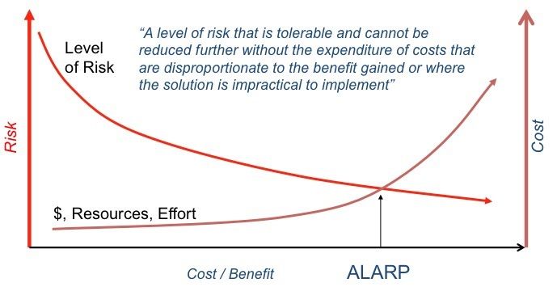
Figure 2: The concept of as low as reasonably practicable (ALARP) (Talbot, 2012)

Proportionate and graduated
Compliance actions in response to identified non-compliance are proportionate to the level of actual or potential harm.
Actions are also graduated, using the full scope of regulatory tools from education to prosecution to match the seriousness of the non-compliance (including potential risk) and history of compliance performance. Additional detail on how this is applied in practice is in the compliance approach section of this strategy. Figure 3 below outlines the concept of a proportionate and graduated regulatory principle.
Earth Resources Regulation may also take enforcement action where it considers it appropriate to do so, irrespective of whether or not such non-compliant activities have been enforced in the past.

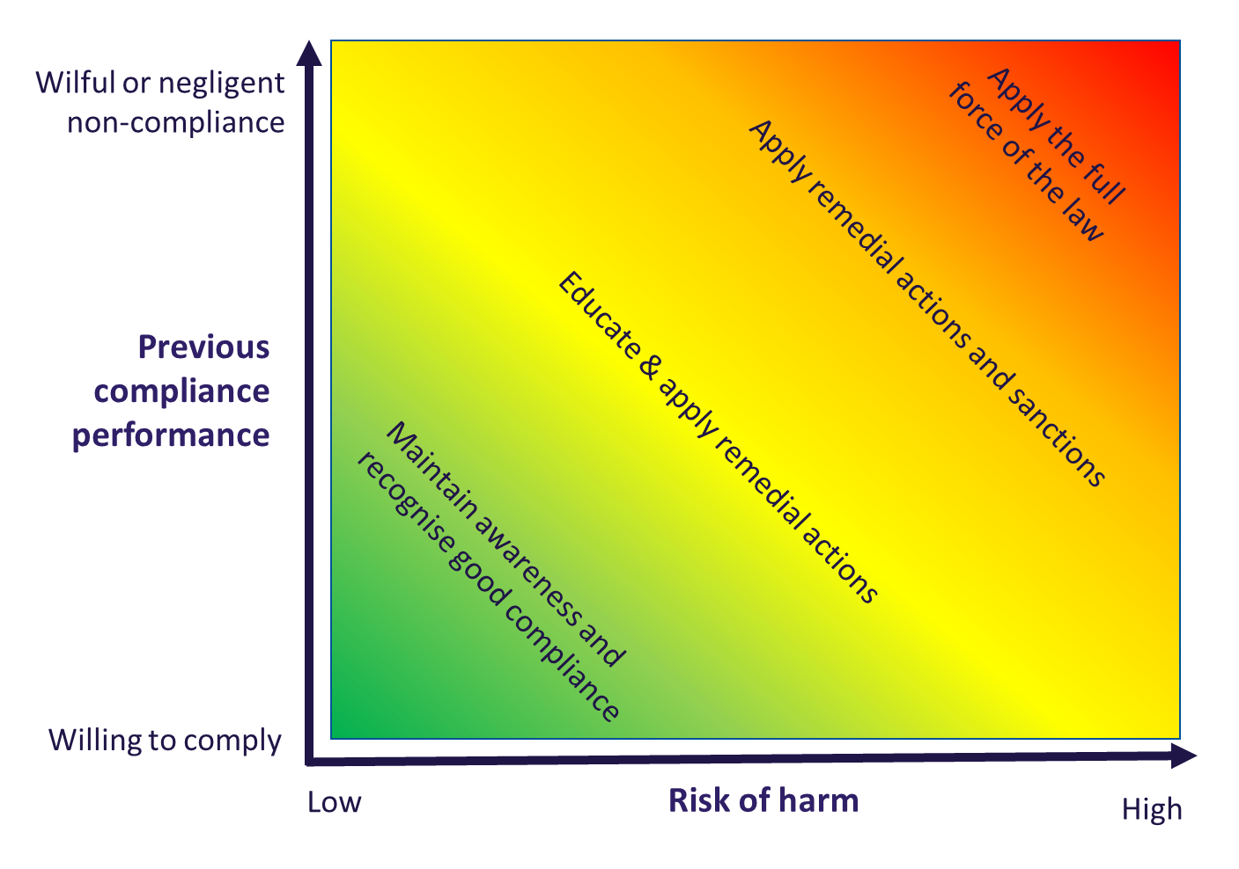
Figure 3: Concept of proportionate and graduated regulatory principle

Consistent and fair
Authority holders will be treated in the same way for equivalent non-compliant actions, risks and circumstances, regardless of company, location or size of operation.
Earth Resources Regulation ensures authority holders are given an opportunity to explain any alleged non-compliant activity and are given sufficient time to undertake remedial action. Earth Resources Regulation will follow-up to ensure remedial action has been taken where non-compliance is identified.

Transparent and accountable
Earth Resources Regulation publishes monthly, quarterly and annual reports on the publicly available website that details compliance and regulatory performance.
In addition to regulatory performance reports, Earth Resources Regulation will publish information on compliance decisions and actions where appropriate and relevant, to provide transparency of compliance action taken. Information on compliance action may be published on Earth Resources Regulation’s public website or in other media.
Publication of compliance actions assures the community and authority holders that the earth resources industry is being regulated appropriately and in accordance with legislation, as well as acting as a deterrent for future non-compliant behaviour.
Companies may be named in any public information released by the regulator about its range of compliance actions. Naming of companies holds the non-compliant authority holder to account and also protects the reputation of the majority of industry participants who comply with their regulatory obligations.
Similarly, company directors’ names may also be released if they are found guilty of an offence by a court. As court proceedings are usually open to the public and tribunal orders and court judgments are public information, the media is also free to report on such matters.
The names of company employees and private citizens, such as recreational prospectors who do not hold a valid Miners Right, will not be published in information released by the regulator. However, exceptions may be made for recidivist or serious offenders.
In all cases, any information on compliance activities will only be published when it is lawful to do so.

Compliance approach
Earth Resources Regulation’s compliance approach encompasses both education and enforcement. It spans from supporting and encouraging compliance through education, including the provision of guidelines and documentation to assist companies in understanding their requirements to addressing serious or recidivist non-compliance through enforcement actions, including prosecution.
Education is an important tool within the regulator’s compliance framework and is used to ensure authority holders can access appropriate information to understand their regulatory obligations and be accountable for fulfilling them.
Earth Resources Regulation will use all available regulatory tools to encourage compliance and deter and address non-compliance, including:
providing guidance and education material and engaging with authority holders on good practice
conducting site inspections and audits and providing feedback on identified issues
implementing remedial action plans for non-compliant activities. This may include remedial notices with specified timeframes for rectification
issuing remedial notices or directions, official warnings, infringement notices, or undertaking prosecutions
cancelling licences, permits and other authorities when justified by risks and impacts and in line with relevant legislation and policy.
Earth Resources Regulation will particularly consider the following factors in determining the most appropriate compliance action for a particular situation:
the risks to be addressed
the degree of harm caused or likely to be caused
the authority holder’s willingness and ability to comply, including recalcitrant or recidivist compliance performance.
Significant non-compliance may also impact a company’s ‘Fit and Proper’ standing, which may impact future applications, renewals and licensing recommendations.

Supporting compliance
Earth Resources Regulation aims to develop and encourage an industry that takes responsibility for its own compliance.
Some of the activities Earth Resources Regulation may undertake to assist authority holders to understand their compliance obligations include:
providing on-site feedback during inspections and audits
issuing industry compliance alerts
publishing fact sheets, codes of practice and guidelines to provide information on specific risk management and to assist with understanding regulatory requirements – such as guidelines on what information is required in a work plan
contributing to industry publications

Monitoring compliance
Earth Resources Regulation uses a wide range of sources of information to assist with compliance monitoring and risk mitigation. This includes information gathered through field activities, industry reports, complaints and tips provided by the community and information and referrals provided from other regulators and government agencies.

Addressing non-compliance
Authority holders are expected to understand and follow the requirements of their authorities. Earth Resources Regulation takes an integrated approach to non-compliance, which involves combining one or more enforcement measures with provision of information and guidance.
In addressing non-compliance, Earth Resources Regulation will use remedial measures to address the non-compliance. This may include the issuing of notices and requirements to implement processes to prevent future recurrence, such as the requirement to vary a work plan. We will also consider whether it is appropriate to implement sanctions, which may include infringement notices, prosecution or in extreme cases cancellation of authorities.
In addressing non-compliance, Earth Resources Regulation will particularly consider:
What information and guidance has previously been given to the authority holder and what further education can be provided if appropriate
What compliance and enforcement action will be taken to ensure the authority holder complies with the law (remedial actions). Whether more stringent enforcement action is warranted

Follow up
Earth Resources Regulation expects authority holders to address non-compliance and provide evidence of remedial action taken.
Earth Resources Regulation will follow-up on identified non-compliance to ensure remedial action has been taken and the non-compliance has been addressed. Follow-up may include site visits or inspections and may be conducted without prior notice. Earth Resources Regulation is likely to take further enforcement action where the remedy has not been applied and the non-compliance has not been resolved.

Enforcement actions
Enforcement activity considers the harm or risk of harm, driver of the non-compliant activity and history of non-compliance.
Our enforcement objectives are to:
Stop the non-compliant activity
Prevent or remedy harm
Hold the authority holder accountable for non-compliance
Deter future non-compliance
Raise awareness of the law.
To achieve these objectives, we may apply both remedies and sanctions as appropriate for the situation and in accordance with legislation and policy.
In determining any compliance action, Earth Resources Regulation may consider:
The harm or potential harm caused as a result of non-compliance. An investigation may be initiated where required
The relevance and quality of the available evidence
General and specific deterrent value – whether enforcement action is likely to deter the specific authority holder or other authority holders from similar conduct
Whether the matter is time-critical – decisions will be made taking account of the statutory time limits that apply to some offences and enforcement actions
Circumstances of the offence – most offences under the MRSDA and Petroleum Act are strict liability offences. However, consideration will be given to the intent of the authority holder, their compliance history, willingness to remedy and take measures to prevent future non-compliance.
When considering the enforcement response, Earth Resources Regulation assesses the seriousness of the alleged offence and the potential impact.
In circumstances where Earth Resources Regulation recommends a matter for prosecution, the offence is referred to DJPR’s Prosecution Services for assessment in accordance with the Victorian Model Litigant Guidelines. Prosecution Services recommends whether to proceed with prosecution or other enforcement measures on behalf of the department, considering the severity of the offence and whether a prosecution is in the public interest.

Priority Risk Areas
Earth Resources Regulation will maintain a priority focus on preventing and responding to the key risks posed by minerals, extractives and petroleum sites to protect public safety, land, infrastructure and the environment. We have identified five risk areas for priority focus for the next 12–18 months, subject to continuing operational review.
Risk | Focus | Detail
Fire | Coal mines, plant and equipment fires | Fires can present a risk to public safety, environment and infrastructure. Coal mines are a key focus for compliance in terms of risk of fire, which can result from plant and equipment fires as well as fire ignition from the landscape. This focus area includes implementing the recommendations of the Hazelwood Mine Fire Inquiry.  Fire risk in quarries, other mines and petroleum sites are also assessed through compliance activities.
Stability | Mines and quarries batters, integrity of tailings storage facilities and land erosion | Most slope failures can be prevented by systematically considering geotechnical risks during the whole life of a mining/quarrying operation and following diligent geotechnical practices.  Erosion of tailings storage facility and slimes dam (collectively called tailings dams) walls, seepage from the base and overtopping during intense rain are three risks that have been identified during recent audits. Internationally, significant tailings dam failures have caused the loss of lives and property and environmental damage.  Risk management of tailings dams involves identifying risks, treating the risks by designing and implementing control or mitigation measures, and monitoring the effectiveness of these treatments.
Rehabilitation | Progressive and final rehabilitation of mines, quarries, petroleum and exploration sites | Effective site rehabilitation underpins confidence in both the resources industry and the regulator. Earth Resources Regulation’s aim is to remove – or if not possible to remove, lower as far as reasonably practicable – rehabilitation risks during operation, closure and post-closure phases.  Progressive rehabilitation is rehabilitation that is undertaken concurrent to mining and extractive operations. It contributes to achieving the final landform as defined in the authority holder’s rehabilitation plan. Earth Resources Regulation expects authority holders to conduct progressive rehabilitation works consistently throughout the life of the site. Rehabilitation should not be confined to the end of operations.  Rehabilitation must include all aspects of an operation, including exploration, appraisal and production, as well as tailings dams, buildings and equipment, satellite locations and additional work areas that may be remote from the main activity centre. Rehabilitation is to be undertaken in accordance with the approved rehabilitation plan.
Community impacts | Including dust, noise and vibrations and security of sites | Resource developments have the potential to pose environmental and public health impacts to the community. With each approval, we regulate authority holders’ management of emissions such as dust and noise, light, and activities such as blasting (e.g. vibration issues) to maintain the risk profile as low as reasonably practicable.  When this does not happen, communities are more likely to lodge complaints, and community dissatisfaction may spread to other businesses in the same industry sector. To reduce this risk, we will address offsite emissions as part of its compliance activities.  Site security non-compliances can result from inadequate fencing and/or signage at sites such as mines or quarries which pose a risk to public safety. To prevent uncontrolled or unauthorised site access requires the implementation of appropriate site management and safety measures.
Authorisations and access | Native Title, land access and annual returns | Compliance with Native Title is generally checked as part of audits / targeted inspections on work plan and authority or licence conditions. Sites with Native Title implications will be targeted as part of a campaign to assess compliance with agreements and conditions relating to Native Title.  Various types of annual returns and reports of operations provide valuable information for the management of earth resources. The ongoing campaign to ensure that such reports are submitted will continue to be a focus until compliance with the provision of such returns achieves acceptable levels.

